Supplemental information for
Tetrapod tracks on Permo–Triassic eolian beds of southern Brazil (Paraná Basin)
Heitor Francischini, Paula Dentzien-Dias, Spencer G. Lucas, Cesar L. Schultz

Supplementary Tables
Table S1. Measurements of the footprints of the SLIA-1 trackway (Dicynodontipus isp.).
Footprint number | Autopodium | Width (mm) | Length (mm) | Width/Length ratio | Maximum depth (mm) | Distance from midline (mm) | Divarication from midline
I | Left pes | 91 | 105 | 0.86 | 36 | 70.4
II | Right pes | 92 | 81 | 1.13 | 33 | 73.3
III | Left manus | 81 | 49 | 1.65 | 43 | 129.6 | 24°
IV | Right manus | 60 | 42 | 1.42 | 50 | 62.3 | 37°
V | Left pes | 90 | 92 | 0.97 | 51 | 93.8
VI | Right pes |  |  |  | 31 | 6.14
VII | Left manus | 78 | 45 | 1.73 | 39 | 102.2 | 30°
VIII | Right manus | 74 | 53 | 1.39 | 52 | 70.0 | 35°
IX | Left pes | 74 | 95 | 0.77 | 26 | 47.7
X | Right pes |  |  |  | 32 | 66.5
XI | Left manus | 60 | 51 | 1.17 | 48 | 122.7 | 18°
XII | Right manus | 81 | 45 | 1.8 | 44 | 36.7 | 32°
XIII | Left pes | 85 | 59 | 1.44 | 43 | 56.2
XIV | Right pes | 84 | 35 | 2.4 | 59 | 51.9
Mean | Manus | 72.33 | 47.5 | 1.52 | 46 | 81.13 | 29.33°
Mean | Pes | 86 | 77.83 | 1.10 | 38.87 | 58.24

Table S2. Mean values of the oblique pace length, the pace angulation, the stride length and the manus-pes distance of the SLIA-1 trackway (Dicynodontipus isp.).
Autopodium | Oblique pace length (mm) | Pace angulation | Stride length (mm) | Manus-pes distance (mm)
Manus | 274.2 | 57.5° | 280.8 | 165
Pes | 262.8 | 64.6° | 261.2

Table S3. Mean values of the oblique pace length, the pace angulation and the stride length of the SLIA-2 trackway (Chelichnus bucklandi).
Oblique pace length (mm) | Pace angulation | Stride length (mm)
66.3 | 83.5° | 84.5

Table S4. Measurements of the footprints of the SLIA-2 trackway (Chelichnus bucklandi).
Footprint number | Autopodium | Width (mm) | Length (mm) | Width/Length ratio | Distance from midline (mm) | Divarication from midline
I | Left | 21 | 12 | 1.75 | 5.9 | 23°
II | Right | 15 | 09 | 1.66 | 15.8 | 24°
III | Left | 23 | 18 | 1.27 | 14.5 | 18°
IV | Right | 14 | 08 | 1.75 | 8.5 | 40°
V | Left | 16 | 10 | 1.60 | 19.3 | 18°
VI | Right | 22 | 16 | 1.37 | 14.0 | 18°
VII | Left | 26 | 15 | 1.73 | 18.1 | 20°
VIII | Right | 17 | 12 | 1.41 | 16.7 | 11°
IX | Left | 19 | 11 | 1.72 | 13.7 | 10°
X | Right | 19 | 11 | 1.72 | 9.4 | 23°
XI | Left | 15 | 08 | 1.87 | 7.6 | 16°
XII | Right | 15 | 07 | 2.14 | 11.5 | 31°
XIII | Left | 19 | 10 | 1.90
XIV | Right | 17 | 06 | 2.83
XV | Left | 21 | 17 | 1.23
Mean | - | 18.6 | 11.3 | 1.64 | 12.9 | 21°

Table S5. Measurements of the footprints of the SLIA-3 trackway (Indeterminate).
Footprint number | Autopodium | Width (mm) | Length (mm) | Width/Length ratio | Distance from midline (mm)
I | Left | 185 | 140 | 1.32 | 123.3
II | Right | 180 | 220 | 0.81 | 112.2
III | Left | 110 | 90 | 1.22 | 116.8
IV | Right | 196 | 215 | 0.91 | 84.4
V | Left | 150 | 155 | 0.96 | 97.2
VI | Right | 124 | 170 | 0.72 | 69.7
Mean | - | 157.5 | 165 | 0.95 | 100.6

Table S6. Mean values of the oblique pace length and the stride length of the SLIA-3 trackway (Indeterminate).
Oblique pace length (mm) | Stride length (mm)
416 | 315

Supplementary figures

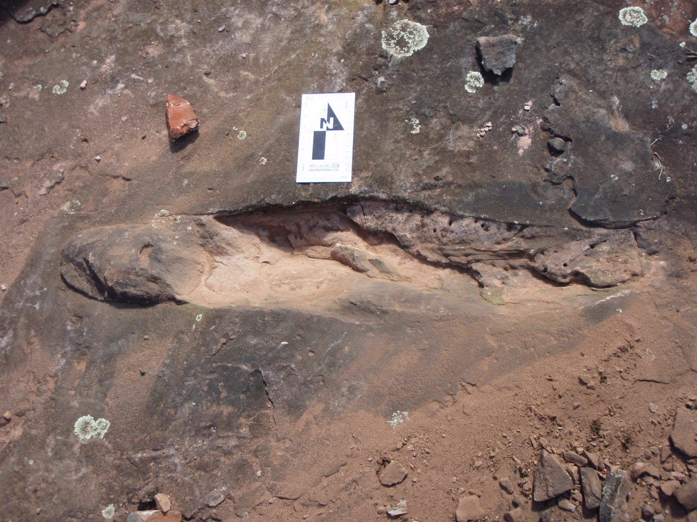
Figure S1. Tetrapod burrow (crotovine) preserved in the same strata than SLIA-1 and SLIA-4 trackways. Scale in centimeters. Image credit: the authors.

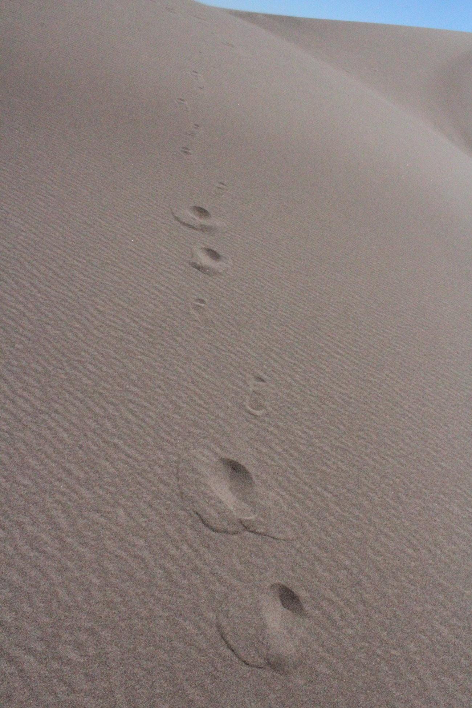
Figure S2. Example of intratrackway morphological variability in eolian sand dunes. Set of footprints produced by a human walking upslope in an eolian dune of the Great Sand Dunes National Park, Colorado, United States of America. Image credit: the authors.
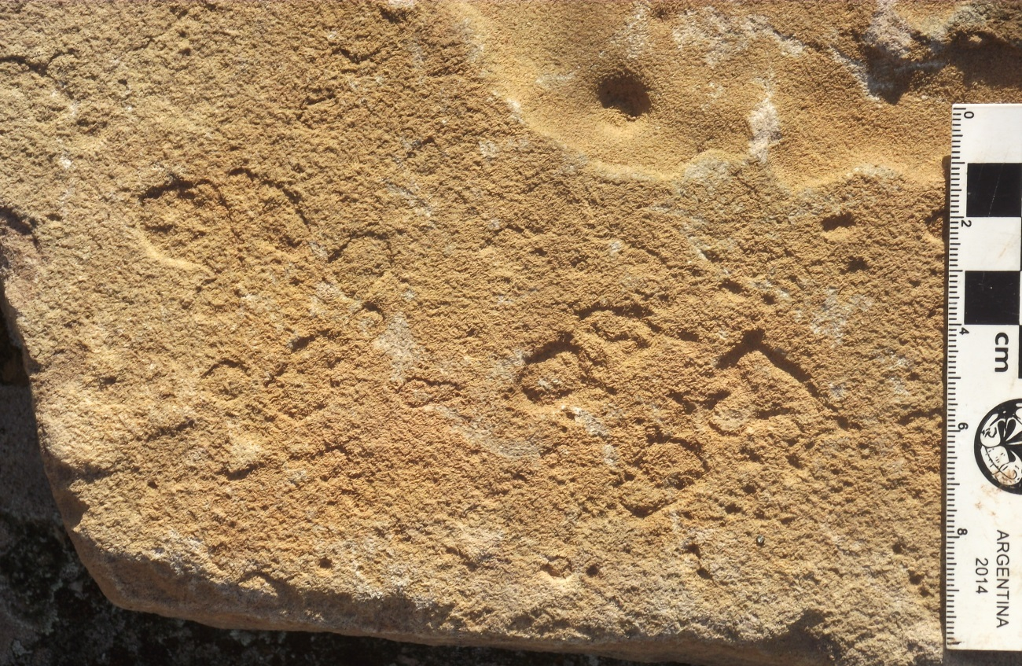
Figure S3. Raindrop marks in an eolian bed of the “Pirambóia Formation”, Brazil. Scale in centimeters. Image credit: the authors.

