Supplementary Materials

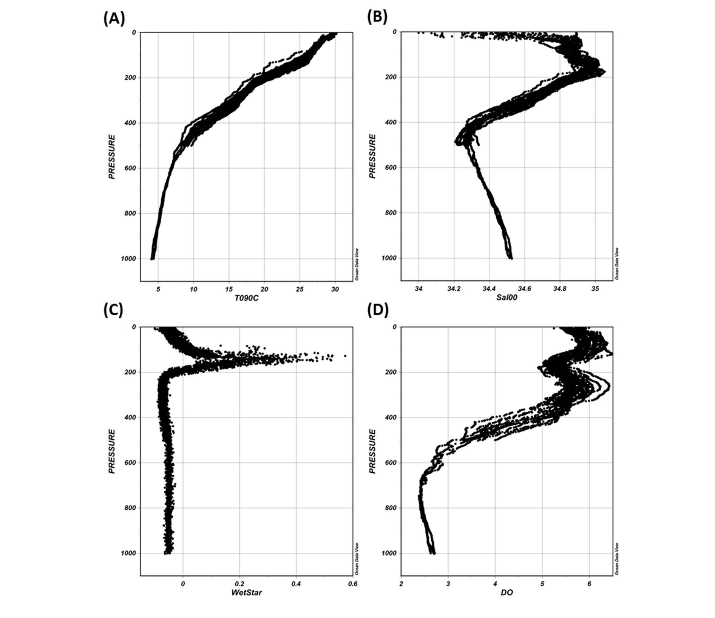

Figure S1. Depth profiles for water parameters measured at sampling stations in Benham Rise. (A) Temperature (T090C), (B) salinity (Sal00), (C) chlorophyll-a (WetStar), and (D) dissolved oxygen (DO).

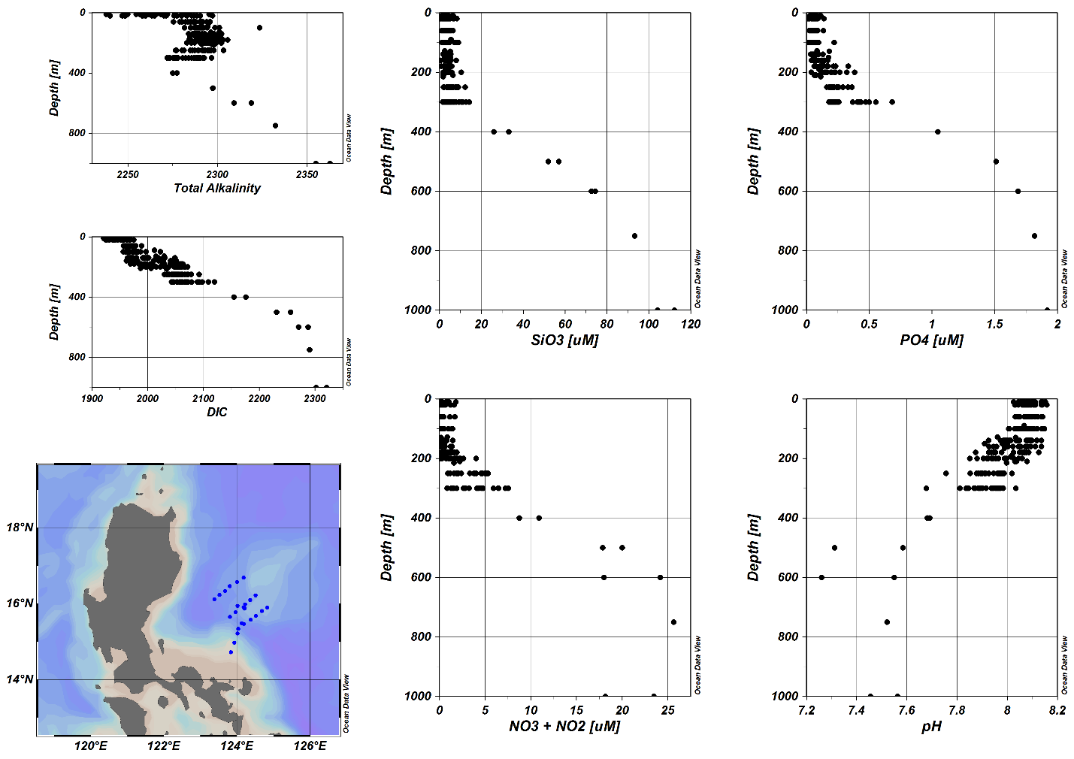

Figure S2. Depth profiles of nutrients and carbonate parameters in Benham Rise. Vertical profiles of chemical parameters for all 24 sampling stations (blue dots in map) covering ten depths per station.

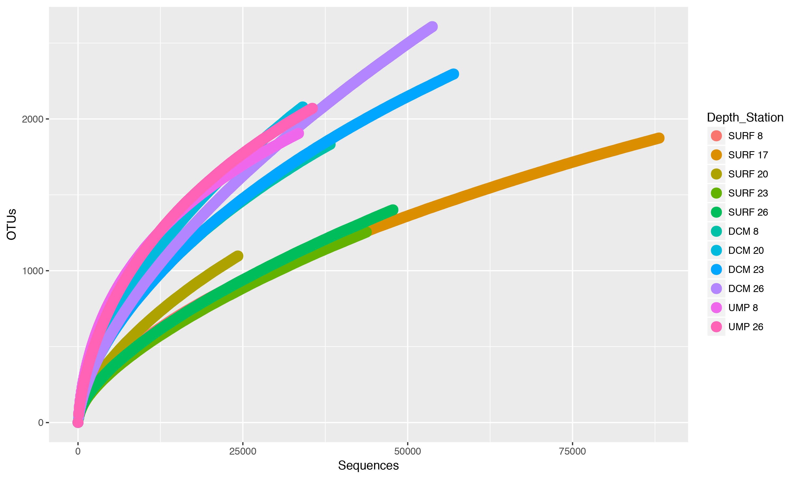

Figure S3. Rarefaction curves for 16S rRNA libraries from the indicated sampling stations and depths.

Table S1. Physical and chemical parameters of waters sampled for microbial analysis

Sample ID | Stn | Lat  (deg) | Long  (deg) | Depth (m) | Temperature(ºC) | Salinity  (psu) | Turbidity  (mg/L) | Chl-a  (mg/L) | PO₄ [uM] | SiO₃ [uM] | NO₃ + NO₂ [uM] | DO [mg/L] | Total Alkalinity | DIC | pH
SURF 8 | 8 | 16.223 | 124.507 | 10 | 29.70 | 34.26 | 0.1217 | 0.00 | 0.11 | 1.16 | UD | 5.79 | 2250 | 1930 | 8.10
SURF 17 | 17 | 16.232 | 123.519 | 10 | 29.75 | 34.62 | 0.1474 | 0.02 | 0.07 | 6.47 | UD | 5.54 | 2280 | 1963 | 8.06
SURF 20 | 20 | 16.576 | 124.002 | 10 | 29.70 | 34.30 | 0.1157 | 0.00 | UD | 1.77 | UD | 5.64 | 2248 | 1938 | 8.09
SURF 23 | 23 | 15.490 | 124.123 | 10 | 29.86 | 34.59 | 0.1161 | 0.00 | UD | 4.39 | UD | 5.61 | 2270 | 1951 | 8.07
SURF 26 | 26 | 14.729 | 123.833 | 10 | 29.17 | 34.48 | 0.1306 | 0.00 | UD | 2.85 | UD | 5.81 | 2257 | 1933 | 8.14
DCM 8 | 8 | 16.223 | 124.507 | 200 | 20.30 | 34.90 | 0.1234 | 0.00 | 0.15 | 1.84 | UD | 5.74 | 2292 | 1996 | 8.05
DCM 20 | 20 | 16.576 | 124.002 | 160 | 24.58 | 34.92 | 0.1141 | 0.35 | 0.04 | 3.51 | 0.27 | 5.34 | 2290 | 2020 | 8.00
DCM 23 | 23 | 15.490 | 124.123 | 140 | 24.63 | 34.97 | 0.1284 | 0.36 | UD | 2.74 | UD | 5.27 | 2302 | 2019 | 8.01
DCM 26 | 26 | 14.729 | 123.833 | 90 | 24.51 | 34.94 | 0.1401 | 0.26 | UD | 5.57 | UD | 5.45 | 2295 | 2012 | 8.07
UMP 8 | 8 | 16.223 | 124.507 | 300 | 16.60 | 34.67 | 0.1268 | 0.00 | 0.26 | 5.33 | UD | 5.34 | 2286 | 2053 | 7.94
UMP 26 | 26 | 14.729 | 123.833 | 300 | 14.47 | 34.53 | 0.1378 | 0.00 | 0.42 | 14.26 | 7.23 | 5.03 | 2289 | 2109 | 7.86
legends: Stn – station, lat – latitude, long – longitude, deg – degree, UD – undetectable

Table S2. CTD data (see excel sheet)

Table S3. Chemical parameter data (see excel sheet)

Table S4. Statistical tests of microbial community structure similarity based on the Yue & Clayton and the Jaccard dissimilarity indices.

Parsimony test
Yue & Clayton |  |  |  | Jaccard
Tree# | Groups | ParsScore | ParsSig | Tree# | Groups | ParsScore | ParsSig
1 | DCM-SURF | 4 | 1 | 1 | DCM-SURF | 1 | 0.009
1 | DCM-UMP | 1 | 0.128 | 1 | DCM-UMP | 1 | 0.142
1 | SURF-UMP | 1 | 0.113 | 1 | SURF-UMP | 1 | 0.128
Unweighted UniFrac
Yue & Clayton |  |  |  | Jaccard
Tree# | Groups | UWScore | UWSig | Tree# | Groups | UWScore | UWSig
1 | DCM-SURF | 0.522015 | 0.793 | 1 | DCM-SURF | 1 | 0.036
1 | DCM-UMP | 1 | 0.332 | 1 | DCM-UMP | 1 | 0.37
1 | SURF-UMP | 1 | 0.282 | 1 | SURF-UMP | 1 | 0.047
Weighted UniFrac
Yue & Clayton |  |  |  | Jaccard
Tree# | Groups | WScore | WSig | Tree# | Groups | WScore | WSig
1 | DCM-SURF | 0.326649 | 0.199 | 1 | DCM-SURF | 1 | <0.0010
1 | DCM-UMP | 1 | <0.0010 | 1 | DCM-UMP | 1 | 0.043
1 | SURF-UMP | 1 | <0.0010 | 1 | SURF-UMP | 1 | <0.0010
AMOVA
Yue & Clayton |  |  |  | Jaccard
DCM-SURF-UMP | Among | Within | Total | DCM-SURF-UMP | Among | Within | Total
SS | 1.34444 | 0.397095 | 1.74153 | SS | 1.32286 | 2.32542 | 3.64827
df | 2 | 8 | 10 | df | 2 | 8 | 10
MS | 0.672219 | 0.0496369 |  | MS | 0.661428 | 0.290677
Fs: | 13.5427 |  |  | Fs: | 2.27547
p-value: | 0.005 |  |  | p-value | <0.001
HOMOVA
Yue & Clayton |  |  |  | Jaccard
 | Bvalue | P-value |  |  | BValue | P-value
DCM-SURF-UMP | 3.11732 | 0.565 |  | DCM-SURF-UMP | 0.0219614 | 0.191
ʃ-LIBSHUFF
Yue & Clayton |  |  |  | Jaccard
Comparison | dCXYScore | Significance |  | Comparison | dCXYScore | Significance
DCM-SURF | 0.00651325 | 0.866 |  | DCM-SURF | 0.1159202 | 0.0072
SURF-DCM | 0.00567132 | 0.7401 |  | SURF-DCM | 0.08439142 | <0.0001
DCM-UMP | 0.83380875 | 0.0679 |  | DCM-UMP | 0.07416752 | 0.0692
UMP-DCM | 0.25853403 | 0.5279 |  | UMP-DCM | 0.13417697 | 0.2675
SURF-UMP | 0.80135013 | <0.0001 |  | SURF-UMP | 0.13425305 | 0.0499
UMP-SURF | 0.23286927 | 0.6656 |  | UMP-SURF | 0.22891821 | 0.0499

Table S5. Depth-associated OTUs. Selected OTUs that differentiate between depths were identified using LEfSe. Selected OTUs responsible for differences in the grouping of samples were identified using indicator analysis.

OTU Number | Taxonomy | Depth | Test | p-value
Otu00005 | Nitrosopumilaceae | UMP | LEfSe | 0.012
Otu00007 | SAR86 | SURF | LEfSe | 0.013
Otu00009 | Marine Group II | DCM | LEfSe | 0.023
Otu00015 | SAR116 | SURF | LEfSe | 0.014
Otu00310 | Nitrospina | UMP | Indicator | 0.019
Otu00702 | Spirochaeta | UMP | Indicator | 0.026

