**SUPPLEMENTARY FILE 1: STRUCTURE analyses and Neighbour-joining unrooted tree**

1. Results of the ΔK calculation performed with STRUCTURE without using the LOCPRIOR option.

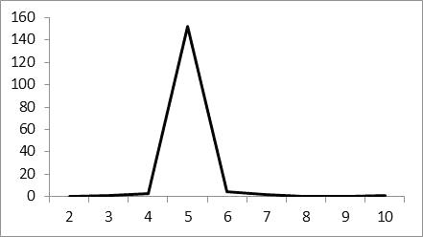

B) Neighbour-joining unrooted tree based on ISSR markers (Nei and Li distances). Bootstrap values were >40% for all nodes.

