Supplementary Data

Synthesis, enzyme inhibitory kinetics mechanism and computational study of N-(4-methoxyphenethyl)-N-(substituted)-4-methylbenzenesulfonamides as novel therapeutic agents for alzheimer’s disease

Muhammad Athar Abbasi^{1,*}, Mubashir Hassan², Aziz-ur-Rehman¹, Sabahat Zahra Siddiqui¹, Syed Adnan Ali Shah^{3,4}, Hussain Raza² and Sung-Yum Seo^{2,*}

¹Department of Chemistry, Government College University, Lahore-54000, Pakistan.
²College of Natural Sciences, Department of Biological Science, Kongju National University, Gongju, 32588, South Korea.
³Faculty of Pharmacy & ⁴Atta-ur-Rahman Institute for Natural Products Discovery (AuRIns), Level 9, FF3, Universiti Teknologi MARA, Puncak Alam Campus, 42300 Bandar Puncak Alam, Selangor Darul Ehsan, Malaysia.

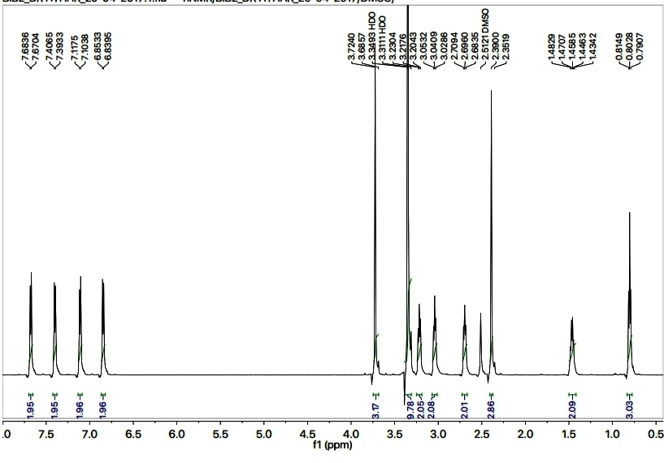
Figure S1: ¹H-NMR spectrum of 5b
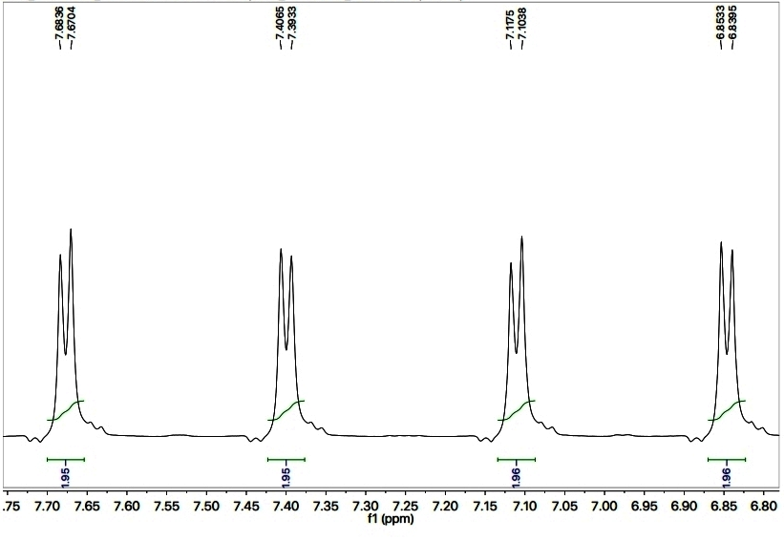
Figure S2: Aromatic region of ¹H-NMR spectrum of 5b.
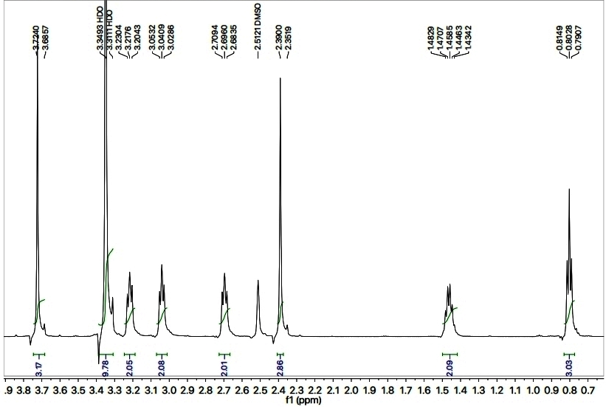
Figure S3: Aliphatic region of ¹H-NMR spectrum of 5b.
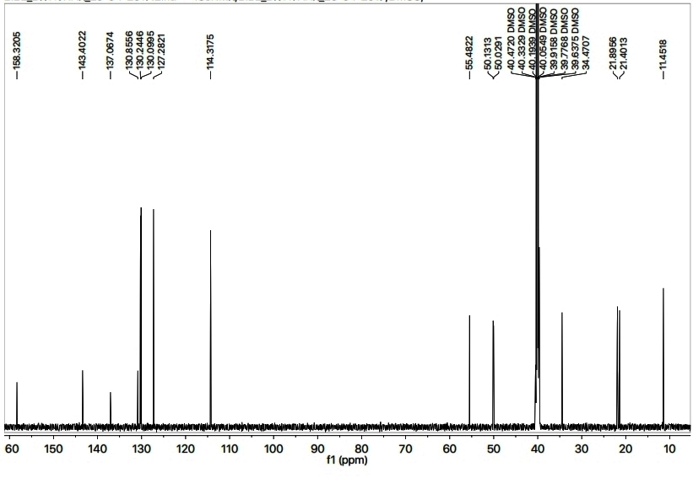
Figure S4: ¹³C-NMR spectrum of 5b.

Figure S5: Docking complex of 5a

Figure S6: Docking complex of 5b

Figure S7: Docking complex of 5d

Figure S8: Docking complex of 5e

Figure S9: Docking complex of 5f

Figure S10: Docking complex of 5g

Figure S11: Docking complex of 5h

Figure S12: Docking complex of 5i

Figure S13: Docking complex of 5j

