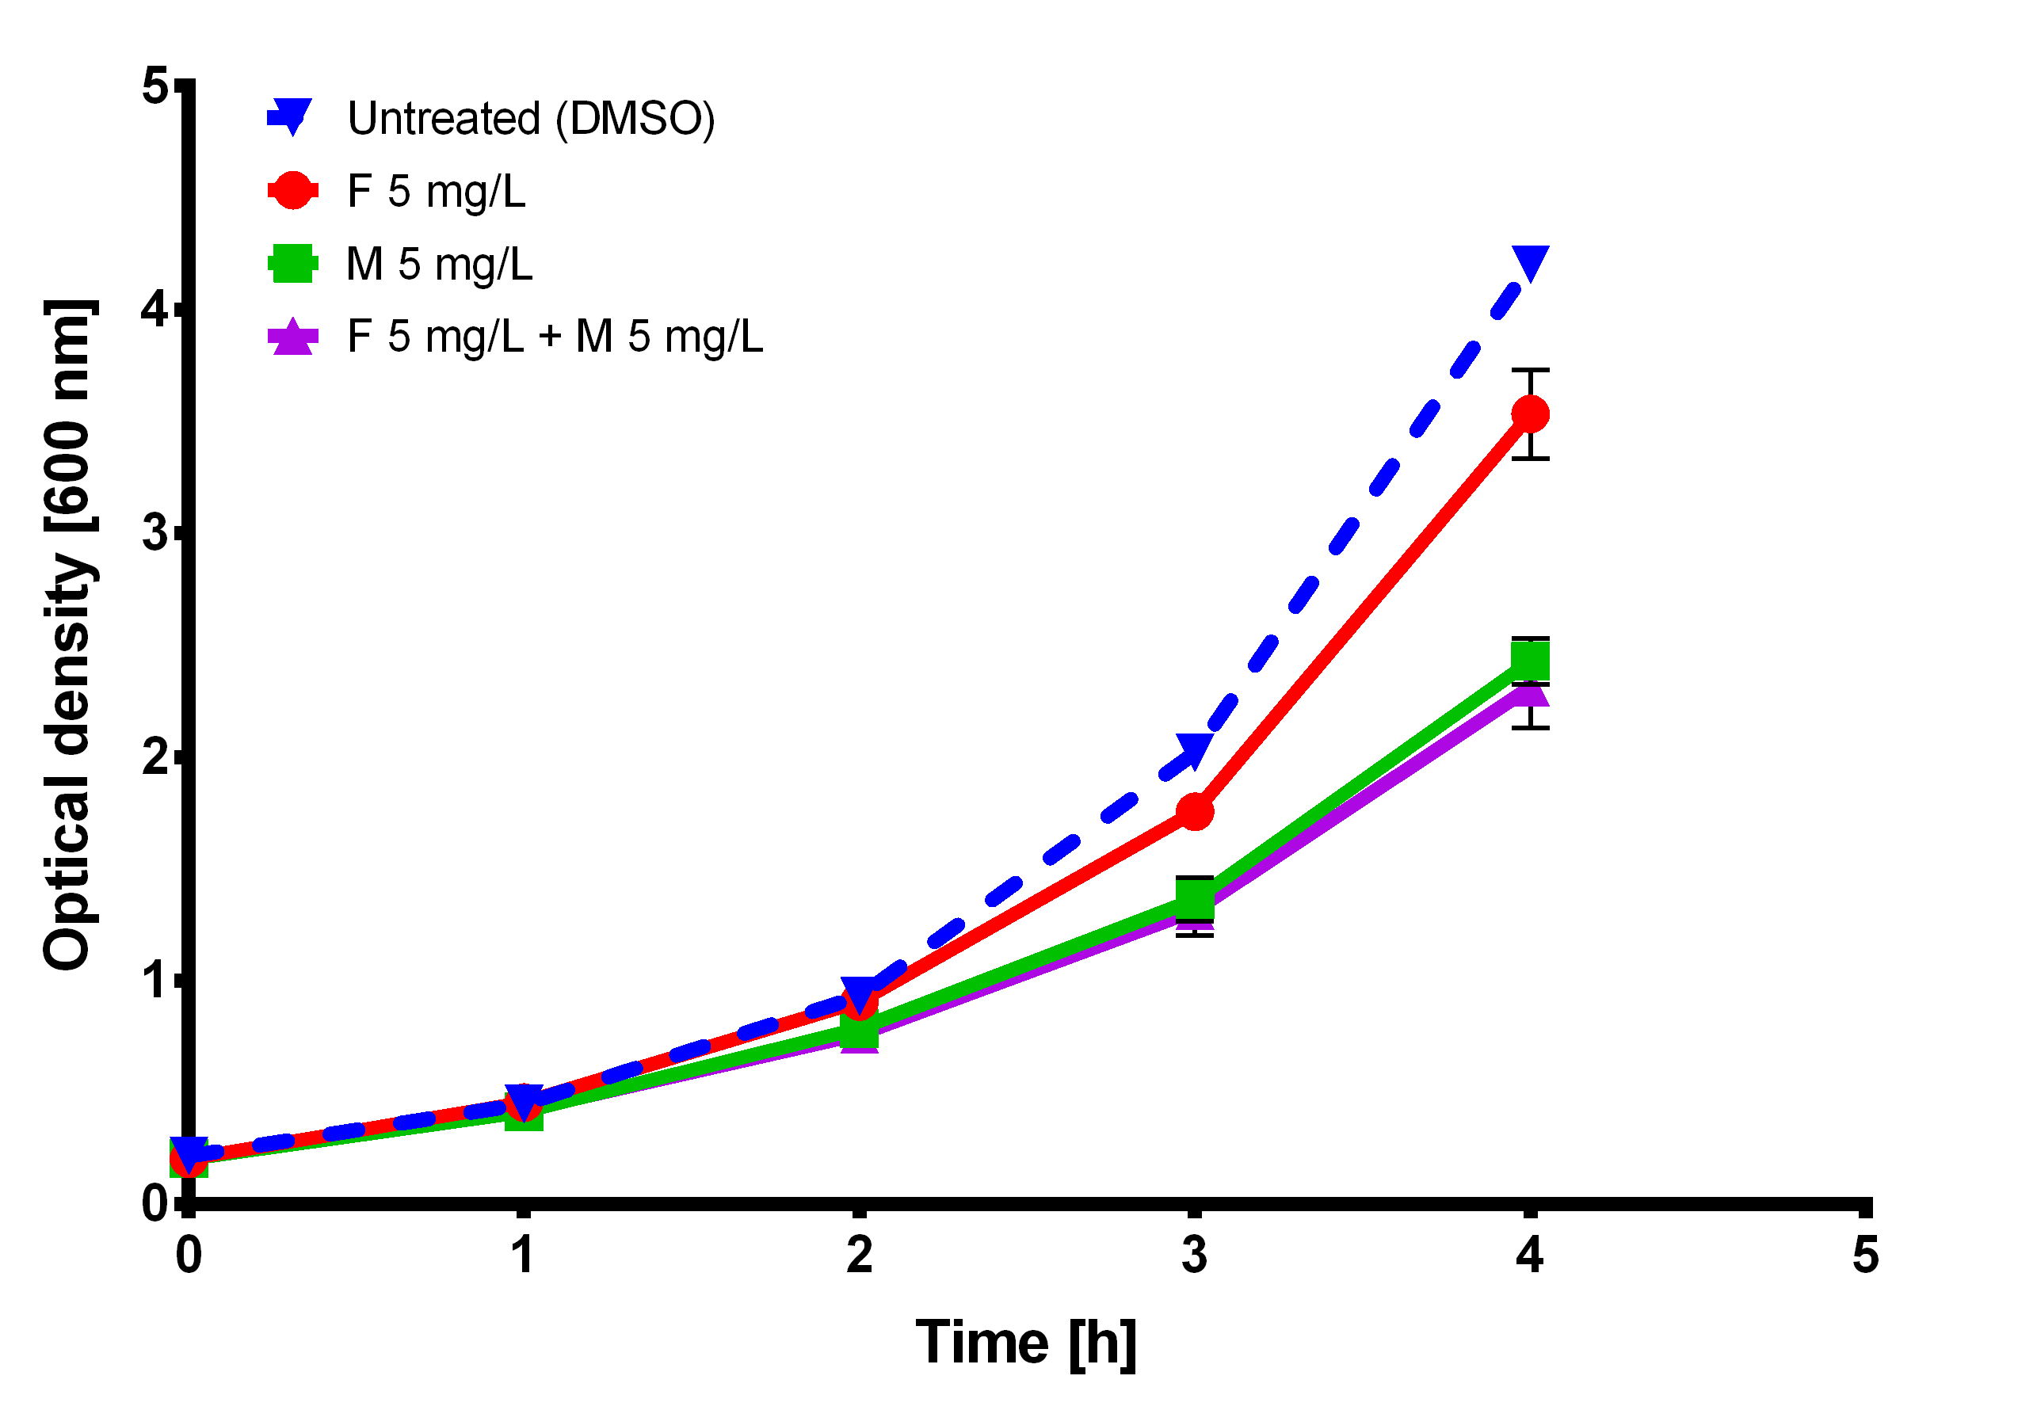
Concentrations of fluconazole and mycophenolic acid that cause differences in C. glabrata ATCC 2001 growth.
The cells were prepared as an overnight culture in liquid YPD at 37 °C. In the morning, they were diluted in fresh YPD to optical density at 600 nm (OD₆₀₀) 0.05 and left to grow at 37 °C back OD₆₀₀ 0.1. At that point the drugs were added and we started to monitor the changes in OD₆₀₀. The OD₆₀₀ is shown, as well as the standard deviation. The figure shows one representative experiment with three independent biological replicates. We were looking for the first time point, where the growth difference in response to either of the drugs or the combination of both was visible, since we have a mechanism with induced tolerance by cells responding to drugs.
F – fluconazole, M – mycophenolic acid
The first time point was determined at 2 h and the next at 4 h. This was backed-up with previous studies, where they observed PDR1 and CDR1 expression at similar time points with similar preparation of cells, for example 2.5 h for PDR1 and CDR1 in (Vermitsky et al., 2006) or 2.2 and 4.4 h in (Kuo et al., 2010) where they studied a response to drugs.

Kuo D., Tan K., Zinman G., Ravasi T., Bar-Joseph Z., Ideker T. 2010. Evolutionary divergence in the fungal response to fluconazole revealed by soft clustering. Genome Biology 11:R77. DOI: 10.1186/gb-2010-11-7-r77.
Vermitsky J-P., Earhart KD., Smith WL., Homayouni R., Edlind TD., Rogers PD. 2006. Pdr1 regulates multidrug resistance in Candida glabrata: gene disruption and genome-wide expression studies. Molecular microbiology 61:704–22. DOI: 10.1111/j.1365-2958.2006.05235.x.

