Supplemental File S1.
A new southern Laramidian ankylosaurid Akainacephalus johnsoni gen. et sp. nov. from the upper Campanian Kaiparowits Formation of southern Utah
Jelle P. Wiersma^{1,2,3*}, Randall B. Irmis^{2,3}
¹Department of Geosciences, James Cook University, Townsville, Queensland, Australia
²Natural History Museum of Utah, Salt Lake City, Utah, United States of America; ³Department of Geology & Geophysics, University of Utah, Salt Lake City, Utah, United States of America
*Email: jelle.wiersma@my.jcu.edu.au
Contents
Text S1. Institutional abbreviations
Table S1. Examined specimens for comparison with Akainacephalus johnsoni (UMNH VP 20202).
Figure S1. Strict Consensus tree from 21 equally most parsimonious phylogenetic trees, including the wildcard taxon Ahshislepelta minor.
Figure S2. Most parsimonious tree from the pruned dataset (Ahshislepelta removed), recovering Akainacephalus johnsoni as a sister taxon to Nodocephalosaurus kirtlandensis, with synapomorphy list.
Figure S3. Most parsimonious tree from the pruned dataset (Ahshislepelta removed), recovering Akainacephalus johnsoni as a sister taxon to Nodocephalosaurus kirtlandensis, with synapomorphy list.
Figure S4. Most parsimonious tree from the pruned dataset (Ahshislepelta removed), recovering Akainacephalus johnsoni as a sister taxon to Nodocephalosaurus kirtlandensis, with synapomorphy list.
Figure S5. Most parsimonious tree from the pruned dataset (Ahshislepelta removed), recovering Akainacephalus johnsoni as a sister taxon to Nodocephalosaurus kirtlandensis, with synapomorphy list.
Figure S6. Most parsimonious tree from the pruned dataset (Ahshislepelta removed), recovering Akainacephalus johnsoni as a sister taxon to Nodocephalosaurus kirtlandensis, with synapomorphy list.
Figure S7. Most parsimonious tree from the pruned dataset (Ahshislepelta removed), recovering Akainacephalus johnsoni as a sister taxon to Nodocephalosaurus kirtlandensis, with synapomorphy list.
Figure S8. Strict Consensus tree from 6 equally most parsimonious phylogenetic trees.
Figure S9. Branch support for the pruned phylogenetic analysis, superimposed on the strict consensus of six equally most parsimonious phylogenetic trees
Figure S10. 50% Majority Rule tree resulting from the Arbour and Currie (2016) and Arbour and Evans (2017) data matrices, used to determine an alternative phylogenetic position of Akainacephalus johnsoni

Text S1. Institutional abbreviations.

Institutional Abbreviations: AMNH, American Museum of Natural History, New York, New York, USA; CMN, Canadian Museum of Nature, Ottawa, Ontario, Canada; INBR, Victor Valley Museum, Apple Valley, California, USA; MPC, Paleontological Center, Mongolian Academy of Sciences, Ulanbataar, Mongolia; UMNH, Natural History Museum of Utah, Salt Lake City, Utah, USA; NMMNH, New Mexico Museum of Natural History and Science, Albuquerque, New Mexico, USA; TMP – Royal Tyrrell Museum of Paleontology, Drumheller, Alberta, Canada; UALVP – University of Alberta Laboratory for Vertebrate Paleontology, Edmonton, Alberta, Canada; USNM, Smithsonian National Museum of Natural History, Washington, DC, USA; ROM, Royal Ontario Museum, Toronto, Ontario, Canada; SMP, State Museum of Pennsylvania, Harrisburg, Pennsylvania, USA; ZPAL, Zaklad Paleobiologii, Polish Academy of Sciences, Warsaw, Poland.

Table S1. Examined specimens for comparison with Akainacephalus johnsoni (UMNH VP 20202).

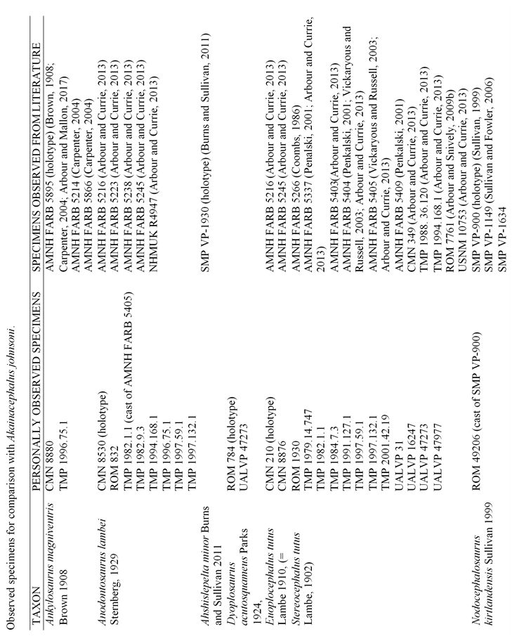

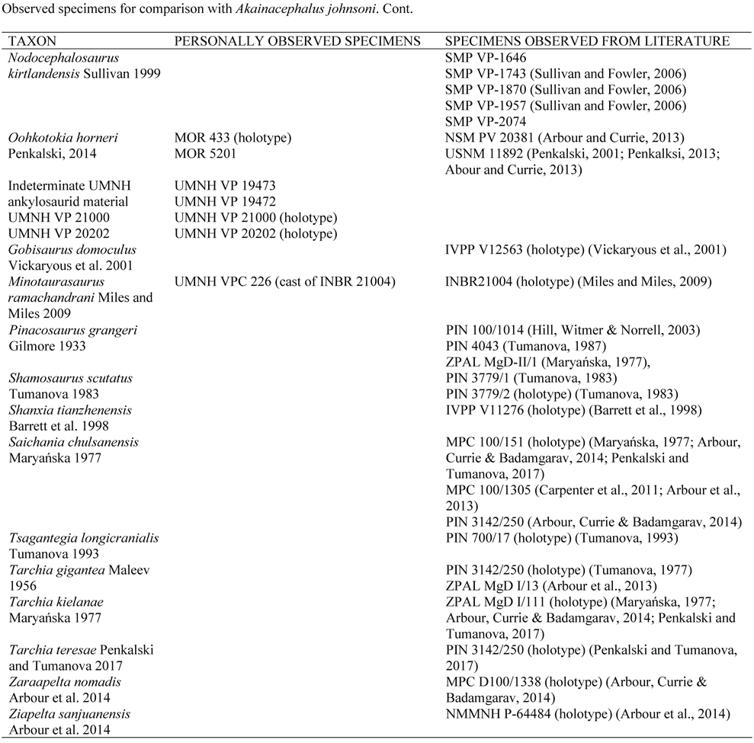

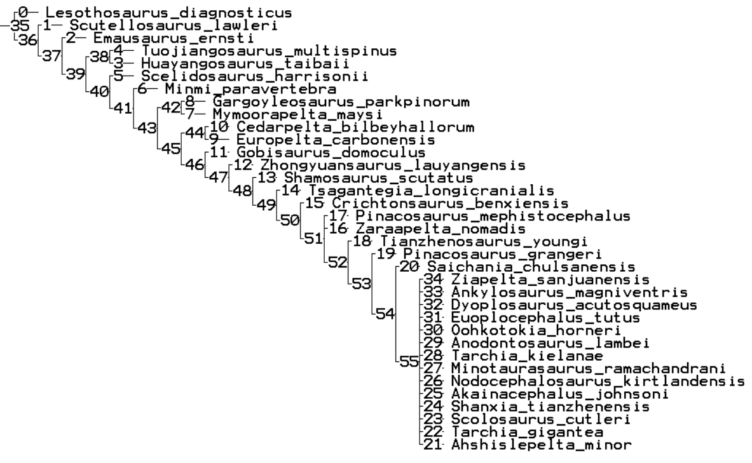
Figure S1. Strict Consensus tree from 21 equally most parsimonious phylogenetic trees, including the wildcard taxon Ahshislepelta minor.

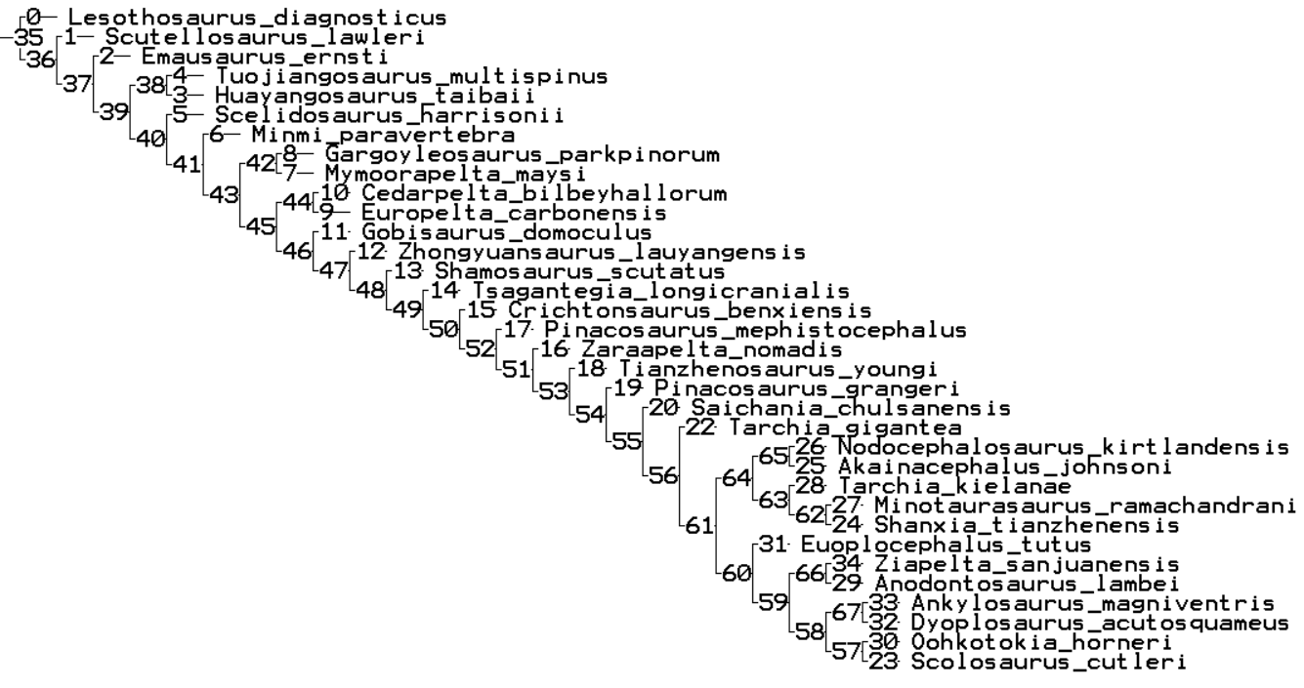
Figure S2. Most parsimonious tree from the pruned dataset (Ahshislepelta removed), recovering Akainacephalus johnsoni as a sister taxon to Nodocephalosaurus kirtlandensis, with synapomorphy list.
Node 37: No synapomorphies
Node 38: 84(1)
Node 39: 3(3), 60(1), 72(1), 98(1), 134(1), 145(2), 169(1), 177(1), 179(1), 189(1), 193(1), 196(1), 201(0), 280(1), 281(1), 284(1), 286(0), 288(0)
Node 40: 37(1), 97(1), 119(1), 138(1)
Node 41: 40(1), 42(1), 82(1), 88(1), 90(1), 92(1), 93(1), 101(1), 120(1), 153(1), 161(1), 162(1), 181(1), 192(1), 199(1), 200(1), 206(1), 219(1), 229(1)
Node 42: 1(1), 15(1), 25(1), 30(2), 32(1), 49(2), 61(1), 100(1)
Node 43: 51(1), 52(1), 104(1), 115(1), 128(1), 129(1), 152(2), 177(1), 254(1), 260(2)
Node 44: 72(1), 98(1), 99(1), 101(2), 122(1), 179(1), 180(1), 196(1), 212(2), 213(1), 230(1), 232(1)
Node 45: 6(1), 14(1), 74(1), 144(1), 148(2), 212(1)
Node 46: 3(1), 28(1), 44(0), 46(0), 49(1), 50(1), 58(1), 59(1), 73(1), 75(1), 124(1), 132(1), 137(1), 142(1), 158(1), 172(1), 183(1), 188(1), 189(1), 195(1), 197(1), 198(1), 201(2), 220(1), 224(1)
Node 47: 9(1), 12(1), 20(2), 23(1), 31(1), 34(1), 41(1), 48(1), 53(1), 56(1), 61(0), 94(1), 119(2)
Node 48: 10(1), 64(1), 111(1)
Node 49: 3(0), 134(1)
Node 50: 17(0), 21(1), 80(0), 102(1), 103(2), 104(1)
Node 51: 2(1), 4(0), 43(1), 44(1), 45(1), 48(3), 49(2), 56(0), 57(1), 63(1), 67(1), 70(1)
Node 52: 1(3), 60(1), 104(2)
Node 53: No synapomorphies
Node 54: 35(1), 54(1), 103(3), 104(3)
Node 55: 4(1), 55(1)
Node 56: 11(1), 129(1), 202(1), 203(1), 204(1), 228(1)
Node 57: 168(1), 174(1), 177(1)
Node 58: 227(2)
Node 59: 233(1), 238(1)
Node 60: 109(0), 210(1)
Node 61: 1(2), 2(2), 67(0), 103(1), 104(1), 111(2), 140(1), 145(2)
Node 62: 5(1), 55(0), 64(2), 121(1), 262(0)
Node 63: No synapomorphies
Node 64: 70(0), 118(1)
Node 65: 132(0), 133(1)
Node 66: 4(0), 10(0), 41(0), 46(1), 57(0)
Node 67: 250(1)
Node 68: 39(0), 64(1)
Node 69: 211(1), 262(1)

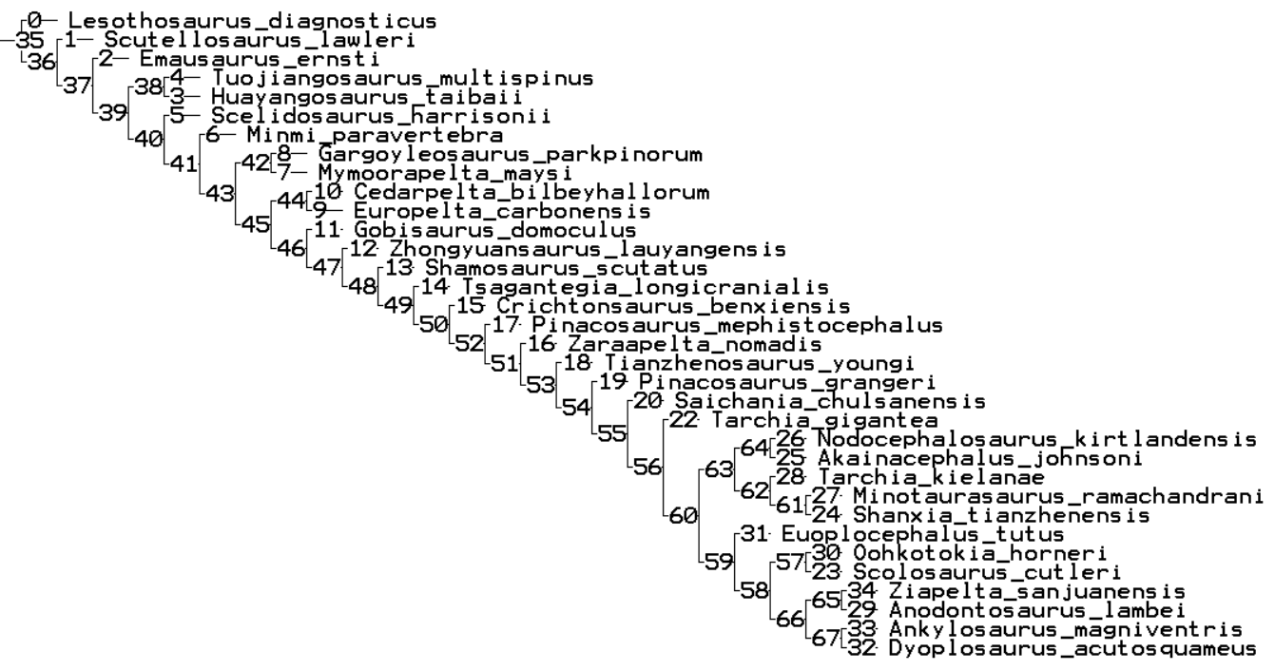
Figure S3. Most parsimonious tree from the pruned dataset (Ahshislepelta removed), recovering Akainacephalus johnsoni as a sister taxon to Nodocephalosaurus kirtlandensis, with synapomorphy list.
Node 37: No synapomorphies
Node 38: 84(1)
Node 39: 3(3), 60(1), 72(1), 98(1), 134(1), 145(2), 169(1), 177(1), 179(1), 189(1), 193(1), 196(1), 201(0), 280(1), 281(1), 284(1), 286(0), 288(0)
Node 40: 37(1), 97(1), 119(1), 138(1)
Node 41: 40(1), 42(1), 82(1), 88(1), 90(1), 92(1), 93(1), 101(1), 120(1), 153(1), 161(1), 162(1), 181(1), 192(1), 199(1), 200(1), 206(1), 219(1), 229(1)
Node 42: 1(1), 15(1), 25(1), 30(2), 32(1), 49(2), 61(1), 100(1)
Node 43: 51(1), 52(1), 104(1), 115(1), 128(1), 129(1), 152(2), 177(1), 254(1), 260(2)
Node 44: 72(1), 98(1), 99(1), 101(2), 122(1), 179(1), 180(1), 196(1), 212(2), 213(1), 230(1), 232(1)
Node 45: 6(1), 14(1), 74(1), 144(1), 148(2), 212(1)
Node 46: 3(1), 28(1), 44(0), 46(0), 49(1), 50(1), 58(1), 59(1), 73(1), 75(1), 124(1), 132(1), 137(1), 142(1), 158(1), 172(1), 183(1), 188(1), 189(1), 195(1), 197(1), 198(1), 201(2), 220(1), 224(1)
Node 47: 9(1), 12(1), 20(2), 23(1), 31(1), 34(1), 41(1), 48(1), 53(1), 56(1), 61(0), 94(1), 119(2)
Node 48: 10(1), 64(1), 111(1)
Node 49: 3(0), 134(1)
Node 50: 17(1), 21(1), 80(0), 102(1), 103(2), 104(1)
Node 51: 2(1), 4(0), 43(1), 44(1), 4(1), 48(3), 49(2), 56(0), 57(1), 63(1), 67(1), 70(1)
Node 52: 1(3), 60(1), 104(2)
Node 53: No synapomorphies
Node 54: 35(1), 54(1), 103(3), 104(3)
Node 55: 4(1), 55(1)
Node 56: 11(1), 129(1), 202(1), 203(1), 204(1), 228(1)
Node 57: 227(1)
Node 58: 211(1), 262(1)
Node 59: 39(0), 64(1)
Node 60: 109(0), 170(1), 210(1)
Node 61: 1(3), 2(2), 67(0), 103(1), 104(1), 111(2), 140(1), 145(2)
Node 62: 5(1), 55(0), 64(2), 121(1), 262(0)
Node 63: 227(2)
Node 64: 233(1), 238(1)
Node 65: No synapomorphies
Node 66: 70(0), 118(1)
Node 67: 132(0), 133(1)
Node 68: 4(0), 10(0), 41(0), 46(1), 57(0)
Node 69: 250(1)

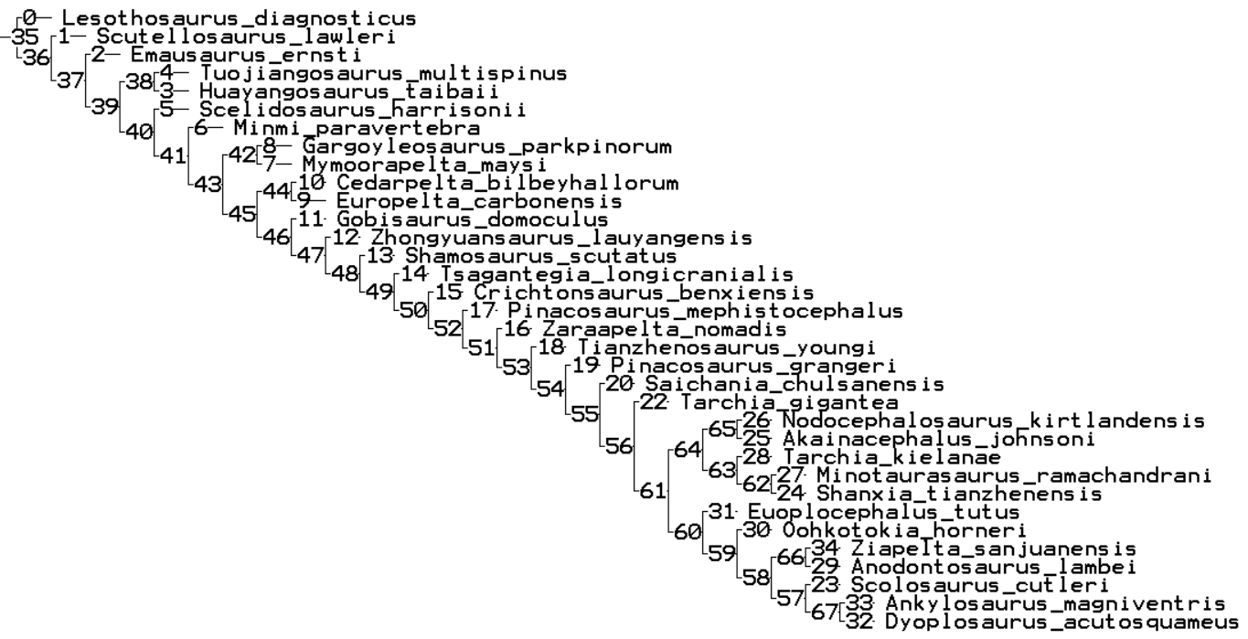
Figure S4. Most parsimonious tree from the pruned dataset (Ahshislepelta removed), recovering Akainacephalus johnsoni as a sister taxon to Nodocephalosaurus kirtlandensis, with synapomorphy list.
Node37: No synapomorphies
Node38: 84(1)
Node39: 3(3), 60(1), 72(1), 98(1), 134(1), 145(2), 169(1), 177(1), 179(1), 189(1), 193(1), 196(1), 201(0), 280(1), 281(1), 284(1), 286(0), 288(0)
Node40: 37(1), 97(1), 119(1), 138(1)
Node41: 40(1), 42(1), 82(1), 88(1), 90(1), 92(1), 93(1), 101(1), 120(1), 153(1), 161(1), 162(1), 181(1), 192(1), 199(1), 200(1), 206(1), 219(1), 229(1)
Node42: 1(1), 15(1), 25(1), 30(2), 32(1), 49(2), 61(1), 100(1)
Node43: 51(1), 52(1), 104(1), 115(1), 128(1), 129(1), 152(2), 177(1), 254(1), 260(2)
Node44: 72(1), 98(1), 99(1), 101(2), 122(1), 179(1), 180(1), 196(1), 212(2), 213(1), 230(1), 232(1)
Node45: 6(1), 14(1), 74(1), 144(1), 148(2), 212(1)
Node46: 3(1), 28(1), 44(0), 46(0), 49(1), 50(1), 58(1), 59(1), 73(1), 75(1), 124(1), 132(1), 137(1), 142(1), 158(1), 172(1), 183(1), 188(1), 189(1), 195(1), 197(1), 198(1), 201(2), 220(1), 224(1)
Node47: 9(1), 12(1), 20(2), 23(1), 31(1), 34(1), 41(1), 48(1), 53(1), 56(1), 61(0), 94(1), 119(2)
Node48: 10(1), 64(1), 111(1)
Node49: 3(0), 134(1)
Node50: 17(1), 21(1), 80(0), 102(1), 103(2), 104(1)
Node51: 2(1), 4(0), 43(1), 44(1), 45(1), 48(3), 49(2), 56(0), 57(1), 63(1), 67(1), 70(1)
Node52: 1(3), 60(1), 104(2)
Node53: No synapomorphies
Node54: 35(1), 54(1), 103(3), 104(3)
Node55: 4(1), 55(1)
Node56: 11(1), 129(1), 202(1), 203(1), 204(1), 228(1)
Node57: 168(1), 174(1), 177(1)
Node58: 227(2)
Node59: 189(0), 191(0)
Node60: 39(0), 64(1)
Node61: 109(0)
Node62: 1(2), 2(2), 67(0), 103(1), 104(1), 111(2), 140(1), 145(2)
Node63: 5(1), 55(0), 64(2), 121(1), 262(0)
Node64: No synapomorphies
Node65: 70(0), 118(1)
Node66: 132(0), 133(1)
Node67: 4(0), 10(0), 41(0), 46(1), 57(0)
Node68: 250(1)
Node69: 211(1), 262(1)

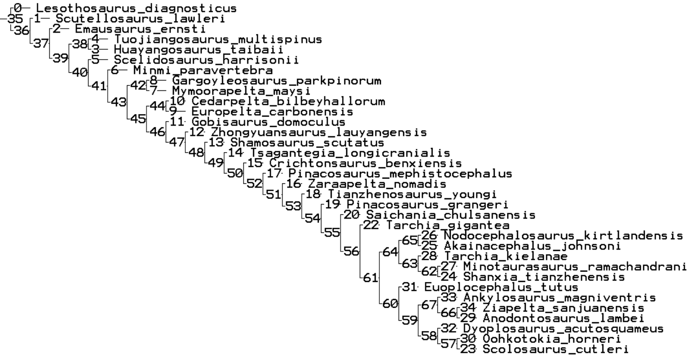
Figure S5. Most parsimonious tree from the pruned dataset (Ahshislepelta removed), recovering Akainacephalus johnsoni as a sister taxon to Nodocephalosaurus kirtlandensis, with synapomorphy list.
Node 37: No synapomorphies
Node 38: 84(1)
Node 39: 3(3), 60(1), 72(1), 98(1), 134(1), 145(2), 169(1), 177(1), 179(1), 189(1), 193(1), 196(1), 201(0), 280(1), 281(1), 284(1), 286(0), 288(0)
Node 40: 37(1), 97(1), 119(1), 138(1)
Node 41: 40(1), 42(1), 82(1), 88(1), 90(1), 92(1), 93(1), 101(1), 120(1), 153(1), 161(1), 162(1), 181(1), 192(1), 199(1), 200(1), 206(1), 219(1), 229(1)
Node 42: 1(1), 15(1), 25(1), 30(2), 32(1), 49(2), 61(1), 100(1)
Node 43: 51(1), 52(1), 104(1), 115(1), 128(1), 129(1), 152(2), 177(1), 254(1), 260(2)
Node 44: 72(1), 98(1), 99(1), 101(2), 122(1), 179(1), 180(1), 196(1), 212(2), 213(1), 230(1), 232(1)
Node 45: 6(1), 14(1), 74(1), 144(1), 148(2), 212(1)
Node 46: 3(1), 28(1), 44(0), 46(0), 49(1), 50(1), 58(1), 59(1), 73(1), 75(1), 124(1), 132(1), 137(1), 142(1), 158(1), 172(1), 183(1), 188(1), 189(1), 195(1), 197(1), 198(1), 201(2), 220(1), 224(1)
Node 47: 9(1), 12(1), 20(2), 23(1), 31(1), 34(1), 41(1), 48(1), 53(1), 56(1), 61(0), 94(1), 119(2)
Node 48: 10(1), 64(1), 111(1)
Node 49: 3(0), 134(1)
Node 50: 17(1), 21(1), 80(0), 102(1), 103(2), 104(1)
Node 51: 2(1), 4(0), 43(1), 44(1), 45(1), 48(3), 49(2), 56(0), 57(1), 63(1), 67(1), 70(1)
Node 52: 1(3), 60(1), 104(2)
Node 53: No synapomorphies
Node 54: 35(1), 54(1), 103(3), 104(3)
Node 55: 4(1), 55(1)
Node 56: 11(1), 129(1), 202(1), 203(1), 204(1), 228(1)
Node 57: 168(1), 174(1), 177(1)
Node 58: 227(2)
Node 59: No synapomorphies
Node 60: 189(0), 191(0)
Node 61: 109(0), 210(1)
Node 62: 1(2), 2(2), 67(0), 103(1), 104(1), 111(2), 140(1), 145(2)
Node 63: 5(1), 55(0), 64(2), 121(1), 262(0)
Node 64: No synapomorphies
Node 65: 70(0), 118(1)
Node 66: 132(0), 133(1)
Node 67: 4(0), 10(0), 41(0), 46(1), 57(0)
Node 68: 250(1)
Node 69: 39(0), 64(1)

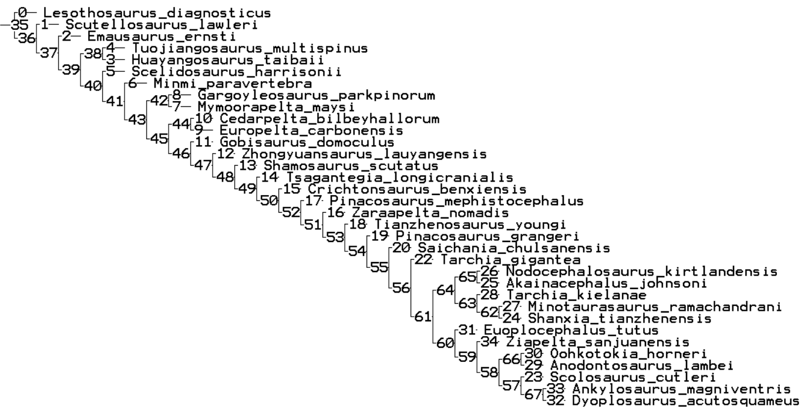
Figure S6. Most parsimonious tree from the pruned dataset (Ahshislepelta removed), recovering Akainacephalus johnsoni as a sister taxon to Nodocephalosaurus kirtlandensis, with synapomorphy list.
Node 37: No synapomorphies
Node 38: 84(1)
Node 39: 3(3), 60(1), 72(1), 98(1), 134(1), 145(2), 169(1), 177(1), 179(1), 189(1), 193(1), 196(1), 201(0), 280(1), 281(1), 284(1), 286(0), 288(0)
Node 40: 37(1), 97(1), 119(1), 138(1)
Node 41: 40(1), 42(1), 82(1), 88(1), 90(1), 92(1), 93(1), 101(1), 120(1), 153(1), 161(1), 162(1), 181(1), 192(1), 199(1), 200(1), 206(1), 219(1), 229(1)
Node 42: 1(1), 15(1), 25(1), 30(2), 32(1), 49(2), 61(1), 100(1),
Node 43: 51(1), 52(1), 104(1), 115(1), 128(1), 129(1), 152(2), 177(1), 254(1), 260(2),
Node 44: 72(1), 98(1), 99(1), 101(2), 122(1), 179(1), 180(1), 196(1), 212(2), 213(1), 230(1), 232(1)
Node 45: 6(1), 14(1), 74(1), 144(1), 148(2), 212(1)
Node 46: 3(1), 28(1), 44(0), 46(0), 49(1), 50(1), 58(1), 59(1), 73(1), 75(1), 124(1), 132(1), 137(1), 142(1), 158(1), 172(1), 183(1), 188(1), 189(1), 195(1), 197(1), 198(1), 201(2), 220(1), 224(1)
Node 47: 9(1), 12(1), 20(2), 23(1), 31(1), 34(1), 41(1), 48(1), 53(1), 56(1), 61(0), 94(1), 119(2)
Node 48: 10(1), 64(1), 111(1)
Node 49: 3(0), 134(1)
Node 50: 17(1), 21(1), 80(0), 102(1), 103(2), 104(1)
Node 51: 2(1), 4(0), 43(1), 44(1), 45(1), 48(3), 49(2), 56(0), 57(1), 63(1), 67(1), 70(1)
Node 52: 1(3), 60(1), 104(2)
Node 53: No synapomorphies
Node 54: 35(1), 54(1), 103(3), 104(3)
Node 55: 4(1), 55(1)
Node 56: 11(1), 129(1), 202(1), 203(1), 204(1), 228(1)
Node 57: 168(1), 174(1), 177(1)
Node 58: 227(2)
Node 59: 238(1)
Node 60: 189(0), 191(0)
Node 61: 109(0), 210(1)
Node 62: 1(2), 2(2), 67(0), 103(1), 104(1), 111(2), 140(1), 145(2)
Node 63: 5(1), 55(0), 121(1), 262(0)
Node 64: No synapomorphies
Node 65: 70(0), 118(1)
Node 66: 132(0), 133(1)
Node 67: 4(0), 10(0), 41(0), 46(1), 57(0)
Node 68: 250(1)
Node 69: 211(1), 262(1)

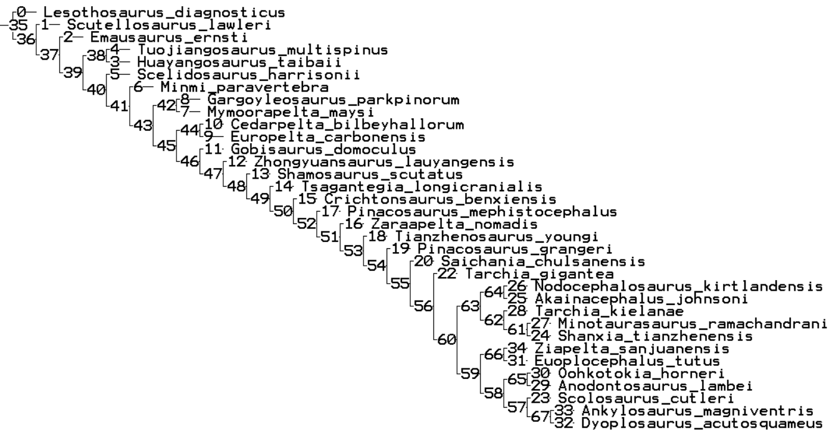
Figure S7. Most parsimonious tree from the pruned dataset (Ahshislepelta removed), recovering Akainacephalus johnsoni as a sister taxon to Nodocephalosaurus kirtlandensis, with synapomorphy list.
Node 37: No synapomorphies
Node 38: 84(1)
Node 39: 3(3), 60(1), 72(1), 98(1), 134(1), 145(2), 169(1), 177(1), 179(1), 189(1), 193(1), 196(1), 201(0), 280(1), 281(1), 284(1), 286(0), 288(0)
Node 40: 37(1), 97(1), 119(1), 138(1)
Node 41: 40(1), 42(1), 82(1), 88(1), 90(1), 92(1), 93(1), 101(1), 120(1), 153(1), 161(1), 162(1), 181(1), 192(1), 199(1), 200(1), 206(1), 219(1), 229(1)
Node 42: 1(1), 15(1), 25(1), 30(2), 32(1), 49(2), 61(1), 100(1)
Node 43: 51(1), 52(1), 104(1), 115(1), 128(1), 129(1), 152(2), 177(1), 254(1), 260(2)
Node 44: 72(1), 98(1), 99(1), 101(2), 122(1), 179(1), 180(1), 196(1), 212(2), 213(1), 230(1), 232(1)
Node 45: 6(1), 14(1), 74(1), 144(1), 148(2), 212(1)
Node 46: 3(1), 28(1), 44(0), 46(0), 49(1), 50(1), 58(1), 59(1), 73(1), 75(1), 124(1), 132(1), 137(1), 142(1), 158(1), 172(1), 183(1), 188(1), 189(1), 195(1), 197(1), 198(1), 201(2), 220(1), 224(1)
Node 47: 9(1), 12(1), 20(2), 23(1), 31(1), 34(1), 41(1), 48(1), 53(1), 56(1), 61(0), 94(1), 119(2)
Node 48: 10(1), 64(1), 111(1)
Node 49: 3(0), 134(1)
Node 50: 17(1), 21(1), 80(0), 102(1), 103(2), 104(1)
Node 51: 2(1), 4(0), 43(1), 44(1), 45(1), 48(3), 49(2), 56(0), 57(1), 63(1), 67(1), 70(1)
Node 52: 1(3), 60(1), 104(2)
Node 53: No synapomorphies
Node 54: 35(1), 54(1), 103(3), 104(3)
Node 55: 4(1), 55(1)
Node 56: 11(1), 129(1), 202(1), 203(1), 204(1), 228(1)
Node 57: 227(1)
Node 58: 211(1), 262(1)
Node 59: 189(0), 191(0)
Node 60: 39(0), 64(1)
Node 61: 109(0), 170(1)
Node 62: 1(2), 2(2), 67(0), 103(1), 104(1), 111(2), 140(1), 145(2)
Node 63: 5(1), 55(0), 64(2), 121(1), 262(0)
Node 64: 227(2)
Node 65: No synapomorphies
Node 66: 70(0), 118(1)
Node 67: 132(0), 133(1)
Node 68: 4(0), 10(0), 41(0), 46(1), 57(0)
Node 69: 250(1)

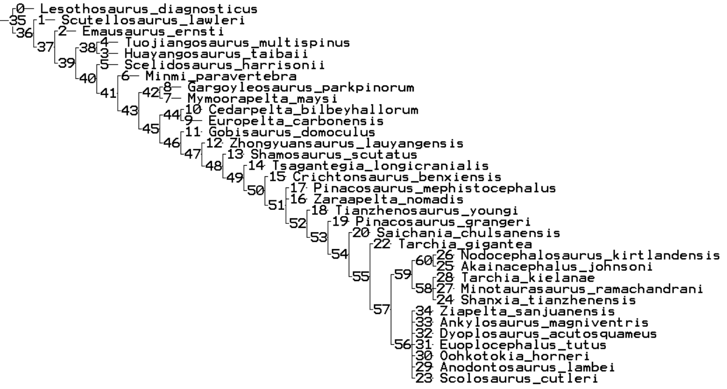
Figure S8. Strict Consensus tree from 6 equally most parsimonious phylogenetic trees. The wildcard taxon Ahshislepelta minor has been pruned from the dataset.

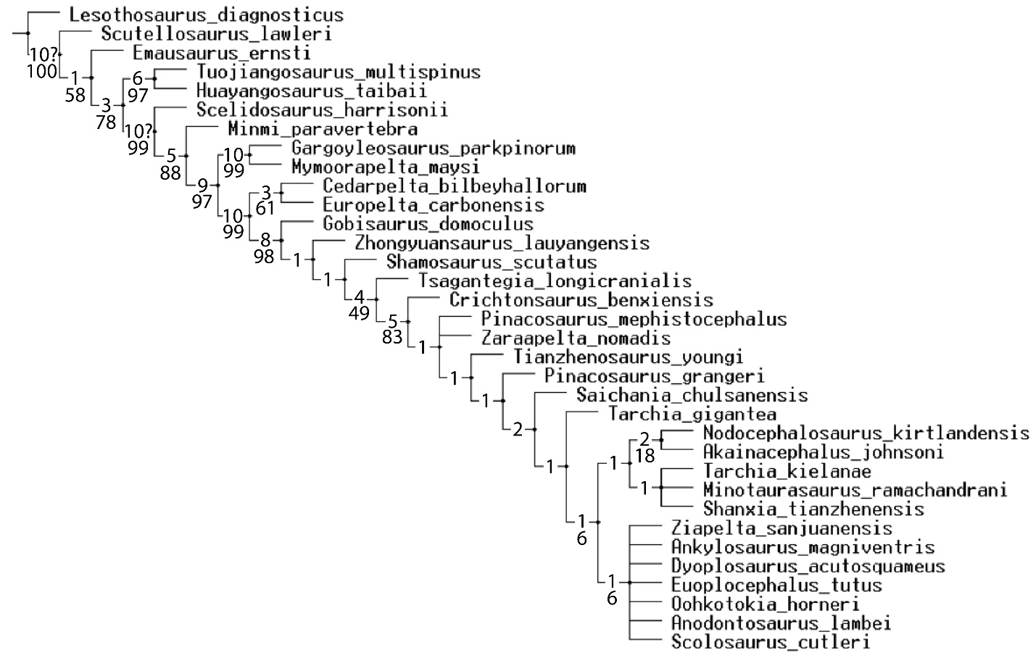
Figure S9. Branch support for the pruned phylogenetic analysis, superimposed on the strict consensus of six equally most parsimonious phylogenetic trees. Bremer support values are indicated as the top value on each branch; bootstrap values (10,000 replicates, sampling with replacement) are indicated as the bottom value.

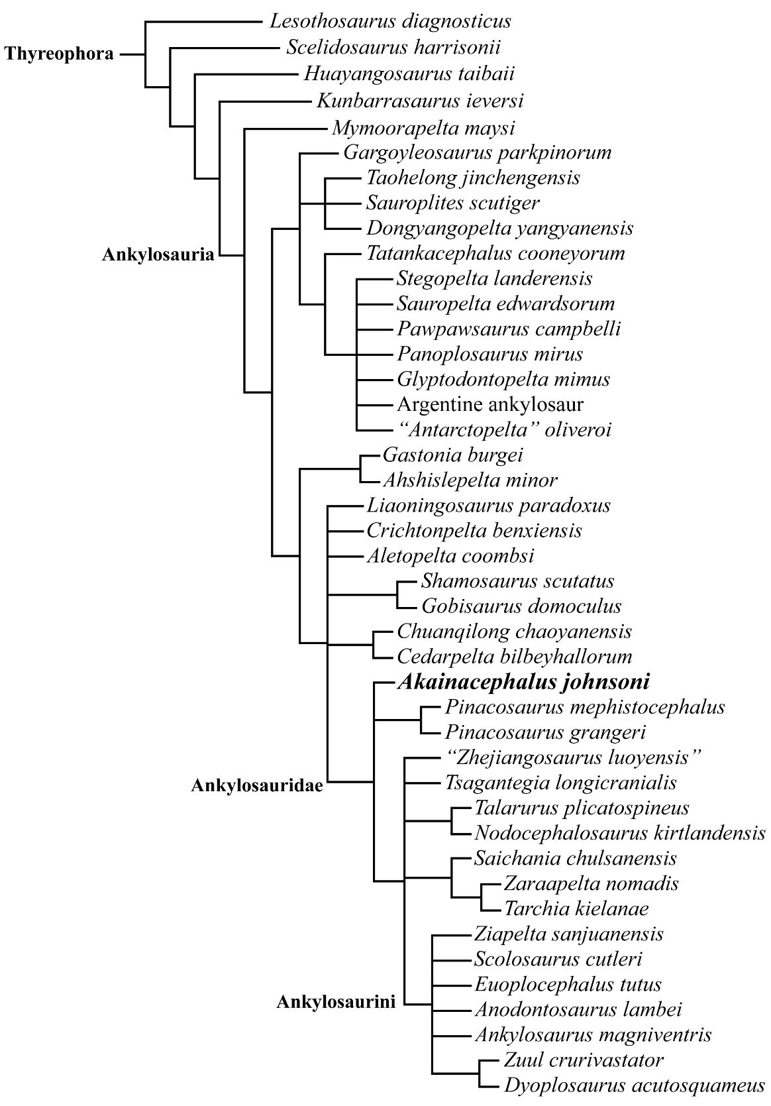

Figure S10. 50% Majority rule tree, resolving Akainacephalus johnsoni as an ankylosaurid, more closely related to Asian ankylosaurid taxa than Laramidian taxa. Note that the resulting topology does not suggest a close evolutionary relationship between A. johnsoni and Nodocephalosaurus kirtlandensis.

