**Supplementary Figures**

**Figure S1** L(K) from STRUCTURE analysis, by way of Structure Harvester. Highest L(K) was obtained for *K*=2. The variance over ten runs was rather large, suggesting that the analysis was unstable, with the exception of *K*=1.



**Figure S2** Evanno’s delta K, by way of Structure Harvester. Delta K suggested two populations in the data set.



**Figure S3** Assignment barplot from STRUCTURE analysis for *K*=2. Every individual was assigned in similar proportions (0.40-0.60) to both clusters, indicating panmixia.

Individual assignment probabilities for K=2.

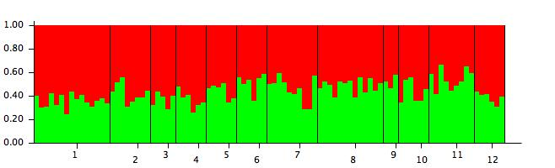

Population