Using Bioinformatics Tools For The Discovery of Dengue RNA-dependent RNA Polymerase Inhibitors
Nomagugu B. Ncubeª, Pritika Ramharackª, Mahmoud E. S. Soliman^{a*}

Supplementary Material

Links for Protein crystal structures:
- https://www.rcsb.org/structure/5K5M
- https://www.rcsb.org/structure/5I3Q
Links for PubChem structures:
- NITD008: https://pubchem.ncbi.nlm.nih.gov/compound/44633776
- Balapiravir: https://pubchem.ncbi.nlm.nih.gov/compound/11691726
- Lycorine: https://pubchem.ncbi.nlm.nih.gov/compound/11822288#section=Top
- Ribavirin: https://pubchem.ncbi.nlm.nih.gov/compound/37542
- 7-Deaza-2’mathyladenosine: https://pubchem.ncbi.nlm.nih.gov/compound/127927
- 3’-dGTP: https://pubchem.ncbi.nlm.nih.gov/compound/148770
- 2’O-metil GTP: https://pubchem.ncbi.nlm.nih.gov/compound/2_-O-Methylguanosine
- NITD-203: https://pubchem.ncbi.nlm.nih.gov/compound/44633774
- Favipiravir: https://pubchem.ncbi.nlm.nih.gov/compound/492405
- Ivermectin: https://pubchem.ncbi.nlm.nih.gov/compound/11957587

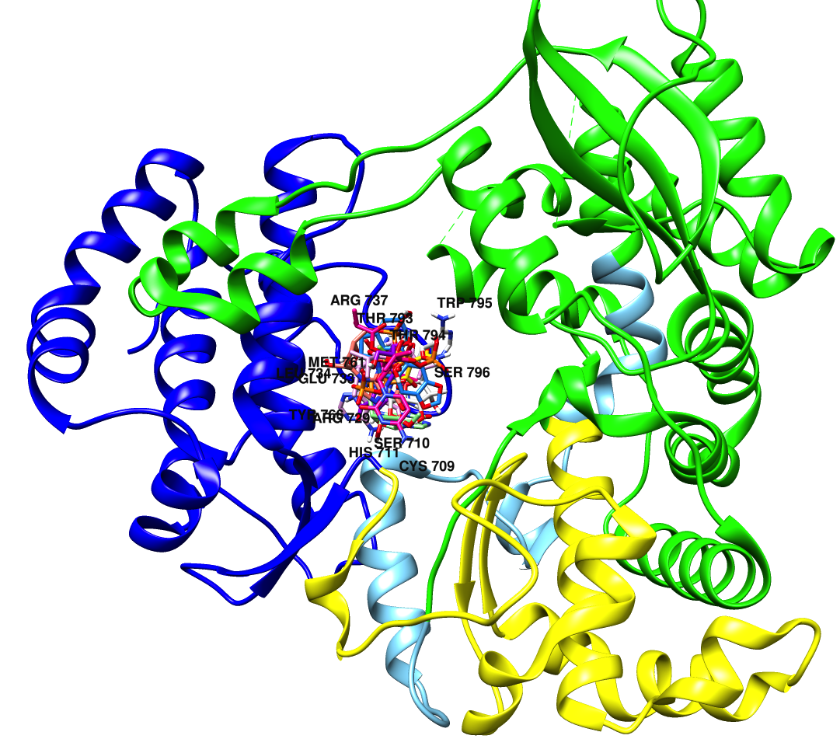
Figure S1: Superimposed docked complexes with GTP-bound RdRp (PDB code: 2J7W). Validation of docking to the active site of the enzyme at the region of natural substrate binding.

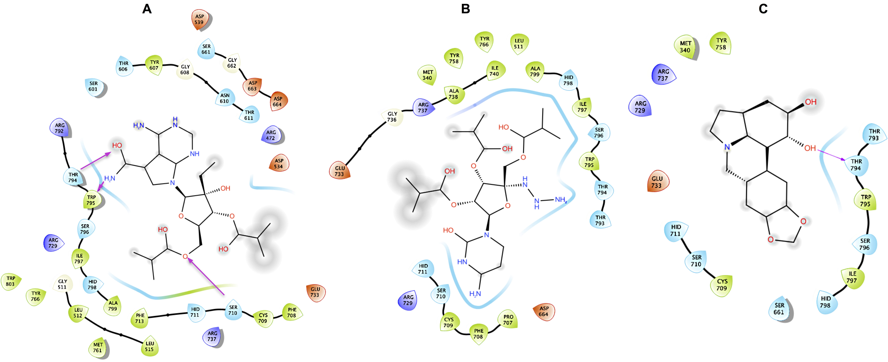

Figure S2: Protein-ligand interaction plots (A) NITD-203 RdRp complex, (B) Balapiravir RdRp Complex, (C) Lycorine RdRp complex.

