Table S2: Plant-Insect interaction and herbivory pattern observerd and originally described by Adolf Straus (1977) in his first comprehensive work on leaf interactions from Willershausen.
¶ not found in the collections; * new ichnospecies type; § named after recent species with the addendum fossilis; H holotype; P paratype;
Coll. No. | Ichnotaxon | Type | Straus orginal Ref. | Plate Ref. | DT | FFG | Host plant | Culprit | Comments
17381§ | cf. Taphrina sp. |  | Straus (1977; Taf. 1, Fig. 19) |  | 16 | Galling | Parrotia sp. | Ascomycetes: Exoascaceae
18419§ | cf. Taphrina sp. |  |  |  | 2 | Fungal | Populus sp. | Ascomycetes: Exoascaceae
Fu 174 | Gymnosporangium sp. |  |  |  | 80 | Fungal | Sorbus graudifolia | Basiodiomycetes: Pucciniaceae
275§ | cf. Eriophyes lateannulatus fossilis |  | Straus (1977; Taf. 4, Fig. 78) |  | 32 | Galling | Tillia sp. | Acarina: Eriophyidae
7257/a§ | Eriophyes exilis fossilis vel Typhlodromus sp. fossilis |  |  |  | 34,16 | Galling | Tillia sp. | Acarina: Laelaptidae
18059§ | Eriophyes exilis fossilis vel Typhlodromus sp. fossilis |  |  |  | 32,33 | Galling | Tillia sp. | Acarina: Laelaptidae
7087/a¶,§ | Aceria aroniae fossilis (=Eriophyes pyri ) |  |  |  |  | Galling | Amelanchier sp. | Acarina: Eriophyidae
2614/a§ | Aceria aroniae fossilis (=Eriophyes pyri ) |  |  |  | 32 | Galling | Crataegus meischnerii | Acarina: Eriophyidae
11661§ | Aceria erinea fossilis |  | Straus (1977; Taf. 1, Fig. 27) |  | 12,3 | Galling | Juglans sp. | Acarina: Eriophyidae
18419§ | Aceria erinea fossilis |  | Straus (1977; Fig. 5) |  | 2 | Galling | Populus sp. | Acarina: Eriophyidae
9160¶,§ | Aceria erinea fossilis |  | Straus (1977; Taf. 1, Fig. 26) |  |  | Galling | Carya sp./ Pterocarya sp. | Acarina: Eriophyidae
3201/a§ | Aceria inangulis fossilis (=Eriophyes inangulis) |  | Straus (1977; Fig. 6) |  | 33 | Galling | Alnus nepalensis | Acarina: Eriophyidae
9159, § | Aceria leionota fossilis (=Eriophyes leionotus) |  | Straus (1977; Taf. 1, Fig. 17) | Plate B, Fig. A | 32,3 | Galling | Betula sp. | Acarina: Eriophyidae
9444/a§ | Aceria leionota fossilis (=Eriophyes leionotus) |  |  | Plate B, Fig. B |  | Galling | ?Carpinus sp. | Acarina: Eriophyidae
17758¶,§ | cf. Aceria macrochela fossilis |  | Straus (1977; Taf. 2, Fig. 41) |  |  | Galling | Acer sp. | Acarina: Eriophyidae
3116§ | cf. Aceria macrochela fossilis |  |  | Plate B, Fig. C | ? | Galling | Acer laetum | Acarina: Eriophyidae
6560§ | cf. Aceria macrochela fossilis |  | Straus (1977; Taf. 4, Fig. 71) | Plate B, Fig. D | 80 | Galling | Acer laetum | Acarina: Eriophyidae
19779§ | cf. Aceria macrochela fossilis |  |  | Plate B, Fig. E | 32 | Galling | Acer laetum | Acarina: Eriophyidae
30808§ | cf. Aceria macrochela fossilis |  |  | Plate B, Fig. F | 32 | Galling | Acer sp. | Acarina: Eriophyidae
30914§ | Aceria nervisequa faginea fossilis |  | Straus (1977; Taf. 3, Fig. 50) | Plate B, Fig. G | 80 | Galling | Fagus sp. | Acarina: Eriophyidae
21979§ | Aceria nervisequa faginea fossilis |  | Straus (1977; Fig. 2) | Plate B, Fig. H | unidentified | Galling | Fagus sp. | Acarina: Eriophyidae
30815§ | Aceria nervisequa faginea fossilis |  |  | Plate B, Fig. K | 46 | Galling | Fagus sylvatica | Acarina: Eriophyidae
30815¶,* | Phyllocecidium internervellum | H |  |  |  | Galling | Fagus sp. | Acarina: Eriophyidae
13748/a§ | Aceria nervisequa nervisequa fossilis |  | Straus (1977; Taf. 1, Fig. 20) | Plate B, Fig. L | unidentified | Galling | Fagus cf. pliocenica | Acarina: Eriophyidae
22848/a§ | Aceria nervisequa nervisequa fossilis |  |  | Plate B, Fig. M | 145 | Galling | Fagus sylvatica | Acarina: Eriophyidae
38/150¶,§ | Aceria stenaspis stenaspis fossilis |  | Straus (1977; Fig. 8) |  |  | Galling | Fagus sp. | Acarina: Eriophyidae
8281¶,§ | Aceria tenella fossilis |  | Straus (1977; Taf. 3, Fig. 46) |  |  | Galling | Carpinus sp. | Acarina: Eriophyidae
5778¶,§ | Schizoneura ulmi fossilis |  |  |  |  | Galling | Ulmus sp. | Hemiptera: Eriostomatidae
2179§ | Schizoneura ulmi fossilis |  | Straus (1977; Fig. 4) | Plate B, Fig. I | not observed | Galling | Ulmus sp. | Hemiptera: Eriostomatidae
13419¶,§ | Schizoneura ulmi fossilis |  | Straus (1977; Taf. 1, Fig. 31) |  |  | Galling | Ulmus sp. | Hemiptera: Eriostomatidae
23403¶,§ | cf. Dasyneura ruebsaameni fossilis vel Cecidophyes reniformis fossilis |  | Straus (1977; Fig. 1) |  |  | Galling | Carpinus sp. | Diptera: Cecidomyiidae vel Acarina: Eriophyidae
3765¶,§ | cf. Dasyneura ruebsaameni fossilis vel Cecidophyes reniformis fossilis |  |  |  |  | Galling | Carpinus sp. | Diptera: Cecidomyiidae vel Acarina: Eriophyidae
23992/a§ | cf. Dasyneura ruebsaameni fossilis vel Cecidophyes reniformis fossilis |  |  | Plate A, Fig. W | 32 | Galling | Carpinus orientalis | Diptera: Cecidomyiidae vel Acarina: Eriophyidae
14652§ | cf. Dasyneura fraxini fossilis |  | Straus (1977; Taf. 1, Fig. 16) | Plate B, Fig. J | 87,1 | Galling | Fraxinus sp. | Diptera: Cecidomyiidae
18935¶,§ | cf. Myzus sp. |  | Straus (1977; Taf. 4, Fig. 83) |  |  | Galling | Prunus sp. | Hemiptera: Aphididae
2928¶,§ | cf. Dreyfusia sp. fossilis |  |  |  |  | Galling | Pinaceae? | Hemiptera: Adelgidae
2425§ | Neuroterus albipes fossilis (= N. laeviusculus) |  | Straus (1977; Taf. 2, Fig. 39) | Plate B, Fig. O | 32 | Galling | Quercus praeerucifolia | Hymenoptera: Cynipidae
2737/a¶,§ | cf. Andricus curvator fossilis |  | Straus (1977; Taf. 1, Fig. 30) |  |  | Galling | Quercus praeerucifolia | Hymenoptera: Cynipidae
9161¶,§ | cf. Andricus curvator fossilis |  |  |  |  | Galling | Quercus praeerucifolia | Hymenoptera: Cynipidae
14200§ | Andricus quercus-radicis fossilis |  | Straus (1977; Taf. 1, Fig. 18) | Plate B, Fig. N | 117 | Galling | Quercus roburoides | Hymenoptera: Cynipidae
7244§ | cf. Andricus sp. |  | Straus (1977; Taf.1, Fig. 25) | Plate B, Fig. S | 12,32 | Galling | Quercus roburoides | Hymenoptera: Cynipidae | Neuroterus as possible culprid could not be excluded. Berger (1949) reported comparable galling structures on Pliocene angiosperm leaves
13732§ | cf. Andricus sp. |  |  | Plate B, Fig. X | 32 | Galling | Quercus praeerucifolia | Hymenoptera: Cynipidae | Neuroterus as possible culprid could not be excluded. Berger (1949) reported comparable galling structures on Pliocene angiosperm leaves
15091§ | cf. Andricus sp. |  | Straus (1977; Taf. 1, Fig. 21) | Plate B, Fig. Y | 32 | Galling | Quercus praeerucifolia | Hymenoptera: Cynipidae | Neuroterus as possible culprid could not be excluded. Berger (1949) reported comparable galling structures on Pliocene angiosperm leaves
17076§ | cf. Andricus sp. |  |  | Plate B, Fig. W | 32 | Galling | Quercus praeerucifolia | Hymenoptera: Cynipidae | Neuroterus as possible culprid could not be excluded. Berger (1949) reported comparable galling structures on Pliocene angiosperm leaves
22705§ | cf. Andricus sp. |  | Straus (1977; Taf. 1, Fig. 24) | Plate B, Fig. Z | 142,12 | Galling | Quercus praeerucifolia | Hymenoptera: Cynipidae | Neuroterus as possible culprid could not be excluded. Berger (1949) reported comparable galling structures on Pliocene angiosperm leaves
5021§ | cf. Mikiola fagi fossilis vel Hartigiola annulipes fossilis |  | Straus (1977; Taf. 1, Fig. 22) | Plate B, Fig. AA | unidentified | Galling |  | Diptera: Cecidomyiidae
5786¶,§ | cf. Mikiola fagi fossilis vel Hartigiola annulipes fossilis |  |  |  |  | Galling |  | Diptera: Cecidomyiidae
8717§ | cf. Didymomyia reaumuriana fossilis |  | Straus (1977; Fig. 3) | Plate B, Fig. T | 78,19 | Galling | Tillia sp. | Diptera: Cecidomyiidae
8717* | Fenusites tiliae | H | Straus (1977; Fig. 3) | Plate B, Fig. T | 78,19 | Mining | Tiliia sp. | Hymenoptera: Tenthredinidae
15650* | Fenusites tiliae |  |  | Plate D, Fig. A | 2,16 | Mining | Tilia saportae | Hymenoptera: Tenthredinidae
21695/a¶,* | Fenusites tiliae |  |  |  |  | Mining | Tiliia sp. | Hymenoptera: Tenthredinidae
22549/a* | Fenusites tiliae |  |  | Plate D, Fig. B | 2,16 | Mining | Tilia cf. savania | Hymenoptera: Tenthredinidae
3042§ | cf. Contarinia carpini fossilis |  | Straus (1977; Taf. 1, Fig. 28) | Plate B, Fig. U | 32 | Galling | Populus willershausensis | Diptera: Cecidomyiidae | Steinbach (1967) and Straus (1962) determined these galls earlier as hymenopteran galls belonging to Andricus curvator
8907¶,§ | cf. Phegomyia fagicola fossilis |  |  |  |  | Galling |  | Diptera: Cecidomyiidae | Steinbach (1967) and Straus (1962) determined these galls earlier as hymenopteran galls belonging to Andricus curvator
12110/a¶,§ | cf. Phegomyia fagicola fossilis |  | Straus (1977; Taf. 2, Fig. 34) |  |  | Galling |  | Diptera: Cecidomyiidae | Steinbach (1967) and Straus (1962) determined these galls earlier as hymenopteran galls belonging to Andricus curvator
19960/a¶,§ | cf. Phegomyia fagicola fossilis |  |  |  |  | Galling |  | Diptera: Cecidomyiidae | Steinbach (1967) and Straus (1962) determined these galls earlier as hymenopteran galls belonging to Andricus curvator
30810* | Petiolocecidium aceris | H | Straus (1977; Taf. 2, Fig. 38) | Plate B, Fig. P | unidentified | Galling | Acer integerrinum | Hemiptera: Pemphigidae | Resemble those structures made by Pemphigus spirotheca (comp. Mädler, 1936)
20197/a* | Petioloceoidium hamamelidacearum | H | Straus (1977; Taf. 2, Fig. 42) | Plate C, Fig. A | unidentified | Galling | Parrotia sp.
10060* | Petioloceoidium hamamelidacearum |  | Straus (1977; Taf. 1, Fig. 32) | Plate B, Fig. Q | 33 | Galling | Parrotia sp.
10959¶,* | Petioloceoidium hamamelidacearum |  | Straus (1977; Taf. 1, Fig. 29) |  |  | Galling | cf. Parrotiopsis sp.
13164§ | Petioloceoidium hamamelidacearum |  |  | Plate B, Fig. AB | 16,3 | Galling | Parrotia persica
3388/a* | Phyllocecidium alni-tuberculosum | H | Straus (1977; Taf. 2, Fig. 33) | Plate B, Fig. R | 32 | Fungal / Galling | Alnus incana | Ascomycetes: Exoascaceae vel.  Diptera: Cecidomyiidae
12143* | Phyllocecidium comma | H | Straus (1977; Taf. 2, Fig. 36) | Plate B, Fig. V |  | Galling | Quercus sp.
20161/a* | Phyllocecidium comma |  |  | Plate C, Fig. B | 32 | Galling | Quercus praeerucifolia
23862* | Phyllocecidium comma |  |  | Plate C, Fig. C | 32 | Galling | Quercus praeerucifolia
7691¶,* | Phyllocecidium cuniculatum | H | Straus (1977; Taf. 3, Fig. 47) |  |  | Galling | cf. Quercus
30815* | Phyllocecidium internervellum |  | Straus (1977; Taf. 2, Fig. 43) | Plate B, Fig. K | 46 | Galling | Fagus sylvatica |  | comp. also with Hartigiola and Aceria nervisequa faginea fossilis
18421/a* | Phyllocecidium medionervisequm | H | Straus (1977; Fig. 9) | Plate C, Fig. D | 53 | Galling | Quercus praeerucifolia | Hymenoptera: Cynipidae (Neuroterus sp.)
30845/a* | Phyllocecidium medionervisequm |  |  | Plate C, Fig. E | 194 | Galling | Quercus roburoides
13156* | Phyllocecidium parrotiae | H | Straus (1977; Taf. 4, Fig. 82) | Plate C, Fig. F | 145 | Fungal / Galling | Parrotia sp. |  | comparapble to fungal infection caused by Rhytisma. Probably also on Parratiopsis
2603* | Phyllocecidium parrotiae |  |  | Plate C, Fig. G | 1 | Fungal / Galling | Parrotia sp. |  | comparapble to fungal infection by Rhytisma. Probaly also on Parratiopsis
7217* | Phyllocecidium parrotiae |  |  | Plate C, Fig. H | 32 | Fungal / Galling | Parrotia sp. |  | comparapble to fungal infection caused by Rhytisma. Probably also on Parratiopsis
7253* | Phyllocecidium parrotiae |  |  | Plate C, Fig. I | 210 | Fungal / Galling | Parrotia sp. |  | comparapble to fungal infection caused by Rhytisma. Probably also on Parratiopsis
7411* | Phyllocecidium parrotiae |  |  | Plate C, Fig. J | 33 | Fungal / Galling | Parrotia sp. |  | comparapble to fungal infection caused by Rhytisma. Probably also on Parratiopsis
9214* | Phyllocecidium parrotiae |  | Straus (1977; Taf. 3, Fig. 48) | Plate C, Fig. K | 120 | Fungal / Galling | Parrotia sp. |  | comparapble to fungal infection caused by Rhytisma. Probably also on Parratiopsis
9673/a* | Phyllocecidium parrotiae |  |  | Plate C, Fig. L | 32,17 | Fungal / Galling | Parrotia sp. |  | comparapble to fungal infection caused by Rhytisma. Probably also on Parratiopsis
10196* | Phyllocecidium parrotiae |  | Straus (1977; Taf. 2, Fig. 40) | Plate C, Fig. M | 2,78 | Fungal / Galling | Parrotia sp. |  | comparapble to fungal infection caused by Rhytisma. Probably also on Parratiopsis
12733¶,* | Phyllocecidium parrotiae |  |  |  |  | Fungal / Galling | Parrotia sp. |  | comparapble to fungal infection caused by Rhytisma. Probably also on Parratiopsis
12818¶,* | Phyllocecidium parrotiae |  |  |  |  | Fungal / Galling | Parrotia sp. |  | comparapble to fungal infection caused by Rhytisma. Probably also on Parratiopsis
13217§ | Phyllocecidium parrotiae |  |  | Plate C, Fig. N | 146 | Fungal / Galling | Parrotia sp. |  | comparapble to fungal infection caused by Rhytisma. Probably also on Parratiopsis
16732* | Phyllocecidium parrotiae |  |  | Plate C, Fig. O | 33 | Fungal / Galling | Parrotia sp. |  | comparapble to fungal infection caused by Rhytisma. Probably also on Parratiopsis
17689* | Phyllocecidium parrotiae |  |  | Plate C, Fig. P | 128 | Fungal / Galling | Parrotia sp. |  | comparapble to fungal infection caused by Rhytisma. Probably also on Parratiopsis
17715* | Phyllocecidium parrotiae |  | Straus (1977; Taf. 2, Fig. 37) | Plate C, Fig. Q | 33 | Fungal / Galling | Parrotia sp. |  | comparapble to fungal infection caused by Rhytisma. Probably also on Parratiopsis
20318/a* | Phyllocecidium parrotiae |  |  | Plate C, Fig. R | 12,16 | Fungal / Galling | Parrotia sp. |  | comparapble to fungal infection caused by Rhytisma. Probably also on Parratiopsis
20892* | Phyllocecidium parrotiae |  |  | Plate C, Fig. S | not observed | Fungal / Galling | Parrotia sp. |  | comparapble to fungal infection caused by Rhytisma. Probably also on Parratiopsis
21920/a§ | Fenusa ulmi fossilis |  | Straus (1977; Fig. 15) | Plate C, Fig. U | 78,2,17 | Mining | Sorbus gabbrensis | Hymenoptera: Tenthredinidae | A comparable mining type is also figured on Ulmus longifolia by Jakubowskaja (1955)
12§ | Fenusa ulmi fossilis |  |  | Plate C, Fig. V | 78 | Mining | Fagus cf. pliocenica | Hymenoptera: Tenthredinidae
3183§ | Fenusa ulmi fossilis |  |  | Plate C, Fig. W | 78 | Mining | Ulmus sp. | Hymenoptera: Tenthredinidae | A comparable mining type is also figured on Ulmus longifolia by Jakubowskaja (1955)
30837¶,§ | Fenusa ulmi fossilis |  |  |  |  | Mining | Ulmus sp. | Hymenoptera: Tenthredinidae | A comparable mining type is also figured on Ulmus longifolia by Jakubowskaja (1955)
14535/a* | Fenusites denckmanni | H | Straus (1977; Taf. 3, Fig. 58) | Plate C, Fig. X | 42 | Mining | Magnolia sp. vel. Syringa sp. | Hymenoptera: Tenthredinidae
17885* | Fenusites denckmanni |  |  |  | 78 | Mining | Magnolia sp. vel. Syringa sp. | Hymenoptera: Tenthredinidae
20987/a* | Fenusites betulacearum | H | Straus (1977; Taf. 3, Fig. 54) | Plate C, Fig. Y | 78 | Mining | Betulaceae indet. | Hymenoptera: Tenthredinidae | Fenusa type
18874* | Fenusites betulacearum |  |  | Plate C, Fig. T | 78,21 | Mining | Betulaceae indet. | Hymenoptera: Tenthredinidae | Fenusa type
18906* | Fenusites betulacearum |  |  | Plate D, Fig. C | 32,63 | Mining | Betulaceae indet. | Hymenoptera: Tenthredinidae; Lepidoptera: Coleophoridae | Fenusa type
20468/a¶,* | Fenusites betulacearum + cf. Coleophora sp. |  | Straus (1977; Taf. 2, Fig. 45) |  |  | Mining | Betulaceae indet. | Hymenoptera: Tenthredinidae | Fenusa type
17924* | Fenusites celtis | H | Straus (1977; Taf. 3, Fig. 53) |  | 21 | Mining | Celtis sp. | Hymenoptera: Tenthredinidae | Fenusa type
21926* | Fenusites fagi | H | Straus (1977; Fig. 13) |  | 15,5 | Mining | Fagus sp. | Hymenoptera: Tenthredinidae | Fenusa type
11339* | Fenusites fagi |  |  |  | 78,16 | Mining | Fagus cf. pliocenica | Hymenoptera: Tenthredinidae | Fenusa type
19782¶,* | Fenusites fagi |  |  |  |  | Mining | Fagus sp. | Hymenoptera: Tenthredinidae | Fenusa type
22508* | Fenusites parrotiae | H | Straus (1977; Fig. 11) |  | 16,78 | Mining | Parrotia sp. |  | additional frass on the leaf caused by Coleoptera: Hispinae vel. Halticidae
30807¶,* | Fenusites parrotiae | P |  |  |  | Mining | Parrotia sp.
30813¶,* | Fenusites zelkovae | H | Straus (1977; Taf. 4, Fig. 73) |  |  | Mining | Zelkova sp. | Hymenoptera: Tenthredinidae | Fenusa type
8068/a¶,* | Fenusites zelkovae |  |  |  |  | Mining | Zelkova sp. | Hymenoptera: Tenthredinidae | Fenusa type
30805¶,* | Fenusites zelkovae |  |  |  |  | Mining | Zelkova sp. | Hymenoptera: Tenthredinidae | Fenusa type
30806* | Fenusites zelkovae |  |  |  |  | Mining | Quercus praeerucifolia | Hymenoptera: Tenthredinidae | Fenusa type
30814/a¶,§ | cf. Profenusa pygmaea fossilis |  |  |  |  | Mining | Quercus petrae vel. Quercus iberica | Hymenoptera: Tenthredinidae | Fenusa type
19783¶,§ | cf. Profenusa pygmaea fossilis |  |  |  |  | Mining | Quercus petrae vel. Quercus iberica | Hymenoptera: Tenthredinidae | Fenusa type
18429 vel 18422§ | cf. Bucculatrix thoracella fossilis |  | Straus (1977; Taf. 3, Fig. 61) |  | 12,32 | Mining | Ampelopsis cordataeformis | Lepidoptera: Lyonetiidae
21040§ | cf. Coleophora sp. |  |  |  | 5 | Mining | Betula maximowicziana | Lepidoptera: Coleophoridae
21695/a§ | cf. Coleophora sp. |  |  |  | 4,5, 80 | Mining | Tilia sp. | Lepidoptera: Coleophoridae
22549/a§ | cf. Coleophora sp. |  |  |  | 2,16 | Mining |  | Lepidoptera: Coleophoridae
22858§ | cf. Coleophora sp. |  | Straus (1977; Taf. 3, Fig. 56) |  |  | Mining |  | Lepidoptera: Coleophoridae
22907¶,§ | cf. Coleophora sp. |  |  |  |  | Mining |  | Lepidoptera: Coleophoridae
22996/a§ | cf. Coleophora sp. |  |  |  | 3 | Mining |  | Lepidoptera: Coleophoridae
30809¶,§ | cf. Coleophora sp. |  |  |  |  | Mining |  | Lepidoptera: Coleophoridae
22788§ | cf. Caloptilia alchimiella fossilis |  |  |  | 1,3 | Mining | Fagus cf. orientalis | Lepidoptera: Gracilariidae
22440§ | cf. Caloptilia roscipenella fossilis |  | Straus (1977; Taf. 4, Fig. 76) |  | 152,  21 | Mining | Fagus sp. | Lepidoptera: Gracilariidae
30838§ | cf. Coriscium sp. |  | Straus (1977; Taf. 3, Fig. 60) |  | 142 | Mining | Magnolia sp. vel. Syringa sp. | Lepidoptera: Gracilariidae
15876/a§ | cf. Parornix sp. |  | Straus (1977; Taf. 3, Fig. 49) |  | 15 | Mining | Carpinus orientalis | Lepidoptera: Gracilariidae
30057§ | Lithocolletis maestingella fossilis |  | Straus (1977; Taf. 3, Fig. 59) |  |  | Mining | Fagus sp. | Lepidoptera: Gracilariidae
15026§ | Lithocolletis maestingella fossilis |  |  |  |  | Mining | Fagus sp. | Lepidoptera: Gracilariidae
15427§ | cf. Incurvaria oehlmanniella fossilis |  | Straus (1977; Taf. 2, Fig. 44) |  | 36 | Mining | cf. Vaccinium sp. | Lepidoptera: Incurvariidae
21313§ | cf. Incurvaria sp. |  | Straus (1977; Taf. 3, Fig. 55) |  | 32,7 | Mining | Berberis sp. | Lepidoptera: Incurvariidae | comp. Hering (1957: 166; Nr. 770)
12724/a§ | cf. Recurvaria nanella |  | Straus (1977; Taf. 3, Fig. 51) |  | 32 | Mining | Sorbus torminalia fossilis | Lepidoptera: Gelechiidae
3050¶,* | Stigmella pliotityrella | H |  |  |  | Mining | Fagus sylvatica | Lepidoptera: Nepticulidae | Holotype described by Kernbach (1967: 105-106, Fig. 4)
9111§ | Stigmella ulmivora fossilis |  |  |  |  | Mining | Ulmus sp. | Lepidoptera: Nepticulidae | comp. Kernbach (1967: 105-106, Fig. 5)
17738§ | Stigmella ulmivora fossilis |  | Straus (1977; Fig. 12) | Plate E, Fig. A | 36 | Mining | ?Sorbus domestica | Lepidoptera: Nepticulidae
22763§ | Stigmellites carpini-orientalis | H | Straus (1977; Taf. 4, Fig. 80) | Plate E, Fig. B | 94 | Mining | Carpinus sp. | Lepidoptera: Nepticulidae
22134§ | Stigmellites carpini-orientalis | P | Straus (1977; Taf. 3, Fig. 62) | Plate E, Fig. C | 94 | Mining | Carpinus sp. | Lepidoptera: Nepticulidae
11137¶,* | Stigmellites heringi | H |  |  |  | Mining | Berberis sp. | Lepidoptera: Nepticulidae | Holotype described by Kernbach (1967: 104-106, Fig. 3)
23973¶,* | Stigmellites zekovae | H | Straus (1977; Fig. 14) |  |  | Mining | Zelkova sp. | Lepidoptera: Nepticulidae
19753/a | Diptera mine undetermined |  |  | Plate E, Fig. F | 90 | Mining | Fraxinus sp. Fraxinus ornus | Diptera vel Coleoptera | most probably these mines belong to mines produced by Diptera larvae (comp. Hering (1957: 456; Nr. 2242)). Alternatively, comparable mines could also be produced by weevils (Coleoptera: Curculionidae) from the genus Steronychus feeding on Fraxinus sp.
8764/a¶,§ | Phytomya ranunculi fossilis |  |  |  |  | Mining | ?Ranunculus repens | Diptera: Agromyzidae | see also discussion in Winkler et al. (2010)
10965§ | Phytomyzites corni | H | Straus (1977; Taf. 3, Fig. 52) | Plate E, Fig. D | 5 | Mining | Fabaceae | Diptera: Agromyzidae
30816¶,§ | cf. Phytagromyza populicola fossilis | H |  |  |  | Mining | Populus latior | Diptera: Agromyzidae
30818¶,§ | cf. Phytagromyza populicola fossilis |  | Straus (1977; Taf. 4, Fig. 75) |  |  | Mining | Populus latior | Diptera: Agromyzidae vel Coleoptera: Curcuionidae | this mine could also be produced by Rhynchaenus cf. populi (Coleoptera: Curculionidae)
19471§ | Cuniculonomus carpini | H | Straus (1977; Taf. 3, Fig. 57) | Plate E, Fig. E | 185 | Mining | Carpinus betulus |  | comp. Engelhardt (1876) and Kinzelbach (1970)
30836¶,§ | Cuniculonomus carpini | P | Straus (1977; Taf. 4, Fig. 79) |  |  | Mining |  | Coleoptera: Curculionidae (Rhychaenus sp.)
30607¶,§ | Loconomus vitis | H | Straus (1977; Taf. 4, Fig. 66, 77) |  |  | Mining | Vitis sp. |  | blotch mine habitus
30821¶ | Loconomus sp. |  | Straus (1977; Taf. 4, Fig. 81) |  |  | Mining | cf. Toona | ?Diptera: Agrpmyzidae (Agromyza, Phytagromyza, Dibolia) | comp. To mines produced by Agromyza, Phytagromyza, Dibolia
2993/a* | Phagophytichnus catellarius | H | Straus (1977; Fig. 10) | Plate A, Fig. T | 297 | Skeletonization | Parrotia persica | Coleoptera | produced by Coleoptera: Chrysomelidae: Halticinae and/or Hispinae
10626* | Phagophytichnus catellarius | P | Straus (1977; Fig. 7) | Plate A, Fig. U | 297 | Skeletonization | Parrotia persica | Coleoptera | produced by Coleoptera: Chrysomelidae: Halticinae and/or Hispinae
13076* | Phagophytichnus catellarius |  |  | Plate A, Fig. V | 298 | Skeletonization | Parrotia persica | Coleoptera | produced by Coleoptera: Chrysomelidae: Halticinae and/or Hispinae
12917* | Phagophytichnus circumsecans |  |  | Plate A, Fig. A | 1,297 | Hole | Parrotia persica | Coleoptera? | interpreted by Straus (1977) as the intitial phase (oviposition site) of Phagophytichnus catellarius
21482* | Phagophytichnus nervillos-reliquens | H | Straus (1977; Taf. 4, Fig. 69) | Plate A, Fig. Q | 17 | Skeletonization | Parrotia persica | ?Coleoptera vel Hymenoptera
7612¶,* | Phagophytichnus nervillos-reliquens |  |  |  |  | Skeletonization
11490/a* | Phagophytichnus nervillos-reliquens |  |  | Plate A, Fig. C | 17,12,2 | Skeletonization |  | ?Coleoptera vel Hymenoptera
21140* | Phagophytichnus nervillos-reliquens |  |  | Plate A, Fig. S | 17 | Skeletonization |  | ?Coleoptera vel Hymenoptera
30892/a* | Phagophytichnus nervillos-reliquens |  |  | Plate A, Fig. R | 17 | Skeletonization | Parrotia persica
11490* | Phagophytichnus marginis-folii |  |  | Plate A, Fig. C | 17,12,2 | Margin | Quercus sp.
11490* | Phagophytichnus circumsecans |  |  | Plate A, Fig. C | 2 | Hole | Quercus sp.
12231a* | Phagophytichnus circumsecans + (Phagophytichnus catellarius) | H | Straus (1977; Taf. 4, Fig. 70) | Plate A, Fig. B | 17,2 | Hole | Parrotia persica | Coleoptera? | Coleoptera: Curculionidae or Coleoptera: Chrysomelidae are able to produce such pattern
13386* | Phagophytichnus marginis-folii | H |  | Plate A, Fig. E | 297 | Margin | Parrotia persica | ?Coleoptera: Curculionidae vel Chrysomelidae | Coleoptera: Curculionidae (Rhynchaenus or Otiorhynchus) or Coleoptera: Chrysomelidae (larvae of Halticinae or Hispinae) are able to produce such pattern
2132/a* | Phagophytichnus marginis-folii |  |  | Plate A, Fig. F | 297 | Margin | Parrotia persica | ?Coleoptera: Curculionidae vel Chrysomelidae | Coleoptera: Curculionidae (Rhynchaenus or Otiorhynchus) or Coleoptera: Chrysomelidae (larvae of Halticinae or Hispinae) are able to produce such pattern
3532* | Phagophytichnus marginis-folii |  | Straus (1977; Taf. 4, Fig. 67) | Plate A, Fig. D | unidentified | Margin |  | ?Coleoptera: Curculionidae vel Chrysomelidae | Coleoptera: Curculionidae (Rhynchaenus or Otiorhynchus) or Coleoptera: Chrysomelidae (larvae of Halticinae or Hispinae) are able to produce such pattern
3612* | Phagophytichnus marginis-folii |  |  | Plate A, Fig. H | 1 | Margin | Fraxinus sp | ?Coleoptera: Curculionidae vel Chrysomelidae | Coleoptera: Curculionidae (Rhynchaenus or Otiorhynchus) or Coleoptera: Chrysomelidae (larvae of Halticinae or Hispinae) are able to produce such pattern
7227* | Phagophytichnus marginis-folii |  |  | Plate A, Fig. G | 81,16 | Margin | Cedrela heliconia | ?Coleoptera: Curculionidae vel Chrysomelidae | Coleoptera: Curculionidae (Rhynchaenus or Otiorhynchus) or Coleoptera: Chrysomelidae (larvae of Halticinae or Hispinae) are able to produce such pattern
13298* | Phagophytichnus marginis-folii |  |  | Plate A, Fig. J | 15,1 | Margin |  | ?Coleoptera: Curculionidae vel Chrysomelidae | Coleoptera: Curculionidae (Rhynchaenus or Otiorhynchus) or Coleoptera: Chrysomelidae (larvae of Halticinae or Hispinae) are able to produce such pattern
20544* | Phagophytichnus marginis-folii |  | Straus (1977; Taf. 4, Fig. 64) | Plate A, Fig. K | 15,1 | Margin |  | ?Coleoptera: Curculionidae vel Chrysomelidae | Coleoptera: Curculionidae (Rhynchaenus or Otiorhynchus) or Coleoptera: Chrysomelidae (larvae of Halticinae or Hispinae) are able to produce such pattern
20615¶,* | Phagophytichnus marginis-folii |  |  |  |  | Margin |  | ?Coleoptera: Curcu,lionidae vel Chrysomelidae | Coleoptera: Curculionidae (Rhynchaenus or Otiorhynchus) or Coleoptera: Chrysomelidae (larvae of Halticinae or Hispinae) are able to produce such pattern
21266* | Phagophytichnus marginis-folii |  |  | Plate A, Fig. I | 12,1 | Margin | Fraxinus ornus | ?Coleoptera: Curculionidae vel Chrysomelidae | Coleoptera: Curculionidae (Rhynchaenus or Otiorhynchus) or Coleoptera: Chrysomelidae (larvae of Halticinae or Hispinae) are able to produce such pattern
22686* | Phagophytichnus marginis-folii |  | Straus (1977; Taf. 4, Fig. 65) | Plate A, Fig. L | 15 | Margin | Parrotia persica | ?Coleoptera: Curculionidae vel Chrysomelidae | Coleoptera: Curculionidae (Rhynchaenus or Otiorhynchus) or Coleoptera: Chrysomelidae (larvae of Halticinae or Hispinae) are able to produce such pattern
30811¶,* | Phagophytichnus marginis-folii |  |  |  |  | Margin |  | ?Coleoptera: Curculionidae vel Chrysomelidae | Coleoptera: Curculionidae (Rhynchaenus or Otiorhynchus) or Coleoptera: Chrysomelidae (larvae of Halticinae or Hispinae) are able to produce such pattern
30819* | Phagophytichnus marginis-folii |  | Straus (1977; Taf. 4, Fig. 72) | Plate A, Fig. N | 14,8 | Margin | Fraxinus ornus | ?Coleoptera: Curculionidae vel Chrysomelidae | Coleoptera: Curculionidae (Rhynchaenus or Otiorhynchus) or Coleoptera: Chrysomelidae (larvae of Halticinae or Hispinae) are able to produce such pattern
30955* | Phagophytichnus marginis-folii |  |  | Plate A, Fig. M | 12 | Margin | Tilia saportaea | ?Coleoptera: Curculionidae vel Chrysomelidae | Coleoptera: Curculionidae (Rhynchaenus or Otiorhynchus) or Coleoptera: Chrysomelidae (larvae of Halticinae or Hispinae) are able to produce such pattern
11710* | Phagophytichnus nervos-mutans | H | Straus (1977; Taf. 4, Fig. 63) | Plate A, Fig. O | 12,32 | Margin | Carya minor
9781* | Phagophytichnus nigromarginatus | H | Straus (1977; Taf. 4, Fig. 68) | Plate A, Fig. P | 8 | Hole | Laburnum sp. | ?Coleoptera: Chrysomelidae | comparable to Phagophytichnus catellarius

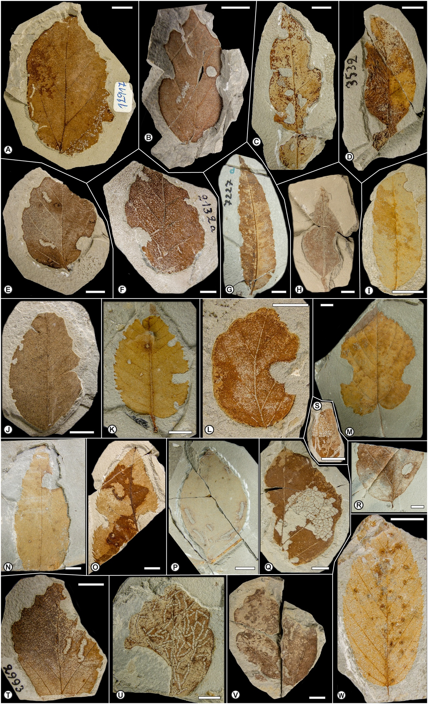
Plate A. Types of hervivorized leaves as described by A. Strauss (1977) from the Pliocene of Willershausen (type material is stored in the Willershausen locality, showing herbivory pattern. The material is deposited in the Geoscience Centre, University of Göttingen (GZG). A. Phagophytichnus circumsecans / Phagophytichnus catellarius (GZG.W 12917); B. Phagophytichnus circumsecans (Holotype, GZG.W 12231); C. Phagophytichnus marginis-folii / Phagophytichnus circumsecans (GZG.W 11490); D. Phagophytichnus marginis-folii (GZG.W 3532); E. Phagophytichnus marginis-folii (Holotype, GZG.W 13386); F. Phagophytichnus marginis-folii (GZG.W 2132/a); G. Phagophytichnus marginis-folii (GZG.W 7227); H. Phagophytichnus marginis-folii (GZG.W 3612); I. Phagophytichnus marginis-folii (GZG.W 21266); J. Phagophytichnus marginis-folii (GZG.W 13298); K. Phagophytichnus marginis-folii (GZG.W 20544); L. Phagophytichnus marginis-folii (GZG.W 22686); M. Phagophytichnus marginis-folii (GZG.W 30955); N. Phagophytichnus marginis-folii (GZG.W 30819); O. Phagophytichnus nervos-mutans (Holotype, GZG.W 11710); P. Phagophytichnus nigromarginatus (Holotype, GZG.W 9781); Q. Phagophytichnus nervillos-reliquens (Holotype, GZG.W 21482); R. Phagophytichnus nervillos-reliquens (GZG.W 30892/a); S. Phagophytichnus nervillos-reliquens (GZG.W 21140); T. Phagophytichnus catellarius (Holotype, GZG.W 2993/a); U. Phagophytichnus catellarius (Paratype, GZG.W 10626); V. Phagophytichnus catellarius (GZG.W 13076); W. cf. Dasyneura ruebsaameni fossilis vel Cecidophyes reniformis fossilis (GZG.W 23992/a). Scale bars represent 10mm.

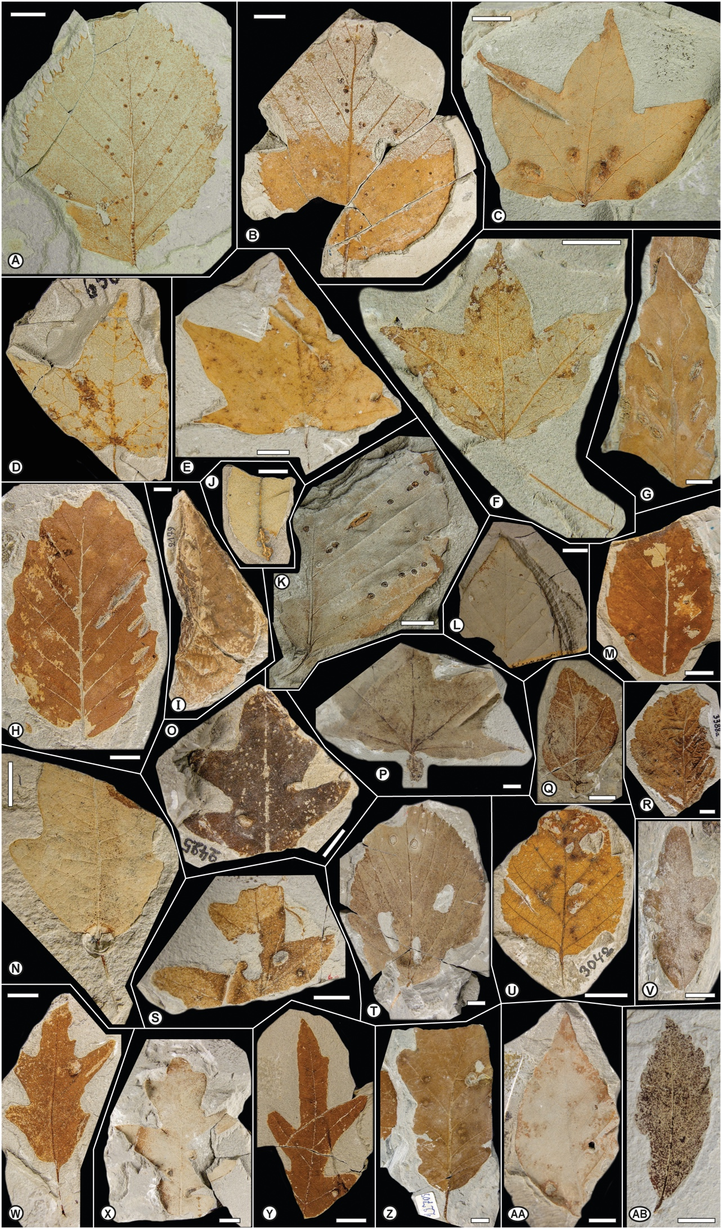
Plate B. Types of hervivorized leaves as described by A. Strauss (1977) from the Pliocene of Willershausen (type material is stored in the Willershausen locality, showing herbivory pattern. The material is deposited in the Geoscience Centre, University of Göttingen (GZG). A. Aceria leionota fossilis (GZG.W 9159); B. Aceria leionota fossilis (GZG.W 9444/a); C. cf. Aceria macrochela fossilis (GZG.W 3116); D. cf. Aceria macrochela fossilis (GZG.W 6560); E. cf. Aceria macrochela fossilis (GZG.W 19779); F. cf. Aceria macrochela fossilis (GZG.W 30808); G. Aceria nervisequa faginea fossilis (GZG.W 30914); H. Aceria nervisequa faginea fossilis (GZG.W 21979); I. Schizoneura ulmi fossilis (GZG.W 2179); J. cf. Dasyneura fraxini fossilis (GZG.W 14652); K. Aceria nervisequa faginea fossilis (GZG.W 30815); L. Aceria nervisequa nervisequa fossilis (GZG.W 13748/a); M. Aceria nervisequa nervisequa fossilis (GZG.W 22848/a); N. Andricus quercus-radicis fossilis (GZG.W 14200); O. Neuroterus albipes fossilis (GZG.W 2425); P. Petiolocecidium aceris (Holotype, GZG.W 30810); Q. Petioloceoidium hamamelidacearum (GZG.W 10060); R. Phyllocecidium alni-tuberculosum (Holotype, GZG.W 3388/a); S. cf. Andricus sp. (GZG.W 7244); T. cf. Didymomyia reaumuriana fossilis (GZG.W 8717) / Fenusites tiliae (Holotype, GZG.W 8717); U. cf. Contarinia carpini fossilis (GZG.W 3042); V. Phyllocecidium comma (Holotype, GZG.W 12143); W. cf. Andricus sp. (GZG.W 17076); X. cf. Andricus sp. (GZG.W 13732); Y. cf. Andricus sp. (GZG.W 15091); Z. cf. Andricus sp. (GZG.W 22705); AA. cf. Mikiola fagi fossilis vel Hartigiola annulipes fossilis (GZG.W 5021); AB. Petioloceoidium hamamelidacearum (GZG.W 13164). Scale bars represent 10mm.

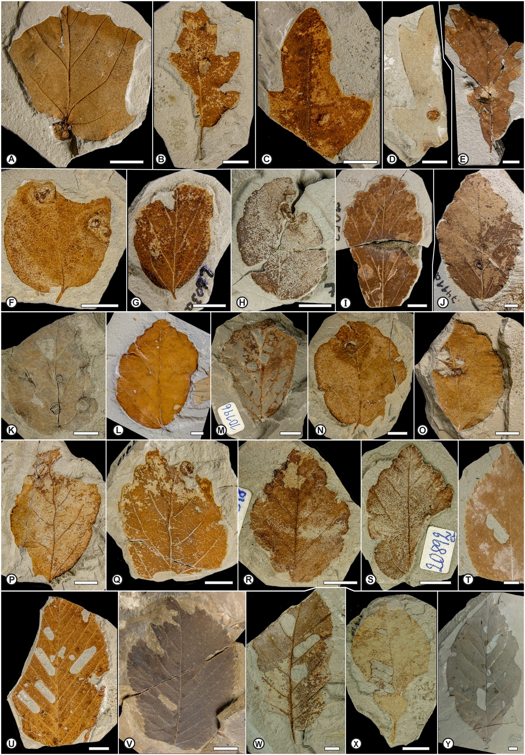

Plate C. Types of hervivorized leaves as described by A. Strauss (1977) from the Pliocene of Willershausen (type material is stored in the Willershausen locality, showing herbivory pattern. The material is deposited in the Geoscience Centre, University of Göttingen (GZG). A. Petioloceoidium hamamelidacearum (Holotype, GZG.W 20197/a); B. Phyllocecidium comma (Paratype, GZG.W 20161/a); C. Phyllocecidium comma (Paratype, GZG.W 23862); D. Phyllocecidium medionervisequm (Holotype, GZG.W 18421/a); E. Phyllocecidium medionervisequm (GZG.W 30845/a); F. Phyllocecidium parrotiae (Holotype, GZG.W 13156); G. Phyllocecidium parrotiae (GZG.W 2603); H. Phyllocecidium parrotiae (GZG.W 7217); I. Phyllocecidium parrotiae (GZG.W 7253); J. Phyllocecidium parrotiae (GZG.W 7411); K. Phyllocecidium parrotiae (GZG.W 9214); L. Phyllocecidium parrotiae (GZG.W 9673/a); M. Phyllocecidium parrotiae (GZG.W 10196); N. Phyllocecidium parrotiae (GZG.W 13217); O. Phyllocecidium parrotiae (GZG.W 16732); P. Phyllocecidium parrotiae (GZG.W 17689); Q. Phyllocecidium parrotiae (GZG.W 17715); R. Phyllocecidium parrotiae (GZG.W 20316/a); S. Phyllocecidium parrotiae (GZG.W 20892); T. Fenusites betulacearum (GZG.W 18874); U. Fenusa ulmi fossilis (GZG.W 21920/a); V. Fenusa ulmi fossilis (GZG.W 12); W. Fenusa ulmi fossilis (GZG.W 3183); X. Fenusites denckmanni (Holotype, GZG.W 14535/a); Y. Fenusites betulacearum (Holotype, GZG.W 20987/a). Scale bars represent 10mm.

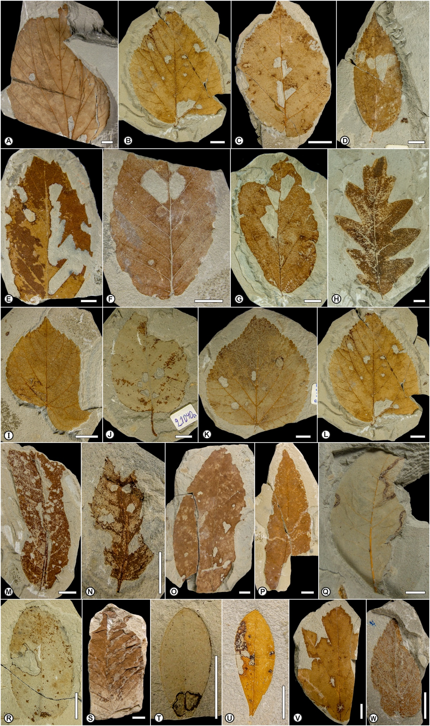
Plate D. Types of hervivorized leaves as described by A. Strauss (1977) from the Pliocene of Willershausen (type material is stored in the Willershausen locality, showing herbivory pattern. The material is deposited in the Geoscience Centre, University of Göttingen (GZG). A. Fenusites tiliae (GZG.W 15650); B. Fenusites tiliae and cf. Coleophora sp. (GZG.W 22549/a); C. Fenusites betulacearum (GZG.W 18906); D. Fenusites celtis (Holotype, GZG.W 17924); E. Fenusites fagi (Holotype, GZG.W 21926); F. Fenusites fagi (GZG.W 11339); G. Fenusites parrotiae (Holotype, GZG.W 22508); H. Fenusites zelovae (Holotype, GZG.W 30806); I. cf. Bucculatrix thoracella fossilis (GZG.W 18422); J. cf. Coleophora sp. (GZG.W 21040); K. cf. Coleophora sp. (GZG.W 21695/a); L. cf. Coleophora sp. (GZG.W 22549/a); M. cf. Coleophora sp. (GZG.W 22858); N. cf. Coleophora sp. (GZG.W 22996/a); O. cf. Caloptilia alchimiella fossilis (GZG.W 22788); P. cf. Caloptilia alchimiella fossilis (GZG.W 22440); Q. cf. Coriscium sp. (GZG.W 30838); R. cf. Parornix sp. (GZG.W 15876/a); S. Lithocolletis maestingella fossilis (GZG.W 30057); T. cf. Incurvaria oehlmanniella fossilis (GZG.W 15427); U. cf. Incurvaria sp. (GZG.W 21313); V. cf. Recurvaria nanella (GZG.W 12724/a); W. Stigmella ulmivora fossilis (GZG.W 9111). Scale bars represent 10mm.

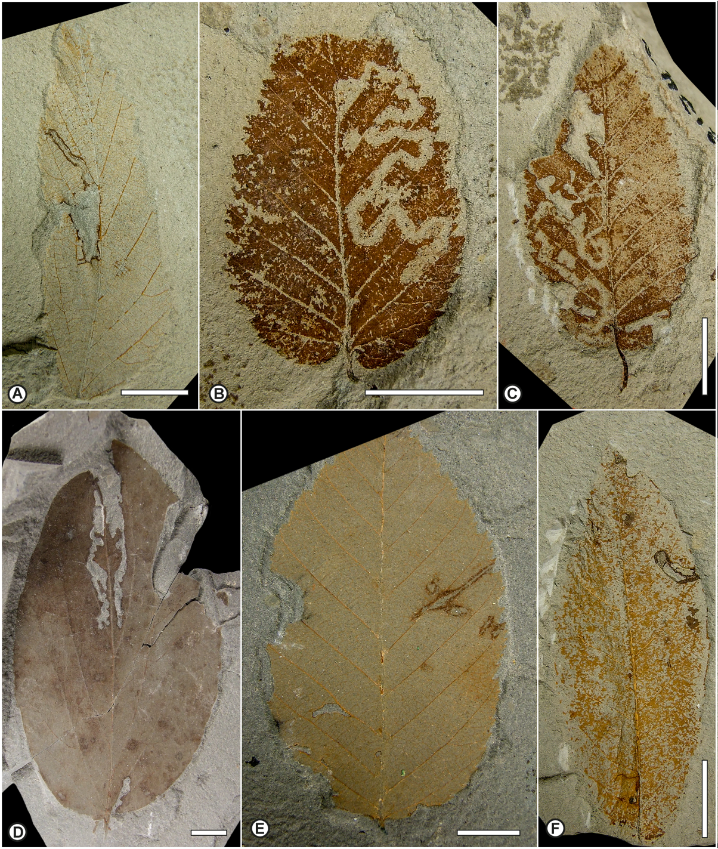

Plate E. Types of hervivorized leaves as described by A. Strauss (1977) from the Pliocene of Willershausen (type material is stored in the Willershausen locality, showing herbivory pattern. The material is deposited in the Geoscience Centre, University of Göttingen (GZG). A. Stigmella ulmivora fossilis (GZG.W 17738); B. Stigmellites carpini-orientalis (Holotype, GZG.W 22763); C. Stigmellites carpini-orientalis (Paratype, GZG.W 22134); D. Phytomyzites corni (Holotype, GZG.W 10965); E. Cuniculonomus carpini (Holotype, GZG.W 19471); F. Diptera mine undetermined (GZG.W 19753/a). Scale bars represent 10mm.

References
Berger W. 1949. Lebensspuren schmarotzender Insekten an jungtertiären Laubblättern. Sitzungsberichte der Österreichische Akademie der Wissenschaften, Mathematisch-naturwissenschaftliche Klasse, Sitzungsberichte Abteilung I, Biologie, Mineralogie, Erdkunde und verwandte Wissenschaften 158:789–792.
Bertling M, Braddy S, Bromley R, Demathieu G, Genise J, Mikuláš R, Nielsen J, Nielsen K, Rindsberg A, Schlirf M, Uchman A. 2006. Names for trace fossils: a uniform approach. Lethaia 39:265–286.
Buhr H. 1964-1965. Bestimmungstabellen der Gallen (Zoo- und Phytocecidien) an Pflanzen Mittel- und Nordeuropas. Band I-II. Jena: VEB Gustav Fischer Verlag.
Cariglino B, Gutiérrez PR. 2011. Plant-insect interactions in a Glossopteris flora from the La Golondrina Formation (Guadalupian–Lopingian), Santa Cruz Province, Patagonia, Argentina. Ameghiniana 48:103–112.
Dieguez C, Nieves-Aldrey J, Barron E. 1996. Fossil galls (zoocecids) from the Upper Miocene of La Cerdana (Lerida, Spain). Review of Palaeobotany and Palynology 94:329–343.
Doorenweerd C, Nieukerken EJV, Sohn J-C, Labandeira CC. 2015. A revised checklist of Nepticulidae fossils (Lepidoptera) indicates an Early Cretaceous origin. Zootaxa 3963:295–334.
Friĉ A. 1882. Fossile Arthropoden aus der Steinkohlen–und Kreideformation Böhmens. Beiträge zur Paläontologie Österreich-Ungarns 2:1–7.
Friĉ A. 1901. Studien im Gebiete der Böhmischen Kreideformation. Palaentolologische Untersuchungen der einselnen Schichten. Die thierischen Reste der Perucer Schichten. Archiv der naturwissenschaftlichen Landesdurch-forschung von Böhmen 9:163–181.
Genise JF. 2017. Insect Trace Fossils in Other Substrates than Paleosols I. Plant Remains. Ichnoentomology: Insect Traces in Soils and Paleosols. Cham: Springer International Publishing, 447–476.
Givulescu R. 1984. Pathological elements on fossil leaves from Chiuzbaia (galls, mines and other insect traces). Dari de Seama ale Sedintelor, Intitutul de Geologie si Geofızica 68:123–133.
Hering EM. 1930. Eine Agromyziden-Mine aus dem Tertiär (Dipt. Agromyz.). Deutsche Entomologische Zeitschrift, NF 1931:63–65.
Hering EM. 1957. Bestimmungstabellen der Blattminen von Europa einschließlich des Mittelmeerbeckens und der Kanarischen Inseln. 's-Gravenhage: Junk.
Iannuzzi R, Labandeira CC. 2008. The oldest record and early history of insect folivory. Annals of the Entomological Society of America 101:79–94.
Jakubowskaja TA. 1955. Sarmatikaja Flora Moldavskoja SSR. Acta Inst. Bot. nom. V. L. Komarovii. Acad. Sci. USSR, Ser. 1, Fasc. 11:64–255. (in Russian)
Kernbach K. 1967. Über die bisher im Pliozän von Willershausen gefundenen Schmetterlings- und Raupenreste. Bericht der Naturhistorischen Gesellschaft Hannover 111:103–108.
Kinzelbach RK. 1970. Eine Gangmine aus dem eozänen Ölschiefer von Messel (Insecta: ?Lepidoptera). Paläontologische Zeitschrift 44:93–96.
Krassilov VA, Rasnitsyn AP. 2008. Plant-Arthropod Interactions in the Early Angiosperm History - Evidence from the Cretaceous of Israel. Sofia, Moscow, Leiden, Boston: Pensoft Publisher & BRILL.
Kustatscher E, Franz M, Heunisch C, Reich M, Wappler T. 2014. Floodplain habitats of braided river systems: depositional environment, flora and fauna of the Solling Formation (Buntsandstein, Lower Triassic) from Bremke and Fürstenberg (Germany). Palaeobiodiversity and Palaeoenvironments 94:237–270.
Labandeira CC. 2002. Paleobiology of middle Eocene plant-insect associations from the Pacific Northwest: A preliminary report. Rocky Mountain Geology 37:31–59.
Labandeira CC. 2006. The four phases of plant-arthropod associations in deep time. Geologica Acta 4:409–438.
Labandeira CC. 2013. Deep-time patterns of tissue consumption by terrestrial arthropod herbivores. Naturwissenschaften 100:355–364.
Labandeira CC, Wilf P, Johnson KR, Marsh F. 2007. Guide to insects (and other) damage types on compressed plant fossils. Version 3.0. Washington, D.C.: Smithsonian Institution.
Lesquereux L. 1892. The flora of the Dakota Group. US Geological Survey Monograph 17:1–400.
Mädler AK. 1936. Eine Blattgalle an einem vorweltlichen Pappel-Blatt. Natur und Volk 66:271–274.
Peñalver E. 2002. Los insectos dípteros del Mioceno del Este de la Península Ibérica: Rubielos de Mora, Ribesalbes y Bicorp. Tafonomía y sistemática. València: Universitat de València.
Potonié H. 1893. Die Flora des Rotliegendes von Thüringen. Abhandlungen der Königlichen Preussischen Geologischen Landesanstalt, NF 9:1–298.
Potonié R. 1921. Mitteilungen über mazerierte kohlige Pflanzenfossilien. Zeitschrift für Botanik 13:79–88.
Robledo JM, Sarzetti LC, Anzótegui LM. 2016. New records and ichnospecies of linear leaf mines from the late Miocene-Pliocene from Argentina and the establishment of leaf-mining ichnotaxobases. Rivista Italiana di Paleontologia e Stratigrafia 122:73–88.
Sarjeant WAS. 1979. Code for trace fossil nomenclature. Palaeogeography, Palaeoclimatology, Palaeoecology 28:147–167.
Sarjeant WAS, Kennedy WJ. 1973. Proposal of a Code for the nomenclature of trace fossils. Canadian Journal of Earth Sciences 10:460–475.
Sarzetti LC, Labandeira CC, Genise JF. 2008. A leafcutter bee trace fossil from the Middle Eocene of Patagonia, Argentina and a review of megachilid (Hymenoptera) ichnology. Palaeontology 51:933–941.
Sarzetti LC, Labandeira CC, Muzón J, Wilf P, Cúneo NR, Johnson KR, Genise JF. 2009. Odonatan Endophytic Oviposition from the Eocene of Patagonia: The Ichnogenus Paleoovoidus and Implications for Behavioral Stasis. Journal of Paleontology 83:431–447.
Simberloff D, Dayan T. 1991. The guild concept and the structure of ecological communities. Annual Review of Ecology and Systematics 22:115–143.
Sohn J-C, Labandeira CC, Davis D, Mitter C. 2012. An annotated catalog of fossil and subfossil Lepidoptera (Insecta: Holometabola) of the world. Zootaxa 3286:1–132.
Steinbach G. 1967. Zur Hymenopterenfauna des Pliozäns von Willershausen/Westharz. Bericht der Naturhistorischen Gesellschaft Hannover 111:95–102.
Straus A. 1962. Die Tongrube zu Willershausen. Heimat-Kalender des Kreises Osterode und des Südwestrandes des Harzes 1962:65–68.
Straus A. 1977. Gallen, Minen und andere Fraßspuren im Pliozän von Willershausen am Harz. Verhandlungen des Botanischen Vereins der Provinz Brandenburg 113:41–80.
van Amerom HWJ. 1966. Phagophytichnus ekowskii nov. ichnogen. & nov. ichnosp., eine Missbildung infolge von Insektenfrass, aus dem spanischen Stepanien (Provinz Leon). Leidse Geologische Mededelingen 38:181-184.
van Amerom HWJ, Boersma WJ. 1971. A new find the ichnofossil Phagophytychnus ekoswkii. Geologie en Mijnbouw 50: 667–670.
von Heyden C. 1862. Gliedertiere aus der Braunkohle des Niederrhein´s, der Wetterau und der Rhön. Palaeontographica 10:62–82.
von Kéler S. 1963. Entomologische Wörterbuch. Berlin (Ost): Deutsche Akademie der Landwirtschaftswissenschaften zu Berlin.
Vasilenko DV. 2005. Damages on Mesozoic plants from the Transbaikalian locality Chernovskie Kopi. Paleontological Journal 39:628–633.
Vasilenko DV. 2007. Feeding damage on upper Permian plants from the Sukhona River. Paleontological Journal 41:207–211.
Vialov OC. 1975. The fossil traces of nourishment of the insects. Paleontological Collection 12:147–155.
Wedmann S, Wappler T, Engel MS. 2009. Direct and indirect fossil records of megachilid bees from the Paleogene of Central Europe (Hymenoptera: Megachilidae). Naturwissenschaften 96:703–712.
Winkler IS, Labandeira CC, Wappler T, Wilf P. 2010. Distinguishing fossil Agromyzidae (Diptera) leaf mines in the fossil record: new taxa from the Paleogene of North America and Germany and their evolutionary implications. Journal of Paleontology 84:935–954.

