Supplemental Information
- Description of eggshell specimens
Elongatoolithidae Zhao, 1975
Macroolithus Zhao, 1975
Macroolithus yaotunensis Zhao, 1975
(Laid by the oviraptorid Heyuannia huangi)

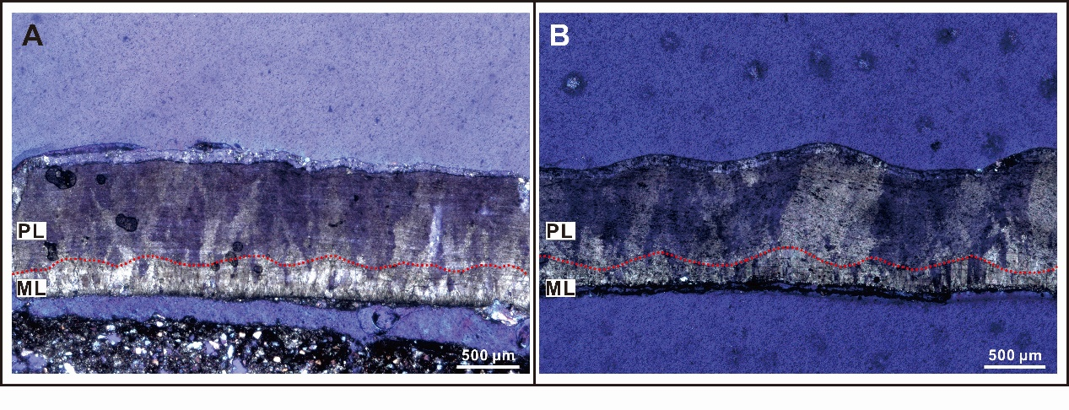
Figure S1 Photographs of the Macroolithus yaotunensis sample from (A) the Liguanqiao Basin in Henan and (B) Nanxiong Basin in Guangdong Provinces, China under the light polarized microscope. The red dashed line marks the undulating boundary between the prismatic layer and mammillary layer, which characterizes the oospecies Macroolithus huangi. ML, mammillary layer; PL, prismatic layer.

- Raman band assignment
Wavenumbers | Assignment | References
957-962 | ν₁PO4, P–O | Crane et al., 2006
967 | ν₁ symmetric ${PO}_{4}^{3-}$ stretching | Walters et al., 1990; Gergely et al. 2010; Frost et al., 2014; Igic et al., 2015
970 | ν₁PO4, P–O | Crane et al., 2006; Igic et al., 2015
980 | ${PO}_{4}^{3-}$ or ${HPO}_{4}^{2-}$ | Sauer et al., 1994; Crane et al., 2006; Igic et al., 2015
1087 | ν₁ symmetric CO₃ stretching | Gunasekaran, Anbalagan & Pandi, 2006

Reference
Gergely G, Wéber F, Lukács I, Tóth AL, Horváth ZE, Mihály J, Balázsi C. 2010. Preparation and characterization of hydroxyapatite from eggshell. Ceramics International 36:803-806. DOI: 10.1016/j.ceramint.2009.09.020
Gunasekaran S, Anbalagan G, Pandi S. 2006. Raman and infrared spectra of carbonates of calcite structure. Journal of Raman Spectroscopy 37(9):892-899. DOI:10.1002/jrs.1518
Igic B, Fecheyr-Lippens D, Xiao M, Chan A, Hanley D, Brennan PRL, Grim T, Waterhouse GIN, Hauber ME, Shawkey MD. 2015. A nanostructural basis for gloss of avian eggshells. Journal of The Royal Society Interface 12:20141210. DOI: 10.1098/rsif.2014.1210
Walters MA, Leung YC, Blumenthal NC, Konsker KA, LeGeros RZ. 1990. A Raman and infrared spectroscopic investigation of biological hydroxyapatite. Journal of Inorganic Biochemistry 39:193-200. DOI: 10.1016/0162-0134(90)84002-7
Zhao, Z. 1975. Microstructures of the dinosaurian eggshells of Nanxiong, Guangdong, and the problems in egg classification. Vertebrata Palasiatica 13(2):105-117.

