Supplemental Information, Appendix S11
Modeled mean scaled mass index (SMI) from 1-way ANOVA style linear models for migrant species at four pasture sites and one reference forest (Aceitillar).
Sites are ordered along x-axis in order of successional stage. Error bars are approximate 95% confidence intervals. See Supplemental Materials Table S4 for test statistics for tests for linear and quadratic trends.

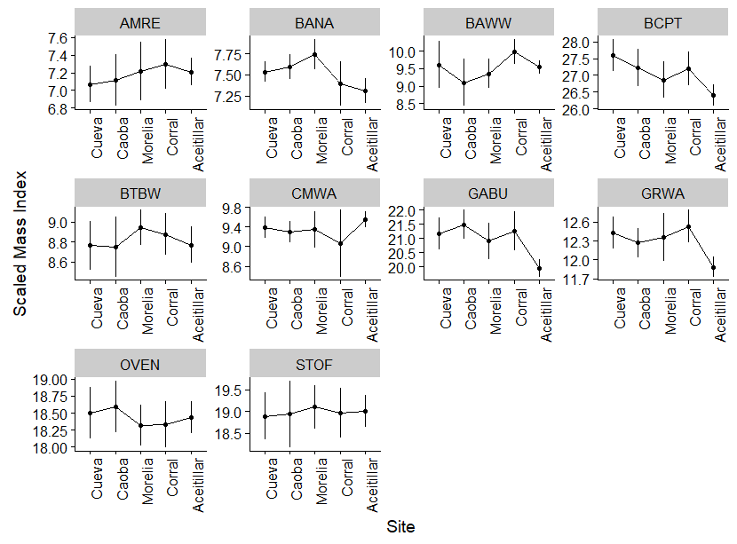
AMRE = American Redstart, BAWW = Black and White Warbler, BTBW = Black-Throated Blue Warbler, CMWA = Cape May Warbler, OVEN = Ovenbird, BANA = Banaquit, BCPT = Black Crowned Palm Tanager, GRWA = Green Warbler, STOF = Stolid Flycatcher

