Supplemental Information, Appendix S5
Modeled capture rates from 1-way ANOVA style generalized linear mixed models for migrant species at four pasture sites and one reference forest (Aceitillar).
Sites are ordered along x-axis in order of successional stage. Error bars are approximate 95% confidence intervals. See Supplemental Materials Table S2 for test statistics for tests for linear and quadratic trends.
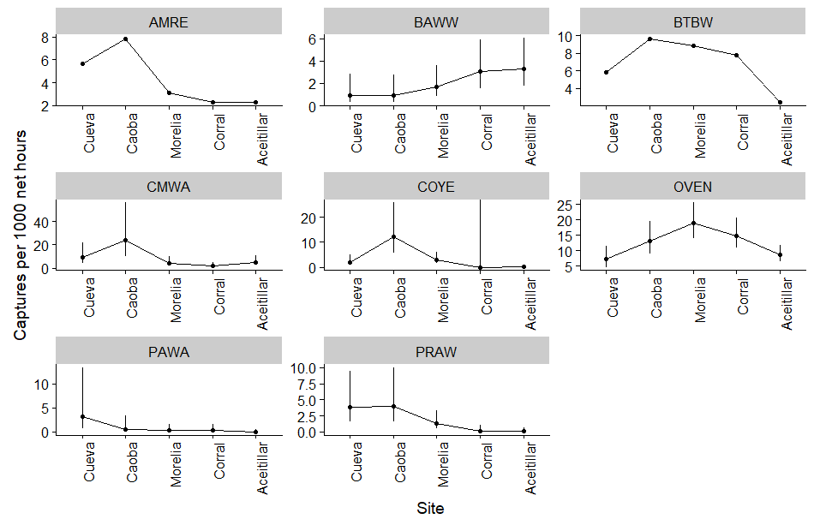
AMRE = American Redstart, BAWW = Black and White Warbler, BTBW = Black-Throated Blue Warbler, CMWA = Cape May Warbler, COYE = Common Yellowthroat, OVEN = Ovenbird, PAWA = Palm Warbler, PRAW = Prairie Warbler

