Supplemental Information, Appendix S9
Percentage composition of flying insects captured on sticky traps (top) and terrestrial insects in leaf litter samples (bottom) from four abandoned pasture sites and a mature forest reference.
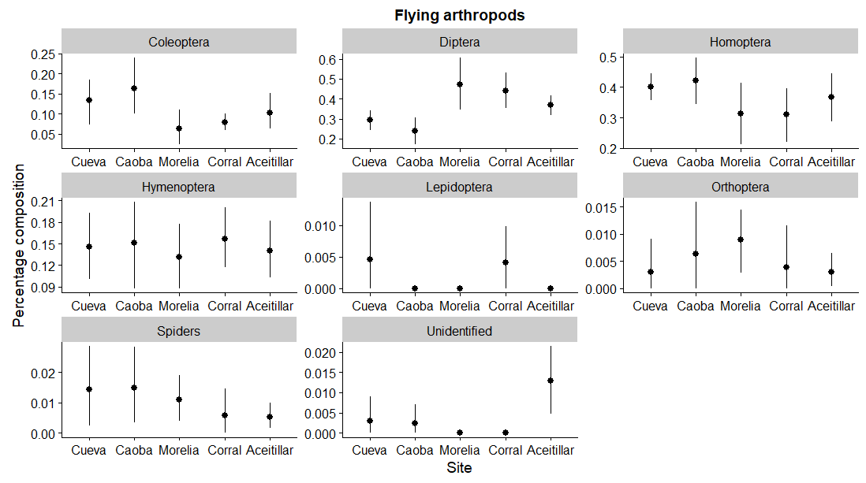
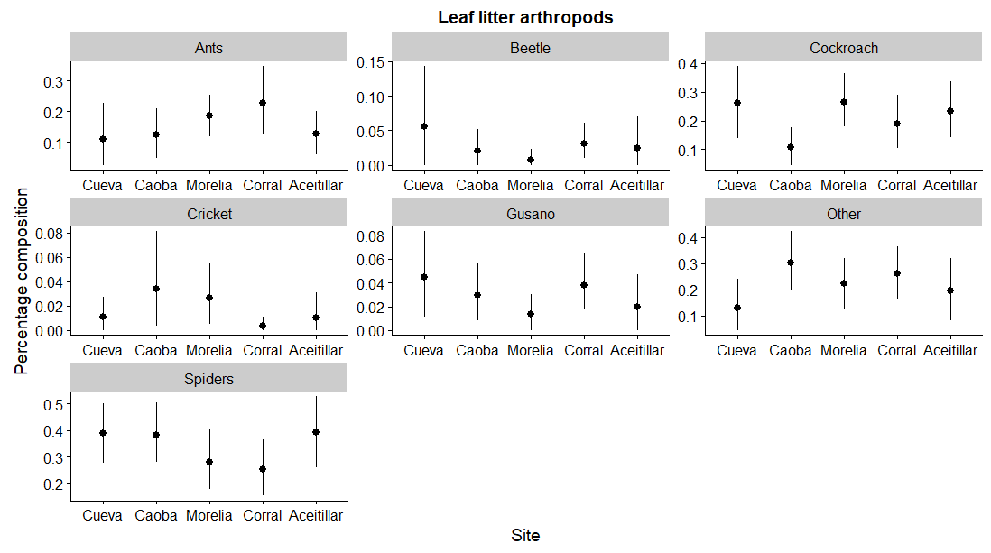

Flying arthropods:
(323) (348) (599) (399) (749)
La Cueva La Caoba Morelia El Corral Aceitillar

Leaf-litter arthropods
(210) (227) (213) (294) (112)

La Cueva La Caoba Morelia El Corral Aceitillar

