Dataset Tables
Cq values of seven candidate reference genes of Rhizophora apiculata in physiological conditions and salt stress tissue samples
(A)

 | Reference Gene | Min | Max | Average | SD | SE | 1st Quartile | 3rd Quartile | Median
Physiolo-gical Tissue samples Cq values | 18S | 12.27 | 15.07 | 14.16 | 0.831 | 0.26 | 13.78 | 14.8 | 14.38
 | EF1α | 18 | 22.08 | 19.986 | 1.21 | 0.38 | 19.12 | 20.72 | 20.27
 | ACTIN | 19.3 | 22.61 | 21.115 | 1.29 | 0.4 | 19.94 | 22.14 | 21.69
 | β-TUB | 19.06 | 22.15 | 20.619 | 1.19 | 0.37 | 19.72 | 21.59 | 20.59
 | GAPDH | 19.83 | 27.36 | 21.771 | 2.226 | 0.704 | 20.645 | 21.88 | 21.13
 | UBQ | 19.8 | 21.42 | 20.683 | 0.6421 | 0.20 | 20.01 | 21.25 | 20.95
 | rbcL | 16.28 | 21.75 | 19.73 | 2.02 | 0.64 | 17.94 | 21.64 | 20.31
Salt stress tissue samples Cq values | 18S | 13.45 | 16.71 | 14.82 | 1.08 | 0.360 | 14.06 | 15.66 | 14.69
 | EF1 α | 17.68 | 21.52 | 20.01 | 1.09 | 0.363 | 19.61 | 23.25 | 20.02
 | ACTIN | 20.3 | 24.21 | 22.49 | 1.302 | 0.43 | 22.51 | 23.25 | 22.61
 | β-TUB | 16.28 | 23.03 | 20.84 | 2.072 | 0.690 | 20.13 | 21.96 | 21.65
 | GAPDH | 18.99 | 24.35 | 21.65 | 1.76 | 0.588 | 20.13 | 22.81 | 21.46
 | UBQ | 20.01 | 25.24 | 23.27 | 1.93 | 0.64 | 22.47 | 24.54 | 23.98
 | rbcL | 12.18 | 21.75 | 15.75 | 3.543 | 1.18 | 13.35 | 16.02 | 14.39

(B) Average Cq values and standard error’s of four reference gene used for sodium/proton antiporter gene (NHX)

 | EF1α |  | ACT |  | 18S |  | UBQ |  | EF1α+ ACT
 | Average | SE | Average | SE | Average | SE | Average | SE | Average | SE
0 h | 1.037934 | 0.394 | 0.701008 | 0.0412 | 1.026588 | 0.24048 | 0.892191 | 0.0216404 | 1.114235 | 0.39444
6 h | 0.821119 | 0.2417 | 0.913853 | 0.006334 | 0.334914 | 0.10551 | 8.895805 | 1.59761 | 0.986148 | 0.24173
12 h | 6.299345 | 0.8012 | 2.118233 | 0.36666 | 4.959307 | 0.07474 | 5.797474 | 0.11481 | 4.371138 | 0.8012
24 hr | 1.381144 | 0.8382 | 0.902 | 0.11195 | 0.876795 | 0.02319 | 0.719293 | 0.2579 | 2.12107 | 0.838243

(C) geNorm Analysis: Physiological tissue samples lowest M value show the most stable reference genes and highest M value represents least stable genes
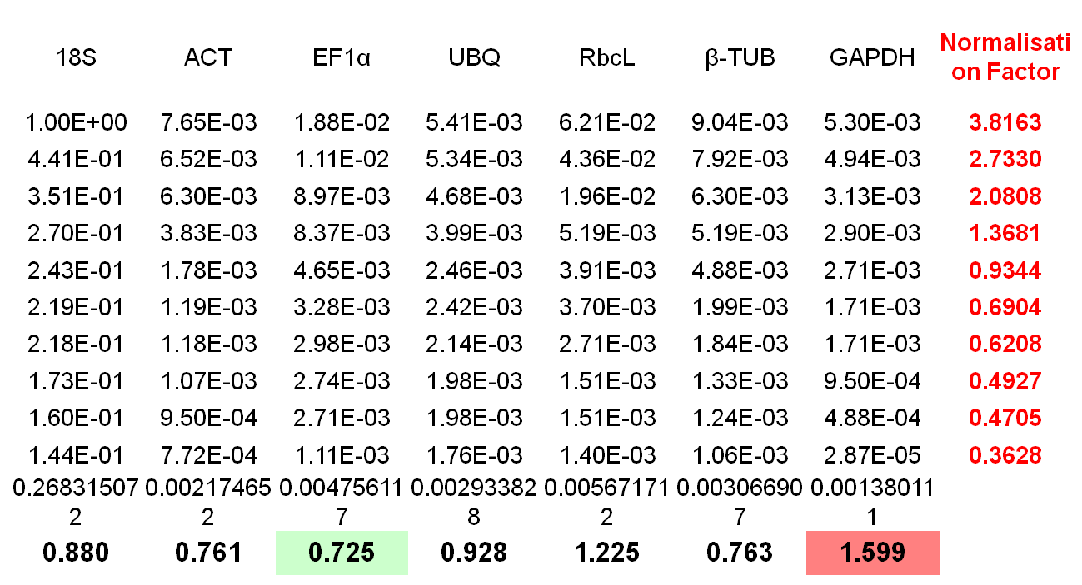
M <1.5

(D) geNorm analysis: In physiological tissue samples the most stable pair of gene
ACT | EF1α | Normalisation Factor
7.65E-03 | 1.88E-02 | 3.7334
6.52E-03 | 1.11E-02 | 2.6491
6.30E-03 | 8.97E-03 | 2.3384
3.83E-03 | 8.37E-03 | 1.7599
1.78E-03 | 4.65E-03 | 0.8953
1.19E-03 | 3.28E-03 | 0.6158
1.18E-03 | 2.98E-03 | 0.5826
1.07E-03 | 2.74E-03 | 0.5324
9.50E-04 | 2.71E-03 | 0.4984
7.72E-04 | 1.11E-03 | 0.2883
0.002174652 | 0.004756117
0.382 | 0.382

(E) geNorm Analysis: salt stress samples lowest M value show the most stable reference genes and highest M value represents least stable genes
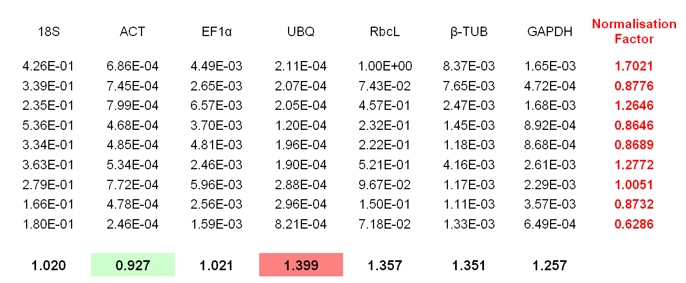
M<1.5

(F) geNorm Analysis: In salt stress samples the most stable pair of gene
Actin | EF1α | Normalisation Factor
6.86E-04 | 4.49E-03 | 1.2628
7.45E-04 | 2.65E-03 | 1.0116
7.99E-04 | 6.57E-03 | 1.6491
4.68E-04 | 3.70E-03 | 0.9472
4.85E-04 | 4.81E-03 | 1.0994
5.34E-04 | 2.46E-03 | 0.8245
7.72E-04 | 5.96E-03 | 1.5440
4.78E-04 | 2.56E-03 | 0.7965
2.46E-04 | 1.59E-03 | 0.4496
0.0005485 | 0.003517799
0.462 | 0.462

(G) NormFinder analysis: physiological tissue sample lowest stability value show the most stable reference genes and highest value represents least stable genes

Gene name | Stability value
18S | 0.410
ACT | 0.164
EF1α | 0.085
UBQ | 0.463
RbcL | 0.500
β-TUB | 0.135
GAPDH | 0.568
Best gene | EF1α
Stability value | 0.085
Best combination of two genes | EF1α and β-TUB
Stability value for best combination of two genes | 0.070

(H) NormFinder analysis: Salt stress samples lowest stability value show the most stable reference genes and highest value represents least stable genes
Gene name | Stability value
18S | 0.273
ACT | 0.196
EF1α | 0.257
UBQ | 0.518
RbcL | 0.499
β-TUB | 0.533
GAPDH | 0.483
Best gene | ACT
Stability value | 0.196
Best combination of two genes | ACT and EF1α
Stability value for best combination of two genes | 0.183

