Comparison of reaction times from Presentation software against a Matlab code that detected the sound envelope of the voice signal

RT obtained from Matlab code | RT obtained from Presentation Software
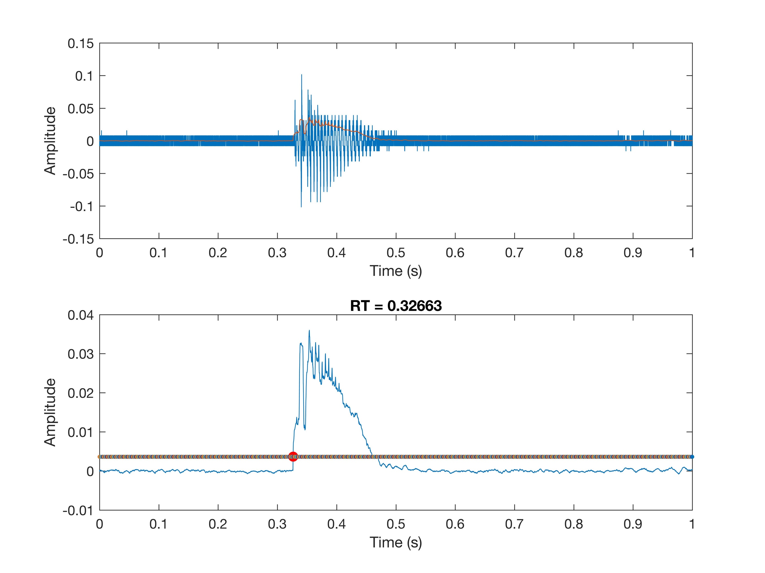  RT = 0.326 s | RT = 0.329 s
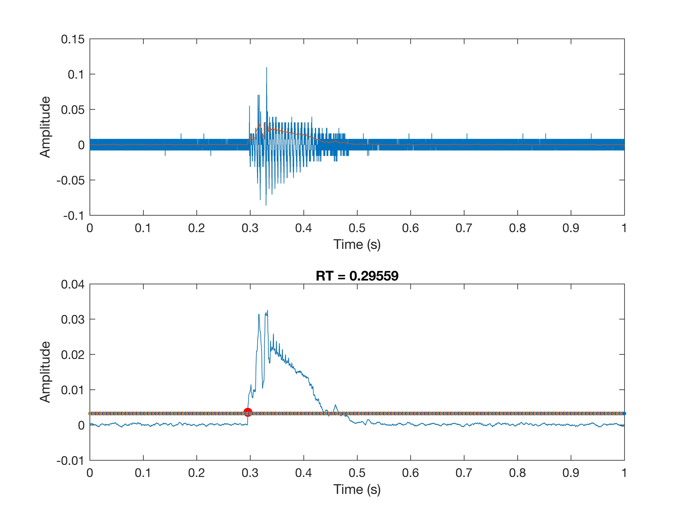  RT = 0.296 s | RT = 0.298 s
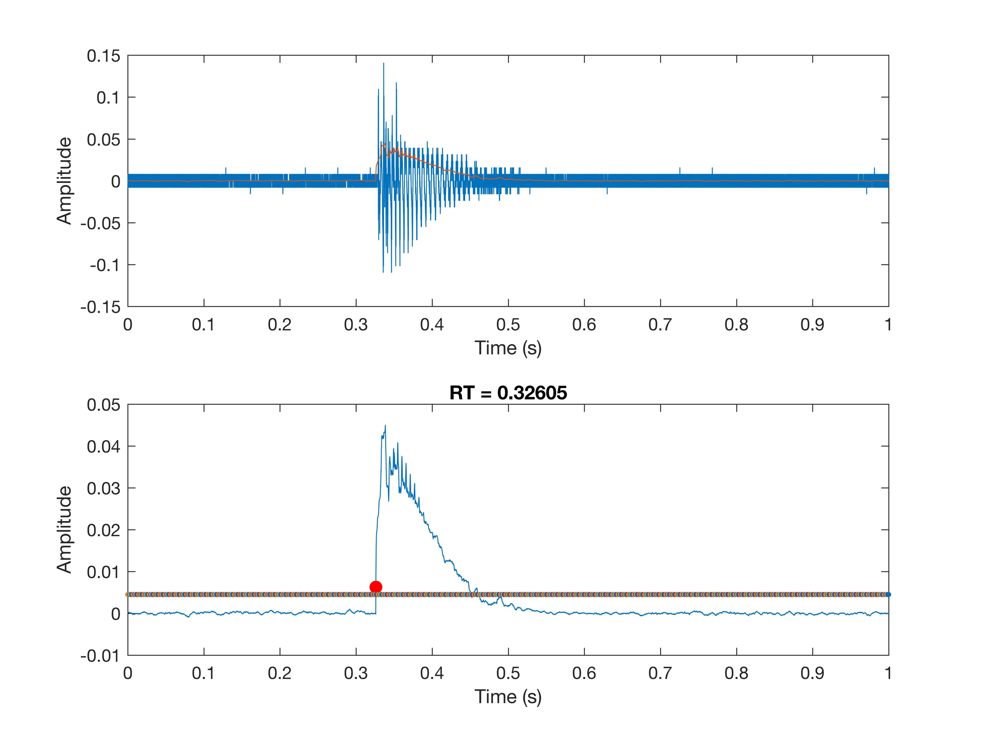  RT = 0.326 s | RT = 0. 329 s

