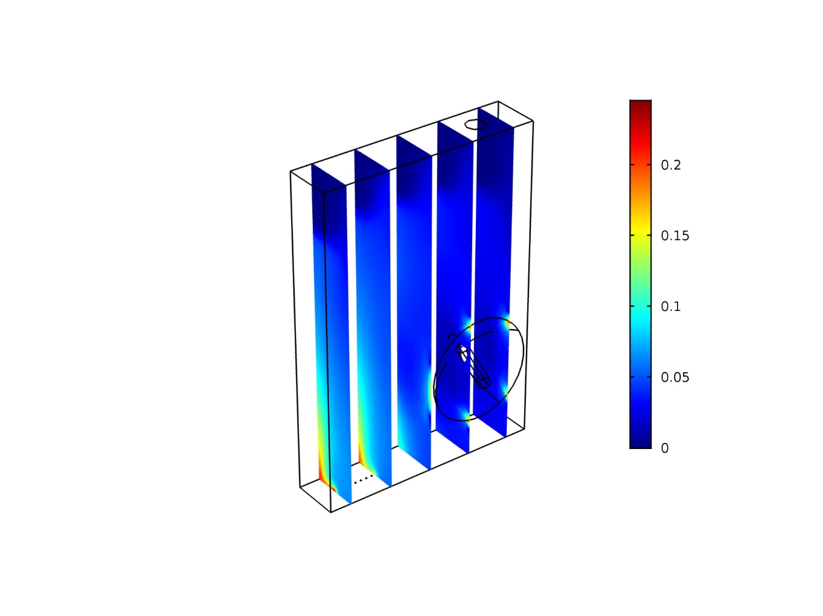

**Figure S13D slice trend of dispersed phase.**

The dispersed phase mixture of CO2 and N2 is plotted at 24 h and for incident light intensitiy, *Iinc*, equal to 300 µmol photons m-2 s-1

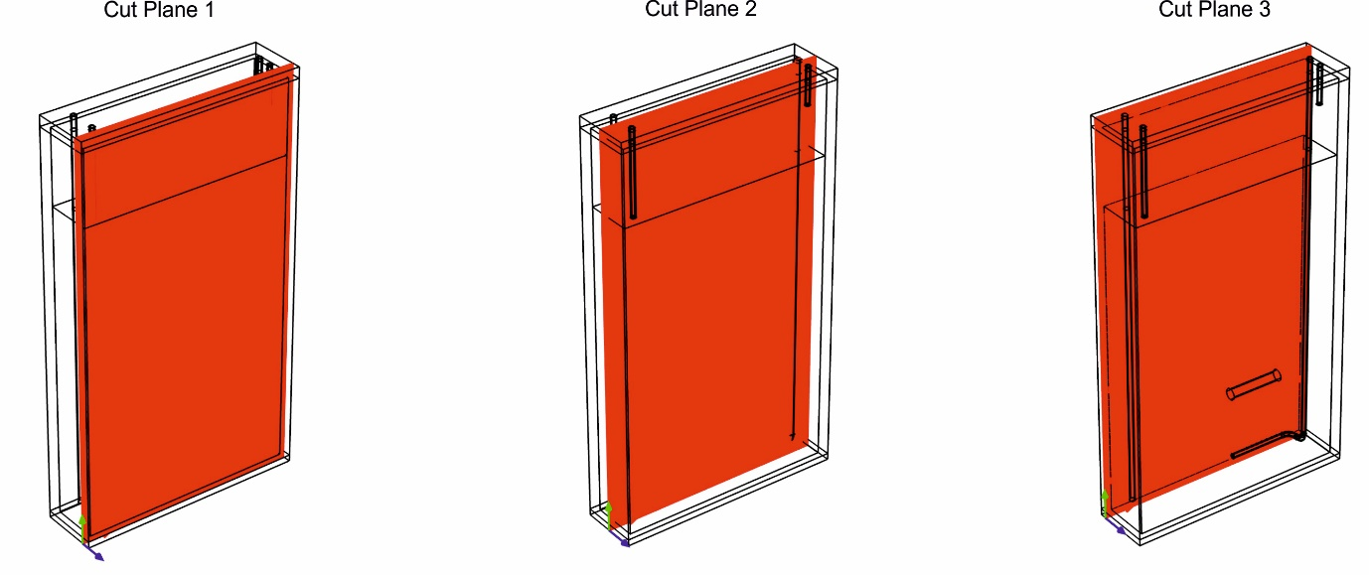

**Figure S2**

|  |  |  |
| --- | --- | --- |
| **Equation** | **Domain** | **Mathematical model** |
|  | 3-4-6-7 | MASS TRANSFER |
|  | 3-4-6-7 |
|  | 3-4-6-7 |
|  | 3-4-6-7 | FLUID-DYNAMICS |
|  | 3-4-6-7 |
|  | 4-6-7 |
|  | 4-6-7 |
|  | 4-6-7 |
|  | 4-6-7 |
|  | 4-6-7 |
|  | 4-6-7 |
| $$∅_{c}+ ∅_{d}=1$$ | 3-4-6-7 |
|  | 3-4-6-7 |
|  | 3-4-6-7 |
| $$μ_{eff}=μ_{i}+μ_{i,T}$$ | 3-4-6-7 |
|  | 3-4-6-7 |
|  | 3-4-6-7 |
|  | 3-4-6-7 |
|  | 3-4-6-7 |
|  | 3-4-6-7 |
|  | 3-4-6-7 |
| $$ρC_{p}\frac{∂T}{∂t}+ ρC_{p}u∙∇T+∇∙q=Q+Q_{r}$$ | all | HEAT TRANSFER WITH RADIATION |
| $$q=-k_{c}∇T$$ | all |
| $$Q_{r}=κ(G-4πI_{b})$$ | 3-4-6-7-8 |
| $$∇∙\left(D_{P1}∇G\right)+κ\left(G-4πI_{b}\right)=0$$ | 3-4-6-7-8 |
| $$G=\int_{4π}{I\left(Ω\right)dΩ}$$ | 3-4-6-7-8 |
| $$D_{P1}=\frac{1}{3κ+σ_{S}(3-a_{1})}$$ | 3-4-6-7-8 |
| $$Ω∙∇I\left(Ω\right)=κI_{b}\left(T\right)-βI\left(Ω\right)+\frac{σ_{S}}{4π}\int_{4π}{I\left(Ω^{'}\right)Φ\left(Ω^{'},Ω\right)dΩ'}$$ | 3-4-6-7-8 |
| $β=κ$ + $σ_{S}$ | 3-4-6-7-8 |
| $$I_{b}\left(T\right)=\frac{n_{r}^{2}σT^{4}}{π}$$ | 3-4-6-7-8 |
| $$\frac{I}{I_{0}}=exp⁡(-βz)$$ | 3-4-6-7-8 |
| $$\frac{I}{I_{0}}=exp⁡\left(-\frac{3{}_{d}z}{d_{b}}-K_{a}z\right)$$ | 3-4-6-7-8 |
| $$μ_{gr}=μ_{max}\frac{C}{k_{s}+C}$$ | 6-7 | GROWTH KINETICS |
| $$μ_{gr}=\frac{μ_{max}∙I}{I+k_{s}+\frac{I^{2}}{k_{i}}}$$ | 6-7 |
|  |  |

**Table S1**

|  |  |  |  |
| --- | --- | --- | --- |
| **Light intensity**  **(µmol photons m-2 s-1)** | | **OD680/OD720** | |
|  |  | |  |
| 50 | 1.774 ± 0.002 | |  |
| 200 | 1.548 ± 0.042 | |  |
| 300 | 1.518 ± 0.009 | |  |
| 500 | 1.496 ± 0.022 | |  |
| 800 | 1.475 ± 0.010 | |  |
| 950 | 1.545 ± 0.035 | |  |
| 1460 | 1.597 ± 0.041 | |  |
| 200* | 1.557 ± 0.017 | |  |
|  |  | |  |
|  |  |  |  |

**Table S2**

|  |  |  |
| --- | --- | --- |
| Domain | Element size | [m] |
| Reator | Height | 0.1983 |
| Width | 0.11 |
| Thickness | 0.024 |
| Sparger | Diameter of inlet | 0.002 |
| Diameter of holes | 0.0004 |
| Number of holes | 7 |
| Lenght | 0.03 |
| Anchor | Diameter | 0.006 |
| Lenght | 0.035 |
| Vessel | Thickness | 0.0033 |

**Table S3**

|  |  |  |
| --- | --- | --- |
|  | Gas phase | Liquid phase |
| Inlet velocity | 150 ml/min | 0 |
| Outlet pressure | Gas outlet condition | Patm, no out |
| Gravity force | g=(9.81)ms-2 g=(9.81)ms-2 | |
| Wall conditions | No gas flux at the reactor boundary;  sparger non-slip model | Wall functions |
| Incident light intensity | 50/200/300/500/800/950/1460 µmol photons m-2s-1 | |

**Table S4**

|  |  |  |  |  |  |  |  |  |
| --- | --- | --- | --- | --- | --- | --- | --- | --- |
| Iin | Iout | Iads | Iads | Vol | mu |  |  | efficiency |
| mmol photons m-2s-1 | mmol photons m-2s-1 | mmol photons m-2s-1 | mol m-3h-1 | L | h-1 | gDW L-1 | mol photons g DW-1 | gDW mol photons-1 |
| 50 | 31.75 | 18.25 | 2.74 | 0.38 | 0.05 | 0.15 | 0.37 | 2.70 |
| 200 | 140.20 | 59.80 | 8.97 | 0.38 | 0.11 | 0.14 | 0.61 | 1.64 |
| 300 | 219.00 | 81.00 | 12.15 | 0.38 | 0.12 | 0.15 | 0.75 | 1.33 |
| 500 | 386.40 | 113.60 | 17.04 | 0.38 | 0.11 | 0.15 | 1.11 | 0.90 |
| 800 | 631.55 | 168.45 | 25.27 | 0.38 | 0.10 | 0.15 | 1.68 | 0.60 |
| 950 | 770.45 | 179.55 | 26.94 | 0.38 | 0.09 | 0.15 | 2.11 | 0.48 |

**Table S5**