Sizemattersscript.R

Nolwenn

Fri Apr 20 14:03:40 2018

#Package needed  
library(phia)

## Loading required package: car

## Warning: package 'car' was built under R version 3.4.4

## Loading required package: carData

## Warning: package 'carData' was built under R version 3.4.4

library(nlme)  
library(lme4)

## Warning: package 'lme4' was built under R version 3.4.4

## Loading required package: Matrix

##   
## Attaching package: 'lme4'

## The following object is masked from 'package:nlme':  
##   
## lmList

library(Rmisc)

## Loading required package: lattice

## Loading required package: plyr

library(ggplot2)  
  
#Begging Analysis  
  
#####import data  
  
dataDir <- file.path("C:/Users/Nolwenn/Dropbox/These", "R")  
fp<- file.path (dataDir, "begging.csv")  
donnees<- read.csv(fp, header=TRUE)  
attach(donnees)  
  
  
##### Average begging and Standard error  
  
dfc <- summarySE(donnees, measurevar="BeggingRaw", groupvars=c("context","Weight"))  
dfc

## context Weight N BeggingRaw sd se ci  
## 1 none H 42 1.517738 1.895559 0.2924911 0.5906977  
## 2 none L 42 3.231667 2.952149 0.4555265 0.9199545  
## 3 own H 24 3.680417 4.627079 0.9444985 1.9538440  
## 4 own L 26 5.301346 3.813974 0.7479818 1.5404974  
## 5 Sibling H 26 3.418462 4.172123 0.8182207 1.6851571  
## 6 Sibling L 24 3.513750 3.745995 0.7646480 1.5817950

dfc <- summarySE(donnees, measurevar="BeggingRaw", groupvars=c("Weight"))  
dfc

## Weight N BeggingRaw sd se ci  
## 1 H 92 2.619076 3.584925 0.3737543 0.7424170  
## 2 L 92 3.890163 3.503718 0.3652878 0.7255993

dfc <- summarySE(donnees, measurevar="BeggingRaw", groupvars=c("context"))  
dfc

## context N BeggingRaw sd se ci  
## 1 none 84 2.374702 2.612136 0.2850074 0.5668682  
## 2 own 50 4.523300 4.259148 0.6023345 1.2104365  
## 3 Sibling 50 3.464200 3.933181 0.5562358 1.1177976

##### check data  
hist(BeggingZ)

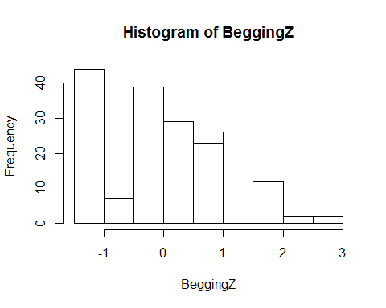

G= ggplot(donnees, aes(x = BeggingZ, color=context))  
G + geom_density()

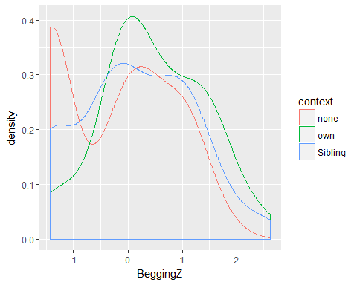

x11()  
shapiro.test(BeggingZ)

##   
## Shapiro-Wilk normality test  
##   
## data: BeggingZ  
## W = 0.93545, p-value = 2.541e-07

qqnorm(BeggingZ)  
qqline(BeggingZ)

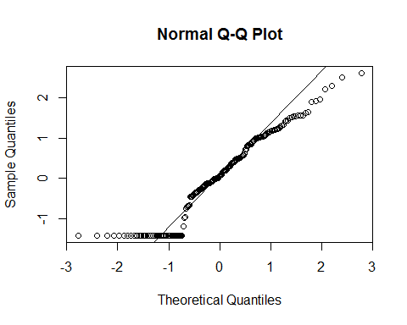

hist(BeggingZ)

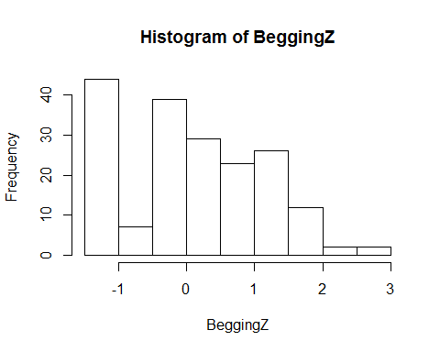

##### Full model begging  
  
lmc<-lmeControl(niterEM=5200,msMaxIter=5200)  
  
M1<- lme(BeggingZ~BroodSize+Weight+ context +  
 Weight :context ,   
 random=~1|nest/ID, method="REML",   
 data=donnees, control=lmc,na.action= na.omit)  
  
summary(M1)

## Linear mixed-effects model fit by REML  
## Data: donnees   
## AIC BIC logLik  
## 525.9234 557.6849 -252.9617  
##   
## Random effects:  
## Formula: ~1 | nest  
## (Intercept)  
## StdDev: 0.3446617  
##   
## Formula: ~1 | ID %in% nest  
## (Intercept) Residual  
## StdDev: 9.645314e-05 0.894707  
##   
## Fixed effects: BeggingZ ~ BroodSize + Weight + context + Weight:context   
## Value Std.Error DF t-value p-value  
## (Intercept) 1.4754976 0.6919753 128 2.132298 0.0349  
## BroodSize -0.1843784 0.0620044 24 -2.973631 0.0066  
## WeightL 0.6256822 0.1952411 25 3.204665 0.0037  
## contextown 0.6474490 0.2364261 128 2.738484 0.0071  
## contextSibling 0.6256704 0.2343735 128 2.669544 0.0086  
## WeightL:contextown 0.0497137 0.3403931 128 0.146048 0.8841  
## WeightL:contextSibling -0.5990961 0.3403931 128 -1.760012 0.0808  
## Correlation:   
## (Intr) BrodSz WeghtL cntxtw cntxtS WghtL:  
## BroodSize -0.974   
## WeightL -0.141 0.000   
## contextown -0.174 0.058 0.413   
## contextSibling -0.103 -0.023 0.417 0.298   
## WeightL:contextown 0.131 -0.056 -0.574 -0.726 -0.144   
## WeightL:contextSibling 0.031 0.056 -0.574 -0.162 -0.720 0.212  
##   
## Standardized Within-Group Residuals:  
## Min Q1 Med Q3 Max   
## -2.49026218 -0.70475675 0.04472147 0.67081015 2.46191664   
##   
## Number of Observations: 184  
## Number of Groups:   
## nest ID %in% nest   
## 26 52

anova(M1)

## numDF denDF F-value p-value  
## (Intercept) 1 128 0.609876 0.4363  
## BroodSize 1 24 8.791758 0.0067  
## Weight 1 25 13.456801 0.0012  
## context 2 128 8.547029 0.0003  
## Weight:context 2 128 1.689488 0.1887

shapiro.test(resid(M1))

##   
## Shapiro-Wilk normality test  
##   
## data: resid(M1)  
## W = 0.99288, p-value = 0.5113

op <- par(mfrow = c(2, 2), mar = c(5, 4, 1, 2))  
plot(M1, add.smooth = FALSE, which = 1)

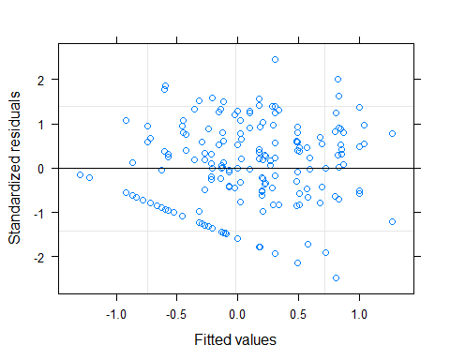

E <- resid(M1)  
hist(E, xlab = "Residuals", main = "")  
plot(Weight, E, xlab = "Weight ",  
 ylab = "Residuals")  
plot(context , E, xlab = "context ",  
 ylab = "Residuals")  
par(op)

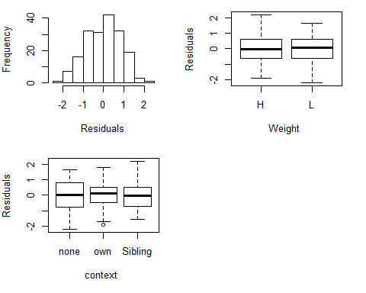

##### Backward selection of the model of begging  
  
M1<- lme(BeggingZ~BroodSize+Weight+ context +  
 Weight:context ,   
 random=~1|nest/ID, method="ML",   
 data=donnees, control=lmc,na.action= na.omit)  
summary(M1)

## Linear mixed-effects model fit by maximum likelihood  
## Data: donnees   
## AIC BIC logLik  
## 512.4828 544.6322 -246.2414  
##   
## Random effects:  
## Formula: ~1 | nest  
## (Intercept)  
## StdDev: 0.3162839  
##   
## Formula: ~1 | ID %in% nest  
## (Intercept) Residual  
## StdDev: 9.026685e-05 0.8816981  
##   
## Fixed effects: BeggingZ ~ BroodSize + Weight + context + Weight:context   
## Value Std.Error DF t-value p-value  
## (Intercept) 1.4794811 0.6726205 128 2.199578 0.0296  
## BroodSize -0.1847251 0.0601716 24 -3.069972 0.0053  
## WeightL 0.6256822 0.1961700 25 3.189490 0.0038  
## contextown 0.6475654 0.2369318 128 2.733129 0.0072  
## contextSibling 0.6247874 0.2343942 128 2.665541 0.0087  
## WeightL:contextown 0.0487143 0.3401096 128 0.143231 0.8863  
## WeightL:contextSibling -0.5980968 0.3401096 128 -1.758541 0.0810  
## Correlation:   
## (Intr) BrodSz WeghtL cntxtw cntxtS WghtL:  
## BroodSize -0.973   
## WeightL -0.146 0.000   
## contextown -0.179 0.059 0.414   
## contextSibling -0.107 -0.023 0.418 0.305   
## WeightL:contextown 0.135 -0.057 -0.577 -0.725 -0.155   
## WeightL:contextSibling 0.033 0.057 -0.577 -0.170 -0.718 0.225  
##   
## Standardized Within-Group Residuals:  
## Min Q1 Med Q3 Max   
## -2.50051262 -0.70866288 0.05599876 0.65279728 2.51613076   
##   
## Number of Observations: 184  
## Number of Groups:   
## nest ID %in% nest   
## 26 52

drop1(M1,test= "Chi")

## Single term deletions  
##   
## Model:  
## BeggingZ ~ BroodSize + Weight + context + Weight:context  
## Df AIC LRT Pr(>Chi)   
## <none> 512.48   
## BroodSize 1 518.71 8.2299 0.00412 **  
## Weight:context 2 511.98 3.4977 0.17397   
## ---  
## Signif. codes: 0 '***' 0.001 '**' 0.01 '*' 0.05 '.' 0.1 ' ' 1

M2<- lme(BeggingZ~BroodSize+Weight+ context,   
 random=~1|nest/ID, method="ML",   
 data=donnees, control=lmc,na.action= na.omit)  
summary(M2)

## Linear mixed-effects model fit by maximum likelihood  
## Data: donnees   
## AIC BIC logLik  
## 511.9805 537.7 -247.9903  
##   
## Random effects:  
## Formula: ~1 | nest  
## (Intercept)  
## StdDev: 0.3233733  
##   
## Formula: ~1 | ID %in% nest  
## (Intercept) Residual  
## StdDev: 7.340426e-05 0.8893134  
##   
## Fixed effects: BeggingZ ~ BroodSize + Weight + context   
## Value Std.Error DF t-value p-value  
## (Intercept) 1.4690039 0.6726018 130 2.184062 0.0308  
## BroodSize -0.1762275 0.0604865 24 -2.913502 0.0076  
## WeightL 0.4765026 0.1329986 25 3.582763 0.0014  
## contextown 0.6689833 0.1636707 130 4.087374 0.0001  
## contextSibling 0.3278203 0.1636707 130 2.002926 0.0473  
## Correlation:   
## (Intr) BrodSz WeghtL cntxtw  
## BroodSize -0.979   
## WeightL -0.099 0.000   
## contextown -0.118 0.026 -0.016   
## contextSibling -0.122 0.026 0.016 0.393  
##   
## Standardized Within-Group Residuals:  
## Min Q1 Med Q3 Max   
## -2.34901426 -0.71735324 0.07079209 0.72859600 2.68992608   
##   
## Number of Observations: 184  
## Number of Groups:   
## nest ID %in% nest   
## 26 52

drop1(M2,test= "Chi")

## Single term deletions  
##   
## Model:  
## BeggingZ ~ BroodSize + Weight + context  
## Df AIC LRT Pr(>Chi)   
## <none> 511.98   
## BroodSize 1 517.43 7.4489 0.0063476 **   
## Weight 1 521.93 11.9463 0.0005475 ***  
## context 2 524.54 16.5631 0.0002531 ***  
## ---  
## Signif. codes: 0 '***' 0.001 '**' 0.01 '*' 0.05 '.' 0.1 ' ' 1

M3<- lme(BeggingZ~ Weight+context,   
 random=~1|nest/ID, method="ML",   
 data=donnees, control=lmc,na.action= na.omit)  
summary(M3)

## Linear mixed-effects model fit by maximum likelihood  
## Data: donnees   
## AIC BIC logLik  
## 517.4294 539.934 -251.7147  
##   
## Random effects:  
## Formula: ~1 | nest  
## (Intercept)  
## StdDev: 0.4234231  
##   
## Formula: ~1 | ID %in% nest  
## (Intercept) Residual  
## StdDev: 7.410147e-05 0.8889621  
##   
## Fixed effects: BeggingZ ~ Weight + context   
## Value Std.Error DF t-value p-value  
## (Intercept) -0.4427858 0.1481405 130 -2.988959 0.0033  
## WeightL 0.4765026 0.1325763 25 3.594176 0.0014  
## contextown 0.6773677 0.1640696 130 4.128540 0.0001  
## contextSibling 0.3362047 0.1640696 130 2.049159 0.0425  
## Correlation:   
## (Intr) WeghtL cntxtw  
## WeightL -0.447   
## contextown -0.427 -0.016   
## contextSibling -0.441 0.016 0.399  
##   
## Standardized Within-Group Residuals:  
## Min Q1 Med Q3 Max   
## -2.3043002 -0.7343987 0.0433515 0.7026885 2.6003035   
##   
## Number of Observations: 184  
## Number of Groups:   
## nest ID %in% nest   
## 26 52

drop1(M3,test= "Chi")

## Single term deletions  
##   
## Model:  
## BeggingZ ~ Weight + context  
## Df AIC LRT Pr(>Chi)   
## <none> 517.43   
## Weight 1 527.38 11.951 0.0005463 ***  
## context 2 530.24 16.807 0.0002241 ***  
## ---  
## Signif. codes: 0 '***' 0.001 '**' 0.01 '*' 0.05 '.' 0.1 ' ' 1

M4<- lme(BeggingZ~ context,   
 random=~1|nest/ID, method="ML",   
 data=donnees, control=lmc,na.action= na.omit)  
summary(M4)

## Linear mixed-effects model fit by maximum likelihood  
## Data: donnees   
## AIC BIC logLik  
## 527.38 546.6696 -257.69  
##   
## Random effects:  
## Formula: ~1 | nest  
## (Intercept)  
## StdDev: 0.3774805  
##   
## Formula: ~1 | ID %in% nest  
## (Intercept) Residual  
## StdDev: 0.2573177 0.904302  
##   
## Fixed effects: BeggingZ ~ context   
## Value Std.Error DF t-value p-value  
## (Intercept) -0.2052147 0.1328434 130 -1.544787 0.1248  
## contextown 0.6771346 0.1698684 130 3.986231 0.0001  
## contextSibling 0.3373183 0.1698684 130 1.985763 0.0492  
## Correlation:   
## (Intr) cntxtw  
## contextown -0.480   
## contextSibling -0.480 0.341  
##   
## Standardized Within-Group Residuals:  
## Min Q1 Med Q3 Max   
## -2.09738388 -0.73955161 -0.04171397 0.74808705 2.38312702   
##   
## Number of Observations: 184  
## Number of Groups:   
## nest ID %in% nest   
## 26 52

drop1(M4,test= "Chi")

## Single term deletions  
##   
## Model:  
## BeggingZ ~ context  
## Df AIC LRT Pr(>Chi)   
## <none> 527.38   
## context 2 539.26 15.877 0.0003568 ***  
## ---  
## Signif. codes: 0 '***' 0.001 '**' 0.01 '*' 0.05 '.' 0.1 ' ' 1

##### Full model selected  
M2<- lme(BeggingZ~BroodSize+Weight+context,   
 random=~1|nest/ID, method="REML",   
 data=donnees, control=lmc,na.action= na.omit)  
summary(M2)

## Linear mixed-effects model fit by REML  
## Data: donnees   
## AIC BIC logLik  
## 524.616 550.1151 -254.308  
##   
## Random effects:  
## Formula: ~1 | nest  
## (Intercept)  
## StdDev: 0.3479758  
##   
## Formula: ~1 | ID %in% nest  
## (Intercept) Residual  
## StdDev: 9.980121e-05 0.8977733  
##   
## Fixed effects: BeggingZ ~ BroodSize + Weight + context   
## Value Std.Error DF t-value p-value  
## (Intercept) 1.4664986 0.6904672 130 2.123922 0.0356  
## BroodSize -0.1759498 0.0621630 24 -2.830460 0.0092  
## WeightL 0.4765026 0.1324270 25 3.598228 0.0014  
## contextown 0.6686378 0.1631850 130 4.097422 0.0001  
## contextSibling 0.3274748 0.1631850 130 2.006770 0.0468  
## Correlation:   
## (Intr) BrodSz WeghtL cntxtw  
## BroodSize -0.980   
## WeightL -0.096 0.000   
## contextown -0.116 0.026 -0.016   
## contextSibling -0.119 0.026 0.016 0.394  
##   
## Standardized Within-Group Residuals:  
## Min Q1 Med Q3 Max   
## -2.34807656 -0.70162575 0.07289837 0.71572363 2.64684525   
##   
## Number of Observations: 184  
## Number of Groups:   
## nest ID %in% nest   
## 26 52

anova(M2)

## numDF denDF F-value p-value  
## (Intercept) 1 130 0.604215 0.4384  
## BroodSize 1 24 8.675335 0.0071  
## Weight 1 25 13.365038 0.0012  
## context 2 130 8.485332 0.0003

##### Interaction calculation  
  
Mposth<-lme(BeggingZ~BroodSize+context+Weight, random=~1|nest/ID, method="REML", data=donnees)  
testInteractions(Mposth, pairwise="context", adjustment="none", label.factors=TRUE)

## Chisq Test:   
## P-value adjustment method: none  
## Value Df Chisq Pr(>Chisq)   
## contextnone-own -0.66864 1 16.7889 4.178e-05 ***  
## contextnone-Sibling -0.32747 1 4.0271 0.04477 *   
## contextown-Sibling 0.34116 1 3.6071 0.05753 .   
## ---  
## Signif. codes: 0 '***' 0.001 '**' 0.01 '*' 0.05 '.' 0.1 ' ' 1

#Parental feeding analysis  
  
##### Data import  
  
detach(donnees)  
dataDir <- file.path("C:/Users/Nolwenn/Dropbox/These", "R")   
fp<- file.path (dataDir, "feeding.csv")   
donnees<- read.csv(fp, header=TRUE)  
attach(donnees)  
  
##### full model and backward selection  
  
M1<-glmer(cbind(Yes,No) ~ Broodsize + Weight+ context+ Weight:context+( 1| nest/ID),  
 family = binomial(cloglog), data = donnees)  
summary(M1)

## Generalized linear mixed model fit by maximum likelihood (Laplace  
## Approximation) [glmerMod]  
## Family: binomial ( cloglog )  
## Formula: cbind(Yes, No) ~ Broodsize + Weight + context + Weight:context +   
## (1 | nest/ID)  
## Data: donnees  
##   
## AIC BIC logLik deviance df.resid   
## 150.1 170.3 -67.1 134.1 84   
##   
## Scaled residuals:   
## Min 1Q Median 3Q Max   
## -2.0192 -0.5782 -0.4846 1.0109 3.4485   
##   
## Random effects:  
## Groups Name Variance Std.Dev.  
## nest (Intercept) 0 0   
## Number of obs: 92, groups: nest, 26  
##   
## Fixed effects:  
## Estimate Std. Error z value Pr(>|z|)   
## (Intercept) -1.9577551 1.1681686 -1.676 0.0938 .   
## Broodsize 0.0080232 0.0997832 0.080 0.9359   
## WeightL 0.0003159 0.5779440 0.001 0.9996   
## contextown 1.9671018 0.4875347 4.035 5.47e-05 ***  
## contextSibling -1.3700715 1.0804688 -1.268 0.2048   
## WeightL:contextown -0.0399509 0.6866308 -0.058 0.9536   
## WeightL:contextSibling 1.7884324 1.2399242 1.442 0.1492   
## ---  
## Signif. codes: 0 '***' 0.001 '**' 0.01 '*' 0.05 '.' 0.1 ' ' 1  
##   
## Correlation of Fixed Effects:  
## (Intr) Brodsz WeghtL cntxtw cntxtS WghtL:  
## Broodsize -0.937   
## WeightL -0.254 0.007   
## contextown -0.371 0.083 0.593   
## contxtSblng -0.118 -0.015 0.267 0.316   
## WghtL:cntxt 0.293 -0.091 -0.842 -0.713 -0.224   
## WghtL:cntxS 0.079 0.039 -0.466 -0.273 -0.872 0.389

drop1(M1,test= "Chi")

## Single term deletions  
##   
## Model:  
## cbind(Yes, No) ~ Broodsize + Weight + context + Weight:context +   
## (1 | nest/ID)  
## Df AIC LRT Pr(Chi)  
## <none> 150.14   
## Broodsize 1 148.15 0.0065 0.9359  
## Weight:context 2 149.46 3.3202 0.1901

M2<-glmer(cbind(Yes,No) ~ Weight*context+( 1| nest/ID),  
 family = binomial(cloglog), data = donnees)  
summary(M2)

## Generalized linear mixed model fit by maximum likelihood (Laplace  
## Approximation) [glmerMod]  
## Family: binomial ( cloglog )  
## Formula: cbind(Yes, No) ~ Weight * context + (1 | nest/ID)  
## Data: donnees  
##   
## AIC BIC logLik deviance df.resid   
## 148.1 165.8 -67.1 134.1 85   
##   
## Scaled residuals:   
## Min 1Q Median 3Q Max   
## -2.0000 -0.5774 -0.5000 1.0000 3.4641   
##   
## Random effects:  
## Groups Name Variance Std.Dev.  
## nest (Intercept) 0 0   
## Number of obs: 92, groups: nest, 26  
##   
## Fixed effects:  
## Estimate Std. Error z value Pr(>|z|)   
## (Intercept) -1.870e+00 4.087e-01 -4.576 4.75e-06 ***  
## WeightL -1.298e-10 5.779e-01 0.000 1.000   
## contextown 1.964e+00 4.858e-01 4.042 5.29e-05 ***  
## contextSibling -1.369e+00 1.080e+00 -1.267 0.205   
## WeightL:contextown -3.496e-02 6.838e-01 -0.051 0.959   
## WeightL:contextSibling 1.784e+00 1.239e+00 1.440 0.150   
## ---  
## Signif. codes: 0 '***' 0.001 '**' 0.01 '*' 0.05 '.' 0.1 ' ' 1  
##   
## Correlation of Fixed Effects:  
## (Intr) WeghtL cntxtw cntxtS WghtL:  
## WeightL -0.707   
## contextown -0.841 0.595   
## contxtSblng -0.378 0.267 0.318   
## WghtL:cntxt 0.598 -0.845 -0.710 -0.226   
## WghtL:cntxS 0.330 -0.466 -0.277 -0.872 0.394

drop1(M2,test= "Chi")

## Single term deletions  
##   
## Model:  
## cbind(Yes, No) ~ Weight * context + (1 | nest/ID)  
## Df AIC LRT Pr(Chi)  
## <none> 148.15   
## Weight:context 2 147.48 3.3269 0.1895

M3<-glmer(cbind(Yes,No) ~ Weight+context+( 1| nest/ID),  
 family = binomial(cloglog), data = donnees)  
summary(M3)

## Generalized linear mixed model fit by maximum likelihood (Laplace  
## Approximation) [glmerMod]  
## Family: binomial ( cloglog )  
## Formula: cbind(Yes, No) ~ Weight + context + (1 | nest/ID  
## Data: donnees  
##   
## AIC BIC logLik deviance df.resid   
## 147.5 160.1 -68.7 137.5 87   
##   
## Scaled residuals:   
## Min 1Q Median 3Q Max   
## -2.1005 -0.5742 -0.5472 0.9521 3.6547   
##   
## Random effects:  
## Groups Name Variance Std.Dev.  
## nest (Intercept) 0 0   
## Number of obs: 92, groups: nest, 26  
##   
## Fixed effects:  
## Estimate Std. Error z value Pr(>|z|)   
## (Intercept) -1.9571 0.3290 -5.949 2.70e-09 ***  
## WeightL 0.1675 0.2903 0.577 0.564   
## contextown 1.9423 0.3419 5.681 1.34e-08 ***  
## contextSibling -0.1799 0.5006 -0.359 0.719   
## ---  
## Signif. codes: 0 '***' 0.001 '**' 0.01 '*' 0.05 '.' 0.1 ' ' 1  
##   
## Correlation of Fixed Effects:  
## (Intr) WeghtL cntxtw  
## WeightL -0.478   
## contextown -0.736 -0.014   
## contxtSblng -0.519 0.025 0.488

drop1(M3,test= "Chi")

## Single term deletions  
##   
## Model:  
## cbind(Yes, No) ~ Weight + context + (1 | nest/ID)  
## Df AIC LRT Pr(Chi)   
## <none> 147.48   
## Weight 1 145.81 0.334 0.5633   
## context 2 190.65 47.177 5.698e-11 ***  
## ---  
## Signif. codes: 0 '***' 0.001 '**' 0.01 '*' 0.05 '.' 0.1 ' ' 1

M4<-glmer(cbind(Yes,No) ~ context+( 1| nest/ID),  
 family = binomial(cloglog), data = donnees)  
summary(M4)

## Generalized linear mixed model fit by maximum likelihood (Laplace  
## Approximation) [glmerMod]  
## Family: binomial ( cloglog )  
## Formula: cbind(Yes, No) ~ context + (1 | nest/ID)  
## Data: donnees  
##   
## AIC BIC logLik deviance df.resid   
## 145.8 155.9 -68.9 137.8 88   
##   
## Scaled residuals:   
## Min 1Q Median 3Q Max   
## -1.9704 -0.5774 -0.5222 1.0150 3.8297   
##   
## Random effects:  
## Groups Name Variance Std.Dev.  
## nest (Intercept) 4.08e-16 2.02e-08  
## Number of obs: 92, groups: nest, 26  
##   
## Fixed effects:  
## Estimate Std. Error z value Pr(>|z|)   
## (Intercept) -1.8698 0.2890 -6.471 9.75e-11 ***  
## contextown 1.9457 0.3418 5.692 1.26e-08 ***  
## contextSibling -0.1872 0.5004 -0.374 0.708   
## ---  
## Signif. codes: 0 '***' 0.001 '**' 0.01 '*' 0.05 '.' 0.1 ' ' 1  
##   
## Correlation of Fixed Effects:  
## (Intr) cntxtw  
## contextown -0.845   
## contxtSblng -0.577 0.488

drop1(M4,test= "Chi")

## Single term deletions  
##   
## Model:  
## cbind(Yes, No) ~ context + (1 | nest/ID)  
## Df AIC LRT Pr(Chi)   
## <none> 145.81   
## context 2 189.33 47.522 4.795e-11 ***  
## ---  
## Signif. codes: 0 '***' 0.001 '**' 0.01 '*' 0.05 '.' 0.1 ' ' 1

##### full model selected  
  
M4<-glmer(cbind(Yes,No) ~ context+( 1| nest/ID),  
 family = binomial(cloglog), data = donnees)  
summary(M4)

## Generalized linear mixed model fit by maximum likelihood (Laplace  
## Approximation) [glmerMod]  
## Family: binomial ( cloglog )  
## Formula: cbind(Yes, No) ~ context + (1 | nest/ID)  
## Data: donnees  
##   
## AIC BIC logLik deviance df.resid   
## 145.8 155.9 -68.9 137.8 88   
##   
## Scaled residuals:   
## Min 1Q Median 3Q Max   
## -1.9704 -0.5774 -0.5222 1.0150 3.8297   
##   
## Random effects:  
## Groups Name Variance Std.Dev.  
## nest (Intercept) 4.08e-16 2.02e-08  
## Number of obs: 92, groups: nest, 26  
##   
## Fixed effects:  
## Estimate Std. Error z value Pr(>|z|)   
## (Intercept) -1.8698 0.2890 -6.471 9.75e-11 ***  
## contextown 1.9457 0.3418 5.692 1.26e-08 ***  
## contextSibling -0.1872 0.5004 -0.374 0.708   
## ---  
## Signif. codes: 0 '***' 0.001 '**' 0.01 '*' 0.05 '.' 0.1 ' ' 1  
##   
## Correlation of Fixed Effects:  
## (Intr) cntxtw  
## contextown -0.845   
## contxtSblng -0.577 0.488