**Sexual dimorphism in adult Little Stints (*Calidris* *minuta*) revealed by DNA sexing and discriminant analysis**

**Supplemental Information**

**Table S1** Discriminant functions with various combinations of measurements for Little Stints before (D5, D6, D7) and after (D8, D9, D10) primary moult. NF – number of females, NM – number of males, THL – total head length, T+T – tarsus-plus-toe, tarsus – tarsus length, wing – wing length, bill – bill length.

|  |  |  |  |  |  |
| --- | --- | --- | --- | --- | --- |
| Discriminant function | NF | NM | Cut-off value | Correctly  sexed [%] | Cross validation  [%] |
| **before primary moult:** |  |  |  |  |  |
| D5 = –51.904 + 0.456 (wing) + 0.178 (T+T) | 69 | 86 | 0.19 | 80.6 | 80.0 |
| D6 = –47.932 + 0.428 (wing) + 0.340 (bill) | 70 | 86 | 0.18 | 81.4 | 80.8 |
| D7 = –52.263 + 0.443 (wing) + 0.229 (THL) | 70 | 86 | 0.17 | 80.8 | 79.5 |
| **after primary moult:** |  |  |  |  |  |
| D8 = –53.636 + 0.510 (wing) + 0.113 (tarsus) | 78 | 77 | -0.01 | 83.9 | 83.9 |
| D9 = –54.619 + 0.506 (wing) + 0.094 (T+T) | 79 | 77 | -0.03 | 84.0 | 84.0 |
| D10 = –53.119 + 0.472 (wing) + 0.329 (bill) | 79 | 77 | -0.03 | 85.3 | 85.3 |

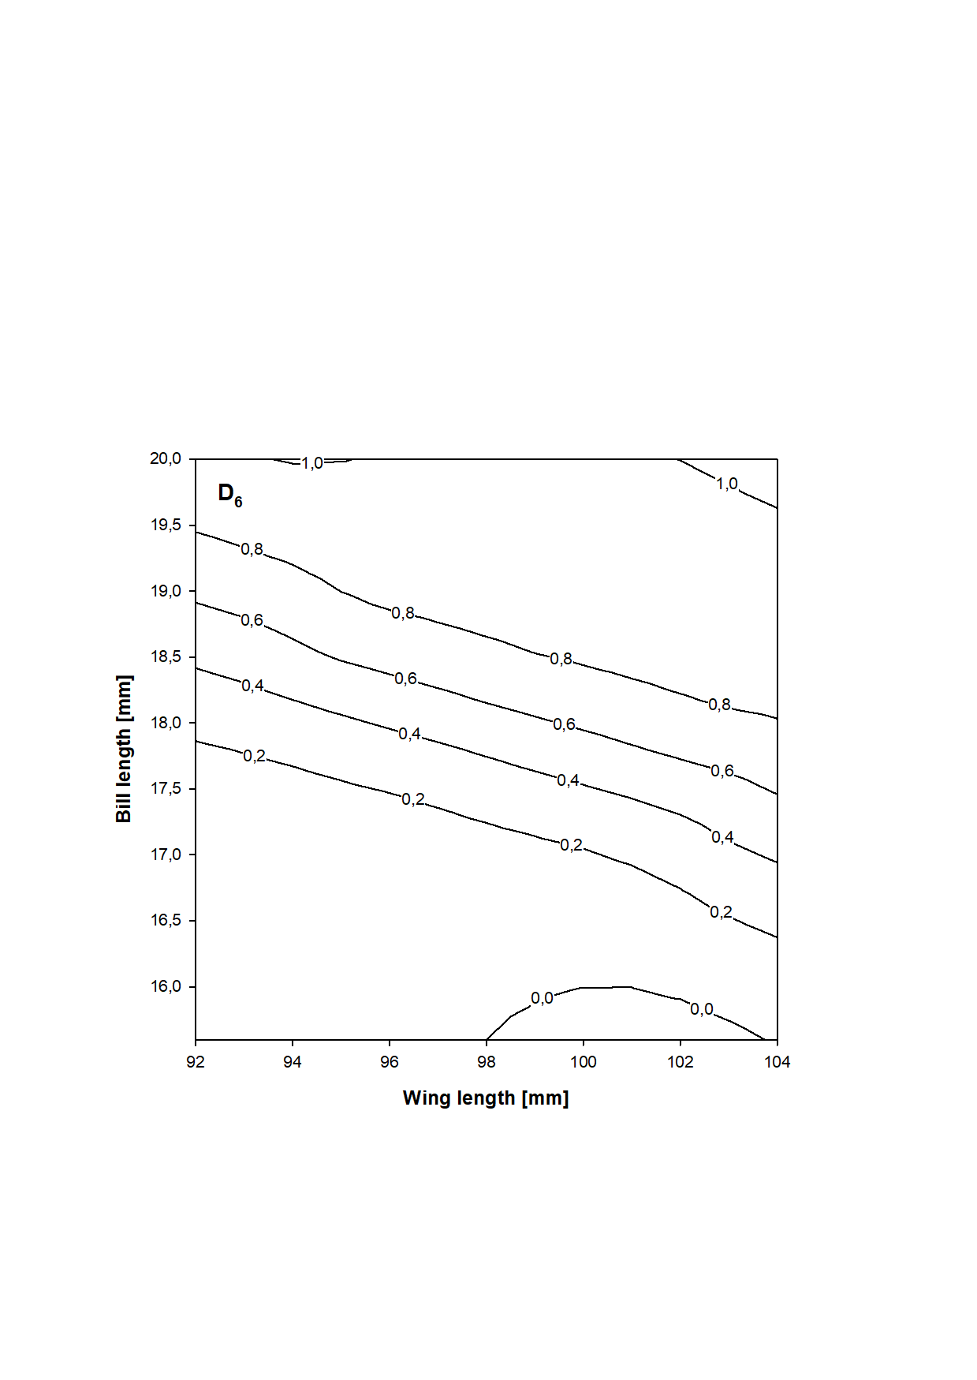

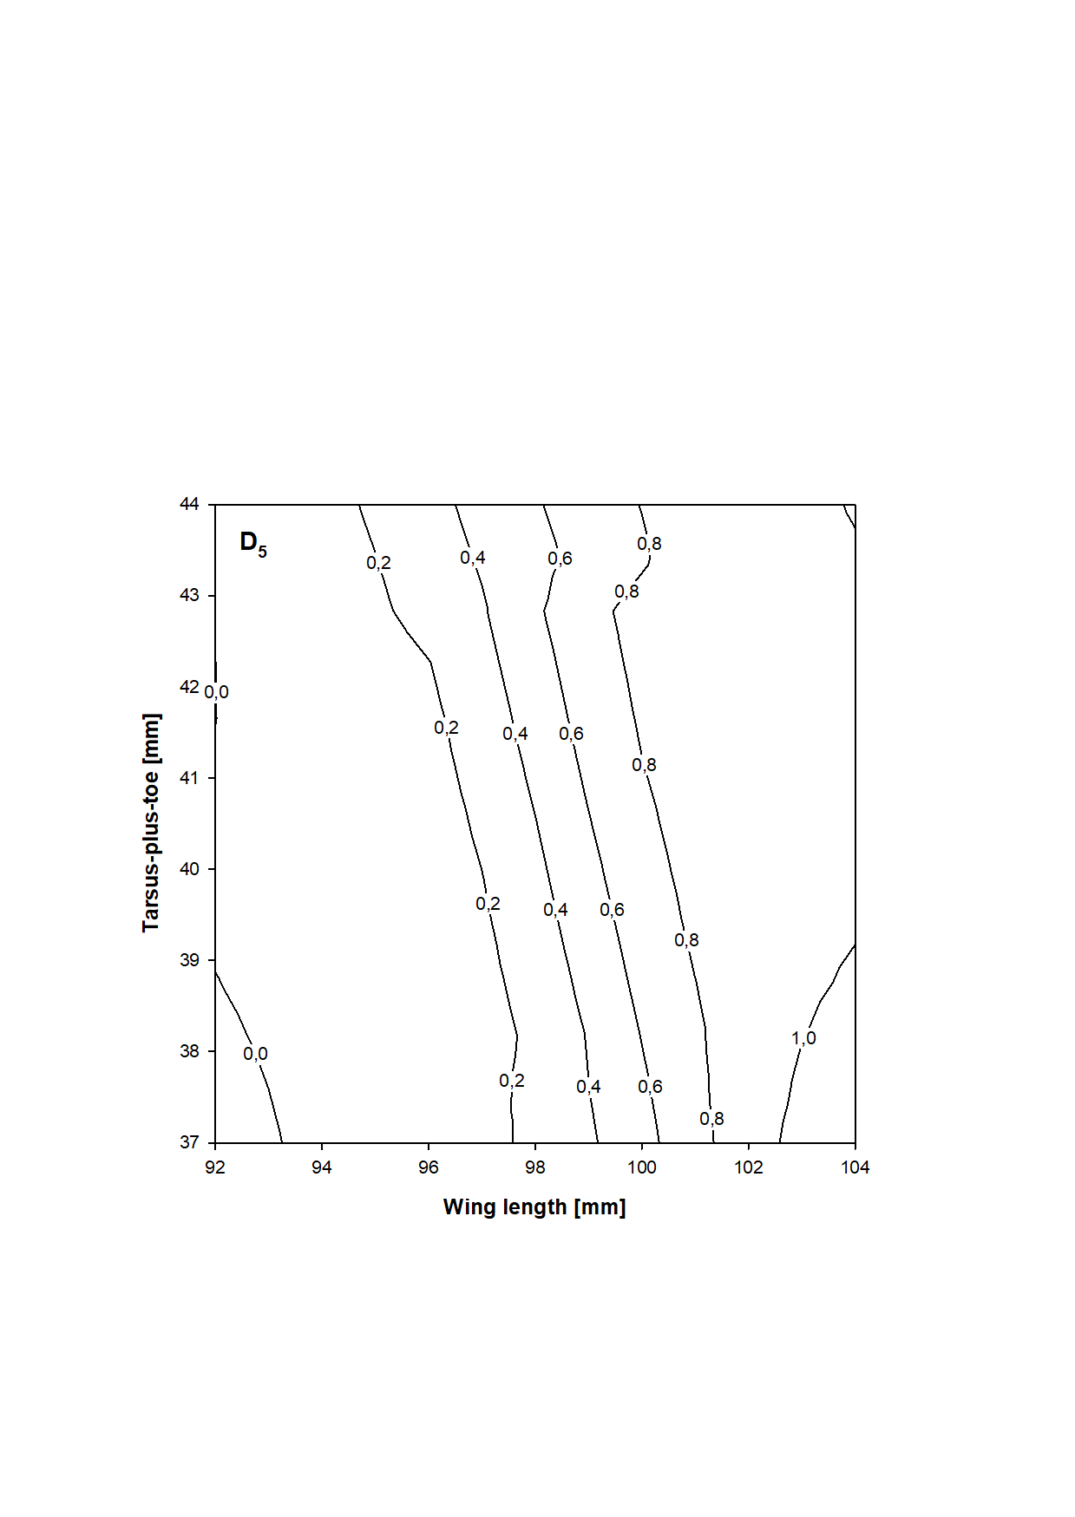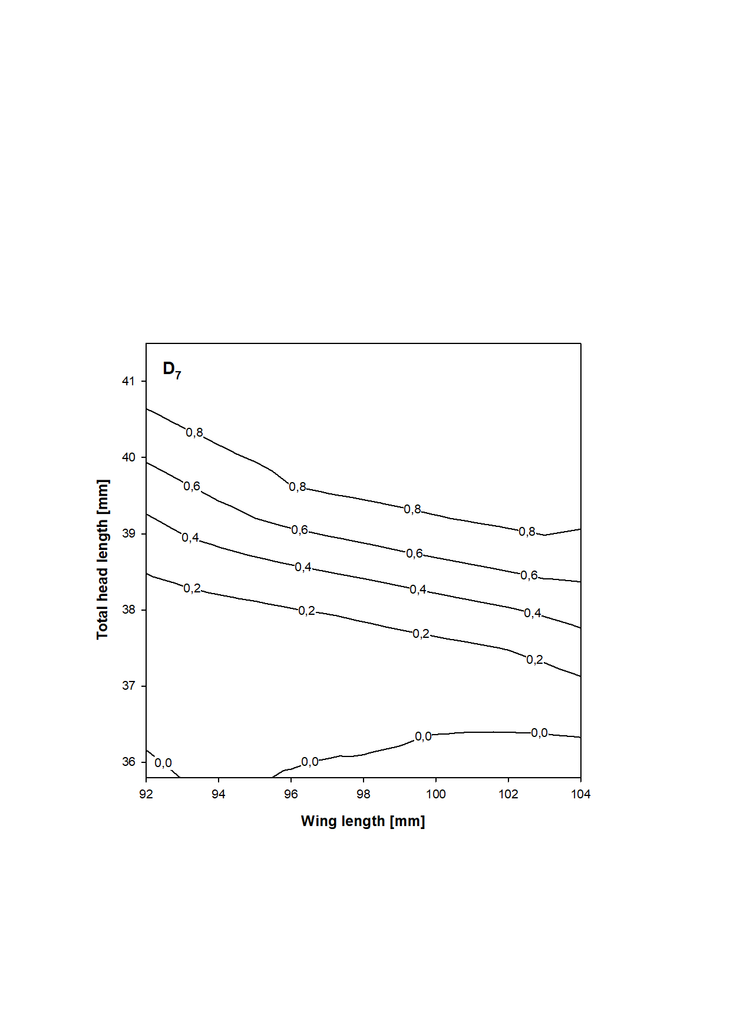

**Figure S1** Probability of being a female (lines and values show the upper limits) in relation to the combination of discriminating morphometric features according to additional discriminant functions (D5, D6, D7) for Little Stints before primary moult.

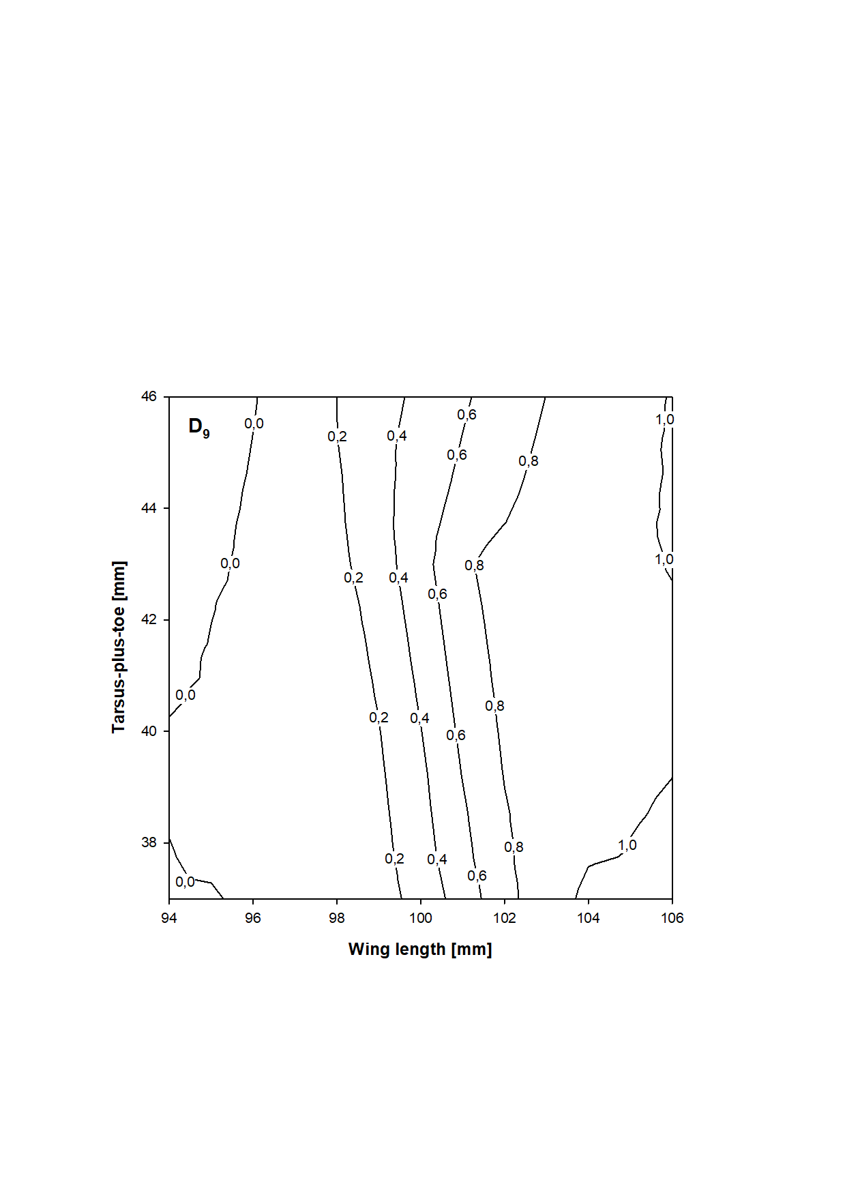

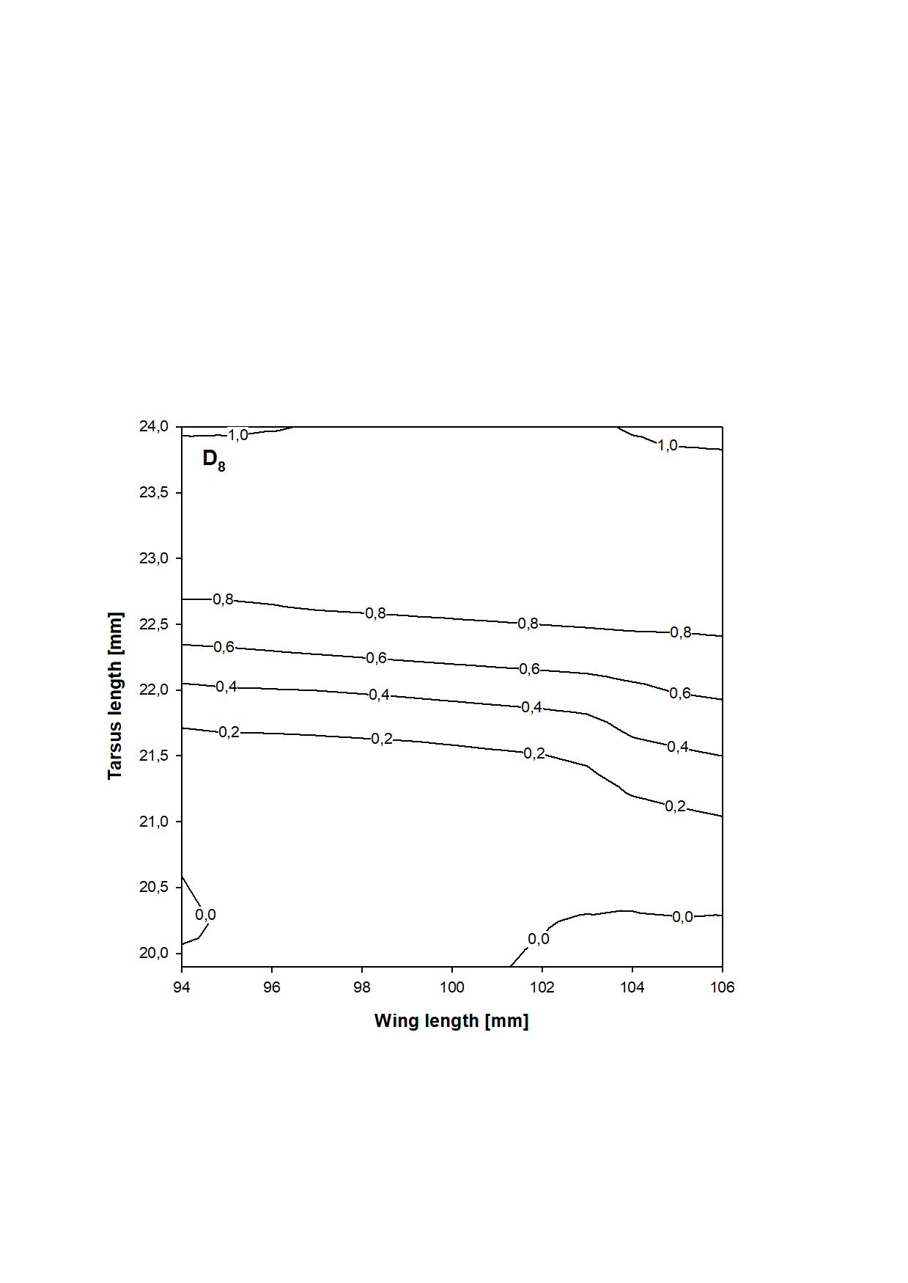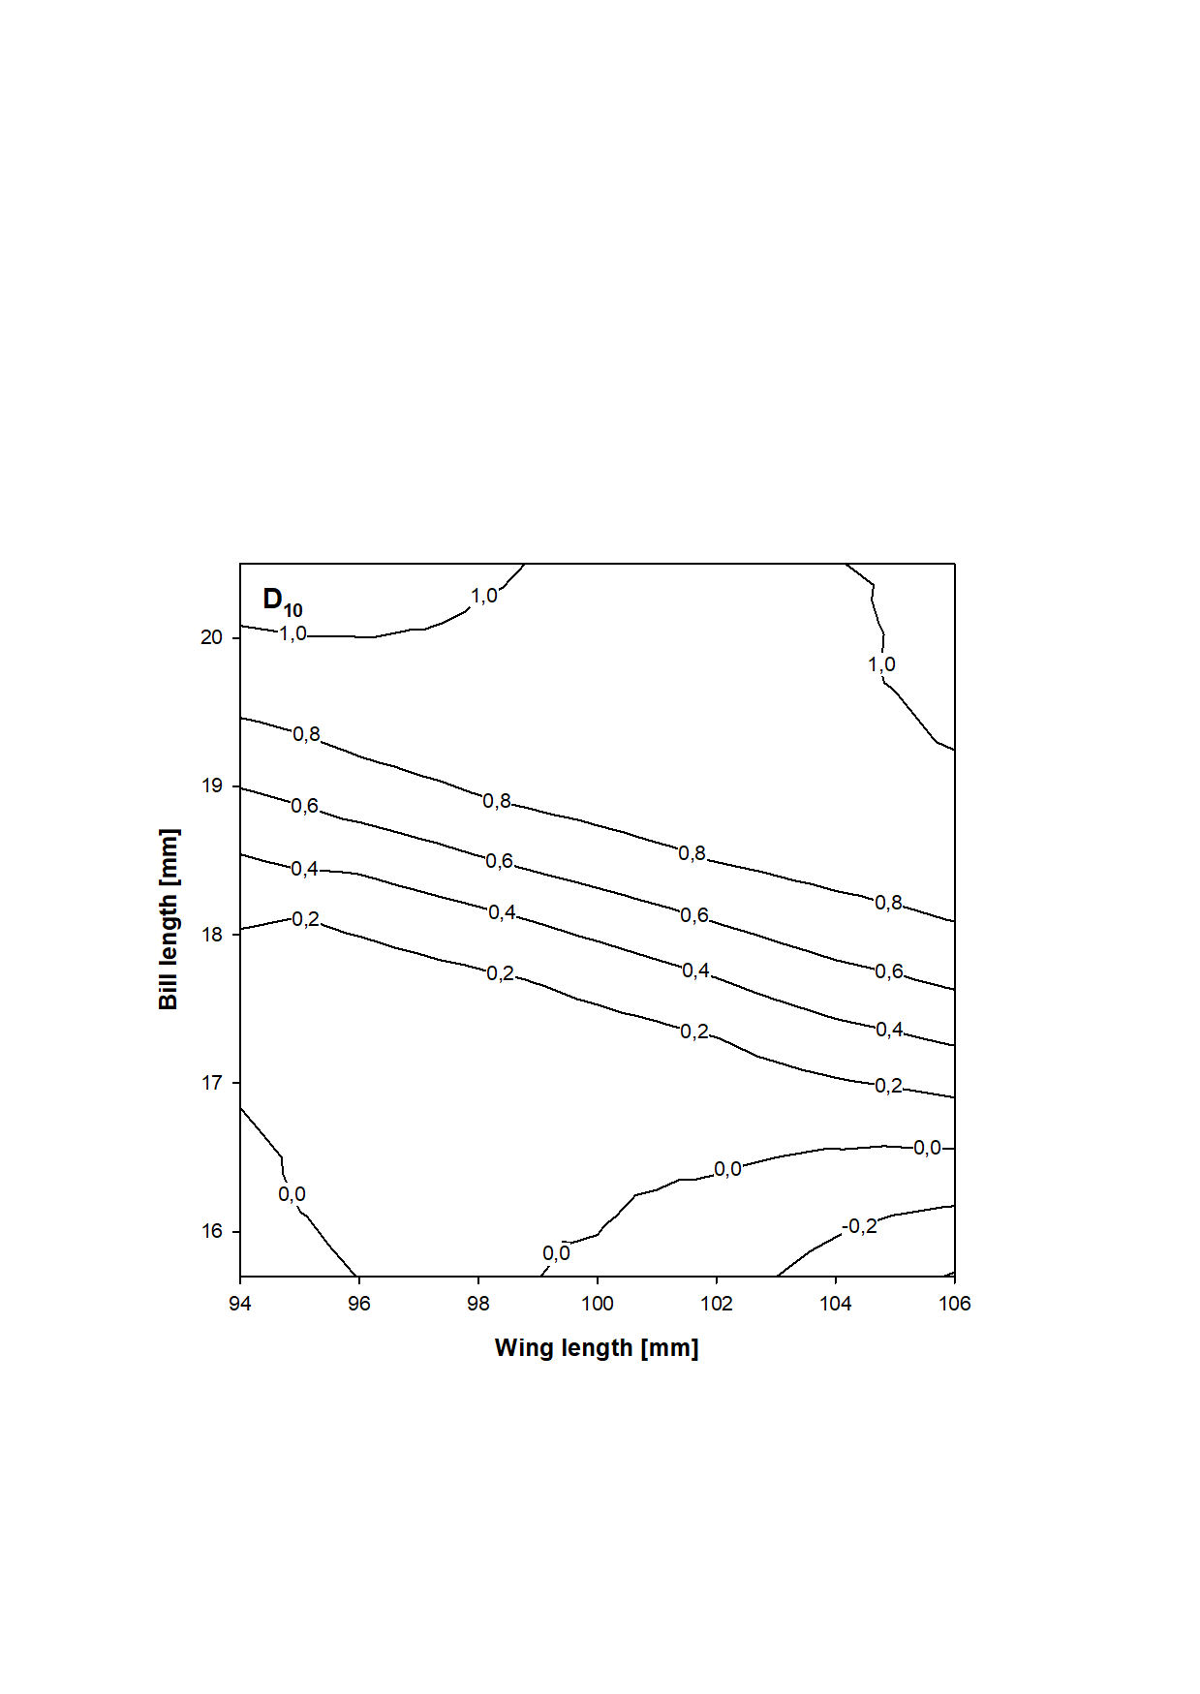

**Figure S2** Probability of being a female (lines and values show the upper limits) in relation to the combination of discriminating morphometric features according to additional discriminant functions (D8, D9, D10) for Little Stints after primary moult.