Supplementary Information

De novo oviduct transcriptome of the moor frog Rana arvalis: a quest for maternal effect candidate genes
Longfei Shu*¹, Jie Qiu² and Katja Räsänen¹
Affiliations:
¹Eawag, Department of Aquatic Ecology, Switzerland and ETH Zürich, Institute of Integrative Biology, Switzerland
²Institutue of Crop Science & Institute of Bioinformatics, College of Agriculture and Biotechnology, Zhejiang University, Hangzhou 310058, China

Corresponding author:
Dr. Longfei Shu
Eawag, Department of Aquatic Ecology, Switzerland and ETH Zürich, Institute of Integrative Biology, CH-8600 Dübendorf, Switzerland;
Email: longfei.shu@wustl.edu; Phone: +1-314-445-8037.

*Current address: Department of Biology, Washington University in St. Louis, St. Louis, MO 63130, USA

List of supplementary materials

Figure S1. Statistics of SSR classification from R. arvalis transcriptome based on oviduct samples from seven individuals
Figure S2. Statistics of SNP numbers in seven cDNA libraries
Figure S3. Differential expression analysis among three populations
Table S1. Distribution of SSRs in the R. arvalis oviduct transcriptome
Table S2. KEGG annotation of R. arvalis oviduct transcriptome
Tables S3-S5. Enrichment of KEGG pathway in the differentially expressed unigenes between population pairs
SI2. List of unigenes that are significantly correlated with embryonic acid tolerance
SI3. List of unigenes with SNP differentiation between the S and T population

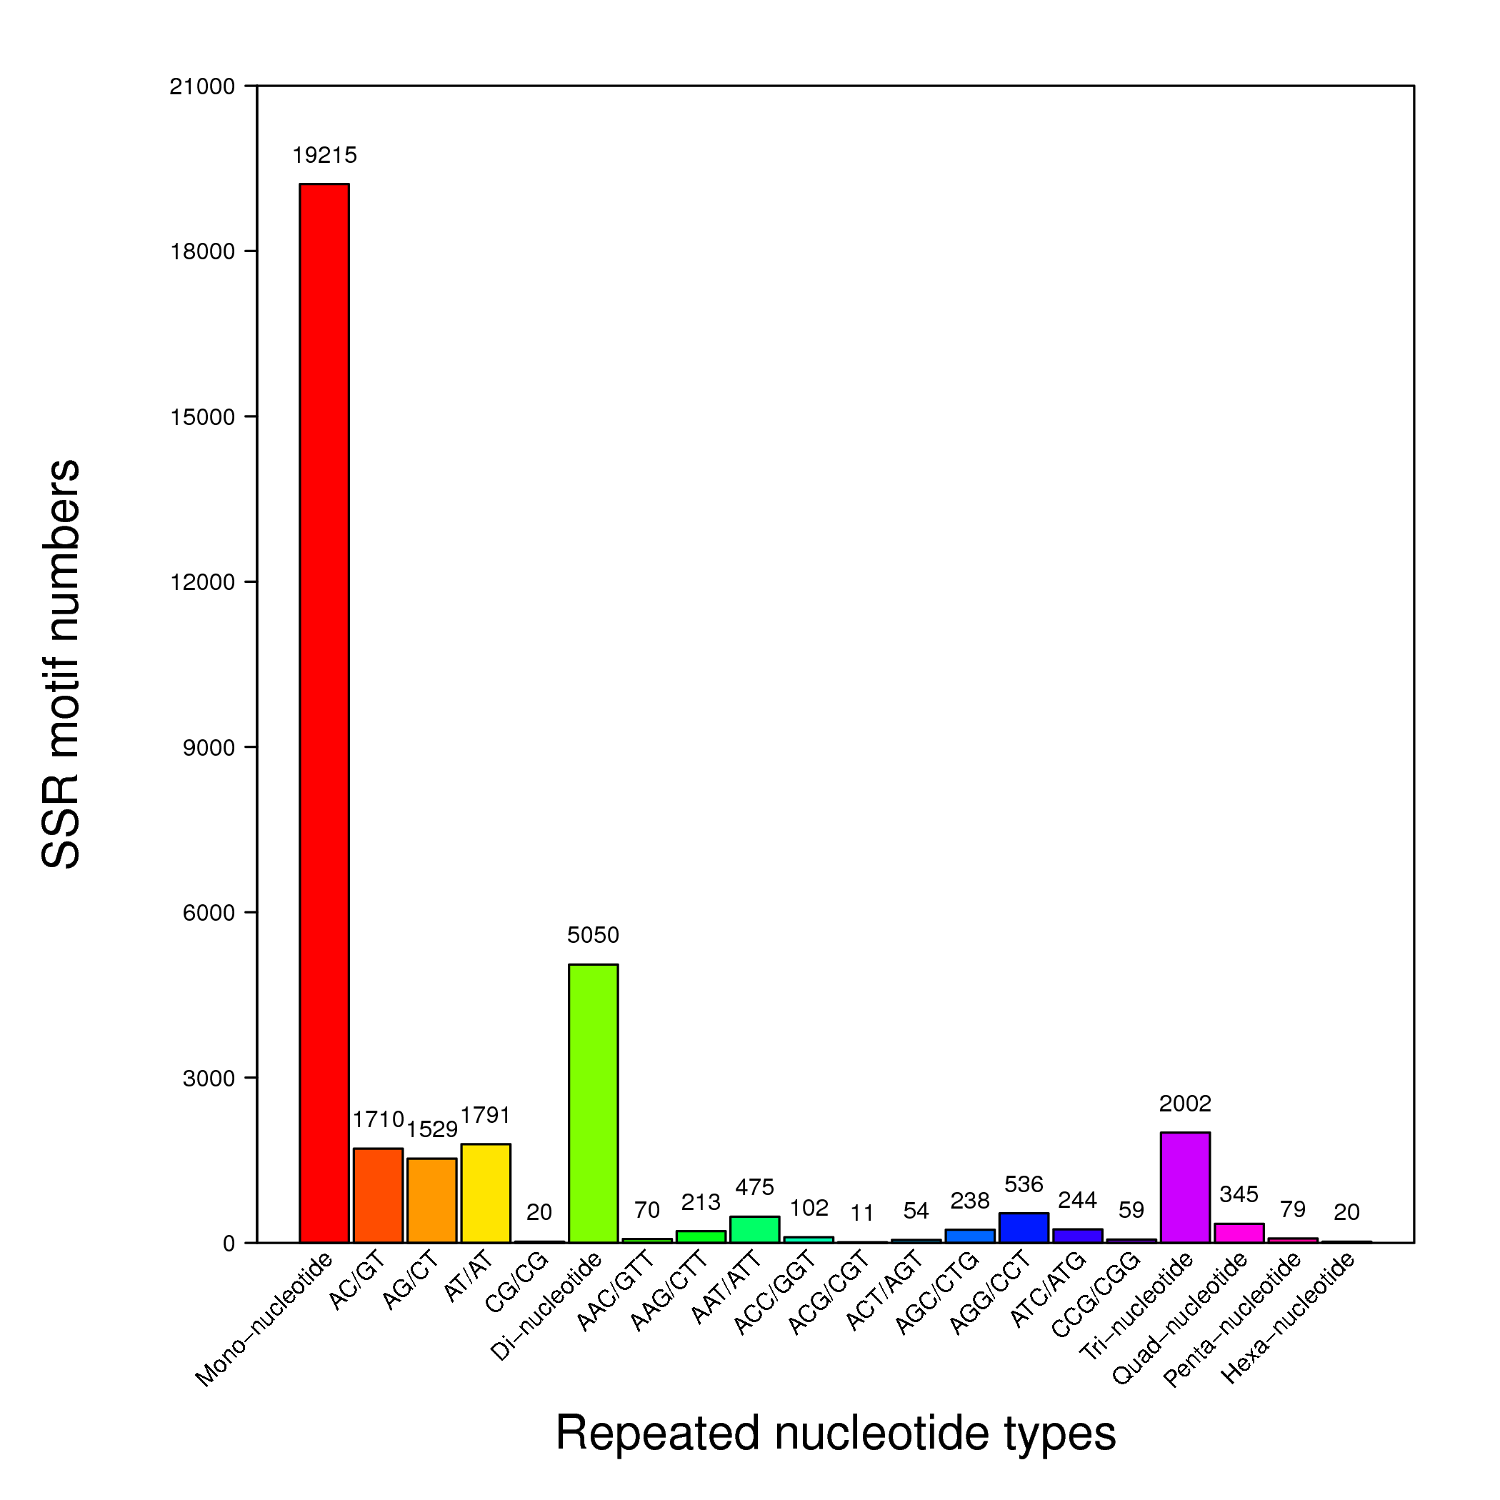
Figure S1 Statistics of SSR classification from R. arvalis transcriptome based on oviduct samples from seven individuals. Among Mono-nucleotide repeats, (A/T)n was the most abundant motif. Among Di-nucleotide repeats, the most abundant repeats were (AC/GT)n, (AG/CT)n and (AT/AT)n. Among Tri-nucleotide motifs, the most abundant repeats were (AAT/ATT)n and (AGG/CCT)n. Among Quad-nucleotide motifs, the most abundant repeats were (AGAT/ATCT)n and (AAAG/CTTT)n. Among Penta-nucleotide motifs, the most abundant repeats were (AGAGG/CCTCT)n and (AAAAT/ATTTT)n. Among Hexa-nucleotide motifs, the most abundant repeats were (AAAAAT/ATTTTT)n and (AGGGGC/CCCCTG)n. After filtration, 8 073 high-quality primer pairs amplifying a single product were obtained.

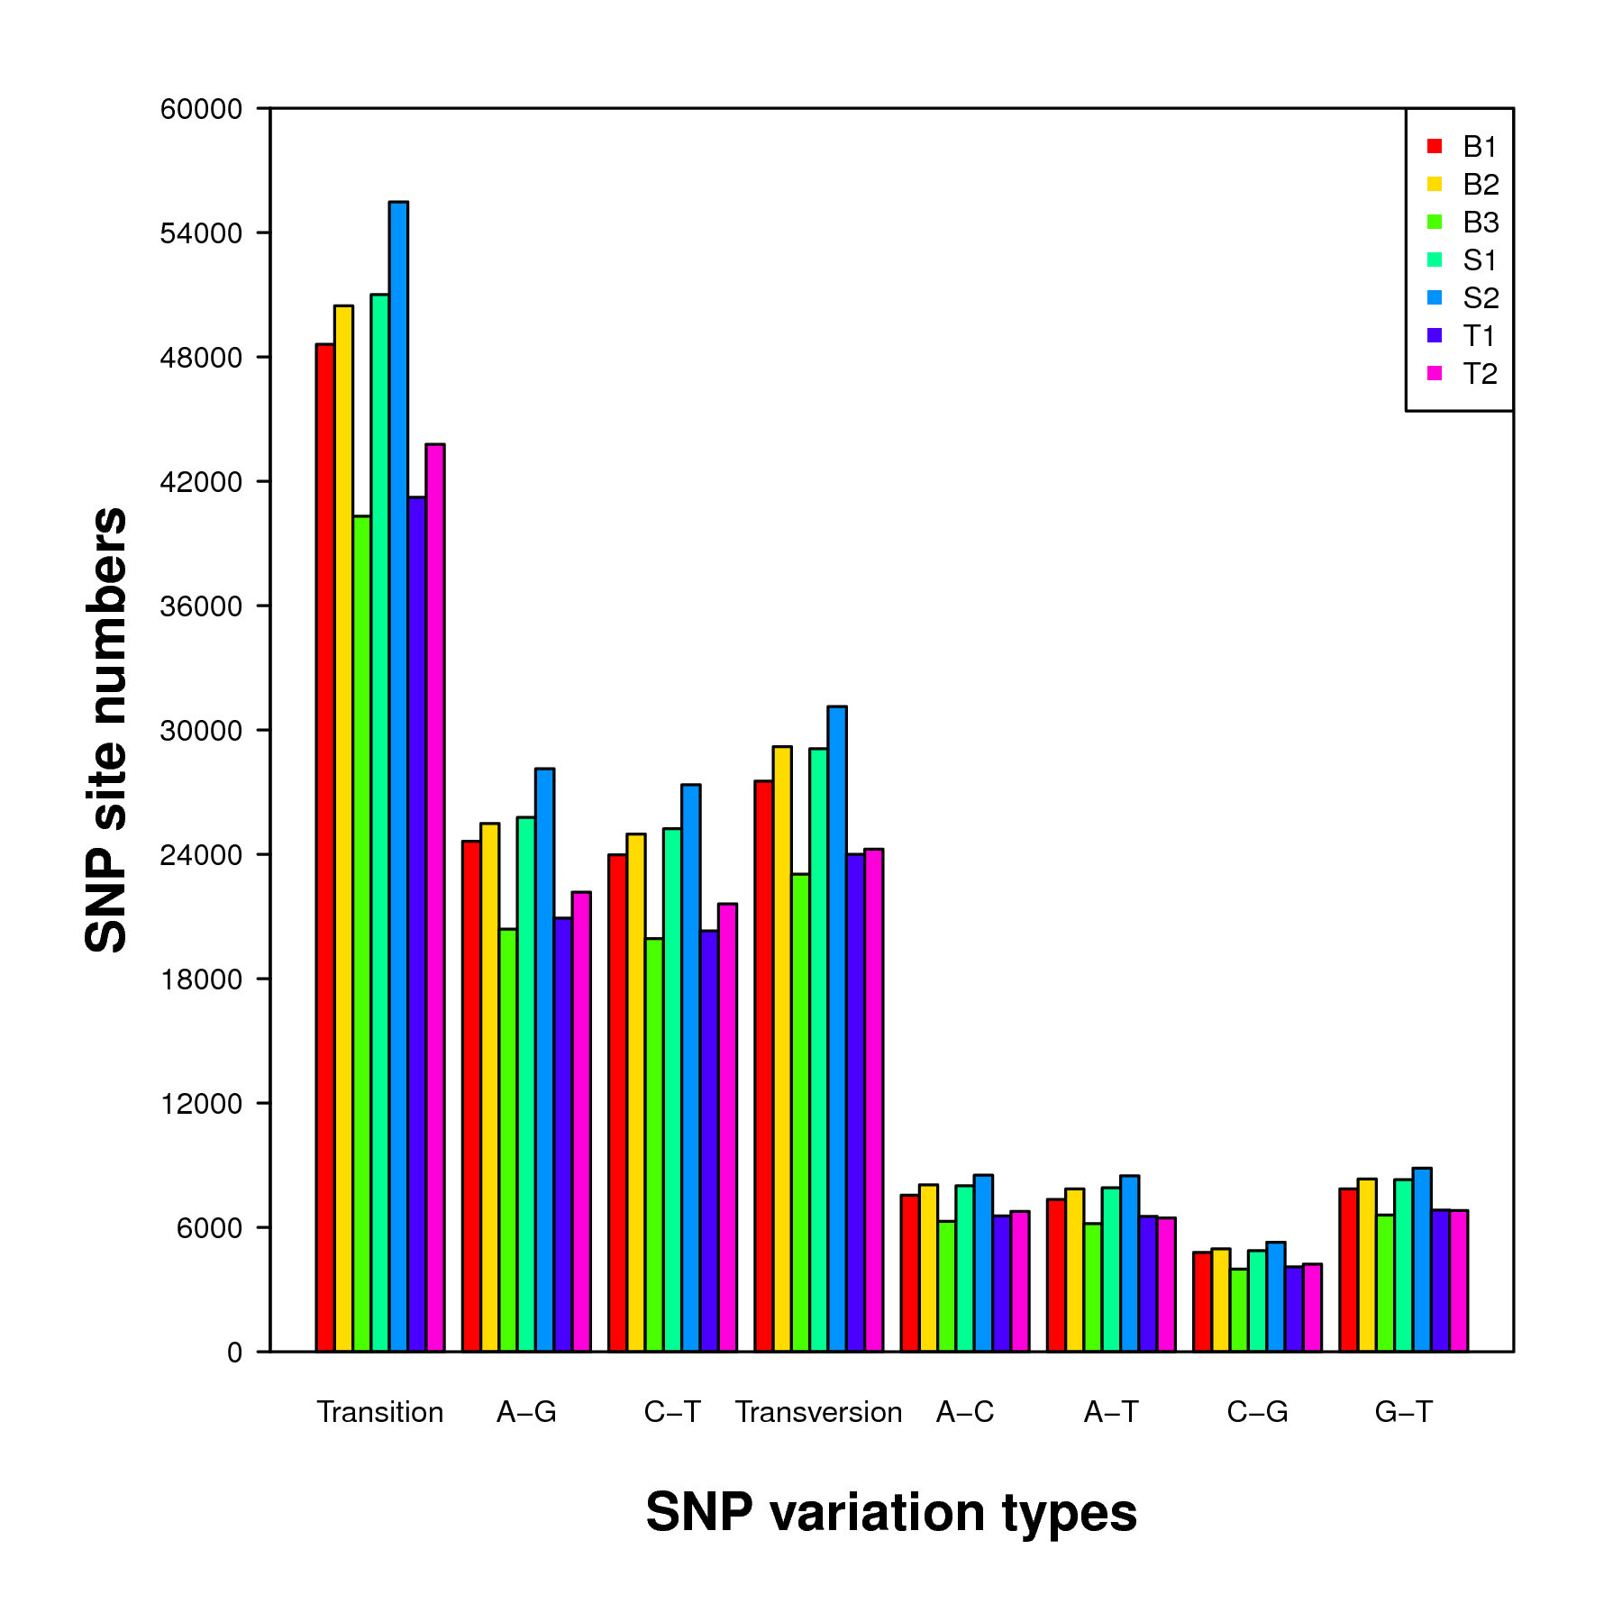
Figure S2 Statistics of SNP numbers in seven cDNA libraries. The X-axis indicates the SNP types, the Y-axis the number of SNPs for a given type. The colors indicate individual females from different populations (acid origin population, T, neutral origin population, S, and intermediate pH population, B). The numbers 1 to 3 indicate the individual identity of the females.

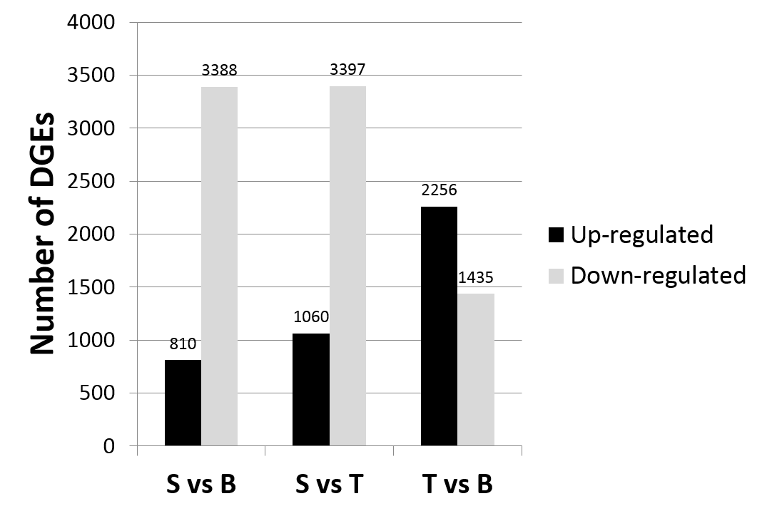
Figure S3 Differential expression analysis among three populations. The X-axis indicates group comparisons, the Y-axis the number of DGEs.

Table S1. Distribution of SSRs in the R. arvalis oviduct transcriptome based on seven individuals.
Number of repeats | Mono-nucleotide repeats | Di-nucleotide repeats | Tri-nucleotide repeats | Quad-nucleotide repeat | Penta-nucleotide repeats | Hexa-nucleotide repeats
4 | 0 | 0 | 0 | 0 | 69 | 20
5 | 0 | 0 | 1,180 | 292 | 10 | 0
6 | 0 | 2,048 | 472 | 50 | 0 | 0
7 | 0 | 1,068 | 286 | 1 | 0 | 0
8 | 0 | 645 | 60 | 1 | 0 | 0
9 | 0 | 467 | 3 | 1 | 0 | 0
10 | 0 | 456 | 1 | 0 | 0 | 0
11 | 0 | 348 | 0 | 0 | 0 | 0
12 | 5,141 | 16 | 0 | 0 | 0 | 0
13 | 3,858 | 1 | 0 | 0 | 0 | 0
14 | 2,742 | 0 | 0 | 0 | 0 | 0
15 | 2,105 | 0 | 0 | 0 | 0 | 0
16 | 1,488 | 0 | 0 | 0 | 0 | 0
17 | 977 | 0 | 0 | 0 | 0 | 0
18 | 826 | 0 | 0 | 0 | 0 | 0
19 | 750 | 0 | 0 | 0 | 0 | 0
20 | 702 | 0 | 0 | 0 | 0 | 0
21 | 397 | 1 | 0 | 0 | 0 | 0
22 | 172 | 0 | 0 | 0 | 0 | 0
23 | 53 | 0 | 0 | 0 | 0 | 0
24 | 4 | 0 | 0 | 0 | 0 | 0
Sub Total | 19,215 | 5,050 | 2,002 | 345 | 79 | 20

Table S2. KEGG annonation of R. arvalis oviduct transcriptome.
Pathway | All genes with pathway annotation (31405) | Pathway ID | Level 1
Metabolic pathways | 3796 (12.09%) | ko01100 | Metabolism
Purine metabolism | 1910 (6.08%) | ko00230 | Metabolism
Huntington's disease | 1612 (5.13%) | ko05016 | Human Diseases
Pathways in cancer | 1405 (4.47%) | ko05200 | Human Diseases
Regulation of actin cytoskeleton | 1202 (3.83%) | ko04810 | Cellular Processes
Focal adhesion | 1161 (3.7%) | ko04510 | Cellular Processes
Calcium signaling pathway | 1159 (3.69%) | ko04020 | Environmental Information Processing
Influenza A | 1121 (3.57%) | ko05164 | Human Diseases
Lysine degradation | 1120 (3.57%) | ko00310 | Metabolism
Ubiquitin mediated proteolysis | 1097 (3.49%) | ko04120 | Genetic Information Processing
Morphine addiction | 1081 (3.44%) | ko05032 | Human Diseases
Herpes simplex infection | 1077 (3.43%) | ko05168 | Human Diseases
Epstein-Barr virus infection | 1058 (3.37%) | ko05169 | Human Diseases
Fc gamma R-mediated phagocytosis | 1051 (3.35%) | ko04666 | Organismal Systems
T cell receptor signaling pathway | 967 (3.08%) | ko04660 | Organismal Systems
Protein processing in endoplasmic reticulum | 950 (3.02%) | ko04141 | Genetic Information Processing
Spliceosome | 910 (2.9%) | ko03040 | Genetic Information Processing
Cell adhesion molecules (CAMs) | 886 (2.82%) | ko04514 | Environmental Information Processing
Olfactory transduction | 886 (2.82%) | ko04740 | Organismal Systems
Tight junction | 859 (2.74%) | ko04530 | Cellular Processes
Endocytosis | 852 (2.71%) | ko04144 | Cellular Processes
MAPK signaling pathway | 797 (2.54%) | ko04010 | Environmental Information Processing
RNA transport | 792 (2.52%) | ko03013 | Genetic Information Processing
Taste transduction | 790 (2.52%) | ko04742 | Organismal Systems
Pyrimidine metabolism | 773 (2.46%) | ko00240 | Metabolism
Vascular smooth muscle contraction | 763 (2.43%) | ko04270 | Organismal Systems
Alzheimer's disease | 753 (2.4%) | ko05010 | Human Diseases
Primary immunodeficiency | 729 (2.32%) | ko05340 | Human Diseases
HTLV-I infection | 683 (2.17%) | ko05166 | Human Diseases
Hepatitis C | 646 (2.06%) | ko05160 | Human Diseases
Amoebiasis | 639 (2.03%) | ko05146 | Human Diseases
Ribosome biogenesis in eukaryotes | 636 (2.03%) | ko03008 | Genetic Information Processing
Insulin signaling pathway | 634 (2.02%) | ko04910 | Organismal Systems
Measles | 629 (2%) | ko05162 | Human Diseases
Transcriptional misregulation in cancer | 615 (1.96%) | ko05202 | Human Diseases
Salmonella infection | 614 (1.96%) | ko05132 | Human Diseases
Phagosome | 575 (1.83%) | ko04145 | Cellular Processes
Chemokine signaling pathway | 571 (1.82%) | ko04062 | Organismal Systems
NF-kappa B signaling pathway | 570 (1.81%) | ko04064 | Environmental Information Processing
Dilated cardiomyopathy | 566 (1.8%) | ko05414 | Human Diseases
Tuberculosis | 563 (1.79%) | ko05152 | Human Diseases
Adherens junction | 561 (1.79%) | ko04520 | Cellular Processes
RNA polymerase | 546 (1.74%) | ko03020 | Genetic Information Processing
Wnt signaling pathway | 544 (1.73%) | ko04310 | Environmental Information Processing
Hypertrophic cardiomyopathy (HCM) | 528 (1.68%) | ko05410 | Human Diseases
Bile secretion | 498 (1.59%) | ko04976 | Organismal Systems
Lysosome | 493 (1.57%) | ko04142 | Cellular Processes
ECM-receptor interaction | 484 (1.54%) | ko04512 | Environmental Information Processing
Neurotrophin signaling pathway | 476 (1.52%) | ko04722 | Organismal Systems
Viral myocarditis | 475 (1.51%) | ko05416 | Human Diseases
mRNA surveillance pathway | 461 (1.47%) | ko03015 | Genetic Information Processing
Pathogenic Escherichia coli infection | 458 (1.46%) | ko05130 | Human Diseases
Axon guidance | 456 (1.45%) | ko04360 | Organismal Systems
Osteoclast differentiation | 440 (1.4%) | ko04380 | Organismal Systems
Leukocyte transendothelial migration | 438 (1.39%) | ko04670 | Organismal Systems
Vibrio cholerae infection | 438 (1.39%) | ko05110 | Human Diseases
Hedgehog signaling pathway | 434 (1.38%) | ko04340 | Environmental Information Processing
Basal cell carcinoma | 430 (1.37%) | ko05217 | Human Diseases
B cell receptor signaling pathway | 429 (1.37%) | ko04662 | Organismal Systems
ABC transporters | 425 (1.35%) | ko02010 | Environmental Information Processing
Prostate cancer | 414 (1.32%) | ko05215 | Human Diseases
Steroid hormone biosynthesis | 412 (1.31%) | ko00140 | Metabolism
Bacterial invasion of epithelial cells | 411 (1.31%) | ko05100 | Human Diseases
RIG-I-like receptor signaling pathway | 405 (1.29%) | ko04622 | Organismal Systems
Cardiac muscle contraction | 400 (1.27%) | ko04260 | Organismal Systems
Toxoplasmosis | 391 (1.25%) | ko05145 | Human Diseases
Dopaminergic synapse | 389 (1.24%) | ko04728 | Organismal Systems
Cell cycle | 388 (1.24%) | ko04110 | Cellular Processes
Oocyte meiosis | 381 (1.21%) | ko04114 | Cellular Processes
Alcoholism | 380 (1.21%) | ko05034 | Human Diseases
Primary bile acid biosynthesis | 368 (1.17%) | ko00120 | Metabolism
Shigellosis | 362 (1.15%) | ko05131 | Human Diseases
Small cell lung cancer | 359 (1.14%) | ko05222 | Human Diseases
Natural killer cell mediated cytotoxicity | 354 (1.13%) | ko04650 | Organismal Systems
Long-term potentiation | 353 (1.12%) | ko04720 | Organismal Systems
Basal transcription factors | 352 (1.12%) | ko03022 | Genetic Information Processing
Neuroactive ligand-receptor interaction | 350 (1.11%) | ko04080 | Environmental Information Processing
Progesterone-mediated oocyte maturation | 350 (1.11%) | ko04914 | Organismal Systems
Serotonergic synapse | 348 (1.11%) | ko04726 | Organismal Systems
ErbB signaling pathway | 329 (1.05%) | ko04012 | Environmental Information Processing
Protein digestion and absorption | 327 (1.04%) | ko04974 | Organismal Systems
Salivary secretion | 327 (1.04%) | ko04970 | Organismal Systems
Gastric acid secretion | 315 (1%) | ko04971 | Organismal Systems
Oxidative phosphorylation | 311 (0.99%) | ko00190 | Metabolism
Parkinson's disease | 310 (0.99%) | ko05012 | Human Diseases
Vasopressin-regulated water reabsorption | 310 (0.99%) | ko04962 | Organismal Systems
Melanogenesis | 308 (0.98%) | ko04916 | Organismal Systems
Chronic myeloid leukemia | 308 (0.98%) | ko05220 | Human Diseases
Amyotrophic lateral sclerosis (ALS) | 305 (0.97%) | ko05014 | Human Diseases
Starch and sucrose metabolism | 304 (0.97%) | ko00500 | Metabolism
Renal cell carcinoma | 302 (0.96%) | ko05211 | Human Diseases
GnRH signaling pathway | 299 (0.95%) | ko04912 | Organismal Systems
Phosphatidylinositol signaling system | 298 (0.95%) | ko04070 | Environmental Information Processing
TGF-beta signaling pathway | 292 (0.93%) | ko04350 | Environmental Information Processing
NOD-like receptor signaling pathway | 291 (0.93%) | ko04621 | Organismal Systems
Hematopoietic cell lineage | 288 (0.92%) | ko04640 | Organismal Systems
RNA degradation | 286 (0.91%) | ko03018 | Genetic Information Processing
mTOR signaling pathway | 285 (0.91%) | ko04150 | Environmental Information Processing
Endometrial cancer | 285 (0.91%) | ko05213 | Human Diseases
Gap junction | 284 (0.9%) | ko04540 | Cellular Processes
Amino sugar and nucleotide sugar metabolism | 283 (0.9%) | ko00520 | Metabolism
Maturity onset diabetes of the young | 281 (0.89%) | ko04950 | Human Diseases
Chagas disease (American trypanosomiasis) | 280 (0.89%) | ko05142 | Human Diseases
Jak-STAT signaling pathway | 275 (0.88%) | ko04630 | Environmental Information Processing
Pancreatic cancer | 271 (0.86%) | ko05212 | Human Diseases
Glioma | 269 (0.86%) | ko05214 | Human Diseases
Pancreatic secretion | 260 (0.83%) | ko04972 | Organismal Systems
Apoptosis | 260 (0.83%) | ko04210 | Cellular Processes
Colorectal cancer | 258 (0.82%) | ko05210 | Human Diseases
Acute myeloid leukemia | 255 (0.81%) | ko05221 | Human Diseases
Arrhythmogenic right ventricular cardiomyopathy (ARVC) | 255 (0.81%) | ko05412 | Human Diseases
Ribosome | 254 (0.81%) | ko03010 | Genetic Information Processing
Pertussis | 244 (0.78%) | ko05133 | Human Diseases
Fc epsilon RI signaling pathway | 244 (0.78%) | ko04664 | Organismal Systems
Notch signaling pathway | 243 (0.77%) | ko04330 | Environmental Information Processing
Peroxisome | 241 (0.77%) | ko04146 | Cellular Processes
VEGF signaling pathway | 240 (0.76%) | ko04370 | Environmental Information Processing
Cholinergic synapse | 236 (0.75%) | ko04725 | Organismal Systems
Cytokine-cytokine receptor interaction | 236 (0.75%) | ko04060 | Environmental Information Processing
Non-small cell lung cancer | 235 (0.75%) | ko05223 | Human Diseases
Long-term depression | 232 (0.74%) | ko04730 | Organismal Systems
Glutamatergic synapse | 231 (0.74%) | ko04724 | Organismal Systems
PPAR signaling pathway | 230 (0.73%) | ko03320 | Organismal Systems
Glycolysis / Gluconeogenesis | 229 (0.73%) | ko00010 | Metabolism
Inositol phosphate metabolism | 224 (0.71%) | ko00562 | Metabolism
Adipocytokine signaling pathway | 224 (0.71%) | ko04920 | Organismal Systems
Glycerophospholipid metabolism | 216 (0.69%) | ko00564 | Metabolism
Complement and coagulation cascades | 214 (0.68%) | ko04610 | Organismal Systems
Carbohydrate digestion and absorption | 207 (0.66%) | ko04973 | Organismal Systems
Synaptic vesicle cycle | 205 (0.65%) | ko04721 | Organismal Systems
Melanoma | 204 (0.65%) | ko05218 | Human Diseases
Legionellosis | 203 (0.65%) | ko05134 | Human Diseases
Toll-like receptor signaling pathway | 202 (0.64%) | ko04620 | Organismal Systems
Amphetamine addiction | 201 (0.64%) | ko05031 | Human Diseases
Antigen processing and presentation | 194 (0.62%) | ko04612 | Organismal Systems
Epithelial cell signaling in Helicobacter pylori infection | 187 (0.6%) | ko05120 | Human Diseases
Thyroid cancer | 182 (0.58%) | ko05216 | Human Diseases
Metabolism of xenobiotics by cytochrome P450 | 181 (0.58%) | ko00980 | Metabolism
p53 signaling pathway | 179 (0.57%) | ko04115 | Cellular Processes
Fanconi anemia pathway | 179 (0.57%) | ko03460 | Genetic Information Processing
Valine, leucine and isoleucine degradation | 177 (0.56%) | ko00280 | Metabolism
Retinol metabolism | 172 (0.55%) | ko00830 | Metabolism
Pentose and glucuronate interconversions | 170 (0.54%) | ko00040 | Metabolism
Retrograde endocannabinoid signaling | 168 (0.53%) | ko04723 | Organismal Systems
Arachidonic acid metabolism | 166 (0.53%) | ko00590 | Metabolism
Staphylococcus aureus infection | 165 (0.53%) | ko05150 | Human Diseases
Galactose metabolism | 163 (0.52%) | ko00052 | Metabolism
N-Glycan biosynthesis | 163 (0.52%) | ko00510 | Metabolism
Dorso-ventral axis formation | 162 (0.52%) | ko04320 | Organismal Systems
Prion diseases | 162 (0.52%) | ko05020 | Human Diseases
Drug metabolism - cytochrome P450 | 161 (0.51%) | ko00982 | Metabolism
Bladder cancer | 161 (0.51%) | ko05219 | Human Diseases
Arginine and proline metabolism | 160 (0.51%) | ko00330 | Metabolism
Type II diabetes mellitus | 159 (0.51%) | ko04930 | Human Diseases
Fatty acid metabolism | 158 (0.5%) | ko00071 | Metabolism
Leishmaniasis | 158 (0.5%) | ko05140 | Human Diseases
GABAergic synapse | 157 (0.5%) | ko04727 | Organismal Systems
Endocrine and other factor-regulated calcium reabsorption | 154 (0.49%) | ko04961 | Organismal Systems
Rheumatoid arthritis | 154 (0.49%) | ko05323 | Human Diseases
Aminoacyl-tRNA biosynthesis | 154 (0.49%) | ko00970 | Genetic Information Processing
Cytosolic DNA-sensing pathway | 152 (0.48%) | ko04623 | Organismal Systems
Nucleotide excision repair | 151 (0.48%) | ko03420 | Genetic Information Processing
Pyruvate metabolism | 149 (0.47%) | ko00620 | Metabolism
Systemic lupus erythematosus | 143 (0.46%) | ko05322 | Human Diseases
Fructose and mannose metabolism | 139 (0.44%) | ko00051 | Metabolism
Mineral absorption | 138 (0.44%) | ko04978 | Organismal Systems
Drug metabolism - other enzymes | 138 (0.44%) | ko00983 | Metabolism
Citrate cycle (TCA cycle) | 134 (0.43%) | ko00020 | Metabolism
Propanoate metabolism | 132 (0.42%) | ko00640 | Metabolism
Cysteine and methionine metabolism | 130 (0.41%) | ko00270 | Metabolism
Ascorbate and aldarate metabolism | 130 (0.41%) | ko00053 | Metabolism
Aldosterone-regulated sodium reabsorption | 127 (0.4%) | ko04960 | Organismal Systems
Phototransduction - fly | 125 (0.4%) | ko04745 | Organismal Systems
Phototransduction | 124 (0.39%) | ko04744 | Organismal Systems
Glycerolipid metabolism | 122 (0.39%) | ko00561 | Metabolism
Glutathione metabolism | 120 (0.38%) | ko00480 | Metabolism
Cocaine addiction | 114 (0.36%) | ko05030 | Human Diseases
Sphingolipid metabolism | 114 (0.36%) | ko00600 | Metabolism
DNA replication | 110 (0.35%) | ko03030 | Genetic Information Processing
Tryptophan metabolism | 109 (0.35%) | ko00380 | Metabolism
Proteasome | 109 (0.35%) | ko03050 | Genetic Information Processing
Other types of O-glycan biosynthesis | 108 (0.34%) | ko00514 | Metabolism
Glycine, serine and threonine metabolism | 107 (0.34%) | ko00260 | Metabolism
Ether lipid metabolism | 107 (0.34%) | ko00565 | Metabolism
Tyrosine metabolism | 106 (0.34%) | ko00350 | Metabolism
Linoleic acid metabolism | 105 (0.33%) | ko00591 | Metabolism
Base excision repair | 102 (0.32%) | ko03410 | Genetic Information Processing
Malaria | 97 (0.31%) | ko05144 | Human Diseases
beta-Alanine metabolism | 96 (0.31%) | ko00410 | Metabolism
Pentose phosphate pathway | 94 (0.3%) | ko00030 | Metabolism
African trypanosomiasis | 92 (0.29%) | ko05143 | Human Diseases
Nicotinate and nicotinamide metabolism | 92 (0.29%) | ko00760 | Metabolism
Alanine, aspartate and glutamate metabolism | 91 (0.29%) | ko00250 | Metabolism
Glycosaminoglycan biosynthesis - heparan sulfate | 89 (0.28%) | ko00534 | Metabolism
Homologous recombination | 88 (0.28%) | ko03440 | Genetic Information Processing
Glyoxylate and dicarboxylate metabolism | 86 (0.27%) | ko00630 | Metabolism
Circadian rhythm - mammal | 84 (0.27%) | ko04710 | Organismal Systems
Porphyrin and chlorophyll metabolism | 82 (0.26%) | ko00860 | Metabolism
Butanoate metabolism | 82 (0.26%) | ko00650 | Metabolism
Autoimmune thyroid disease | 81 (0.26%) | ko05320 | Human Diseases
MAPK signaling pathway - fly | 78 (0.25%) | ko04013 | Environmental Information Processing
Histidine metabolism | 78 (0.25%) | ko00340 | Metabolism
Allograft rejection | 77 (0.25%) | ko05330 | Human Diseases
SNARE interactions in vesicular transport | 76 (0.24%) | ko04130 | Genetic Information Processing
Fat digestion and absorption | 75 (0.24%) | ko04975 | Organismal Systems
Mismatch repair | 74 (0.24%) | ko03430 | Genetic Information Processing
Vitamin digestion and absorption | 73 (0.23%) | ko04977 | Organismal Systems
Collecting duct acid secretion | 73 (0.23%) | ko04966 | Organismal Systems
Glycosylphosphatidylinositol(GPI)-anchor biosynthesis | 73 (0.23%) | ko00563 | Metabolism
Protein export | 72 (0.23%) | ko03060 | Genetic Information Processing
Graft-versus-host disease | 69 (0.22%) | ko05332 | Human Diseases
Type I diabetes mellitus | 69 (0.22%) | ko04940 | Human Diseases
Terpenoid backbone biosynthesis | 66 (0.21%) | ko00900 | Metabolism
Biosynthesis of unsaturated fatty acids | 65 (0.21%) | ko01040 | Metabolism
Regulation of autophagy | 63 (0.2%) | ko04140 | Cellular Processes
Fatty acid elongation | 63 (0.2%) | ko00062 | Metabolism
Mucin type O-Glycan biosynthesis | 58 (0.18%) | ko00512 | Metabolism
Proximal tubule bicarbonate reclamation | 58 (0.18%) | ko04964 | Organismal Systems
Other glycan degradation | 57 (0.18%) | ko00511 | Metabolism
Glycosaminoglycan degradation | 55 (0.18%) | ko00531 | Metabolism
Phenylalanine metabolism | 54 (0.17%) | ko00360 | Metabolism
Intestinal immune network for IgA production | 54 (0.17%) | ko04672 | Organismal Systems
Glycosphingolipid biosynthesis - lacto and neolacto series | 52 (0.17%) | ko00601 | Metabolism
Selenocompound metabolism | 49 (0.16%) | ko00450 | Metabolism
Ubiquinone and other terpenoid-quinone biosynthesis | 46 (0.15%) | ko00130 | Metabolism
Non-homologous end-joining | 46 (0.15%) | ko03450 | Genetic Information Processing
Steroid biosynthesis | 45 (0.14%) | ko00100 | Metabolism
Glycosphingolipid biosynthesis - ganglio series | 44 (0.14%) | ko00604 | Metabolism
Pantothenate and CoA biosynthesis | 43 (0.14%) | ko00770 | Metabolism
Circadian rhythm - fly | 42 (0.13%) | ko04711 | Organismal Systems
alpha-Linolenic acid metabolism | 40 (0.13%) | ko00592 | Metabolism
Butirosin and neomycin biosynthesis | 39 (0.12%) | ko00524 | Metabolism
Glycosaminoglycan biosynthesis - keratan sulfate | 38 (0.12%) | ko00533 | Metabolism
Sulfur relay system | 38 (0.12%) | ko04122 | Genetic Information Processing
One carbon pool by folate | 37 (0.12%) | ko00670 | Metabolism
Glycosaminoglycan biosynthesis - chondroitin sulfate | 35 (0.11%) | ko00532 | Metabolism
Riboflavin metabolism | 34 (0.11%) | ko00740 | Metabolism
Glycosphingolipid biosynthesis - globo series | 34 (0.11%) | ko00603 | Metabolism
Caffeine metabolism | 32 (0.1%) | ko00232 | Metabolism
Asthma | 32 (0.1%) | ko05310 | Human Diseases
Renin-angiotensin system | 31 (0.1%) | ko04614 | Organismal Systems
Folate biosynthesis | 29 (0.09%) | ko00790 | Metabolism
Sulfur metabolism | 29 (0.09%) | ko00920 | Metabolism
Fatty acid biosynthesis | 24 (0.08%) | ko00061 | Metabolism
Synthesis and degradation of ketone bodies | 23 (0.07%) | ko00072 | Metabolism
Cyanoamino acid metabolism | 17 (0.05%) | ko00460 | Metabolism
Taurine and hypotaurine metabolism | 16 (0.05%) | ko00430 | Metabolism
Vitamin B6 metabolism | 14 (0.04%) | ko00750 | Metabolism
Nicotine addiction | 13 (0.04%) | ko05033 | Human Diseases
Phenylalanine, tyrosine and tryptophan biosynthesis | 13 (0.04%) | ko00400 | Metabolism
D-Arginine and D-ornithine metabolism | 11 (0.04%) | ko00472 | Metabolism
Valine, leucine and isoleucine biosynthesis | 11 (0.04%) | ko00290 | Metabolism
Thiamine metabolism | 10 (0.03%) | ko00730 | Metabolism
Lipoic acid metabolism | 6 (0.02%) | ko00785 | Metabolism
Biotin metabolism | 6 (0.02%) | ko00780 | Metabolism
D-Glutamine and D-glutamate metabolism | 5 (0.02%) | ko00471 | Metabolism
Insect hormone biosynthesis | 4 (0.01%) | ko00981 | Metabolism
Polyketide sugar unit biosynthesis | 2 (0.01%) | ko00523 | Metabolism
Lysine biosynthesis | 2 (0.01%) | ko00300 | Metabolism

Table S3 Enrichment of KEGG pathway in the differentially expressed unigenes between S and B populations.
Pathway | DEGs with pathway annotation (1717) | All genes with pathway annotation (31405) | Pvalue | Qvalue | Pathway ID
Ribosome | 87 (5.07%) | 254 (0.81%) | 0.000 | 0.000 | ko03010
Oxidative phosphorylation | 82 (4.78%) | 311 (0.99%) | 0.000 | 0.000 | ko00190
Parkinson's disease | 74 (4.31%) | 310 (0.99%) | 0.000 | 0.000 | ko05012
Proteasome | 44 (2.56%) | 109 (0.35%) | 0.000 | 0.000 | ko03050
Metabolic pathways | 313 (18.23%) | 3796 (12.09%) | 0.000 | 0.000 | ko01100
Alzheimer's disease | 88 (5.13%) | 753 (2.4%) | 0.000 | 0.000 | ko05010
Lysosome | 66 (3.84%) | 493 (1.57%) | 0.000 | 0.000 | ko04142
Phototransduction - fly | 28 (1.63%) | 125 (0.4%) | 0.000 | 0.000 | ko04745
Phagosome | 70 (4.08%) | 575 (1.83%) | 0.000 | 0.000 | ko04145
Vibrio cholerae infection | 57 (3.32%) | 438 (1.39%) | 0.000 | 0.000 | ko05110
Antigen processing and presentation | 34 (1.98%) | 194 (0.62%) | 0.000 | 0.000 | ko04612
Pathogenic Escherichia coli infection | 56 (3.26%) | 458 (1.46%) | 0.000 | 0.000 | ko05130
Glycolysis / Gluconeogenesis | 34 (1.98%) | 229 (0.73%) | 0.000 | 0.000 | ko00010
Citrate cycle (TCA cycle) | 24 (1.4%) | 134 (0.43%) | 0.000 | 0.000 | ko00020
Protein processing in endoplasmic reticulum | 87 (5.07%) | 950 (3.02%) | 0.000 | 0.000 | ko04141
Protein export | 15 (0.87%) | 72 (0.23%) | 0.000 | 0.000 | ko03060
Gastric acid secretion | 36 (2.1%) | 315 (1%) | 0.000 | 0.000 | ko04971
Collecting duct acid secretion | 14 (0.82%) | 73 (0.23%) | 0.000 | 0.000 | ko04966
Amphetamine addiction | 26 (1.51%) | 201 (0.64%) | 0.000 | 0.001 | ko05031
Alcoholism | 40 (2.33%) | 380 (1.21%) | 0.000 | 0.001 | ko05034
N-Glycan biosynthesis | 22 (1.28%) | 163 (0.52%) | 0.000 | 0.001 | ko00510
Spliceosome | 76 (4.43%) | 910 (2.9%) | 0.000 | 0.002 | ko03040
Pentose phosphate pathway | 15 (0.87%) | 94 (0.3%) | 0.000 | 0.002 | ko00030
Pyruvate metabolism | 20 (1.16%) | 149 (0.47%) | 0.000 | 0.002 | ko00620
Oocyte meiosis | 38 (2.21%) | 381 (1.21%) | 0.000 | 0.003 | ko04114
Rheumatoid arthritis | 20 (1.16%) | 154 (0.49%) | 0.000 | 0.003 | ko05323
Systemic lupus erythematosus | 19 (1.11%) | 143 (0.46%) | 0.000 | 0.003 | ko05322
Huntington's disease | 118 (6.87%) | 1612 (5.13%) | 0.001 | 0.007 | ko05016
Aminoacyl-tRNA biosynthesis | 19 (1.11%) | 154 (0.49%) | 0.001 | 0.007 | ko00970
Other types of O-glycan biosynthesis | 15 (0.87%) | 108 (0.34%) | 0.001 | 0.007 | ko00514
Synaptic vesicle cycle | 23 (1.34%) | 205 (0.65%) | 0.001 | 0.007 | ko04721
Galactose metabolism | 19 (1.11%) | 163 (0.52%) | 0.002 | 0.012 | ko00052
PPAR signaling pathway | 24 (1.4%) | 230 (0.73%) | 0.002 | 0.014 | ko03320
Gap junction | 28 (1.63%) | 284 (0.9%) | 0.002 | 0.014 | ko04540
Glutathione metabolism | 15 (0.87%) | 120 (0.38%) | 0.002 | 0.016 | ko00480
Propanoate metabolism | 16 (0.93%) | 132 (0.42%) | 0.002 | 0.016 | ko00640
Fat digestion and absorption | 11 (0.64%) | 75 (0.24%) | 0.002 | 0.016 | ko04975
Cardiac muscle contraction | 36 (2.1%) | 400 (1.27%) | 0.002 | 0.016 | ko04260
Insulin signaling pathway | 52 (3.03%) | 634 (2.02%) | 0.002 | 0.016 | ko04910
Phototransduction | 15 (0.87%) | 124 (0.39%) | 0.003 | 0.020 | ko04744
Vasopressin-regulated water reabsorption | 29 (1.69%) | 310 (0.99%) | 0.004 | 0.022 | ko04962
Tryptophan metabolism | 13 (0.76%) | 109 (0.35%) | 0.007 | 0.039 | ko00380
Long-term potentiation | 31 (1.81%) | 353 (1.12%) | 0.007 | 0.039 | ko04720
Arginine and proline metabolism | 17 (0.99%) | 160 (0.51%) | 0.007 | 0.039 | ko00330
Legionellosis | 20 (1.16%) | 203 (0.65%) | 0.008 | 0.045 | ko05134
Valine, leucine and isoleucine degradation | 18 (1.05%) | 177 (0.56%) | 0.008 | 0.046 | ko00280
Pancreatic secretion | 24 (1.4%) | 260 (0.83%) | 0.009 | 0.047 | ko04972
Glycosaminoglycan biosynthesis - heparan sulfate | 11 (0.64%) | 89 (0.28%) | 0.009 | 0.048 | ko00534
Starch and sucrose metabolism | 27 (1.57%) | 304 (0.97%) | 0.009 | 0.048 | ko00500

Table S4 Enrichment of KEGG pathway in the differentially expressed unigenes between S and T populations.
Pathway | DEGs with pathway annotation (1529) | All genes with pathway annotation (31405) | Pvalue | Qvalue | Pathway ID
Ribosome | 87 (5.69%) | 254 (0.81%) | 0.000 | 0.000 | ko03010
Oxidative phosphorylation | 73 (4.77%) | 311 (0.99%) | 0.000 | 0.000 | ko00190
Parkinson's disease | 68 (4.45%) | 310 (0.99%) | 0.000 | 0.000 | ko05012
Proteasome | 41 (2.68%) | 109 (0.35%) | 0.000 | 0.000 | ko03050
Alzheimer's disease | 82 (5.36%) | 753 (2.4%) | 0.000 | 0.000 | ko05010
Antigen processing and presentation | 35 (2.29%) | 194 (0.62%) | 0.000 | 0.000 | ko04612
Lysosome | 60 (3.92%) | 493 (1.57%) | 0.000 | 0.000 | ko04142
Pathogenic Escherichia coli infection | 54 (3.53%) | 458 (1.46%) | 0.000 | 0.000 | ko05130
Vibrio cholerae infection | 52 (3.4%) | 438 (1.39%) | 0.000 | 0.000 | ko05110
Metabolic pathways | 260 (17%) | 3796 (12.09%) | 0.000 | 0.000 | ko01100
Phagosome | 61 (3.99%) | 575 (1.83%) | 0.000 | 0.000 | ko04145
Phototransduction - fly | 21 (1.37%) | 125 (0.4%) | 0.000 | 0.000 | ko04745
Glycolysis / Gluconeogenesis | 27 (1.77%) | 229 (0.73%) | 0.000 | 0.000 | ko00010
Citrate cycle (TCA cycle) | 19 (1.24%) | 134 (0.43%) | 0.000 | 0.000 | ko00020
Protein processing in endoplasmic reticulum | 75 (4.91%) | 950 (3.02%) | 0.000 | 0.000 | ko04141
Protein export | 13 (0.85%) | 72 (0.23%) | 0.000 | 0.001 | ko03060
Collecting duct acid secretion | 13 (0.85%) | 73 (0.23%) | 0.000 | 0.001 | ko04966
Huntington's disease | 110 (7.19%) | 1612 (5.13%) | 0.000 | 0.003 | ko05016
Glutathione metabolism | 16 (1.05%) | 120 (0.38%) | 0.000 | 0.003 | ko00480
Alcoholism | 35 (2.29%) | 380 (1.21%) | 0.000 | 0.003 | ko05034
Fat digestion and absorption | 12 (0.78%) | 75 (0.24%) | 0.000 | 0.003 | ko04975
Amphetamine addiction | 22 (1.44%) | 201 (0.64%) | 0.000 | 0.004 | ko05031
N-Glycan biosynthesis | 18 (1.18%) | 163 (0.52%) | 0.001 | 0.011 | ko00510
Cardiac muscle contraction | 34 (2.22%) | 400 (1.27%) | 0.001 | 0.013 | ko04260
Spliceosome | 65 (4.25%) | 910 (2.9%) | 0.001 | 0.014 | ko03040
Proximal tubule bicarbonate reclamation | 9 (0.59%) | 58 (0.18%) | 0.002 | 0.018 | ko04964
Arginine and proline metabolism | 17 (1.11%) | 160 (0.51%) | 0.002 | 0.019 | ko00330
Pyruvate metabolism | 16 (1.05%) | 149 (0.47%) | 0.003 | 0.022 | ko00620
Phototransduction | 14 (0.92%) | 124 (0.39%) | 0.003 | 0.025 | ko04744
Gastric acid secretion | 27 (1.77%) | 315 (1%) | 0.003 | 0.027 | ko04971
Rheumatoid arthritis | 16 (1.05%) | 154 (0.49%) | 0.004 | 0.028 | ko05323
Glycosaminoglycan biosynthesis - heparan sulfate | 11 (0.72%) | 89 (0.28%) | 0.004 | 0.030 | ko00534
Systemic lupus erythematosus | 15 (0.98%) | 143 (0.46%) | 0.004 | 0.032 | ko05322
Insulin signaling pathway | 46 (3.01%) | 634 (2.02%) | 0.005 | 0.035 | ko04910
Legionellosis | 19 (1.24%) | 203 (0.65%) | 0.005 | 0.035 | ko05134
Synaptic vesicle cycle | 19 (1.24%) | 205 (0.65%) | 0.006 | 0.038 | ko04721
Arachidonic acid metabolism | 16 (1.05%) | 166 (0.53%) | 0.007 | 0.048 | ko00590

Table S5 Enrichment of KEGG pathway in the differentially expressed unigenes between T and B populations.
Pathway | DEGs with pathway annotation (615) | All genes with pathway annotation (31405) | Pvalue | Qvalue | Pathway ID
Morphine addiction | 39 (6.34%) | 1081 (3.44%) | 0.000 | 0.030 | ko05032
Salivary secretion | 17 (2.76%) | 327 (1.04%) | 0.000 | 0.030 | ko04970

