Figure S1. Number of passes of white sharks (Carcharodon carcharias) during the 297 trials according to approach type and level of intent (white = low; grey = medium; black = high).

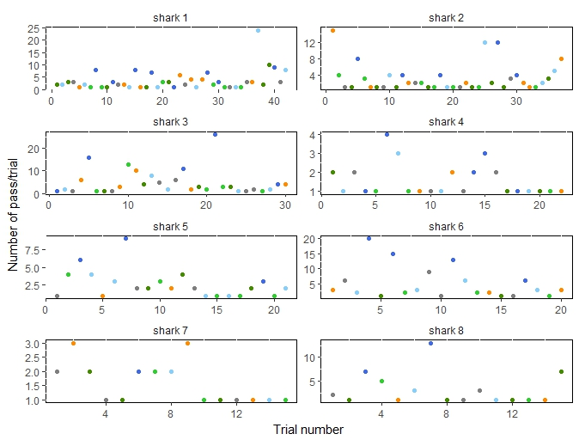
Figure S2. Number of passes during the 15-minute trials for the eight white sharks that interacted with the boards on 15 trials or more. Grey = control; orange = Chillax Wax; light green = magnet band; green = magnet leash; light blue = Rpela; blue = Shark Shield (Ocean Guardian) Freedom+ Surf.

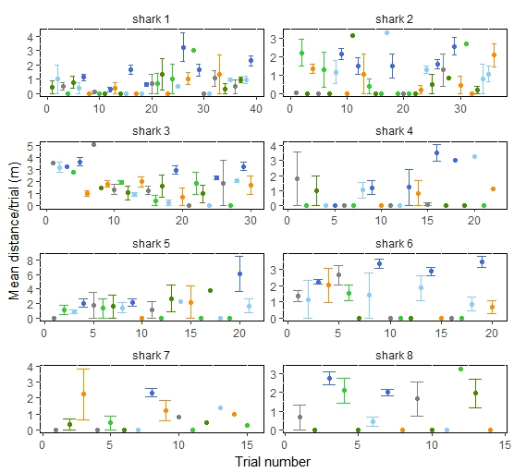
Figure S3. Mean distance between white shark and the bait for the eight sharks that interacted with the boards on 15 trials or more. Error bars represent standard errors. Grey = control; orange = Chillax Wax; light green = magnet band; green = magnet leash; light blue = Rpela; blue = Shark Shield (Ocean Guardian) Freedom+ Surf.

Table S1. Estimated deterrent level coefficients (β) and their standard errors (SE), z-values of factors included in the top-ranked model (indicated for each variable), and the individual coefficient Type I error estimate (P) when relevant.
Level | β | SE | z | P
Bait ~ deterrent
intercept | 3.061 | 1.013 | 3.02 | 0.003
Chillax Wax | -0.305 | 1.065 | -0.29 | 0.775
Magnet band | -1.855 | 1.036 | -1.79 | 0.073
Magnet leash | 0.628 | 1.236 | 0.51 | 0.612
Rpela | -1.337 | 1.047 | -1.28 | 0.202
Surf+ | -4.906 | 1.088 | -4.51 | < 0.001
Distance ~ deterrent
intercept | 3.181 | 0.032 | 98.34
Chillax Wax | -0.005 | 0.036 | -0.14
Magnet band | 0.003 | 0.034 | 0.09
Magnet leash | -0.014 | 0.039 | -0.37
Rpela | -0.046 | 0.034 | -1.38
Surf+ | 0.140 | 0.031 | 4.54
Passes ~ deterrent + trial
intercept | -0.408 | 0.056 | -7.35
Chillax Wax | 0.050 | 0.057 | 0.88
Magnet band | 0.009 | 0.056 | 0.15
Magnet leash | -0.034 | 0.057 | -0.60
Rpela | 0.032 | 0.058 | 0.55
Surf+ | 0.176 | 0.056 | 3.16
Trial | 0.002 | 0.001 | 1.64

