Figure S1. Specificity detection of primers for each candidate genes by melting curves.

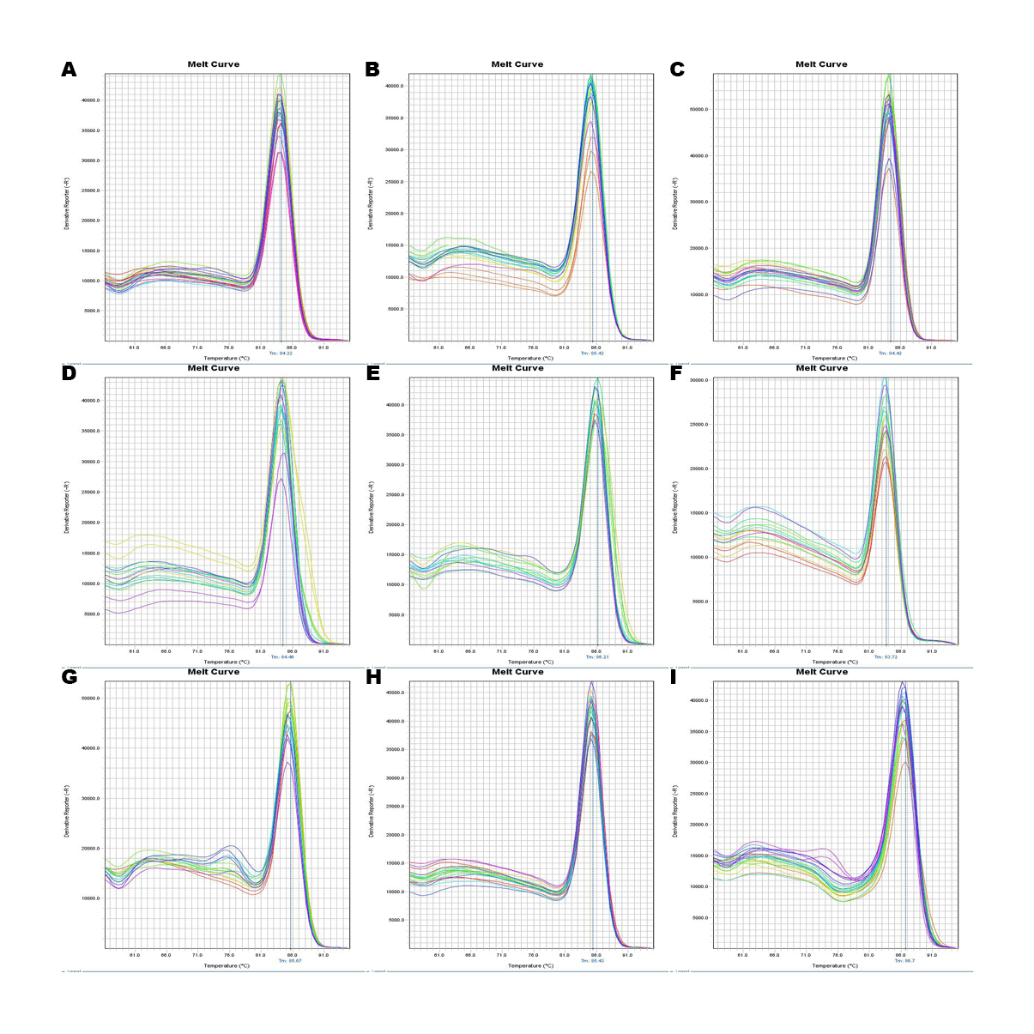
Dissociation curves of 9 candidate reference genes 18S rRNA (A); ACTB (B); B2M (C); EF1A (D); GAPDH (E); HRPT (F); RNAPol II (G); RPL7 (H); TUBA (I), reveal single peaks, which obtained from three technical replicates of different cDNA samples.

