Figure S2. 1.5 % agarose gel electrophoresis is exhibiting specific qRT-PCR products with expected size for each candidate reference gene.

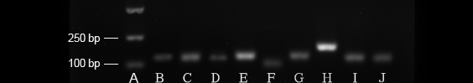

Trans2K DNA marker (A); RNAPol II (B); RPL7 (C); HRPT (D); GAPDH (E); TUBA (F); B2M (G); 18S rRNA (H); EF1A (I); ACTB (J).

