Supplementary note 2
The transition of $2×2$ tables and their probability.
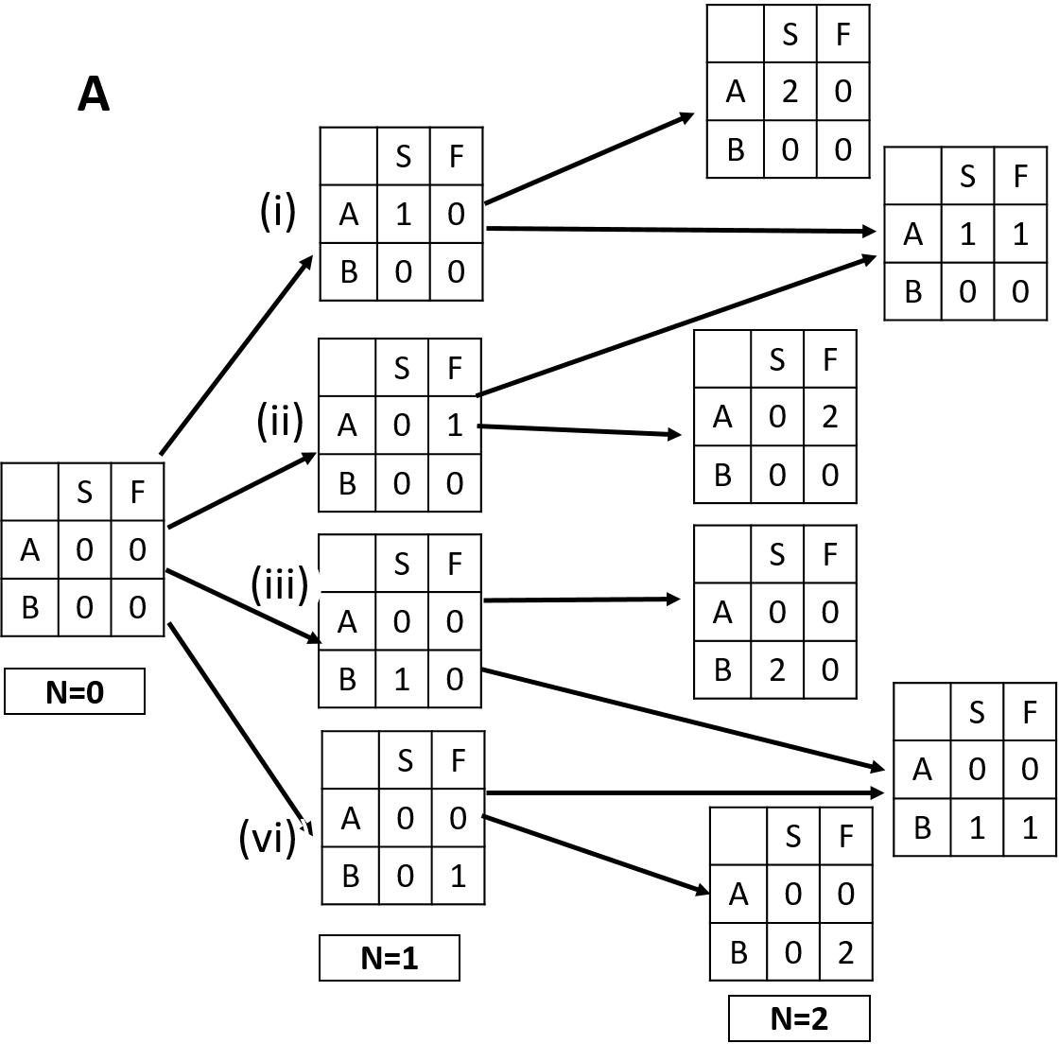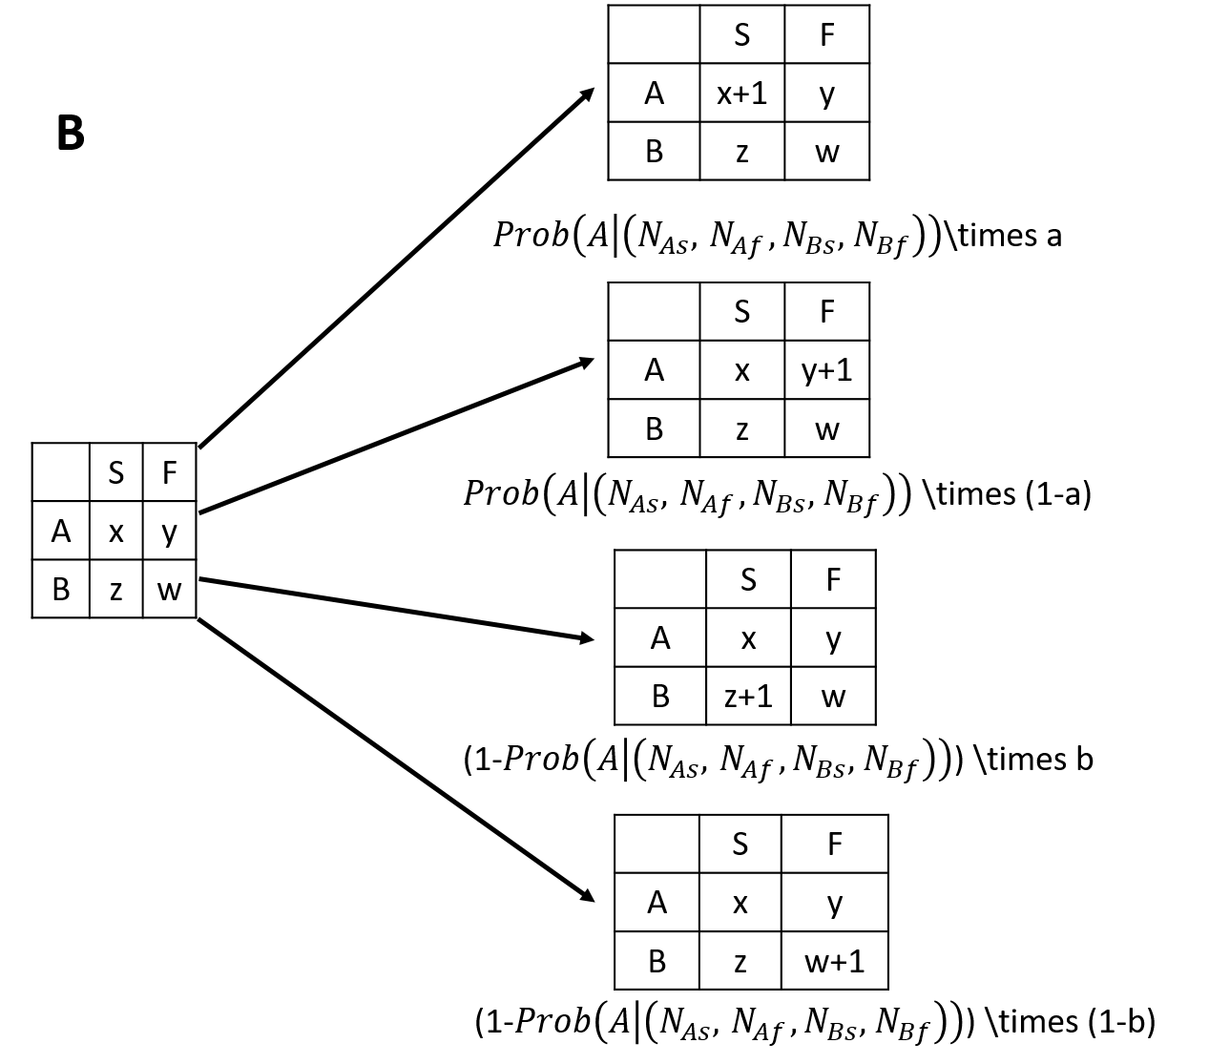
Legend: The panel A indicates the transition of $2×2$ tables. It starts from the left table with four cells all zero due to no outcomes of patient’s selection at the state of $N=0$. When a new patient $(N=1)$ is enrolled, the state should be shifted to right by one step. For each step, there are four possible events when a patient is enrolled; (i) it selects A and turns out to be a success, (ii) it selects A and turns out to be a failure, (iii) it selects B and turns out to be a success and (iv) it selects B and turns out to be a failure. When the second patient entries there are 8 possible events but six types of tables shown as the right side at the state of total patient number $N=2$. Each arrow indicates each possible event and shows connection between the occurred event table and its prior table. Similarly, the number of possible states consisted of $2×2$ table increases with the increase of the number of patients as shown. The panel B indicates the four possible events and their transition probabilities. When $Prob\left(A | \left(N_{As}, { N}_{Af}, N_{Bs},{ N}_{Bf}\right)\right)$is explicitly given, the occurrence probability of every $2×2$ table can be calculated exactly. $Prob\left(A | \left(N_{As}, { N}_{Af}, N_{Bs},{ N}_{Bf}\right)\right)$is explicitly given for E.st population and also for T.st population with fixed w values. Therefore, the exact probability of all table states is calculable for them. In case of $T.st$ with heterogeneous optimism/pessimism attitudes, $w$ values vary among individuals and $Prob\left(A | \left(N_{As}, { N}_{Af}, N_{Bs},{ N}_{Bf}\right)\right)$ vary among individuals stochastically, that makes the calculation of exact probability of each tables impossible.

