Supplementary file 01



**S01-1. The chromatogram of extract 5 (200 μg/mL).** Method: 5-100% ACN in 20 min, 100% ACN until 28 min as mobile phase, flow 1 mL/min, λ = 254 nm. Column Phenomenex Luna C-18, 5 µm, 4.6X250 mm. HPLC VARIAN, ProStar 230 Ternary Solvent Delivery Module, ProStar 335 Photodiode Array Detector.



**S01-2. The chromatogram of extract 21 (200 μg/mL).** Method: 5-100% ACN in 20 min, 100% ACN until 28 min as mobile phase, flow 1 mL/min, λ = 254 nm. Column Phenomenex Luna C-18, 5 µm, 4.6X250 mm. HPLC VARIAN, ProStar 230 Ternary Solvent Delivery Module, ProStar 335 Photodiode Array Detector.

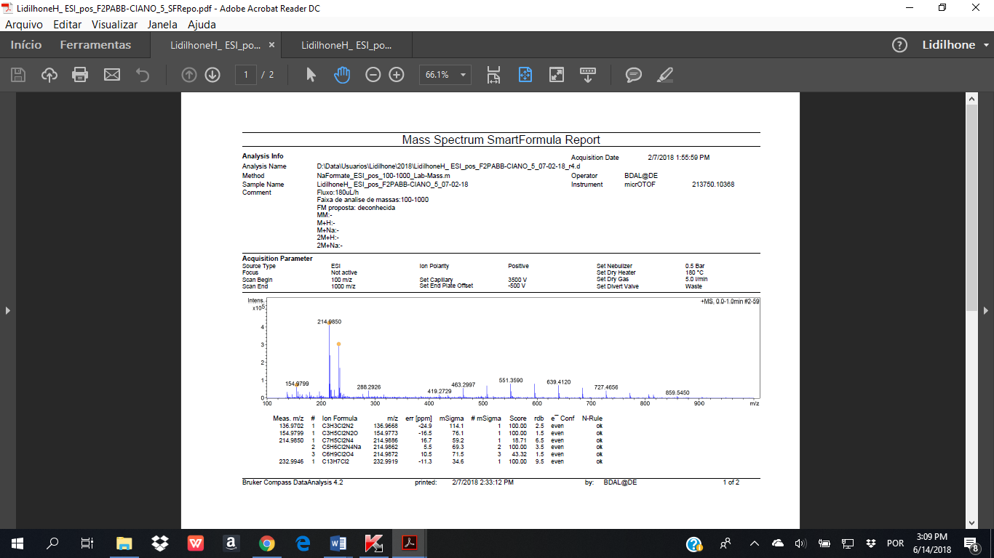

**S01-3. The mass spectrum of extract 5.**

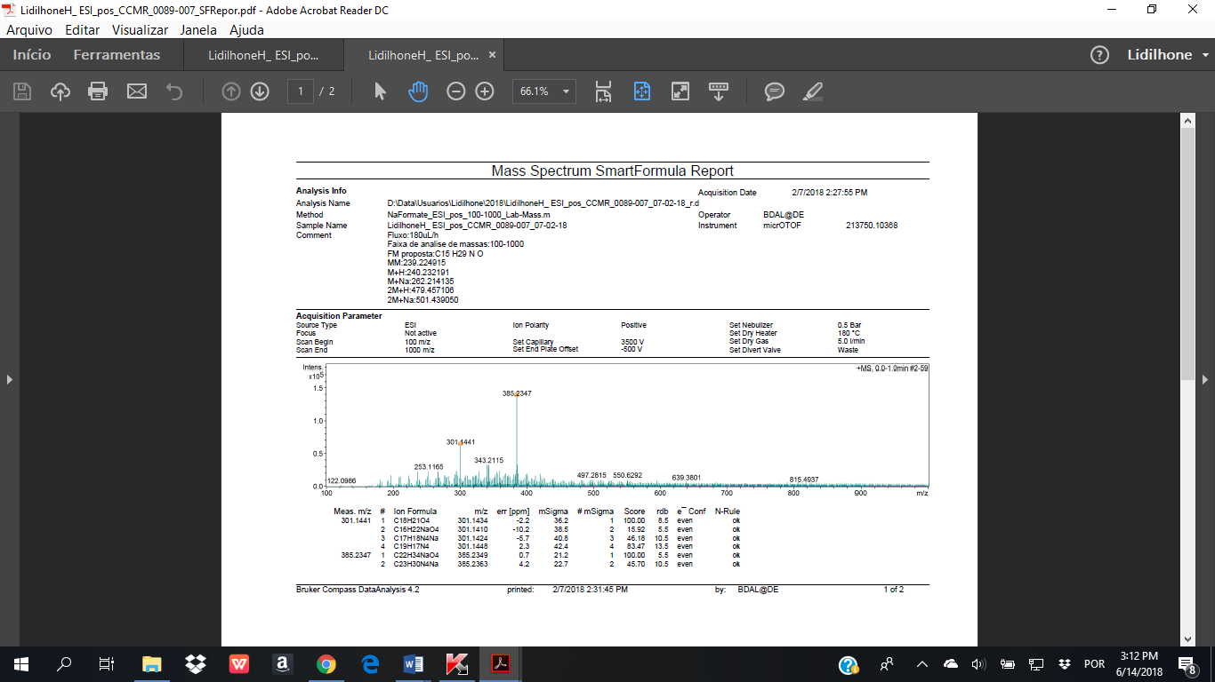

**S01-4. The mass spectrum of extract 21.**