Lateralization of anterior positivity
To confirm the left lateralization of the anterior positivity, we extended the corresponding ANOVA by the factor hemisphere (left, right), and included equivalent right hemisphere electrodes (Fp2, F4, F8, Fc6, and T8) while excluding midline electrodes Fz and Fpz. We found a main effect of hemisphere [F(1, 31) = 25.32, p < .001, η_{p}² = 0.06], and a main effect of condition [F(2, 62) = 3.52, p = 0.036], as well as an interaction effect [F(2, 62) = 4.30, p = 0.018]. Pairwise t-tests are summarized in the Table S5 and values are displayed in Fig. S2.
Table S5. Pairwise t-tests between noun types for both hemispheres
Pairwise t-tests | Left hemisphere | Right hemisphere
EXP vs. USP | t(31) = -3.86, p < .001 | t(31) = -2.06, p = .048
EXP vs. ANOM | t(31) = -2.00, p = .055 | t(31) = -0.59, p = .560
USP vs. ANOM | t(31) = 1.28, p = .210 | t(31) = 0.84, p = .410
Uncorrected p-values

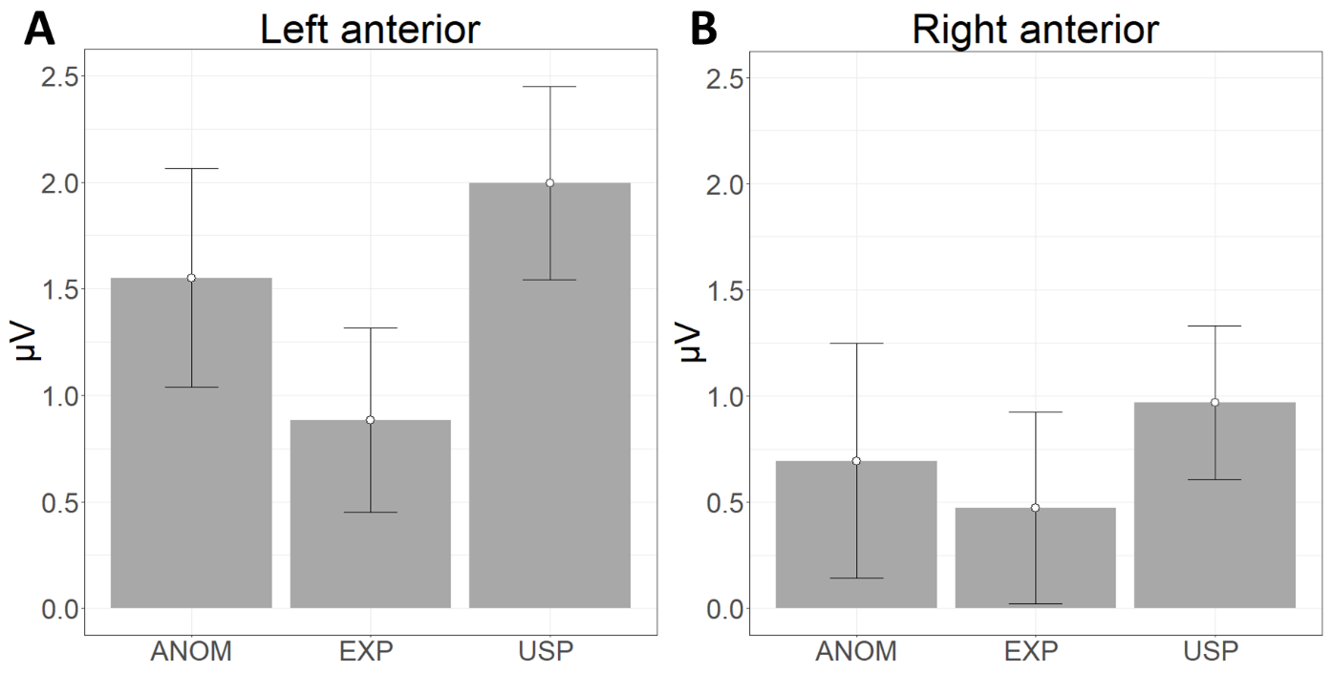
Figure S2. Mean amplitudes for 600 to 1000 ms and the three noun conditions (EXP, USP, ANOM) for left anterior (A) and right anterior (B) scalp channels. Error bars represent 95% confidence intervals (values are adjusted using method from Morey (2008)).
Reference
Morey RD. 2008. Confidence intervals from normalized data: a correction to Cousineau (2005). Tutorials in Quantitative Methods for Psychology 4(2):61-64 DOI 10.20982/tqmp.04.2.p061

