Appendix A

Figure legends

Figure S1. Region-specific patterns in field-level P. manihoti pest pressure (expressed as total number of mealybugs per 50 plants; Log10-transformed) and A. lopezi parasitism, as recorded at 110 different sites during the 2014-2017 dry season. Local parasitism rates are contrasted with established thresholds for successful biological control (Hawkins & Cornell 1994) (i.e., maxima of 33-36% for parasitoids in exotic locations), as depicted by the red box.
Figure S2. Temporal fluctuations in domestic (Thai Baht/kg) and export price (US$ FOB Bangkok) of cassava starch over a 2008-2016 period, covering the late 2008 P. manihoti invasion, the Nov. 2009 introduction of A. lopezi and subsequent region-wide distribution of the parasitoid (over 2010-2014). Data sourced from Thai Tapioca Starch Association (http://www.thaitapiocastarch.org).

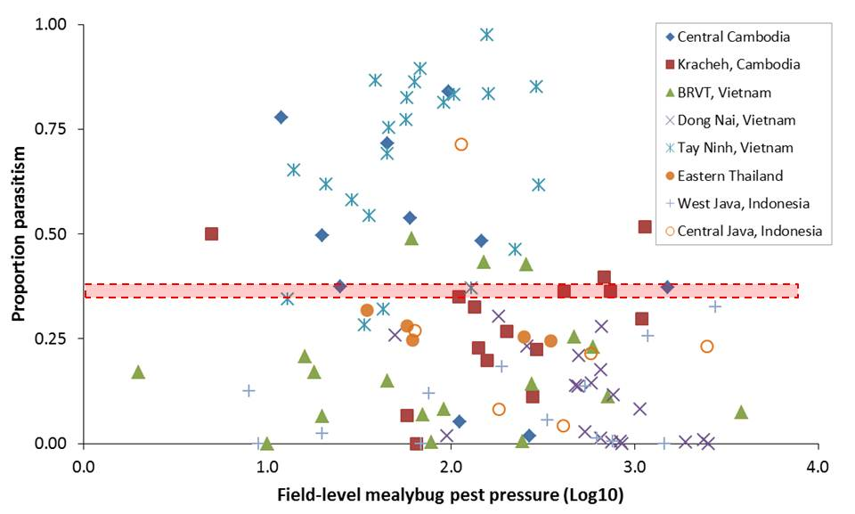

Figure S1.

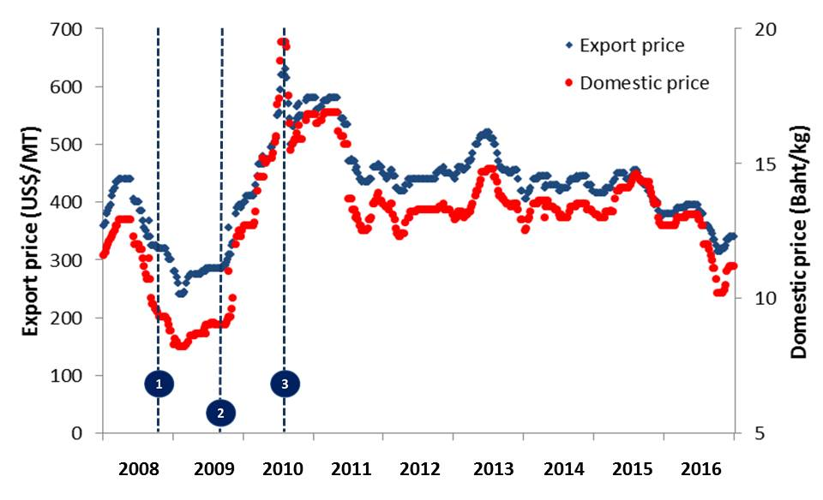

Figure S2.

Table S1. Additional information on model structure, describing all the models tested, and the output of the selected model (section iv)

Model | DF | AIC | Adjusted R2 values | p-value | Comments
yield ~ time + rain + tmin + Int | 6 | 743.5 | 0.1 | 8.45E-05 | Model with the least AIC value obtained from step wise regression approach
yield ~ time*Int + time*rain + time*tmin | 9 | 719.3 | 0.22 | 3.78E-09 | Selected model
yield ~ time*Int + rain + tmin | 7 | 717 | 0.22 | 6.48E-10
yield ~ Int + time*rain + tmin, data | 7 | 741.5 | 0.11 | 4.27E-05
yield ~ Int + rain + time*tmin | 7 | 745.5 | 0.09 | 0.00024

Yield: yields measured across all regions

Rain: noted precipitation values across regions wherein yields were measured

Tmin: noted minimum temperature values across regions wherein yields were measured

Int: Corresponds to year of introduction of Anagyrus lopezi. “Absence” (dummy coded as 0) during the 2008, 2009 and 2010 growing seasons, and “Presence” (dummy coded as 1) for 2011 and 2012 growing seasons

Time : Corresponds to year for which the agro-climatic variables and yields were measured (i.e. from 2008 to 2012)

DF: Degrees of freedom

AIC: Akaike information criterion score

