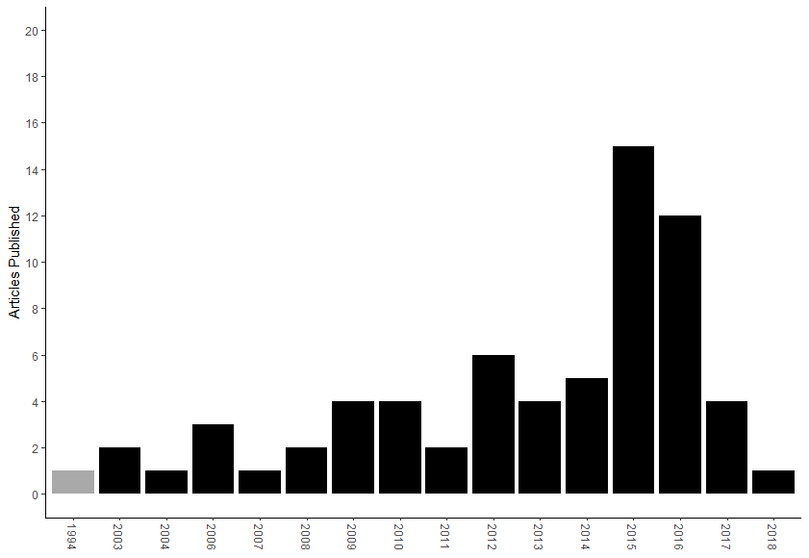

Figure 1. Range of years papers were published

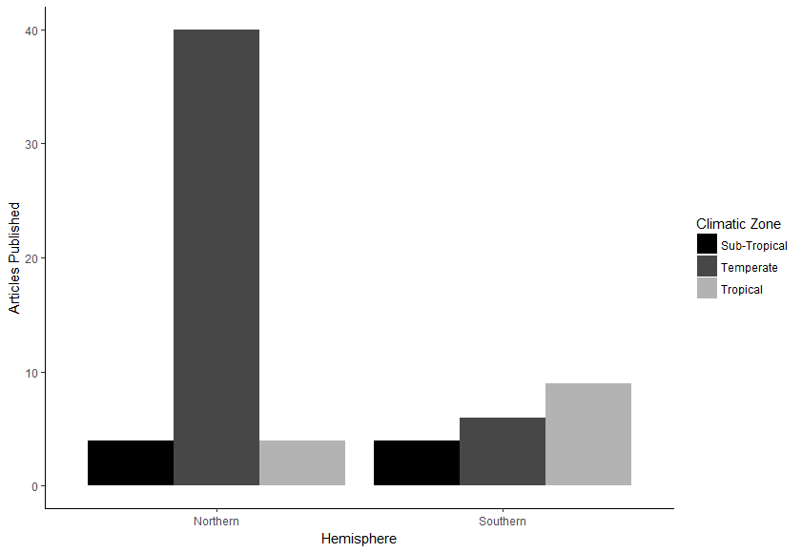

Figure 2. Biome and hemisphere

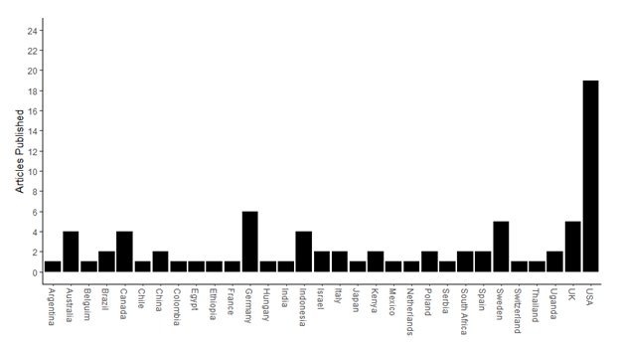

Figure 3. Country studies were conducted in.

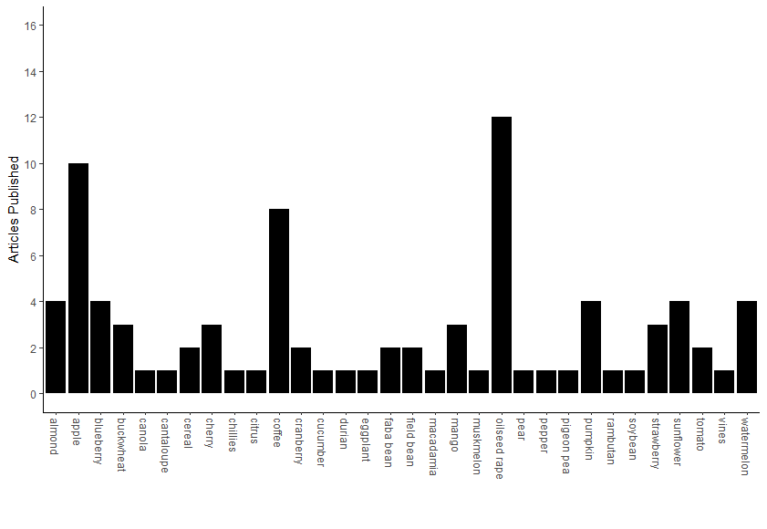

Figure 4. Crop species studies were conducted in

Table 1. Details of the 68 pollination studies that incorporated RST.

