Supplementary file 6
The logo of ten motifs in study.
The conserved motifs of ZmCNGC proteins were using the MEME Suite web server (http://meme-suite.org/index.html) with the maximum number of motif sets at 10 and optimum width of motifs from 6 to 200 amino acids.
Motif 1
Motif2
Motif 3
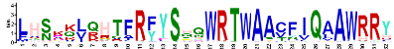
Motif 4
Motif5
Motif6
Motif7
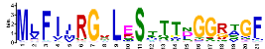
Motif 8
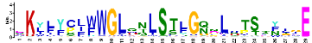
Motif 9
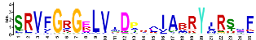
Motif10
