Supplemental Figure S1. Risk of bias summary showing review authors’ judgments about each risk of bias domain in trials included the review. Trials are listed alphabetically by author name*
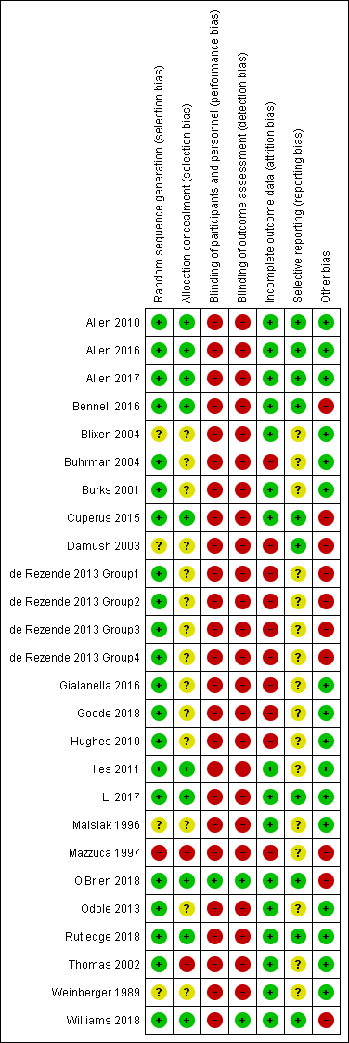

Notes: Green, low risk; yellow, unclear risk; red, high risk
*In four studies (Allen 2016, Allen 2017, Hughes 2010, Rezende 2013) for blinding of outcome assessment (detection bias) risk of bias was low for objectively measured weight.

