Supplemental Figure S2. Forest plots of main meta-analyses findings for comparison telephone-based interventions (with educational materials) versus usual care

Forest plot of outcome: Pain intensity

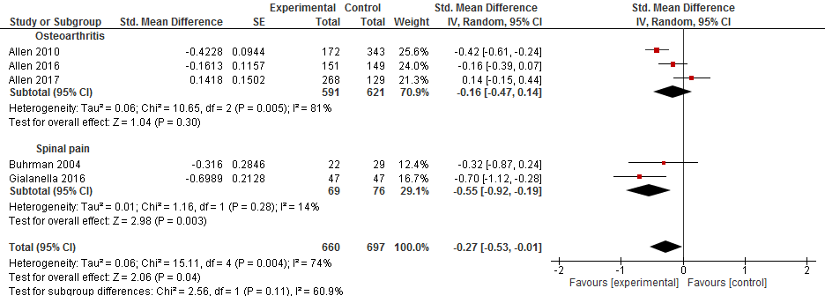

Forest plot of outcome: Disability

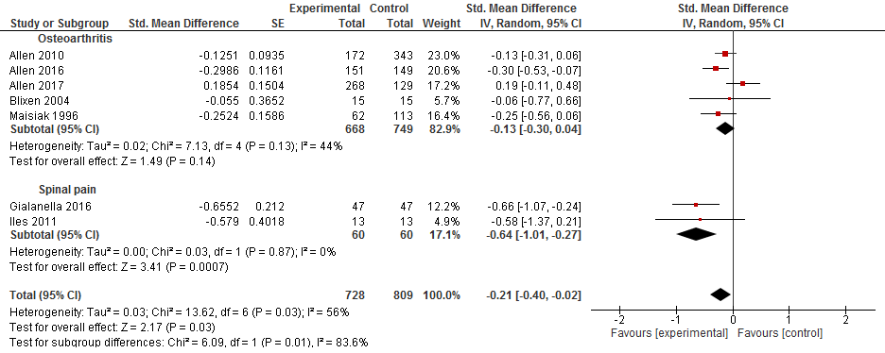

Forest plot of outcome: Psychological symptoms

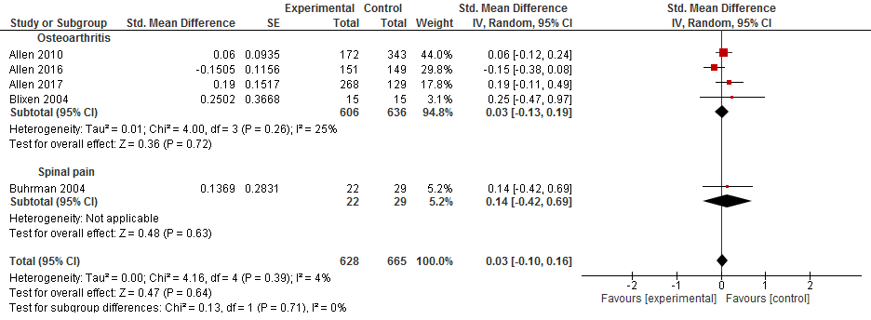

Forest plot of outcome: Self-efficacy

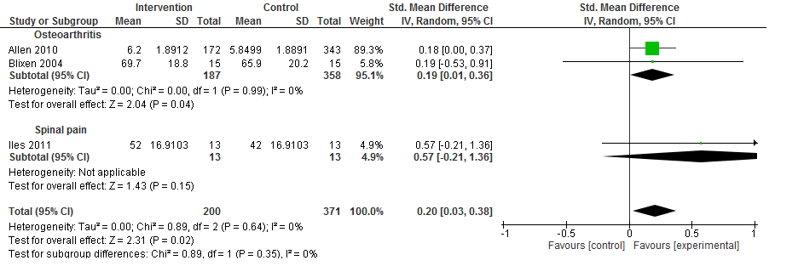

Forest plot of outcome: Weight loss

