Supplemental Figure S3. Forest plots of disability outcome subgroup and sensitivity analyses for comparison telephone-based interventions (with educational material) versus usual care

Subgroup analysis: Single component

Subgroup analysis: Multicomponent

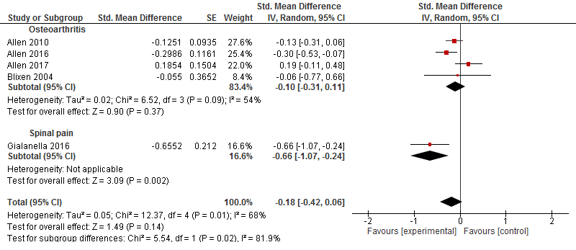

Sensitivity analysis: Excluding small trials

