Supplemental Figure S4. Forest plots of main meta-analyses findings for comparison telephone plus face-to-face interventions versus usual care

Forest plot of outcome: Pain intensity

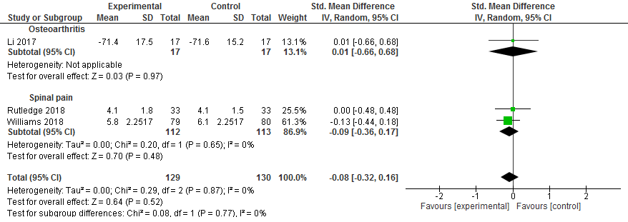

Forest plot of outcome: Disability

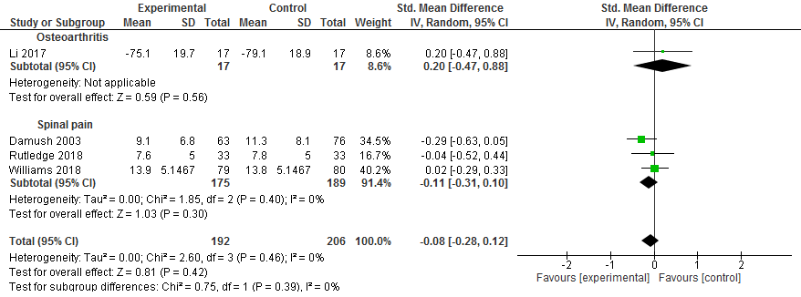

Forest plot of outcome: Psychological symptoms

