Suplement 4: Sequencing results of Coptoformica samples also containing the excluded samples

Supplement 4, figure 1. Maximum likelihood tree of COI barcodes of seven Coptoformica species and three additional Formica species.
Bootstrap values shown next to the nodes. The haplotypes F_fennica_312, F_fennica_304 and F_ fennica_310 do not seem to belong to the otherwise monophyletic Coptoformica, and were therefore excluded from the final analysis.
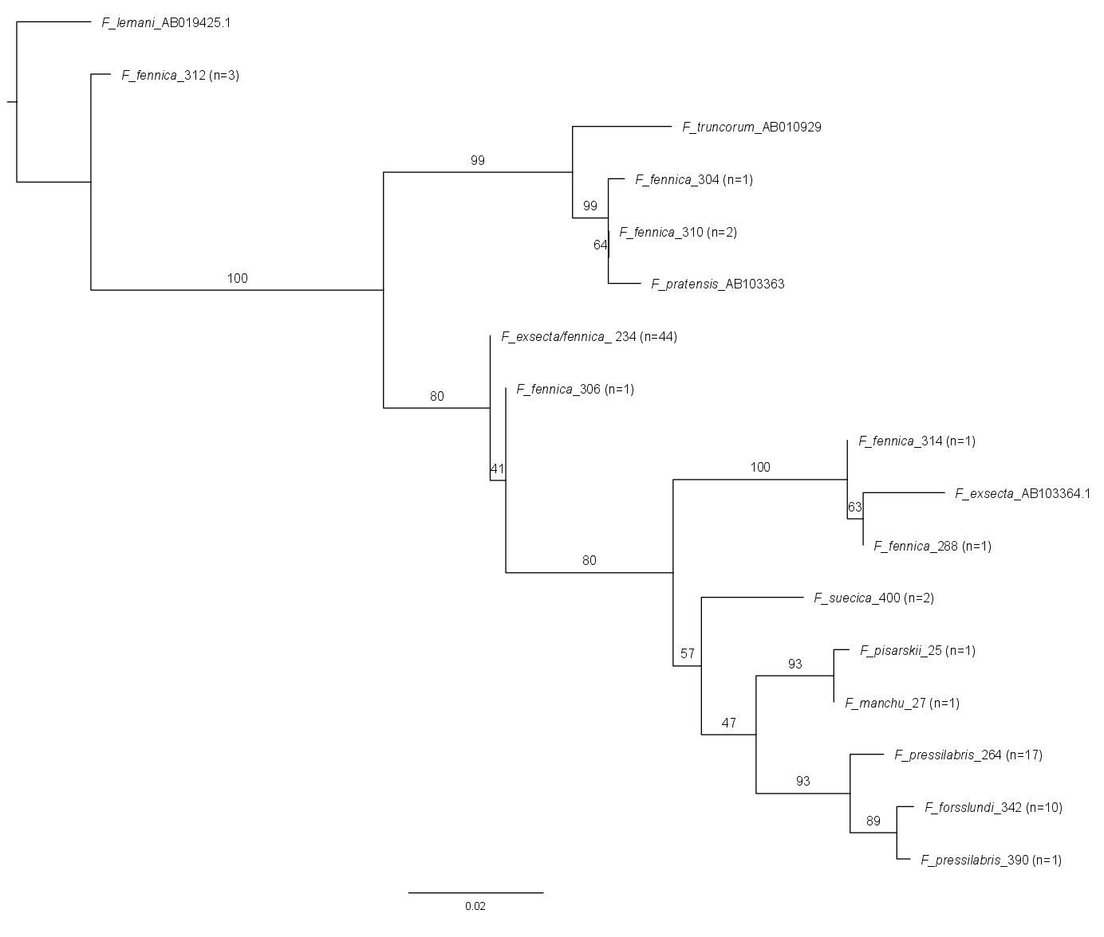
Supplement 4, Table 1. Divergences between all of the COI barcode haplotypes found in this study.
Below diagonal: number of differing nucleotides. Above diagonal: percentages of differing nucleotides.
Haplotypes: | n | 1 | 2 | 3 | 4 | 5 | 6 | 7 | 8 | 9 | 10 | 11 | 12 | 13 | 14
1 F_fennica_312 | 3 |  | 4.57 | 4.57 | 4.19 | 4.95 | 4.95 | 4.00 | 5.33 | 5.71 | 5.14 | 4.95 | 5.52 | 4.76 | 4.95
2 F_fennica_310 | 2 | 24 |  | 0.19 | 3.43 | 4.57 | 4.76 | 3.24 | 5.14 | 5.14 | 5.33 | 5.14 | 4.76 | 4.38 | 4.57
3 F_fennica_304 | 1 | 24 | 1 |  | 3.43 | 4.57 | 4.76 | 3.24 | 5.14 | 5.14 | 5.33 | 5.14 | 4.76 | 4.38 | 4.57
4 F_fennica_306 | 1 | 22 | 18 | 18 |  | 3.05 | 3.24 | 0.19 | 4.00 | 3.24 | 3.81 | 3.62 | 3.43 | 3.43 | 3.62
5 F_fennica_314 | 1 | 26 | 24 | 24 | 16 |  | 0.19 | 3.24 | 1.14 | 3.24 | 3.43 | 3.62 | 3.43 | 3.62 | 3.24
6 F_fennica_288 | 1 | 26 | 25 | 25 | 17 | 1 |  | 3.43 | 0.95 | 3.43 | 3.62 | 3.81 | 3.62 | 3.62 | 3.24
7 F_exsecta/fennica_234 | 44 | 21 | 17 | 17 | 1 | 17 | 18 |  | 3.81 | 3.43 | 4.00 | 3.81 | 3.62 | 3.62 | 3.81
8 F_exsecta_AB103364.1 | - | 28 | 27 | 27 | 21 | 6 | 5 | 20 |  | 4 | 3.81 | 4.00 | 3.81 | 3.81 | 3.81
9 F_suecica_400 | 2 | 30 | 27 | 27 | 17 | 17 | 18 | 18 | 21 |  | 2.48 | 2.29 | 3.24 | 3.24 | 3.62
10 F_pisarskii_25 | 1 | 27 | 28 | 28 | 20 | 18 | 19 | 21 | 20 | 13 |  | 0.19 | 2.48 | 2.48 | 2.86
11 F_manchu_27 | 1 | 26 | 27 | 27 | 19 | 19 | 20 | 20 | 21 | 12 | 1 |  | 2.29 | 2.29 | 2.67
12 F_pressilabris_264 | 17 | 29 | 25 | 25 | 18 | 18 | 19 | 19 | 20 | 17 | 13 | 12 |  | 1.14 | 1.14
13 F_pressilabris_390 | 1 | 25 | 23 | 23 | 18 | 19 | 19 | 19 | 20 | 17 | 13 | 12 | 6 |  | 0.38
14 F_forsslundi_342 | 10 | 26 | 24 | 24 | 19 | 17 | 17 | 20 | 20 | 19 | 15 | 14 | 6 | 2

