Table S3. Degree Heating Weeks (DHW) data from NOAA.
Source: https://coralreefwatch.noaa.gov/satellite/dhw.php
(a) March 2005
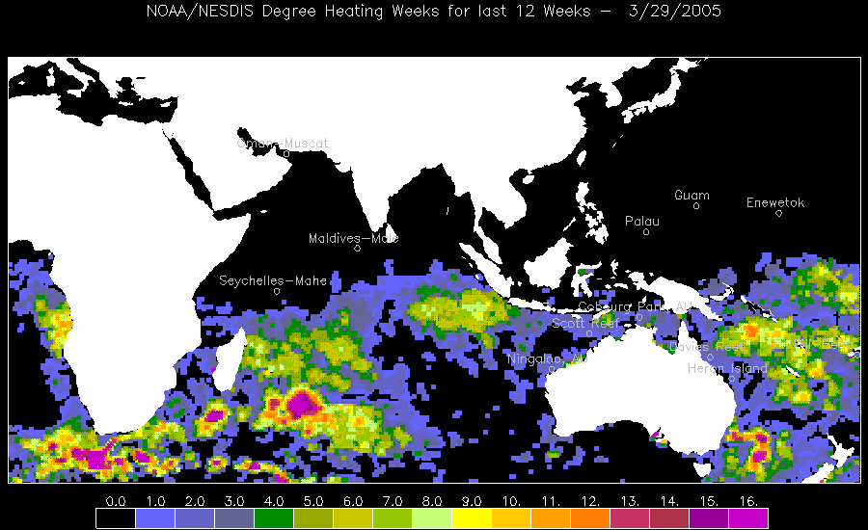
(b) April 2005
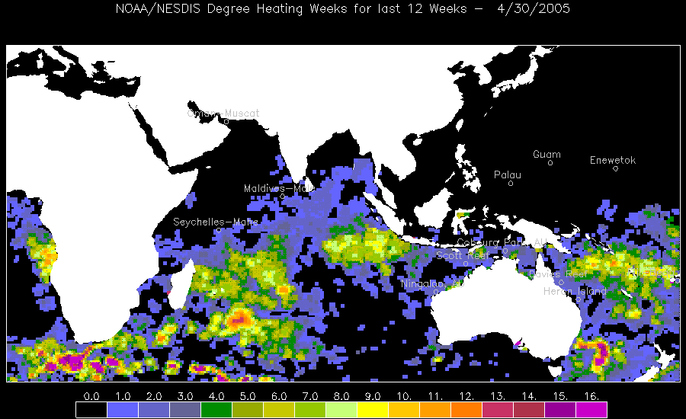
(c) May 2005
