Installing Solver in Excel.
To fit data in the template, the Solver Add-in of Excel should be installed. In Excel 2016 the Add-ins can be found under the File tab of the Excel ribbon.
Under the File tab select Options.
In the options select Add-ins.

Next select Go next to manage Excel Add-ins.
Check the Solver Add-in and click OK.
The solver Add-in should now be available in the data tab of the Excel ribbon.
Fitting Data in the template
Insert the data to be fit into the first sheet of the spreadsheet, in the example below the simulated data from the uncompetitive inhibition supplementary data is displayed.
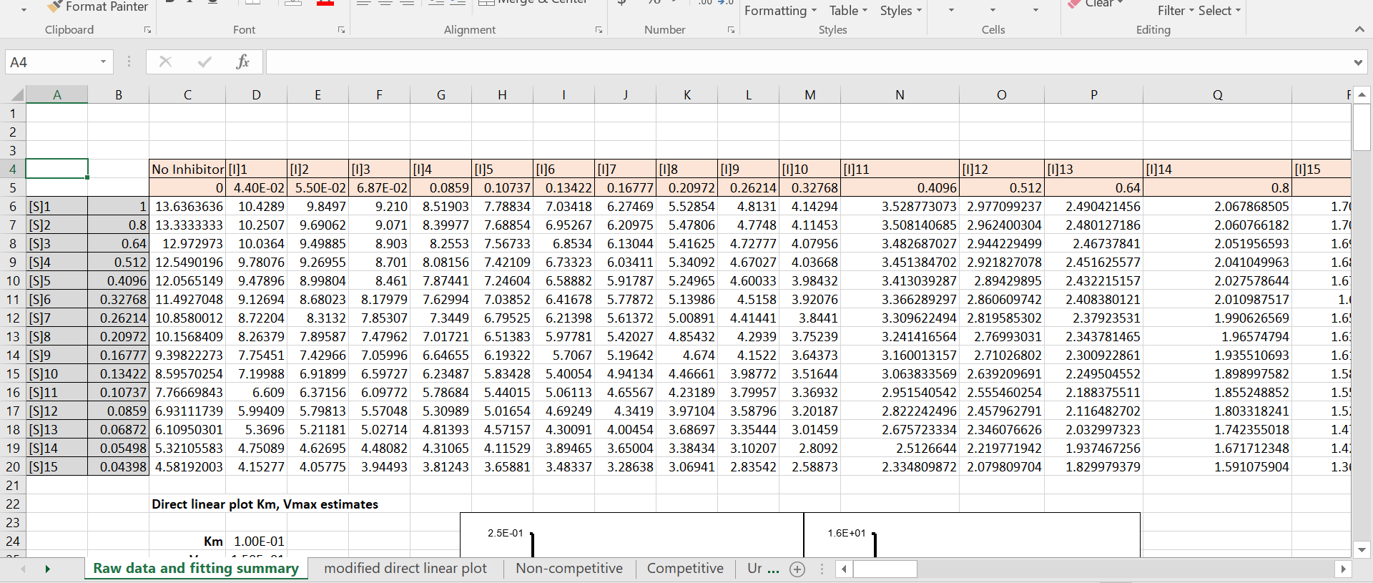
From the raw data, the template estimates the initial kinetic parameters for the global fitting using a modified direct linear plot for the K_{M} and V_{max} along with a K_{i} estimate based on a linear decrease in activity with increasing inhibitor concentrations.
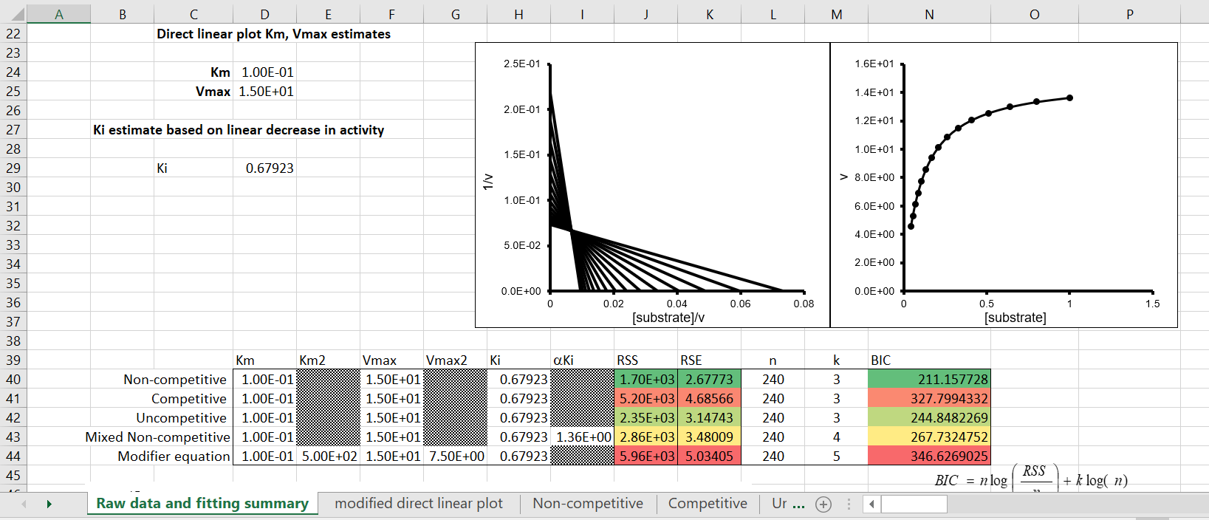

The additional values of K_{m2} and αK_{i} are just multiples of K_{m} and K_{i} respectively. If desired the initial values may be changed manually. These initial values provide a rough fitting of the data which can now be optimized using the Solver Add-in.
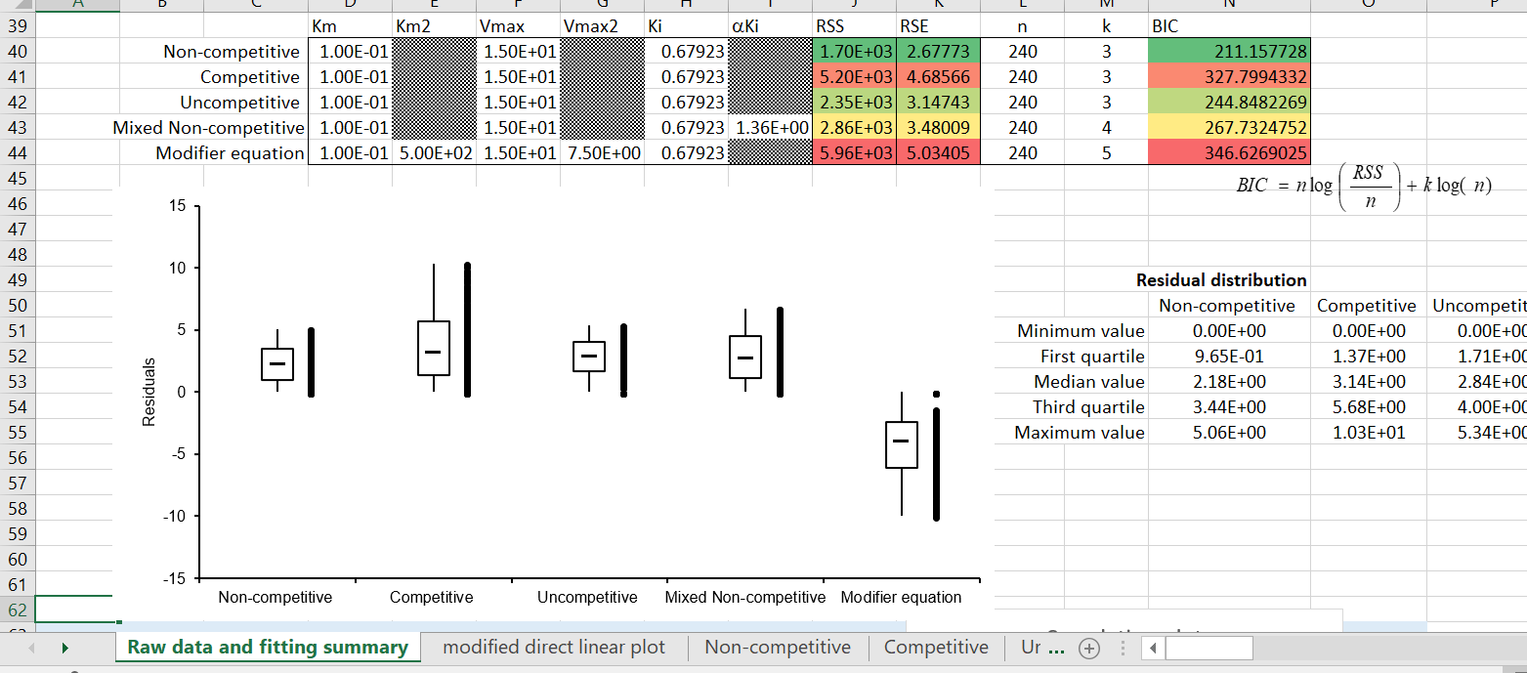
Open the Solver Add-in the Data tab and select the objective, which depending on the model to be fit would be the RSS value of that model (i.e., for the Non-competitive model select the RSS in J40).
Make sure that the objective RSS value is going to be minimized.

Then select the variables to be changed, in this case, the K_{m} V_{max} and K_{i} of the non-competitive model located in the cells D40, F40 and H40, then hit Solve.
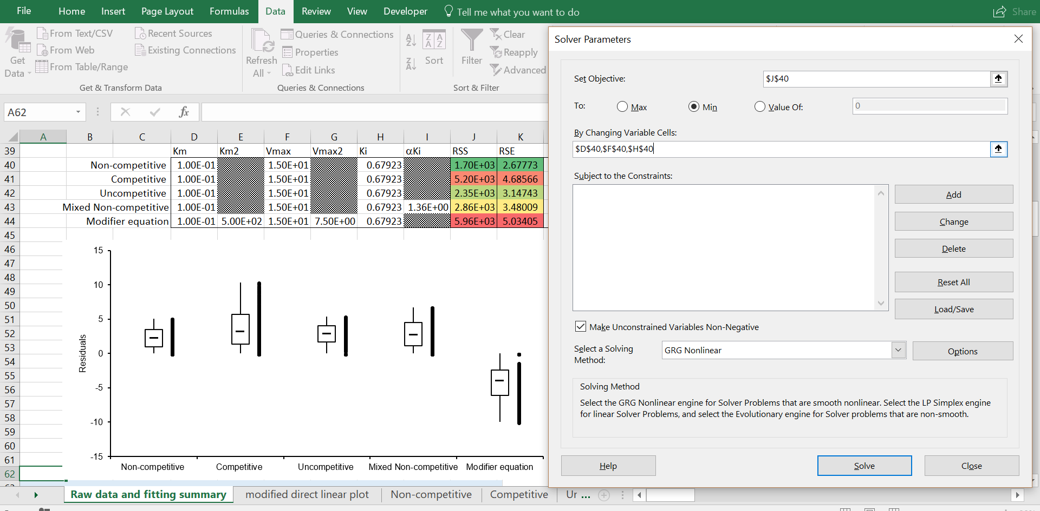
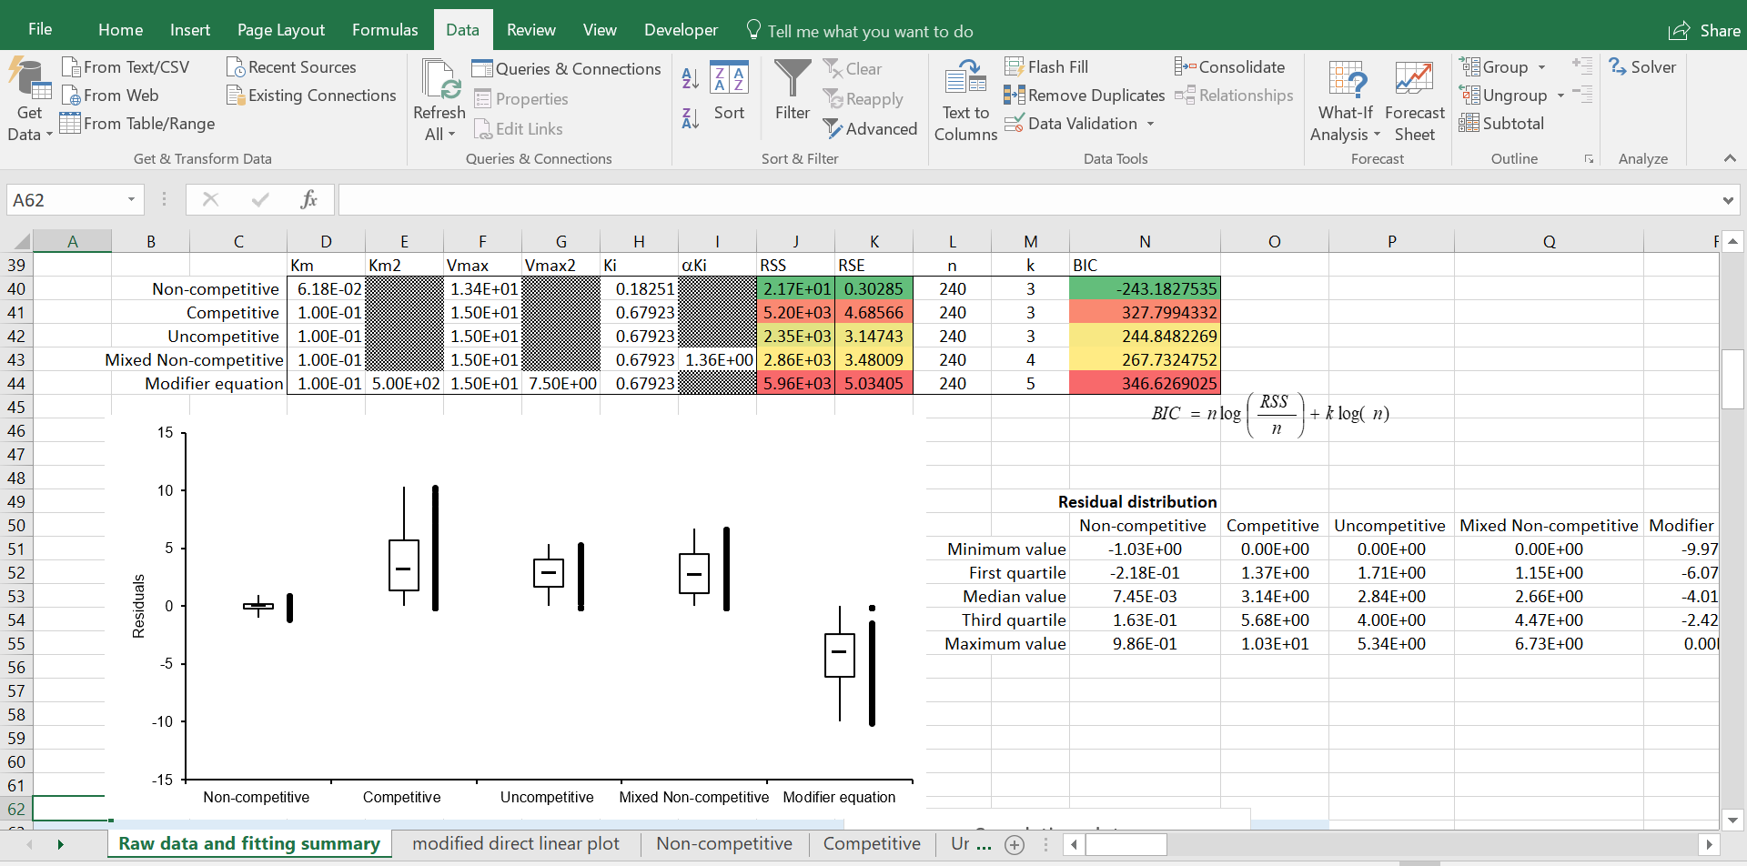

Repeat the fitting process with each model minimizing the RSS values by varying their respective kinetic parameters.
