**Draft data**

For Fig. 3B, HeLa cells were treated with PFEE-W/C and sub-fractions and stained with hoechst 33342, then the morphology of nuclei was observed by inverted fluorescence microscopy.

Untreated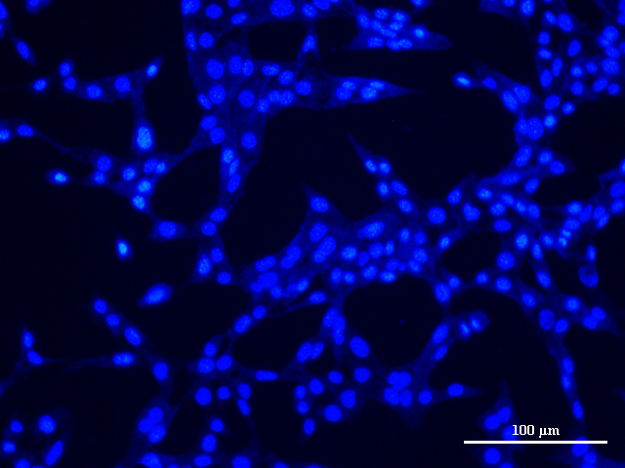

DMSO

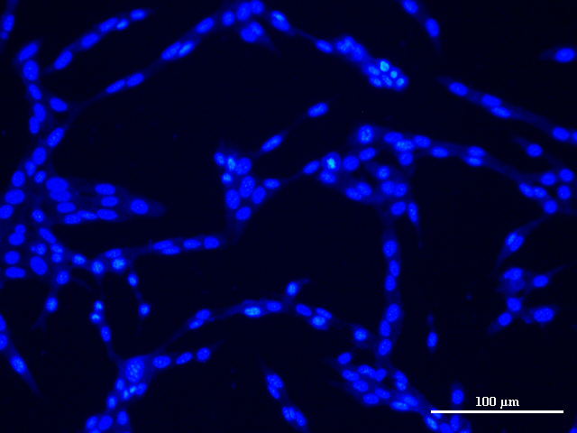

Cisplatin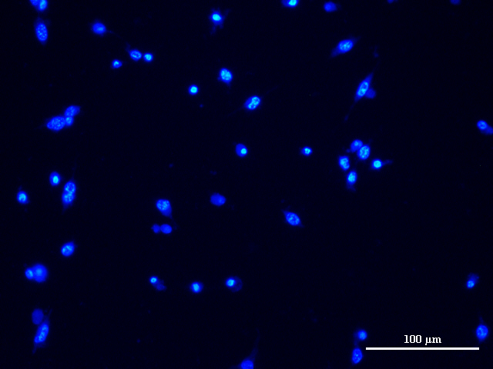

PFEE-W

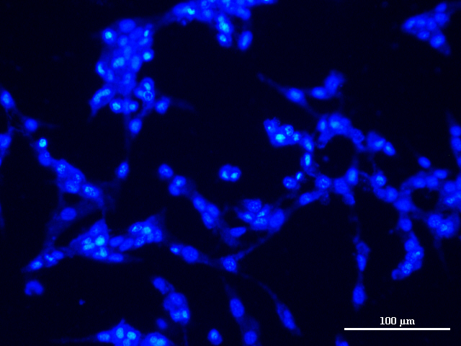

Pe-W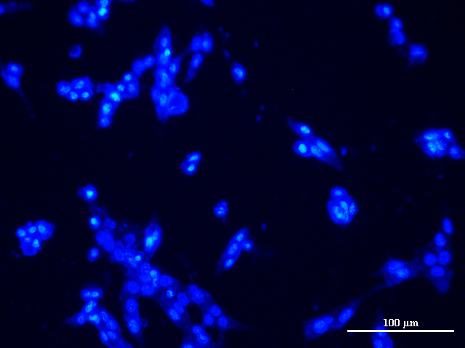

Ea-W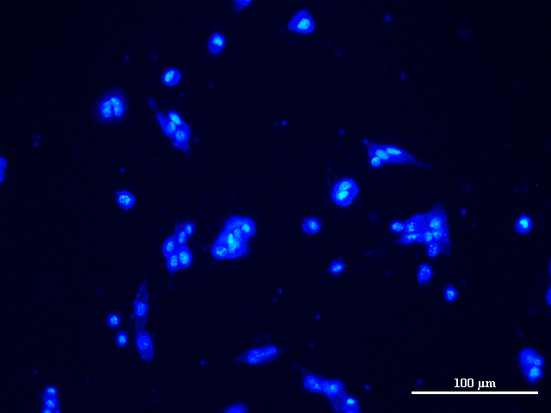

PFEE-C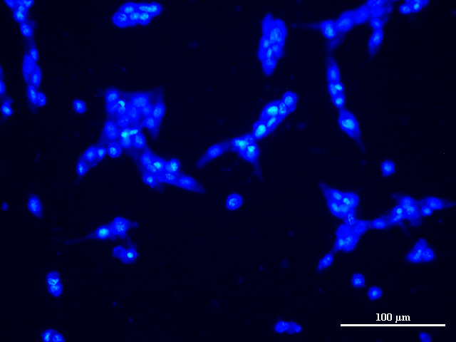

Pe-C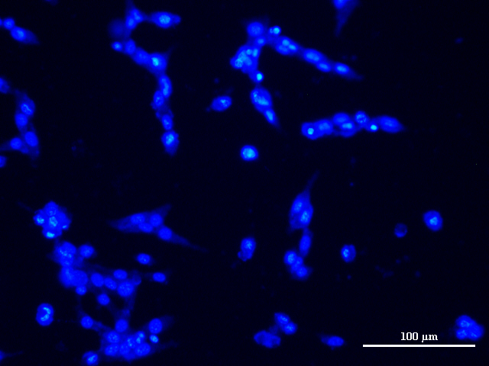

Ea-C

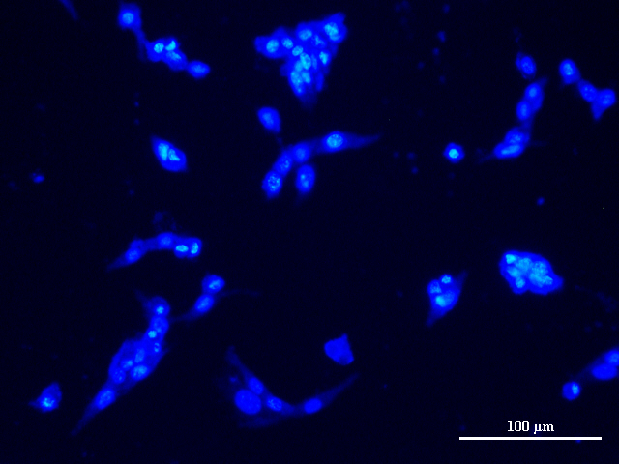

For Table 2 and 3, the chemical composition of fatty acids of Pe-W and Pe-C were detected by GC-MS. The total ion current chromatograms of fatty acids of Pe-W and Pe-C were shown.

Pe-W



Pe-C

