Identification of CD44⁺/CD24⁻ Phenotype Content by Flow Cytometry

parent MCF-7 cells (1.1%) parent MCF-7 cells (1.09%) parent MCF-7 cells (0.8%)
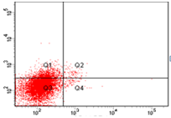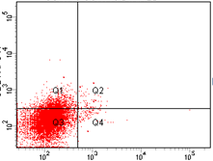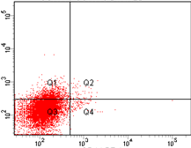
Group 1

unsorted (33.1%) unsorted (36.3%) unsorted (30.1%)
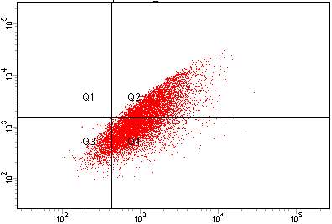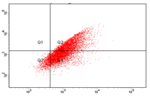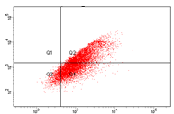
Group 2

After 3 days of sorting After 3 days of sorting After 3 days of sorting
(75.5%) (84.4%) (82.1%)
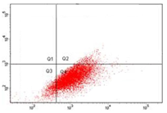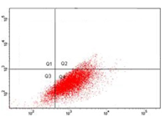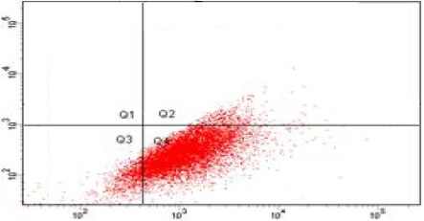
Group 3

CSCs after 21 days of sorting CSCs after 21 days of sorting CSCs after 21 days of sorting
(31.6%) (39.4%) (35.5%)
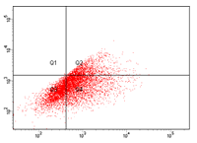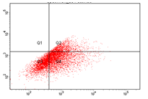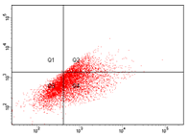
Group 4
Surface marker CD44+/CD24- expression analyzed for: (Group 1 triplicate) parent MCF-7 cells (1.0%), (Group 2 triplicate) unsorted mammospheres (33.2%); (Group 3 triplicate) sorted CSCs mammospheres after 3 days of sorting (81.0%); (Group 4 triplicate) CSCs mammospheres after 21 days of sorting (35.5%)

INTR.20 (34.6%) INTR.20 (44.2%) INTR.20 (40.5%)
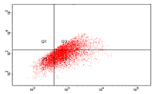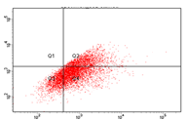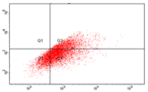
Group 5

CONT.5 (45.6%) CONT.5 (57.7%) CONT.5 (51.6%)
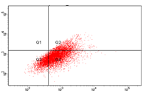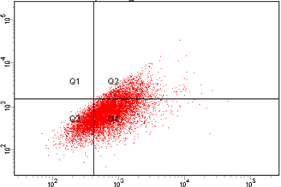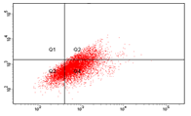
Group 6

INTR.40 (0.30%) INTR.40 (0.32%) INTR.40 (0.28%)
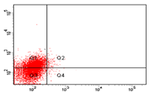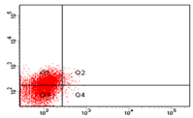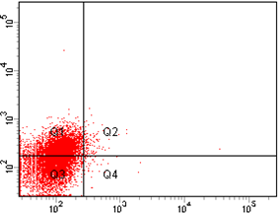
Group 7

CONT.15 (0.46%) CONT.15 (0.54%) CONT.15 (0.5%).
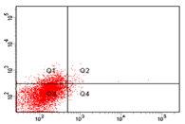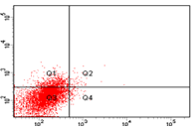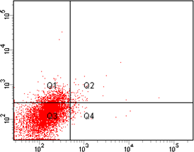
Group 8
Surface marker CD44+/CD24- expression analyzed for: (Group 5 triplicate) hypoxic CSCs mammospheres INTR.20 (39.8%); (Group 6 triplicate) hypoxic CSCs mammospheres CONT.5 (51.6%); (Group 7 triplicate) hypoxic CSCs mammospheres INTR.40 (0.3%); (Group 8 triplicate) for hypoxic CSCs mammospheres CONT.15 (0.5%).

