Supplementary materials for

Analysis of the complete genome sequence of a marine streptomycete Streptomyces sp. S063 CGMCC 14582 reveals its potential to produce novel secondary metabolites including anti-complement agents
Liang-Yu Chen¹, Hao-Tian Cui², Chun Su^{3*}, Feng-Wu Bai² and Xin-Qing Zhao^{2*}
¹School of Life Science and Biotechnology, Dalian University of Technology, Dalian 116023, China.
²State Key Laboratory of Microbial Metabolism and School of Life Science and Biotechnology, Shanghai Jiao Tong University, Shanghai 200240, China.
³National Engineering Laboratory for Resource Developing of Endangered Chinese Crude Drugs in Northwest China, College of Life Sciences, Shaanxi Normal University, Xi’an 710119, China.

*Corresponding authors:
Dr. Chun Su. E-mail: suchun@snnu.edu.cn. Tel: +86-29-85310581. Fax: +86-29-85310623; Prof. Dr. Xinqing Zhao, E-mail: xqzhao@sjtu.edu.cn. Tel: +86-21-34206673. Fax: +86-21-34208028.

Supplementary tables

Table S1 Culture medium used in this study
Name | Composition (g/L) | pH
A1 | yeast extract 4, soluble starch 10, peptone 2, sea salt 28 | 7.0
TSB | tryptone 17, soy peptone 3, glucose 2.5, K₂HPO₄ 2.5 | 7.2
MS | starch or cellulose 10, K₂HPO₄ 0.5, MgSO₄ 0.5, NaCl 0.5，KNO₃ 1, agar 20 | 7.0
M2 | soluble starch 20, glucose 10, peptone 5, yeast extract 5, CaCO₃ 5 | 7.0
M3 | soluble starch 20, soybean powder 25, NH₄Cl 2, NaCl 2, K₂HPO₄ 0.5, CaCO₃ 5 | 7.2
M8 | malt extract 40, yeast extract 4, glucose 2, NH₄Cl 0.8, Na₂HPO₄ 1 | 6.0
M9 | sucrose 20, soybean powder 10, corn syrup 10, KCl 8 | 6.5
M12 | glucose 100, yeast extract 10, CaCO₃ 2 | 6.8
M17 | glucose 10, soy flour 10, corn syrup 10, glycerol 5, yeast extract 5, NaCl 5, CaCO₃ 2 | 5.7
M19 | soluble starch 20, cotton seed powder 5, yeast extract 2.5, NaCl 1, K₂HPO₄ 0.75, MgSO₄·7H₂O 1, CaCO₃ 3 | 7.5
M22 | malt extract 35, corn starch 30, corn syrup 15, cotton seed powder 15, CaCO₃ 2 | 7.5

Table S2 Primers used in this study
Name | Sequence
apra F | TGTAGGCTGGAGCTGCTTC
apra R | TATTCCGGGGATCCGTCGAC
4-k1 F | GCCTGCAGGTCGACTCTAGA CGACGGAAACACGGGAGAATCA
4-k1 R | CGAAGCAGCTCCAGCCTACA TGAAGTGCTCCACGAACAGTCC
4-k3 F | TCGACGGATCCCCGGAATAT TACGGAGTCGTGACGTGTGC
4-k3 R | AATTCGAGCTCGGTACCCGG CGGAGCCGTGAACTGACACT
23-k1 F | GCCTGCAGGTCGACTCTAGA CGCAAGTACCACAAGCACCTGA
23-k1 R | CGAAGCAGCTCCAGCCTACA TGTCGGAGTTCCTGGGCTGA
23-k3 F | TCGACGGATCCCCGGAATAT AGATGCTGCTGCGCACTCT
23-k3 R | AATTCGAGCTCGGTACCCGG CTACCAGACCACCCGGAGC
25-k1 F | GCCTGCAGGTCGACTCTAGA GCACGGATCGCCGAATGGAT
25-k1 R | CGAAGCAGCTCCAGCCTACA TGGTGGGCCAGCATCTCGAT
25-k3 F | TCGACGGATCCCCGGAATAT GCGGTGATCTCATCGATTCGG
25-k3 R | AATTCGAGCTCGGTACCCGG GGGGCTCATGAACCGGCG
28-k1 F | GCCTGCAGGTCGACTCTAGA ATGAGCACCCAGACAGCCCA
28-k1 R | CGAAGCAGCTCCAGCCTACA TTCAGGCCTGCTGGTGCAG
28-k3 F | TCGACGGATCCCCGGAATAT GGTCAGCCGTTGAACGTGTCC
28-k3 R | AATTCGAGCTCGGTACCCGG ATGCGCATGCGACCCACC
4-773 F | ACGACGTCCTCGCCACCGGACTGTTCGTGGAGCACTTCA TGTAGGCTGGAGCTGCTTC
4-773 R | GACGGCCGGGGTGCGGCGCGCACACGTCACGACTCCGTA TATTCCGGGGATCCGTCGAC
4-p18 F | ACCGAACGACCGGGTGGCCAGTGTCAGTTCACGGCTCCG CCGGGTACCGAGCTCGAATT
4-p18 R | CTCTCTCGGTTGTCGAATGATTCTCCCGTGTTTCCGTCG TCTAGAGTCGACCTGCAGGC
23-773 F | AGCCCCTTCGGGTCGCGGGTCAGCCCAGGAACTCCGACA TGTAGGCTGGAGCTGCTTC
23-773 R | AGGGGTCGACGGAGACGTACAGAGTGCGCAGCAGCATCT TATTCCGGGGATCCGTCGAC
23-p18 F | ACCTCCCGCAGCCCGCGGCGGCTCCGGGTGGTCTGGTAG CCGGGTACCGAGCTCGAATT
23-p18 R | GGACATCTCCGACAGCTTCAGGTGCTTGTGGTACTTGCG TCTAGAGTCGACCTGCAGGC
25-773 F | AGAGGCGCTGGAAGGCCTGATCGAGATGCTGGCCCACCA TGTAGGCTGGAGCTGCTTC
25-773 R | GTGGGGACGGCAGGCCGTCCGAATCGATGAGATCACCGC TATTCCGGGGATCCGTCGAC
25-p18 F | CATCACCCCCGCGGCCCCGCCCGCCGGTTCATGAGCCCC CCGGGTACCGAGCTCGAATT
25-p18 R | CGCCGGTGACGTCGCCGCGATCCATTCGGCGATCCGTGC TCTAGAGTCGACCTGCAGGC
28-773 F | ATGCGGTGGACCCCCGCACCCTGCACCAGCAGGCCTGAA TGTAGGCTGGAGCTGCTTC
28-773 R | GCGCACCGGGCCCGACCCGGACACGTTCAACGGCTGACC TATTCCGGGGATCCGTCGAC
28-p18 F | CTCGGCGGAGGTCCAGCTCAGGGTGGGTCGCATGCGCAT CCGGGTACCGAGCTCGAATT
28-p18 R | GGCGGTCGGTGCCTCGCGGTGGGCTGTCTGGGTGCTCAT TCTAGAGTCGACCTGCAGGC
4yan F | ACACGATCATCGACCACACCTG
23yan F | CATCGAGGTCGAGCACCTGTT
25yan F | TACGGCAAGCCGTACTGGA
28yan F | CGTGATCGAACTGCTGCGC
773yan R | ATCCATTGCCCCTGCCACCT
Note: The underlined letters indicate the homologous regions.

Table S3 General features of Streptomyces sp. S063
Items | Description
Classification | Domain Bacteria
 | Phylum Actinobacteria
 | Class Actinobacteria
 | Order Actinomycetales
 | Family Streptomycetaceae
 | Genus Streptomyces
 | Species Streptomyces badius
 | Strain: S063
Gram stain | Positive
Motility | Motionless
Pigmentation | Yellowish white
Cell shape | Branched mycelia
Temperature range (°C) | 4-37, optimally at 28
Biotic relationship | Free living
Salinity (w/v) | 0.5-9.5%, optimum 3.5% NaCl*
Relation to oxygen | Aerobic
Note: *, TSB medium contains 0.5% (w/v) NaCl.

Table S4 Number of genes associated with general COG functional categories
Code | No. | Percentage | Description
J | 208 | 2.93 | Translation, ribosomal structure and biogenesis
A | 4 | 0.06 | RNA processing and modification
K | 683 | 9.61 | Transcription
L | 233 | 3.28 | Replication, recombination and repair
B | 2 | 0.03 | Chromatin structure and dynamics
D | 53 | 0.75 | Cell cycle control, Cell division, chromosome partitioning
V | 129 | 1.81 | Defense mechanisms
T | 429 | 6.03 | Signal transduction mechanisms
M | 269 | 3.78 | Cell wall/membrane biogenesis
N | 8 | 0.11 | Cell motility
U | 46 | 0.65 | Intracellular trafficking and secretion
O | 159 | 2.24 | Posttranslational modification, protein turnover, chaperones
C | 294 | 4.14 | Energy production and conversion
G | 456 | 6.50 | Carbohydrate transport and metabolism
E | 462 | 6.54 | Amino acid transport and metabolism
F | 112 | 1.58 | Nucleotide transport and metabolism
H | 231 | 3.25 | Coenzyme transport and metabolism
I | 264 | 3.71 | Lipid transport and metabolism
P | 251 | 3.53 | Inorganic ion transport and metabolism
Q | 243 | 3.42 | Secondary metabolites biosynthesis, transport and catabolism
R | 753 | 10.59 | General function prediction only
S | 423 | 5.95 | Function unknown
- | 2,740 | 38.54 | Not in COGs
Note: The percentage is calculated based on the total number of protein coding genes in the genome.

Table S5 Genome comparison of Streptomyces sp. S063 and the subspecies of S. griseus using OrthoANIu values
Organism/Name | Strain | Assembly | Size (Mb) | Scaffolds | Gene | OrthoANIu value (%) | AAL (bp) #
S. griseus subsp. griseus | NBRC 13350 | GCA_000010605.1 | 8.55 | 1* | 7,284 | 89.9 | 4,055,388
S. griseus | BIG105 | GCA_001715295.1 | 6.87 | 16** | 5,996 | 82.45 | 2,763,591
S. griseus | NRRL B-2165 | GCA_001723115.1 | 8.10 | 1,108** | 7,277 | 90.02 | 3,607,713
S. griseus subsp. griseus | NRRL B-2682 | GCA_001723125.1 | 7.96 | 1,244** | 7,202 | 90.22 | 3,539,928
S. griseus | S4-7 | GCA_000932225.2 | 7.69 | 3 | 6,927 | 93.53 | 4,320,872
S. griseus | DSM 40236 | GCA_900105705.1 | 8.63 | 4 | 7,381 | 89.87 | 4,138,770
S. griseus subsp. rhodochrous | NRRL B-2931 | GCA_000718205.1 | 8.03 | 67 | 7,120 | 88.7 | 3,818,413
S. griseus subsp. rhodochrous | NRRL B-2930 | GCA_000721205.1 | 8.03 | 85 | 7,114 | 88.79 | 3,794,648
S. griseus subsp. griseus | NRRL F-2227 | GCA_000721575.1 | 8.04 | 86 | 7,055 | 88.75 | 3,829,922
S. griseus subsp. griseus | NRRL F-5144 | GCA_000719355.1 | 7.85 | 89 | 7,110 | 93.6 | 4,267,182
S. griseus subsp. rhodochrous | NRRL B-2929 | GCA_001270675.1 | 8.03 | 102 | 7,125 | 88.79 | 3,802,556
S. griseus subsp. griseus | NRRL B-2307 | GCA_000717375.1 | 7.20 | 135 | 6,391 | 78.82 | 2,288,652
S. griseus subsp. rhodochrous | NRRL B-2932 | GCA_000718235.1 | 7.84 | 142 | 6,808 | 88.86 | 3,844,738
S. griseus subsp. griseus | NRRL F-5618 | GCA_000719435.1 | 7.10 | 165 | 6,247 | 78.82 | 2,349,132
S. griseus subsp. griseus | NRRL WC-3480 | GCA_000717795.1 | 8.33 | 166 | 7,177 | 89.9 | 4,021,963
S. griseus subsp. griseus | NRRL B-2621 | GCA_000721035.1 | 7.43 | 174 | 6,717 | 79.43 | 2,402,716
S. griseus subsp. rhodochrous | NRRL B-1691 | GCA_000719035.1 | 8.09 | 228 | 7,124 | 88.75 | 3,798,650
S. griseus subsp. griseus | NRRL B-2621 | GCA_000718525.1 | 7.43 | 239 | 6,731 | 79.49 | 2,414,674
S. griseus subsp. griseus | NRRL F-5621 | GCA_000719495.1 | 7.34 | 240 | 6,438 | 78.75 | 2,257,522
S. griseus subsp. griseus | NRRL WC-3645 | GCA_000720255.1 | 9.89 | 265 | 9,047 | 78.14 | 2,290,396
S. griseus subsp. griseus | NRRL WC-3066 | GCA_001509565.1 | 7.15 | 287 | 6,322 | 78.82 | 2,288,023
S. griseus subsp. rhodochrous | NRRL B-2933 | GCA_000717555.2 | 7.84 | 4,281 | - | 89.08 | 2,825,857
Note: #AAL, Average aligned length; *, complete level; **, scaffold level; the rest genomes are contig level. OrthoANIu value and AAL value are calculated by comparing Streptomyces sp. S063 with the selected strains.

Table S6 Deduced gene functions of Cluster17
Gene | Identity | Coverage | Subject gene | Function
gene4741 | 85 | 61.8 | BAG19226.1 | AmfT protein
gene4742 | 100 | 100.0 | BAG19225.1 | AmfS protein
gene4743 | 83 | 95.8 | BAG19224.1 | membrane translocator
gene4744 | 86 | 97.1 | BAG19223.1 | membrane translocator
gene4745 | 92 | 100.0 | BAG19222.1 | transcriptional regulator

Table S7 Deduced gene functions of Cluster8
Gene | Identity | Coverage | Subject gene | Function
gene975 | 98 | 100.0 | EFE73293.1 | transmembrane-transport protein
gene976 | 98 | 98.4 | EFE73294.1 | TetR-family transcriptional regulator
gene977 | 94 | 100.0 | EFE73295.1 | conserved hypothetical protein
gene978 | 98 | 100.0 | EFE73296.1 | oxidoreductase
gene979 | 99 | 100.0 | EFE73297.1 | argininosuccinate lyase ArgH
gene980 | 99 | 100.0 | EFE73298.1 | argininosuccinate synthase ArgG
gene981 | 97 | 100.0 | EFE73300.1 | secreted protein
gene982 | 100 | 100.0 | EFE73301.1 | arginine repressor
gene983 | 96 | 99.0 | EFE73302.1 | N2-acetyl-L-ornithine: 2-oxoglutarate aminotransferase ArgD
gene984 | 97 | 100.0 | EFE73303.1 | N-acetylglutamate kinase ArgB
gene985 | 96 | 100.0 | EFE73304.1 | N2-acetyl-L-ornithine: L-glutamate N-acetyltransferase ArgJ
gene986 | 97 | 99.7 | EFE73305.1 | N-acetyl-gamma-glutamylphosphate reductase
gene987 | 98 | 100.0 | EFE73306.1 | cysteine synthase
gene988 | 95 | 98.6 | EFE73307.1 | ornithine cyclodeaminase
gene989 | 91 | 101.2 | EFE73308.1 | non-ribosomal peptide synthetase
gene990 | 90 | 100.0 | EFE73309.1 | conserved hypothetical protein
gene991 | 91 | 100.0 | EFE73310.1 | conserved hypothetical protein
gene992 | 96 | 88.0 | EFE73312.1 | nonribosomal peptide synthetase
gene993 | 93 | 94.8 | EFE73312.1 | nonribosomal peptide synthetase
gene994 | 92 | 87.6 | EFE73312.1 | nonribosomal peptide synthetase
gene995 | 91 | 100.0 | EFE73312.1 | nonribosomal peptide synthetase
gene996 | 92 | 96.2 | EFE73312.1 | nonribosomal peptide synthetase
gene997 | 88 | 97.1 | EFE73313.1 | nonribosomal peptide synthetase
gene998 | 92 | 100.4 | EFE73313.1 | nonribosomal peptide synthetase
gene999 | 94 | 97.7 | EFE73314.1 | pyridoxal-5'-phosphate-dependent enzyme

Table S8 Deduced gene functions of Cluster20
Gene | Identity | Coverage | Subject gene | function
gene5506 | 53 | 101.6 | BAP34706.1 | LuxR-family transcriptional regulator
gene5507 | 77 | 96.6 | BAP34705.1 | NAD-dependent epimerase/dehydratase
gene5508 | 73 | 94.7 | BAP34704.1 | UDP-glucose/GDP-mannose dehydrogenase
gene5509 | 64 | 96.9 | BAP34703.1 | LmbE family protein
gene5510 | 62 | 103.4 | BAP34763.1 | type I polyketide synthase
gene5515 | 63 | 106.0 | BAP34740.1 | type I polyketide synthase
gene5516 | 62 | 89.1 | BAP34739.1 | type I polyketide synthase
gene5517 | 59 | 105.5 | BAP34738.1 | regulatory protein TetR
gene5518 | 72 | 94.9 | BAP34737.1 | ABC-type multidrug transport system
gene5519 | 68 | 100.0 | BAP34736.1 | ABC-type multidrug transport system
gene5520 | 60 | 97.7 | BAP34735.1 | thioesterase involved in non-ribosomal peptide biosynthesis
gene5521 | 61 | 101.9 | BAP34734.1 | type I polyketide synthase
gene5522 | 64 | 91.6 | BAP34733.1 | type I polyketide synthase
gene5523 | 58 | 97.5 | BAP34733.1 | type I polyketide synthase
gene5524 | 59 | 100.0 | BAP34733.1 | type I polyketide synthase
gene5525 | 81 | 100.8 | BAP34719.1 | cytochrome P450
gene5526 | 66 | 93.9 | BAP34718.1 | AMP-dependent synthetase and ligase
gene5527 | 58 | 100.0 | BAP34717.1 | acyl carrier protein
gene5528 | 70 | 94.3 | BAP34707.1 | AMP-dependent synthetase and ligase
gene5529 | 68 | 94.7 | BAP34708.1 | malonyl-CoA-ACP transacylase
gene5530 | 73 | 97.3 | BAP34709.1 | (PLP)-dependent aspartate aminotransferase superfamily
gene5531 | 75 | 97.3 | BAP34710.1 | radical-SAM L-lysine 2,3-aminomutase
gene5532 | 75 | 98.7 | BAP34711.1 | proline iminopeptidase
gene5533 | 77 | 98.4 | BAP34712.1 | glycosyltransferase
gene5534 | 64 | 99.7 | BAP34715.1 | glucose-1-phosphate thymidylyltransferase
gene5535 | 66 | 91.7 | BAP34714.1 | dTDP-glucose 4,6-dehydratase
gene5536 | 48 | 98.7 | BAP34742.1 | NDP-hexose 2,3-dehydratase
gene5537 | 59 | 97.5 | BAP34716.1 | N-methyltransferase
gene5538 | 46 | 84.8 | BAP34741.1 | glycosyltransferase
gene5540 | 46 | 99.3 | BAP34747.1 | cytochrome P450
gene5541 | 61 | 98.8 | BAP34746.1 | glycosyltransferase
gene5542 | 68 | 96.2 | BAP34743.1 | NDP-hexose-3-ketoreductase
gene5543 | 73 | 98.5 | BAP34745.1 | aminotransferase

Table S9 Analysis of transporters according to TransportDB transporter family in the genomes of Streptomyces sp. S063 and its related strains
Family | 063 | 1 | 2 | 3 | 4 | 5 | 6 | 7 | 8 | 9 | 10 | 11 | 12 | 13 | 14 | 15 | 16 | 17 | 18 | 19 | 20 | 21
SSS | 1 | 3 | 2 | 4 | 2 | 2 | 2 | 3 | 2 | 7 | 6 | 6 | 2 | 0 | 3 | 0 | 0 | 1 | 0 | 1 | 1 | 1
Nramp | 1 | 3 | 2 | 1 | 1 | 1 | 1 | 1 | 1 | 5 | 4 | 4 | 5 | 2 | 3 | 1 | 2 | 4 | 1 | 1 | 2 | 1
TRAP-T | 0 | 1 | 2 | 1 | 1 | 1 | 1 | 1 | 1 | 4 | 4 | 4 | 4 | 4 | 4 | 1 | 1 | 1 | 1 | 1 | 1 | 1
BCCT | 12 | 4 | 4 | 1 | 2 | 3 | 3 | 3 | 3 | 3 | 1 | 1 | 1 | 1 | 2 | 1 | 2 | 2 | 2 | 2 | 2 | 1
Trk | 3 | 1 | 1 | 1 | 1 | 2 | 2 | 3 | 3 | 1 | 1 | 1 | 1 | 1 | 3 | 1 | 3 | 3 | 1 | 1 | 1 | 1
Tat | 3 | 2 | 2 | 1 | 5 | 5 | 5 | 2 | 2 | 3 | 3 | 3 | 1 | 1 | 1 | 2 | 2 | 2 | 0 | 0 | 0 | 0
MOP | 5 | 3 | 3 | 1 | 2 | 4 | 4 | 1 | 1 | 5 | 3 | 3 | 1 | 0 | 2 | 2 | 0 | 3 | 1 | 0 | 0 | 0
NSS | 0 | 1 | 1 | 0 | 1 | 1 | 1 | 1 | 1 | 1 | 0 | 0 | 0 | 0 | 0 | 1 | 1 | 1 | 0 | 1 | 0 | 0
RhtB | 1 | 0 | 1 | 1 | 3 | 2 | 2 | 1 | 1 | 1 | 1 | 1 | 0 | 0 | 1 | 0 | 1 | 0 | 0 | 0 | 0 | 0
ArsB | 0 | 0 | 0 | 0 | 0 | 1 | 1 | 0 | 0 | 1 | 1 | 1 | 1 | 0 | 0 | 0 | 0 | 0 | 0 | 0 | 0 | 0
ThrE | 1 | 1 | 1 | 0 | 1 | 1 | 1 | 0 | 0 | 1 | 1 | 1 | 0 | 0 | 0 | 0 | 0 | 0 | 0 | 0 | 0 | 0
LIV-E | 0 | 0 | 0 | 0 | 1 | 1 | 1 | 0 | 0 | 1 | 1 | 1 | 0 | 0 | 0 | 0 | 0 | 0 | 0 | 0 | 0 | 0
DAACS | 0 | 0 | 0 | 0 | 1 | 1 | 1 | 0 | 0 | 1 | 1 | 1 | 0 | 0 | 0 | 0 | 0 | 0 | 0 | 0 | 0 | 0
LctP | 0 | 0 | 0 | 0 | 1 | 1 | 1 | 0 | 0 | 2 | 1 | 1 | 0 | 0 | 0 | 0 | 0 | 0 | 0 | 0 | 0 | 0
MscL | 2 | 0 | 0 | 0 | 2 | 1 | 1 | 0 | 0 | 1 | 1 | 1 | 0 | 0 | 0 | 0 | 0 | 0 | 0 | 0 | 0 | 0
GPTS | 2 | 0 | 1 | 0 | 2 | 2 | 1 | 0 | 0 | 2 | 2 | 2 | 0 | 0 | 0 | 0 | 0 | 0 | 0 | 0 | 0 | 0
ACR3 | 1 | 0 | 0 | 0 | 1 | 1 | 1 | 0 | 0 | 1 | 1 | 1 | 0 | 0 | 0 | 0 | 0 | 0 | 0 | 0 | 0 | 0
NhaA | 10 | 0 | 0 | 0 | 3 | 3 | 3 | 0 | 0 | 2 | 0 | 0 | 0 | 0 | 0 | 1 | 0 | 0 | 0 | 0 | 0 | 0
NCS1 | 0 | 0 | 1 | 6 | 4 | 2 | 2 | 2 | 2 | 3 | 1 | 1 | 1 | 0 | 0 | 0 | 0 | 0 | 0 | 0 | 1 | 0
POT | 0 | 0 | 0 | 0 | 2 | 2 | 2 | 0 | 0 | 3 | 1 | 1 | 0 | 0 | 0 | 0 | 0 | 0 | 0 | 0 | 0 | 0
MscS | 1 | 0 | 0 | 0 | 3 | 3 | 2 | 0 | 0 | 4 | 2 | 2 | 0 | 0 | 0 | 0 | 0 | 0 | 1 | 1 | 0 | 0
Amt | 0 | 0 | 0 | 0 | 3 | 3 | 3 | 0 | 0 | 2 | 2 | 2 | 0 | 0 | 0 | 0 | 0 | 0 | 0 | 0 | 0 | 0
TTT | 0 | 0 | 0 | 1 | 4 | 2 | 2 | 0 | 0 | 5 | 2 | 3 | 1 | 1 | 1 | 1 | 1 | 2 | 0 | 0 | 0 | 0
GntP | 2 | 0 | 0 | 0 | 2 | 2 | 2 | 0 | 0 | 5 | 3 | 3 | 0 | 0 | 0 | 0 | 0 | 0 | 0 | 0 | 0 | 0

Note: Marine isolated strain was marked in light blue; abundance color of the marine adaption genes: blue, 0; yellow, middle; red, 10 or more.
Strain description: 063, Streptomyces sp. S063; 1, S. sulphureus DSM 40104; 2, S. sulphureus L180; 3, Streptomyces sp. CNT360; 4, S. nanshensis 10399; 5, S. qinglanensis 10379; 6, S. nanshensis 10374; 7, Streptomyces sp. AA1529; 8, Streptomyces sp. CNT318; 9, S. nanshensis 01066; 10, S. abyssalis 10389; 11, S. abyssalis 10390; 12, Streptomyces sp. TAA486; 13, S. nanshensis 10429; 14, Streptomyces sp. TAA204; 15, Streptomyces sp. CNH287; 16, S. oceani 02100; 17, Streptomyces sp. CNS606; 18, Streptomyces sp. W007; 19, Streptomyces sp. CNB091; 20, S. griseus NBRC 13350; 21, S. fulvissimus DSM 40593.
MAT family: SSS, sodium symporter; Nramp, metal ion (Mn²⁺) transporter; TRAP-T, tripartite ATP-independent periplasmic transporters; BCCT, betaine/carnitine/choline transporter; Trk, K⁺ transporter; Tat, twin arginine targeting; MOP, multidrug/oligosaccharidyl-lipid/polysaccharides; NSS, neurotransmitter: sodium symporter; RhtB, resistance to homoserine/threonine; ArsB, arsenite-antimonite; ThrE, threonine/serine exporter; LIV-E, branched chain amino acid exporter; DAACS, dicarboxylate/amino acid: cation (Na⁺ or H⁺) symporter; LctP, lactate permease; MscL, large conductance mechanosensitive ion channel; GPTS, general phosphotransferase system; ACR3, arsenical resistance-3; NhaA, Na⁺: H⁺ antiporters; NCS1, the nucleobase: cation symporter-1; POT, proton-dependent oligopeptide transporter; MscS, small conductance mechanosensitive ion channel; Amt, ammonia transporter channel; TTT, tripartite tricarboxylate transporters; GntP, gluconate: H⁺ symporter.

Supplementary figure legends

Figure S1 Comparison of the genome of Streptomyces sp. S063 and the reference genomes.

Circles from inside to outside: Circle 1, gene location; Circle 2, GC Content; Circle 3, GC Skew; Circle 4-11, genome of S. griseus NBRC 13350, S. fulvissimus DSM 40593, Streptomyces sp. SirexAA-E, S. venezuelae ATCC 10712, S. avermitillis MA-4680, S. albus J1074, S. scabiei 87-22, S. bingchenggensis BCW-1; Circle 12-15, genome of marine-derived strains, Streptomyces sp. CNQ-509, Streptomyces sp. SCSIO 03032, Streptomyces sp. PVA 94-07, Streptomyces sp. PVA 94-10. This comparison figure was built by BLAST Ring Image Generator (BRIG) version 0.95.

Figure S2 Neighbor-joining tree showing the phylogenetic relationships of Streptomyces sp. S063 with the related reference strains based on 16S-23S rRNA internal transcribed spacer sequences.
The sequences were selected based on the alignment from BLAST and the NJTree was constructed by Geneious. Bootstrap values were set as 1000 replicates. Bar, 0.01 substitutions per nucleotide position.

Figure S3 The GNPS map of Streptomyces sp. S063.

The culture collected from A1 agar was cut into small pieces and extracted by MeOH:Water (1:1), ACN:EtOAc (1:1) and EtOAc, respectively. The samples were analyzed by HPLC-MS/MS and the acquired data was upload and compared with GNPS. The generated data from GNPS was visualized by Cytoscape v3.4.

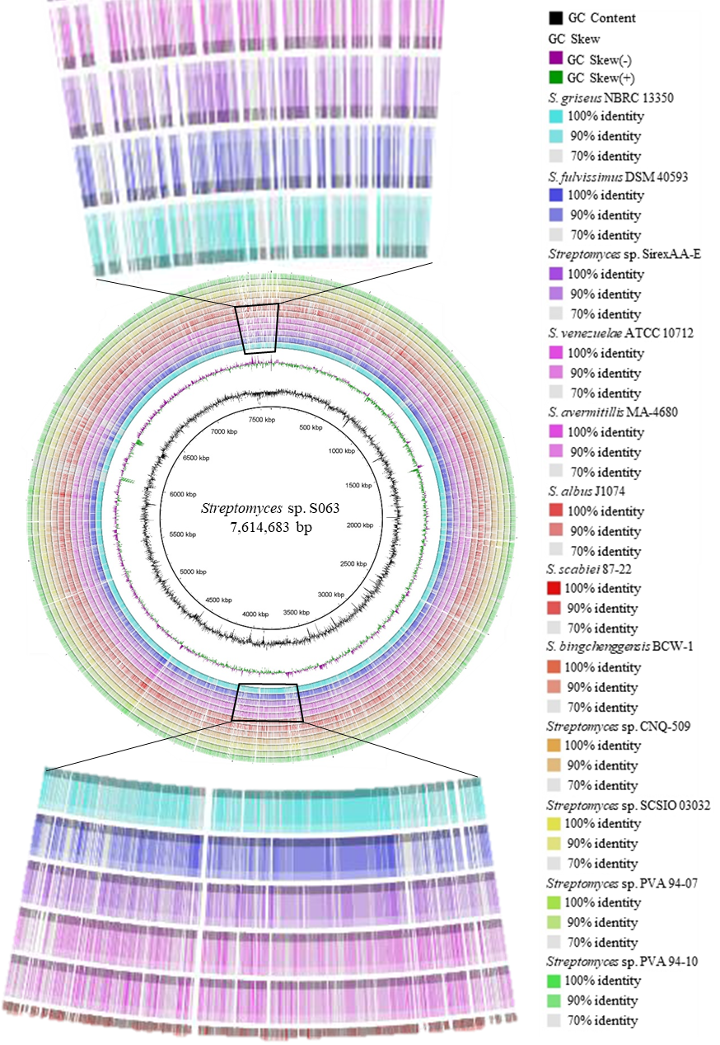

Figure S1
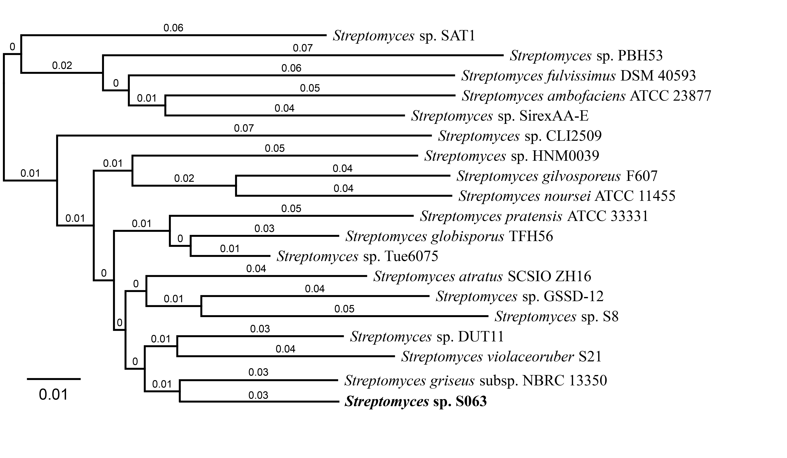
Figure S2

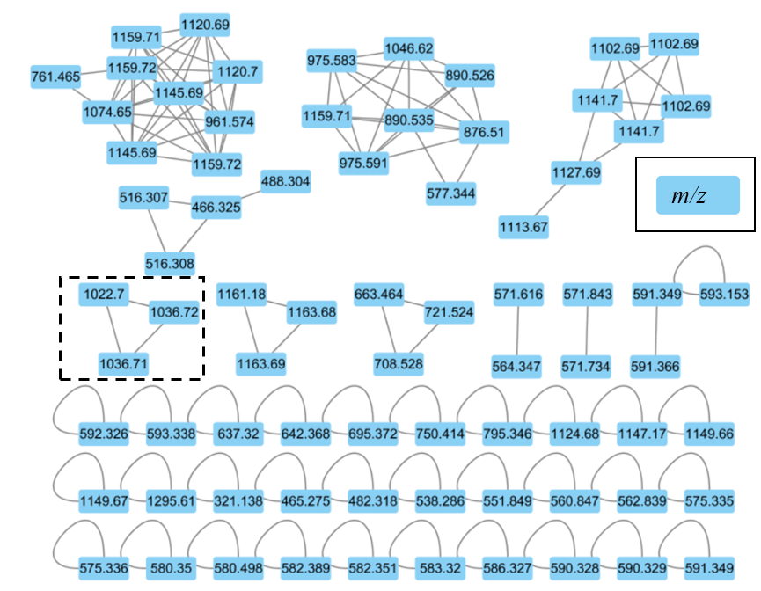

Figure S3

