Supplementary material

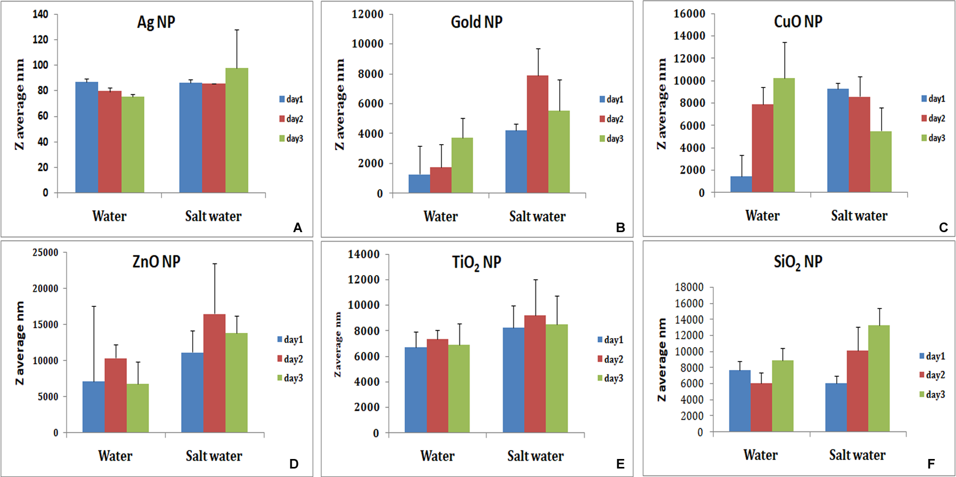

Figure S1 The pattern of distribution of particles in MilliQ and salt water. DLS measurements were made up to 48 h. We show increase in aggregates size for some of the nanoparticles. Except TiO₂ and SiO₂; most of the particles remain suspended and do not show visible sediment.

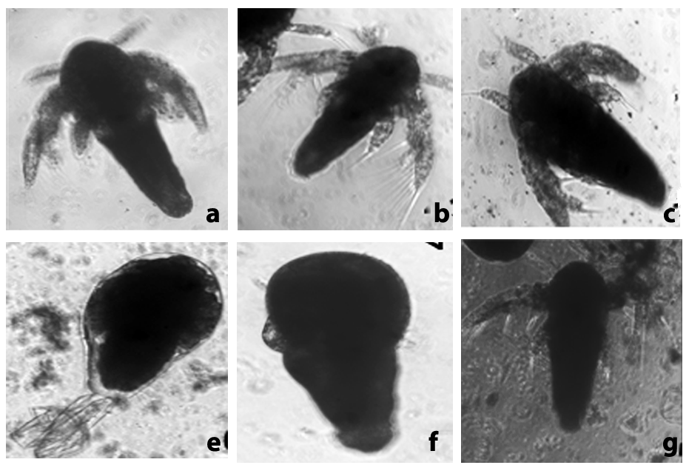
Figure S2 Images of Artemia hatched in presence of nanoparticles; a - control, b, g -silver nanoparticles, c-CuO nanoparticles. Nauplii do not show any gross abnormality but often one sees still-dead nauplii enclosed in the membrane (e, f) where appendages are not free.

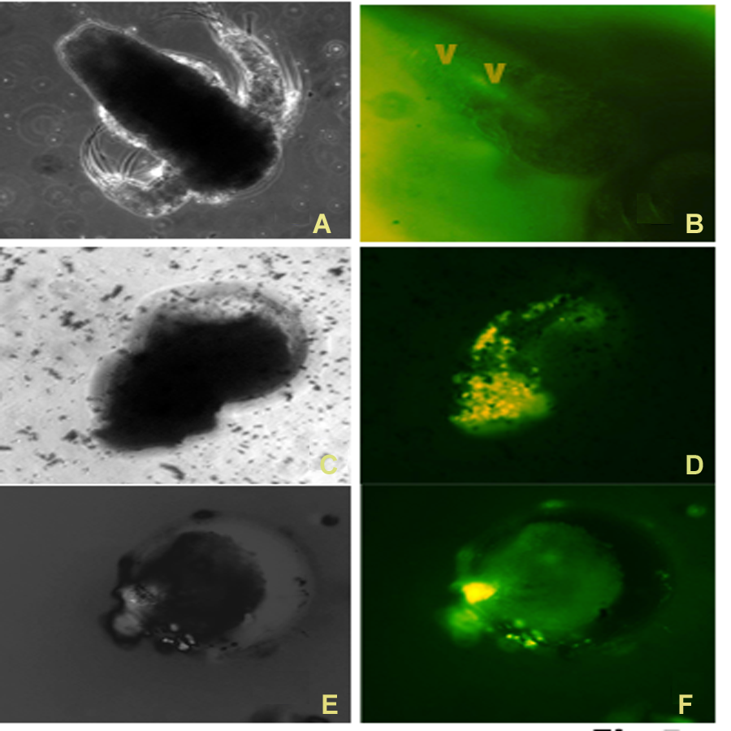
Figure S3 Artemia hatched in the presence of silver nanoparticles, were stained for reactive oxygen species using DCFDA, and dead nauplii showed the staining in gut (V), and whole body in stilldead unhatched nauplii within the membrane [C-F].

Supplementary Table 1
Percent hatching of Artemia in presence of SiO₂ nanoparticles. Data of individual experiments to show that at lower concentrations of SiO₂NPs the hatching rate was higher.

 | Percent hatching | Percent hatching | Percent hatching | Percent hatching | Percent hatching | Percent hatching | Percent hatching | Mean percent hatching | SD
blank | 50 | 97.974 | 71.9 | 70 | 75 | 49.46 | 79.19 | 70.5034 | 16.910
SiO2-100mg/L | 44.14 | 79.9633 | 58.8 | 50 | 30 | 11.76 | 60.86 | 48.5638 | 22.210
SiO2-10mg/L | 80.5 | 91.8233 | 80.5 | 82 | 28.85 | 45.45 | 74.64 | 67.2105 | 22.9229
SiO2-1mg/L | - | 89.46 | 91 | 86.6 | 77.32 | 63.4 | - | 81.556 | 11.453

