**A NEW TESTUDINOID TURTLE FROM THE MIDDLE TO LATE EOCENE OF VIETNAM AND ITS IMPLICATION FOR GEOEMYDID SYSTEMATICS**

Rafaella C. Garbin, Madelaine Böhme, Walter G. Joyce

**SUPPLEMENTARY MATERIAL**

**Appendix S5.** Consensus tree including fossil geoemydids

The consensus of the geoemydid phylogeny including each fossil species at a time is given below from figures S1 to S12.

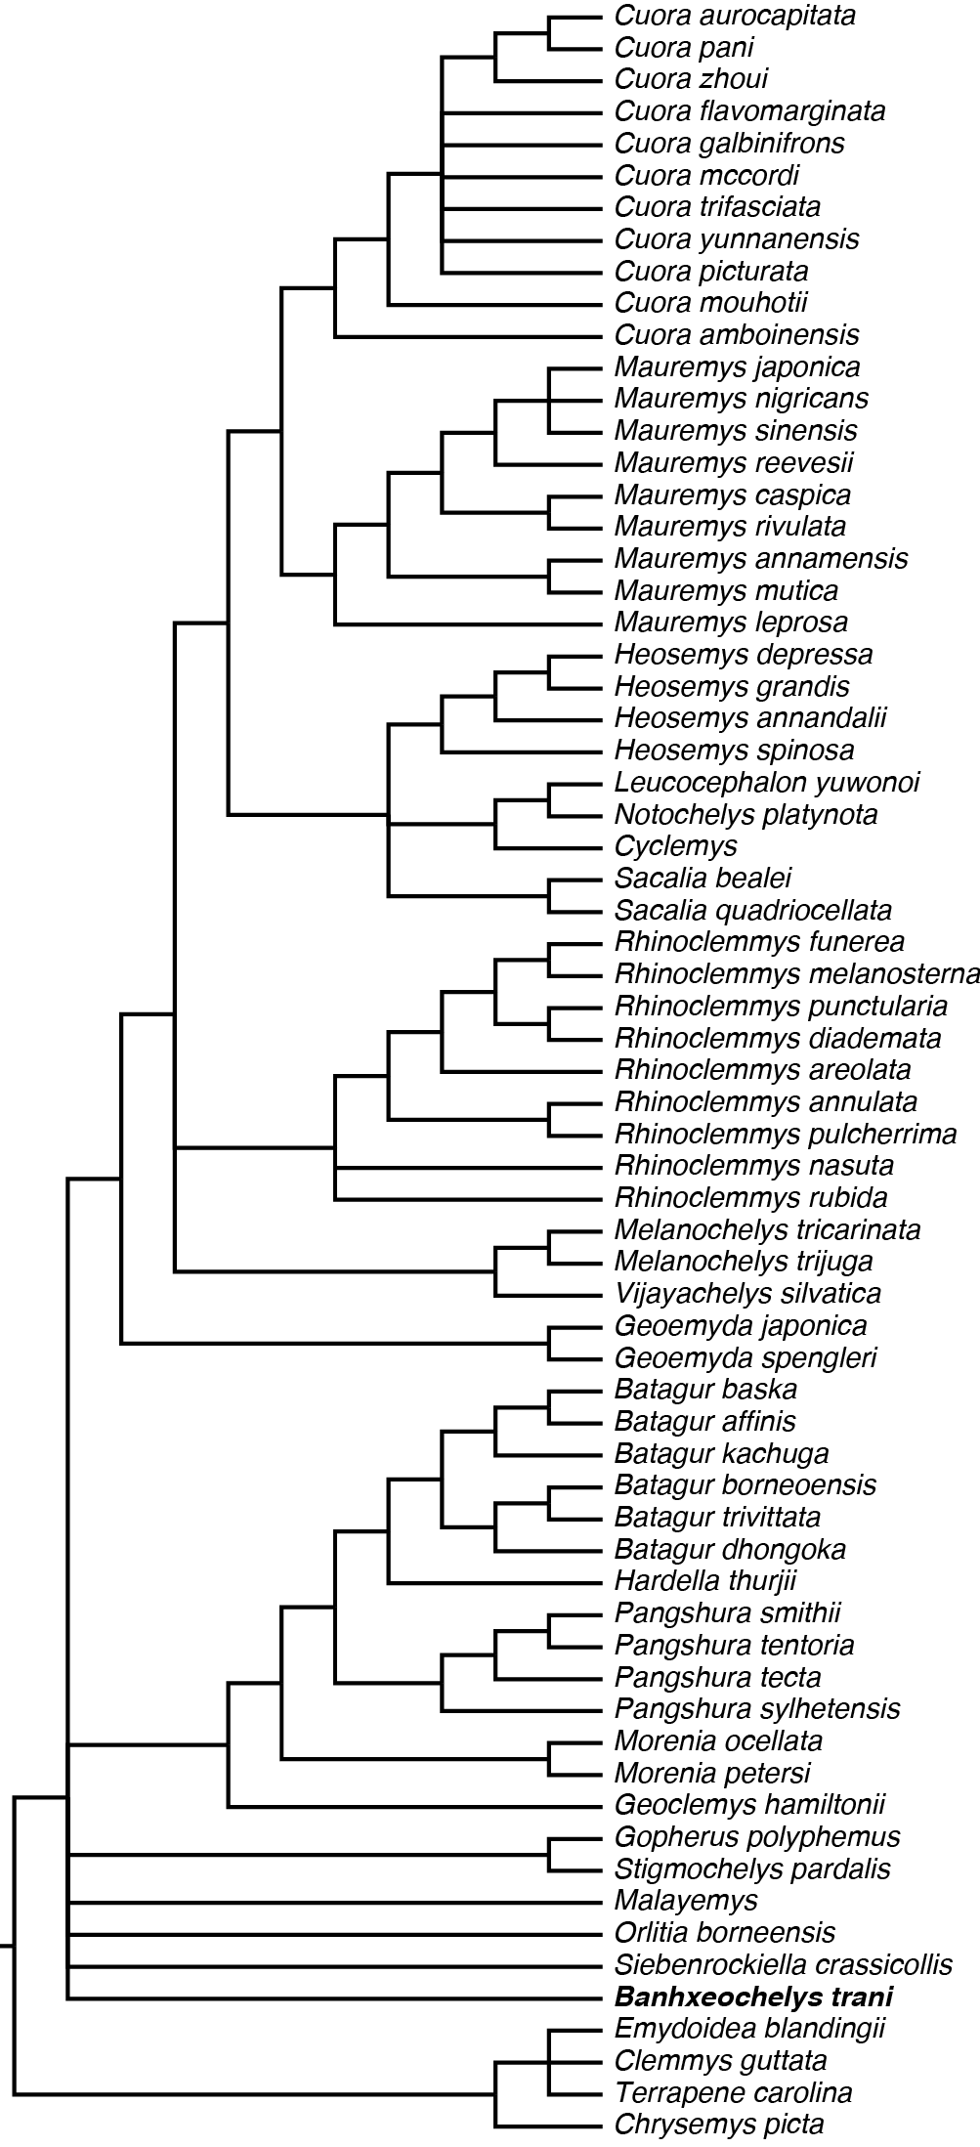

Figure S5.1: Strict consensus of total-evidence analysis with inclusion of the fossil testudinoid *Banhxeochelys trani* gen. et sp. nov.

position%20fossils/S5_bridgeremys_pusilla.pdf

Figure S5.2: Strict consensus of total-evidence analysis with inclusion of the putative fossil geoemydid *Bridgeremys pusilla*.

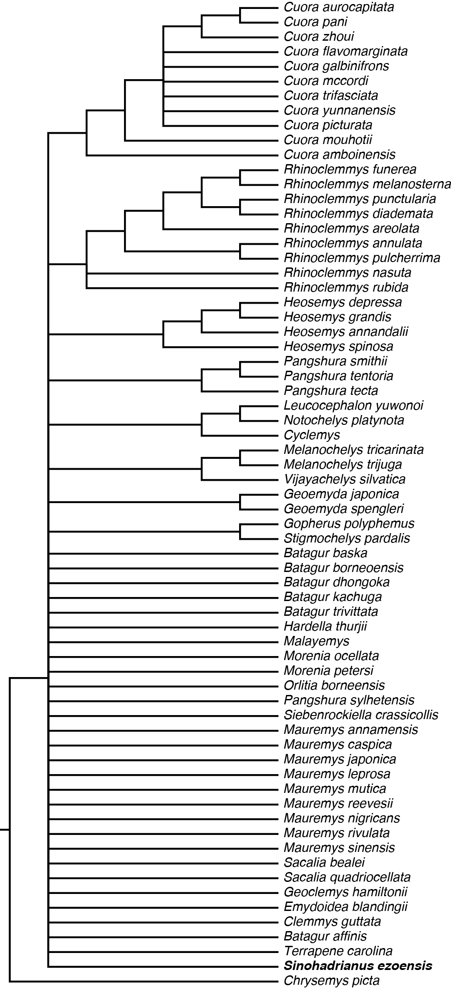

Figure S5.3: Strict consensus of total-evidence analysis with inclusion of the putative fossil testudinoid *Sinohadrianus ezoensis*.

position%20fossils/S5_iso_lacuna.pdf

Figure S5.4: Strict consensus of total-evidence analysis with inclusion of the putative fossil geoemydid *Isometremys lacuna.*

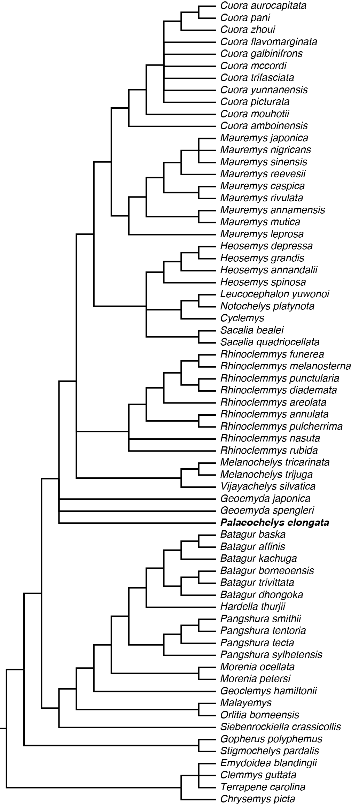

Figure S5.5: Strict consensus of total-evidence analysis with inclusion of the putative fossil geoemydid *Palaeochelys elongata*.

position%20fossils/S5_guangdongemys.pdf

Figure S5.6: Strict consensus of total-evidence analysis with inclusion of the putative fossil geoemydid *Guangdongemys pingi*.

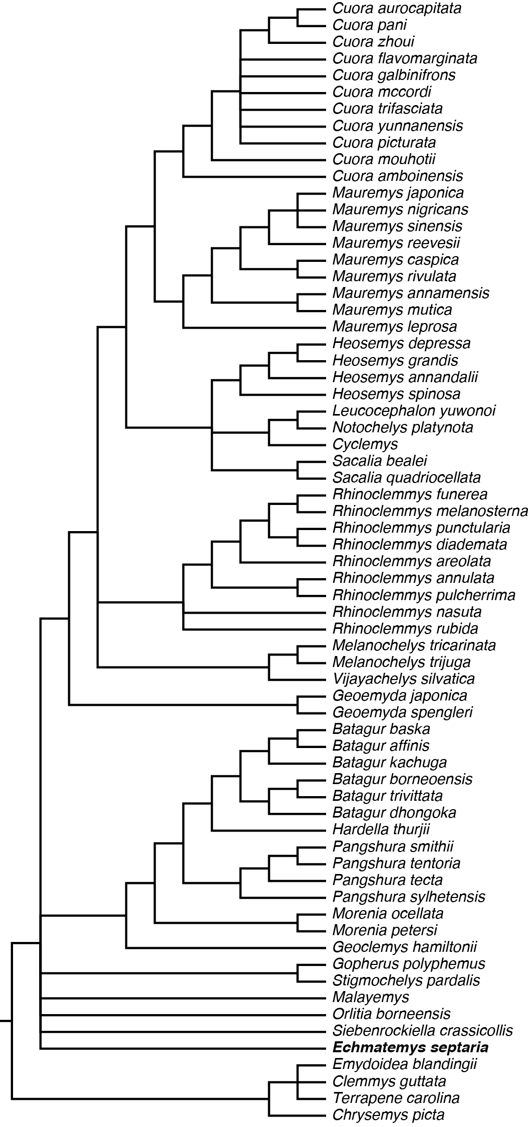

Figure S5.7: Strict consensus of total-evidence analysis with inclusion of the putative fossil geoemydid *Echmatemys septaria*.

.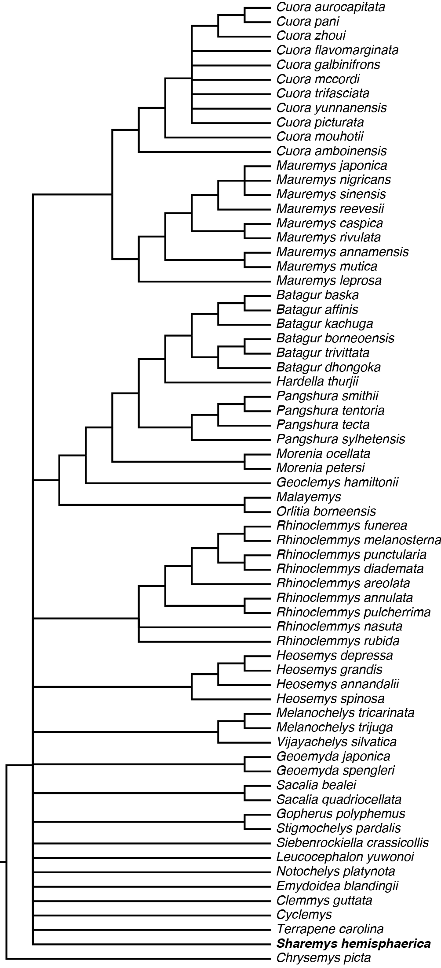

Figure S5.8: Strict consensus of total-evidence analysis with inclusion of the putative fossil testudinoid *Sharemys hemisphaerica*.

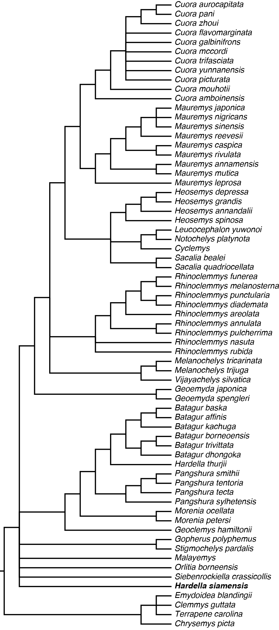

Figure S5.9: Strict consensus of total-evidence analysis with inclusion of the putative fossil geoemydid *Hardella siamensis*.

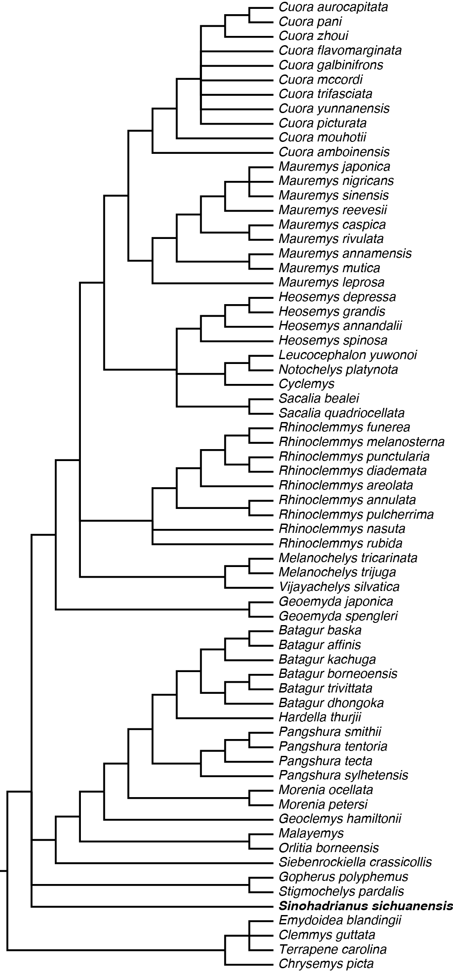

Figure S5.10: Strict consensus of total-evidence analysis with inclusion of the putative fossil testudinoid *Sinohadrianus sichuanensis*.

position%20fossils/S5_mauremys.pdf

Figure S11: Strict consensus of total-evidence analysis with inclusion of the putative fossil geoemydid *Mauremys thanhinensis*.

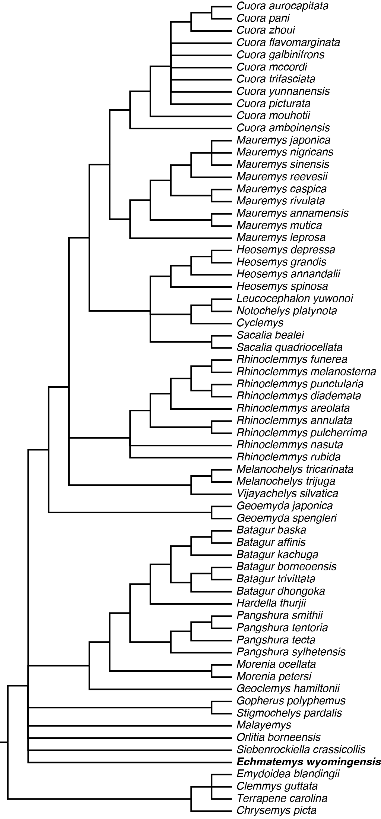

Figure S12: Strict consensus of total-evidence analysis with inclusion of the putative fossil geoemydid *Echmatemys wyomingensis.*