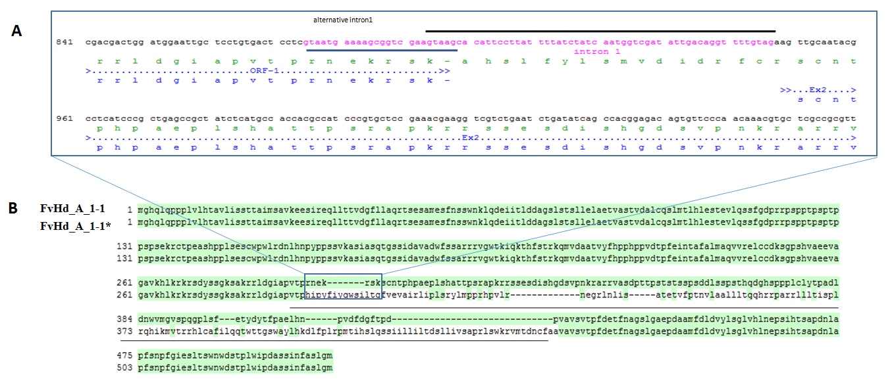

Supplementary Figure 1. (A) FvHd_a_1-1 gene with alternative but incorrect intron (blue line) and intron1 (black line) as confirmed by sequencing of cDNA, (B) FvHd_A_1-1 protein sequences of the correct (510 AA), and alternative but incorrect (*) prediction.

