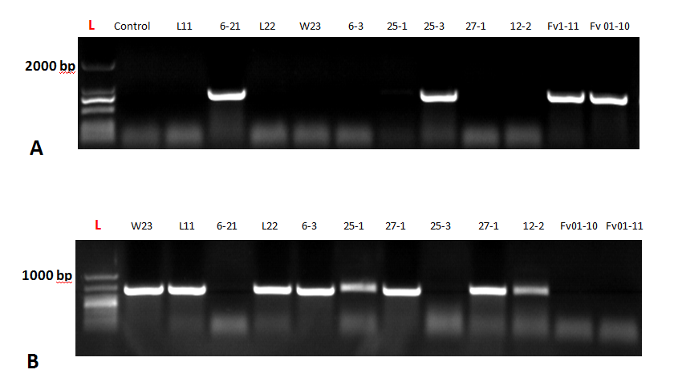
(A) PCR results showing amplification of FvHd_a_1-1 gene in different F. velutipes strains. Marker is indicated as L (red font); (B) amplification of FvHd_a_2-1 gene in different F. velutipes strains.

