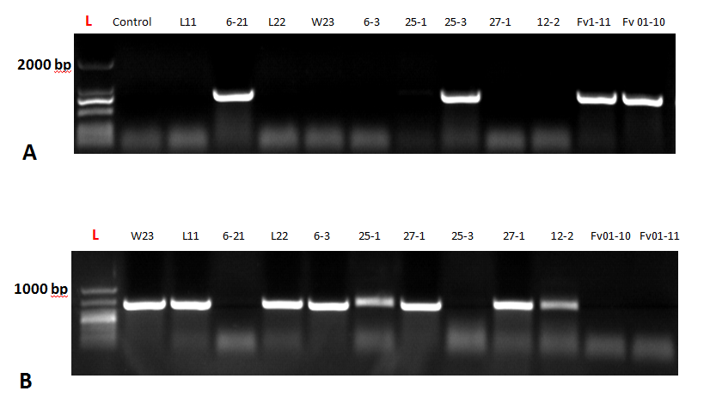
Supplementary Figure 4. (A)PCR amplification of complete HD-a loci of different F. velutipes strains; (B) Nested PCR amplification inside the HD-b sublocus (a region in-between HD-b genes) in different F. velutipes strains

