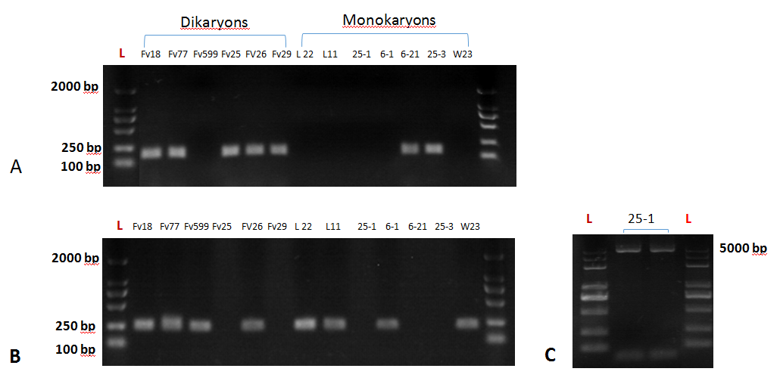

Supplementary Figure 5. (A) PCR amplification of a region between MIP and Hd_a_1-1 ; (B) result of amplification between MIP and Hd_A_2_1 gene in different F. velutipes strains; (C ) amplification of extra region between MIP and Hd_a_2-1 in 25-1 strains of F. velutipes .

