Warning # 853 in column 23. Text: da_DK
The LOCALE subcommand of the SET command specifies a locale
for which collation and translation are not available.
GET
FILE='/Users/jacobfloeaaskov/Desktop/PROJECTS/HOLOLENS/SPSS Data/Kategorisk.sav'.
DATASET NAME DataSet1 WINDOW=FRONT.
FREQUENCIES VARIABLES=L1S1 L1S2 L2S1 L2S2 L3S1 L3S2 L4S1 L4S2 L5S1 L5S2 S1 S2
/BARCHART PERCENT
/ORDER=ANALYSIS.

Frequencies

Notes
Output Created |  | 20-SEP-2018 16:27:08
Comments
Input | Data | /Users/jacobfloeaaskov/Desktop/PROJECTS/HOLOLENS/SPSS Data/Kategorisk.sav
 | Active Dataset | DataSet1
 | Filter | <none>
 | Weight | <none>
 | Split File | <none>
 | N of Rows in Working Data File | 85
Missing Value Handling | Definition of Missing | User-defined missing values are treated as missing.
 | Cases Used | Statistics are based on all cases with valid data.
Syntax |  | FREQUENCIES VARIABLES=L1S1 L1S2 L2S1 L2S2 L3S1 L3S2 L4S1 L4S2 L5S1 L5S2 S1 S2  /BARCHART PERCENT  /ORDER=ANALYSIS.
Resources | Processor Time | 00:00:04,56
 | Elapsed Time | 00:00:04,00

[DataSet1] /Users/jacobfloeaaskov/Desktop/PROJECTS/HOLOLENS/SPSS Data/Kategorisk.sav

Statistics
 |  | L1S1 | L1S2 | L2S1 | L2S2 | L3S1 | L3S2 | L4S1 | L4S2 | L5S1
N | Valid | 13 | 12 | 13 | 12 | 13 | 12 | 13 | 12 | 13

Statistics
 |  | L5S2 | S1 | S2
N | Valid | 12 | 65 | 60

Frequency Table

L1S1
 |  | Frequency | Percent | Valid Percent
Valid | 0 | 3 | 3,53 | 23,08
 | 1 | 10 | 11,76 | 76,92
 | Total | 13 | 15,29 | 100,00

L1S2
 |  | Frequency | Percent | Valid Percent
Valid | 0 | 4 | 4,71 | 33,33
 | 1 | 8 | 9,41 | 66,67
 | Total | 12 | 14,12 | 100,00

L2S1
 |  | Frequency | Percent | Valid Percent
Valid | 0 | 2 | 2,35 | 15,38
 | 1 | 11 | 12,94 | 84,62
 | Total | 13 | 15,29 | 100,00

L2S2
 |  | Frequency | Percent | Valid Percent
Valid | 0 | 4 | 4,71 | 33,33
 | 1 | 8 | 9,41 | 66,67
 | Total | 12 | 14,12 | 100,00

L3S1
 |  | Frequency | Percent | Valid Percent
Valid | 0 | 3 | 3,53 | 23,08
 | 1 | 10 | 11,76 | 76,92
 | Total | 13 | 15,29 | 100,00

L3S2
 |  | Frequency | Percent | Valid Percent
Valid | 0 | 4 | 4,71 | 33,33
 | 1 | 8 | 9,41 | 66,67
 | Total | 12 | 14,12 | 100,00

L4S1
 |  | Frequency | Percent | Valid Percent
Valid | 0 | 3 | 3,53 | 23,08
 | 1 | 10 | 11,76 | 76,92
 | Total | 13 | 15,29 | 100,00

L4S2
 |  | Frequency | Percent | Valid Percent
Valid | 0 | 4 | 4,71 | 33,33
 | 1 | 8 | 9,41 | 66,67
 | Total | 12 | 14,12 | 100,00

L5S1
 |  | Frequency | Percent | Valid Percent
Valid | 0 | 3 | 3,53 | 23,08
 | 1 | 10 | 11,76 | 76,92
 | Total | 13 | 15,29 | 100,00

L5S2
 |  | Frequency | Percent | Valid Percent
Valid | 0 | 2 | 2,35 | 16,67
 | 1 | 10 | 11,76 | 83,33
 | Total | 12 | 14,12 | 100,00

S1
 |  | Frequency | Percent | Valid Percent
Valid | 0 | 14 | 16,47 | 21,54
 | 1 | 51 | 60,00 | 78,46
 | Total | 65 | 76,47 | 100,00

S2
 |  | Frequency | Percent | Valid Percent
Valid | 0 | 18 | 21,18 | 30,00
 | 1 | 42 | 49,41 | 70,00
 | Total | 60 | 70,59 | 100,00

Bar Chart

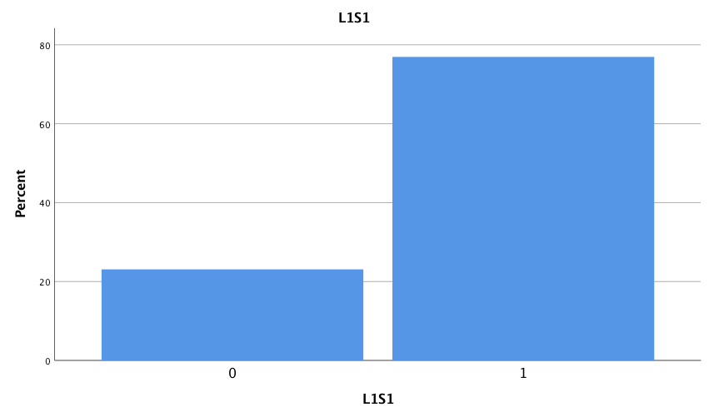

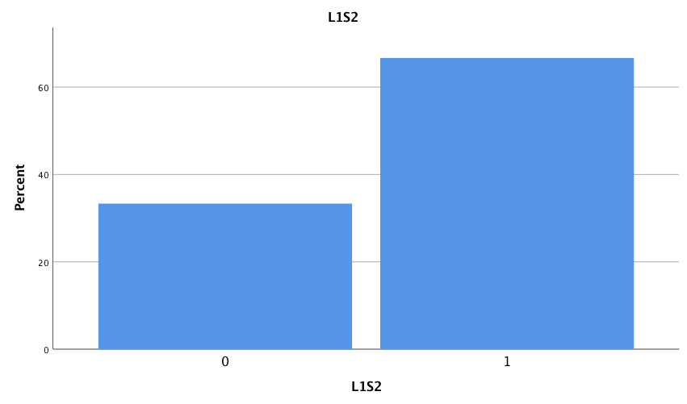

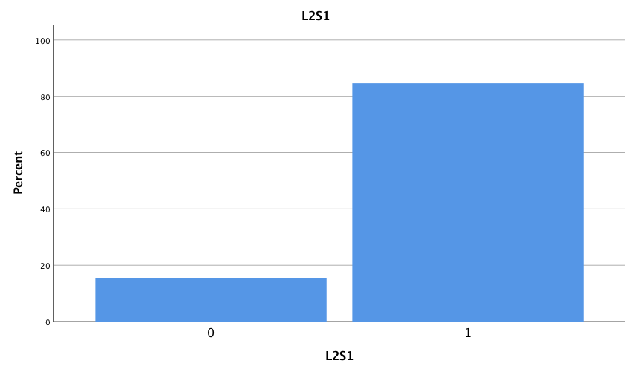

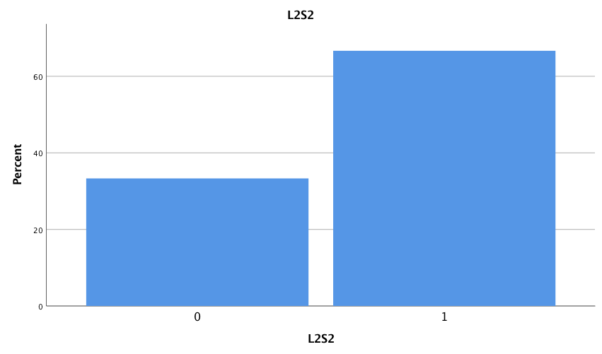

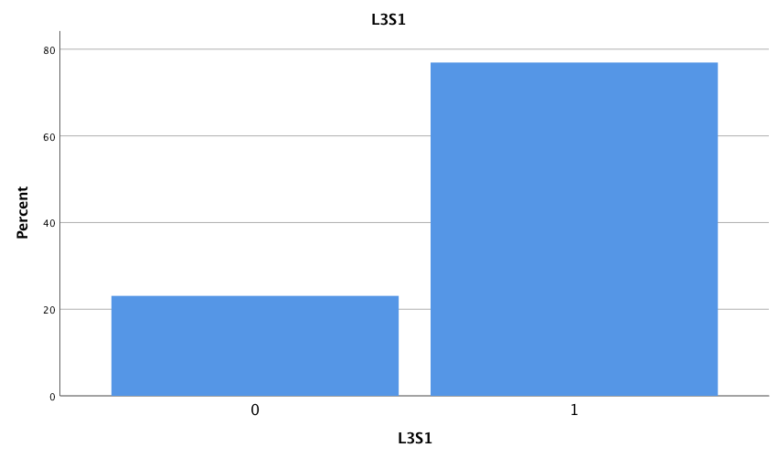

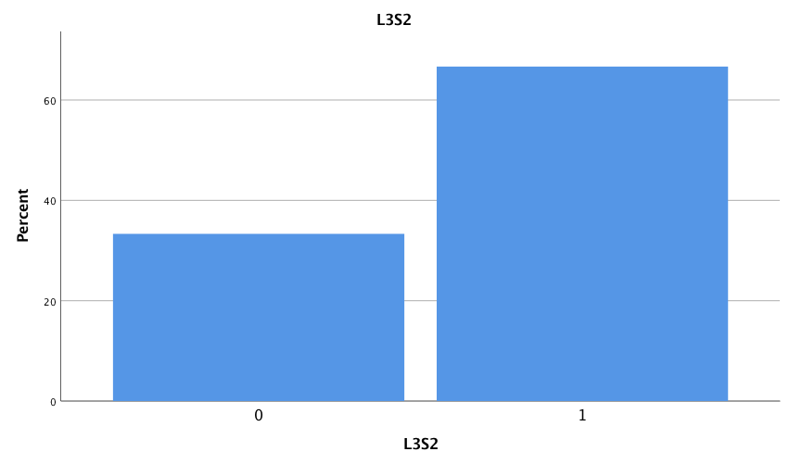

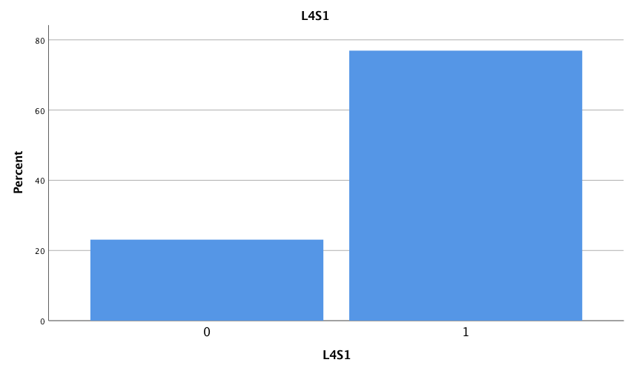

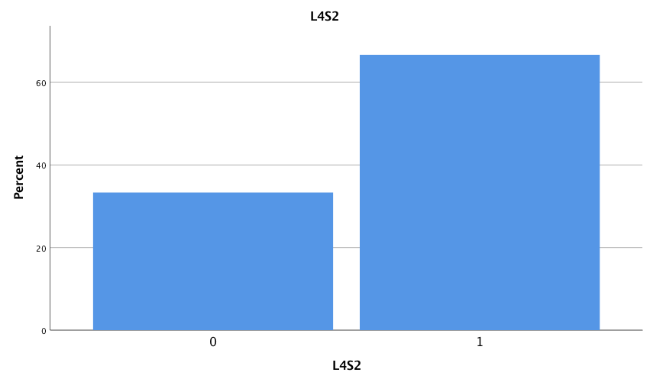

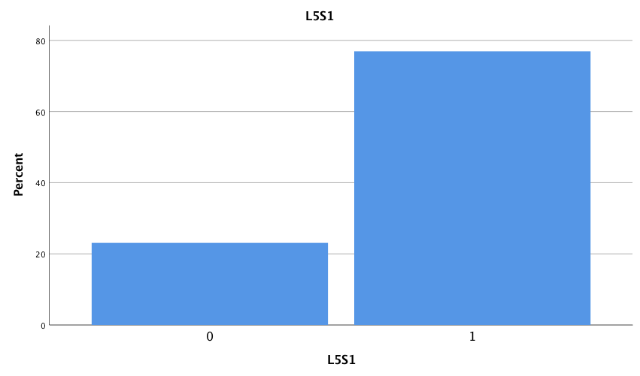

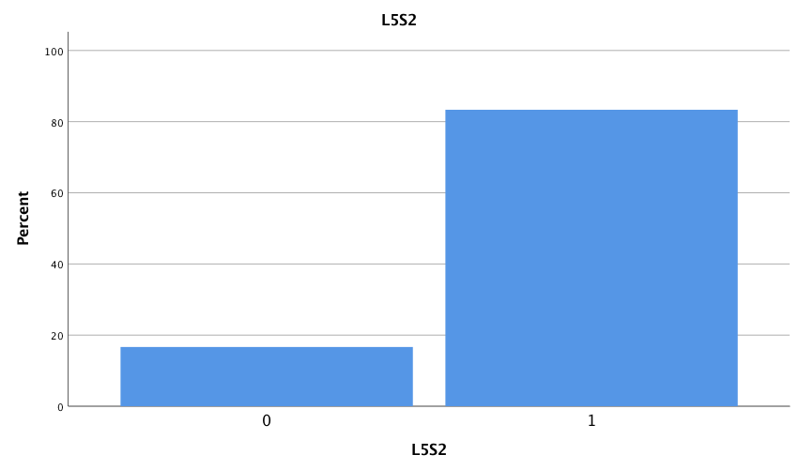

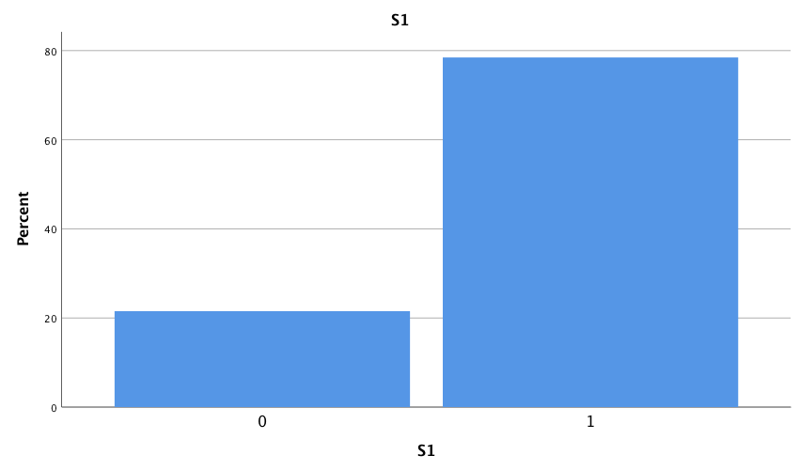

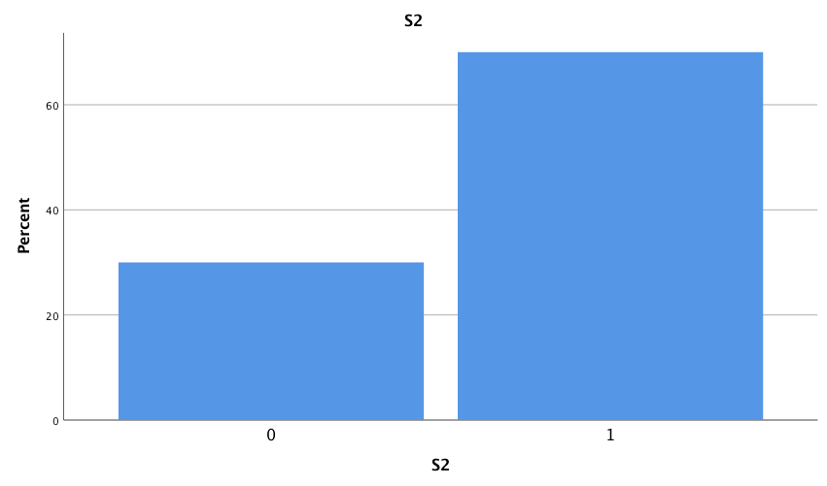

CROSSTABS
/TABLES=L1S1 BY L1S2
/FORMAT=AVALUE TABLES
/STATISTICS=MCNEMAR
/CELLS=COUNT TOTAL
/COUNT ROUND CELL.

L1S1 * L1S2 Crosstabulation
 |  |  | L1S2 |  | Total
 |  |  | 0 | 1
L1S1 | 0 | Count | 2 | 1 | 3
 |  | % of Total | 16,7% | 8,3% | 25,0%
 | 1 | Count | 2 | 7 | 9
 |  | % of Total | 16,7% | 58,3% | 75,0%
Total |  | Count | 4 | 8 | 12
 |  | % of Total | 33,3% | 66,7% | 100,0%

Reapeatability between sessions: 16.7%+58.3% = 75%

Chi-Square Tests
 | Value | Exact Sig. (2-sided)
McNemar Test |  | 1,000ª
N of Valid Cases | 12

a. Binomial distribution used.

CROSSTABS
/TABLES=L2S1 BY L2S2
/FORMAT=AVALUE TABLES
/STATISTICS=MCNEMAR
/CELLS=COUNT TOTAL
/COUNT ROUND CELL.

L2S1 * L2S2 Crosstabulation
 |  |  | L2S2 |  | Total
 |  |  | 0 | 1
L2S1 | 0 | Count | 0 | 1 | 1
 |  | % of Total | 0,0% | 8,3% | 8,3%
 | 1 | Count | 4 | 7 | 11
 |  | % of Total | 33,3% | 58,3% | 91,7%
Total |  | Count | 4 | 8 | 12
 |  | % of Total | 33,3% | 66,7% | 100,0%
Repeatability between sessions: 58.3%

Chi-Square Tests
 | Value | Exact Sig. (2-sided)
McNemar Test |  | ,375ª
N of Valid Cases | 12

a. Binomial distribution used.

CROSSTABS
/TABLES=L3S1 BY L3S2
/FORMAT=AVALUE TABLES
/STATISTICS=MCNEMAR
/CELLS=COUNT TOTAL
/COUNT ROUND CELL.

L3S1 * L3S2 Crosstabulation
 |  |  | L3S2 |  | Total
 |  |  | 0 | 1
L3S1 | 0 | Count | 2 | 0 | 2
 |  | % of Total | 16,7% | 0,0% | 16,7%
 | 1 | Count | 2 | 8 | 10
 |  | % of Total | 16,7% | 66,7% | 83,3%
Total |  | Count | 4 | 8 | 12
 |  | % of Total | 33,3% | 66,7% | 100,0%
Repeatability between sessions: 16.7%+66.7% = 83.3%

Chi-Square Tests
 | Value | Exact Sig. (2-sided)
McNemar Test |  | ,500ª
N of Valid Cases | 12

a. Binomial distribution used.

CROSSTABS
/TABLES=L4S1 BY L4S2
/FORMAT=AVALUE TABLES
/STATISTICS=MCNEMAR
/CELLS=COUNT TOTAL
/COUNT ROUND CELL.

L4S1 * L4S2 Crosstabulation
 |  |  | L4S2 |  | Total
 |  |  | 0 | 1
L4S1 | 0 | Count | 2 | 0 | 2
 |  | % of Total | 16,7% | 0,0% | 16,7%
 | 1 | Count | 2 | 8 | 10
 |  | % of Total | 16,7% | 66,7% | 83,3%
Total |  | Count | 4 | 8 | 12
 |  | % of Total | 33,3% | 66,7% | 100,0%
Repeatability between sessions: 16.7%+66.7%=83.3%

Chi-Square Tests
 | Value | Exact Sig. (2-sided)
McNemar Test |  | ,500ª
N of Valid Cases | 12

a. Binomial distribution used.

CROSSTABS
/TABLES=L5S1 BY L5S2
/FORMAT=AVALUE TABLES
/STATISTICS=MCNEMAR
/CELLS=COUNT TOTAL
/COUNT ROUND CELL.

L5S1 * L5S2 Crosstabulation
 |  |  | L5S2 |  | Total
 |  |  | 0 | 1
L5S1 | 0 | Count | 1 | 2 | 3
 |  | % of Total | 8,3% | 16,7% | 25,0%
 | 1 | Count | 1 | 8 | 9
 |  | % of Total | 8,3% | 66,7% | 75,0%
Total |  | Count | 2 | 10 | 12
 |  | % of Total | 16,7% | 83,3% | 100,0%
Repeatability between sessions: 8.3%+66.7%=75%

Chi-Square Tests
 | Value | Exact Sig. (2-sided)
McNemar Test |  | 1,000ª
N of Valid Cases | 12

a. Binomial distribution used.

CROSSTABS
/TABLES=S1 BY S2
/FORMAT=AVALUE TABLES
/STATISTICS=MCNEMAR
/CELLS=COUNT TOTAL
/COUNT ROUND CELL.

S1 * S2 Crosstabulation
 |  |  | S2 |  | Total
 |  |  | 0 | 1
S1 | 0 | Count | 7 | 4 | 11
 |  | % of Total | 11,7% | 6,7% | 18,3%
 | 1 | Count | 11 | 38 | 49
 |  | % of Total | 18,3% | 63,3% | 81,7%
Total |  | Count | 18 | 42 | 60
 |  | % of Total | 30,0% | 70,0% | 100,0%

Repeatability between sessions overall: 11.7%+63.3%=75%

Chi-Square Tests
 | Value | Exact Sig. (2-sided)
McNemar Test |  | ,118ª
N of Valid Cases | 60

a. Binomial distribution used.

