**Table S3:** Statistical results of repeated measures ANOVA with time as a within-subjects factor and behavior as a between-subjects factor.

1. Assumptions tests

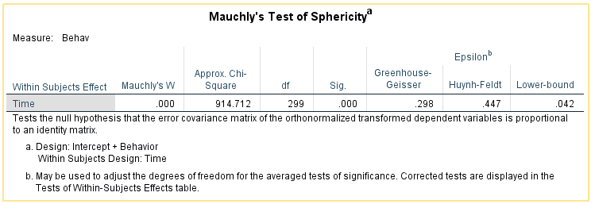

Since the Mauchly’s test of sphericity is failed, we will use Greenhouse-Geisser correction for the degrees of freedom.

1. Within-subjects effects, between-subjects effects, and interaction

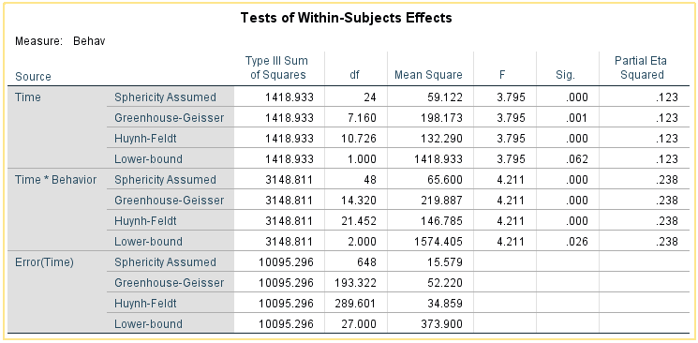

Using Greenhouse-Geisser method to adjust the degrees of freedom, the result reveals the significant effect from time (*F* (7.160, 193.322)=3.795, *P*=0.001) and significant effect from the interaction between time and behavior (*F*(14.320, 193.322)=4.211, *P* <0.001).

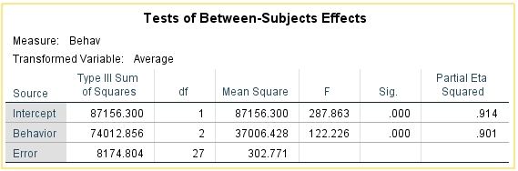

There is a significant effect from behavior (*F*(2,27)=122.226, *P* <0.001).

1. **Pairwise Comparison on each Time-interval**

Based on the results in B, we are interested in the comparison of behaviors on each time-interval. We used One-Way ANOVA with Tukey’s Honest Significant Differences (HSD) tests. The corresponding time series figures (Mean ± SE) is presented in Fig. 5a.

