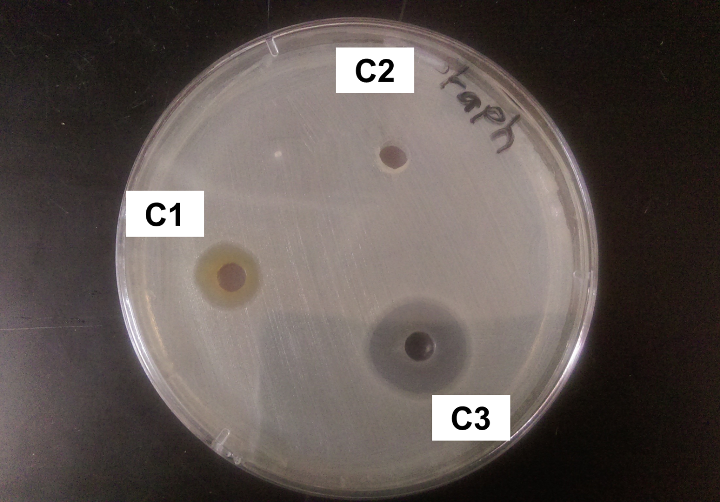
Figure 1: AgNO₃ effect on (C3), AgNPS-OLE (C3) and OLE alone effect on Staphylococcus aureus.

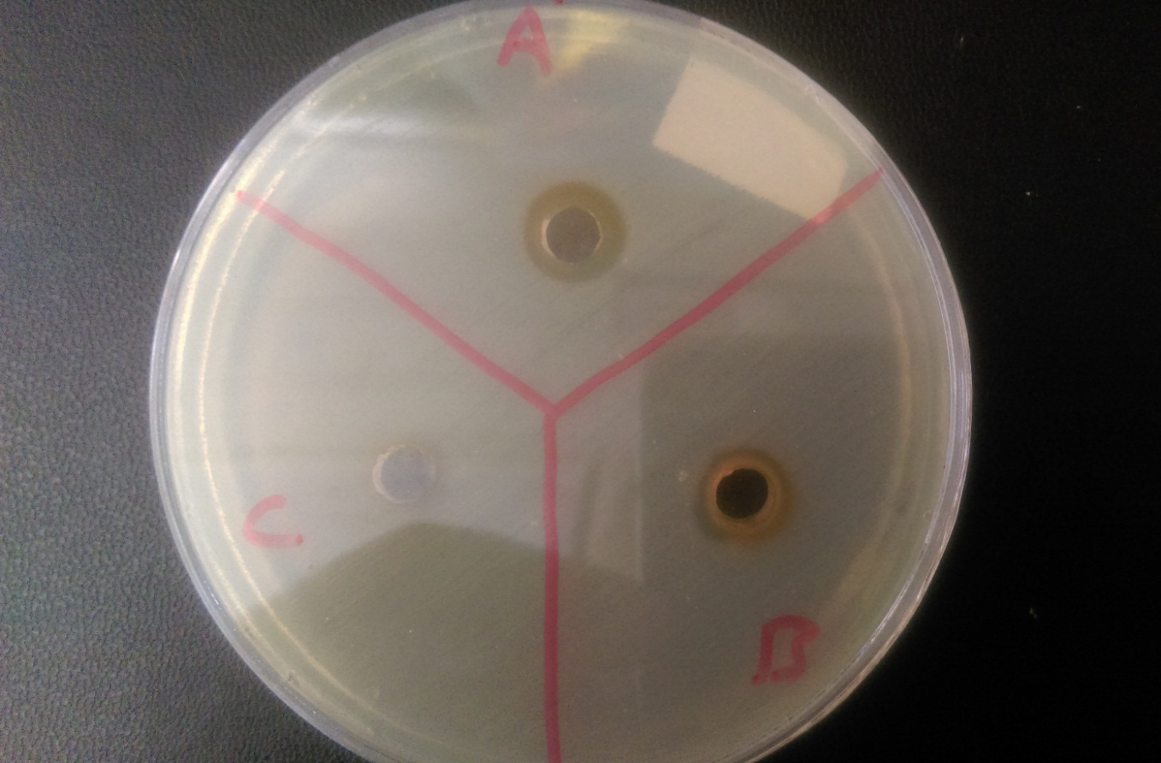
Figure 2: (A) and (B) AgNPs-OLE effect on E-Coli. (C) is a control of only the OLE.
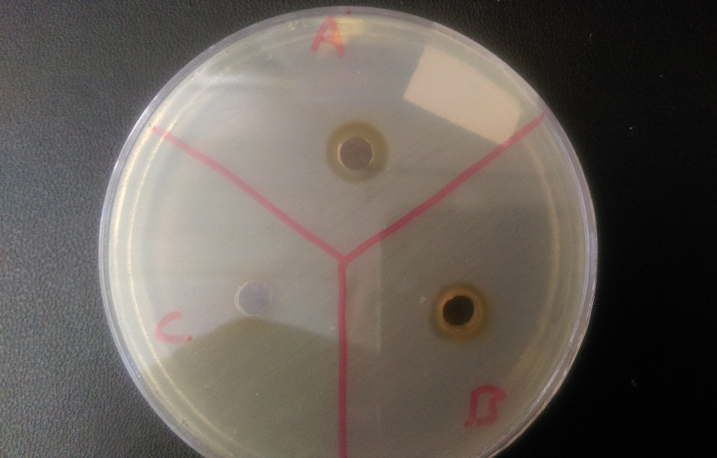
Figure 3: (A) and (B) AgNPs-OLE effect on Salmonella. (C) is a control of only the OLE.
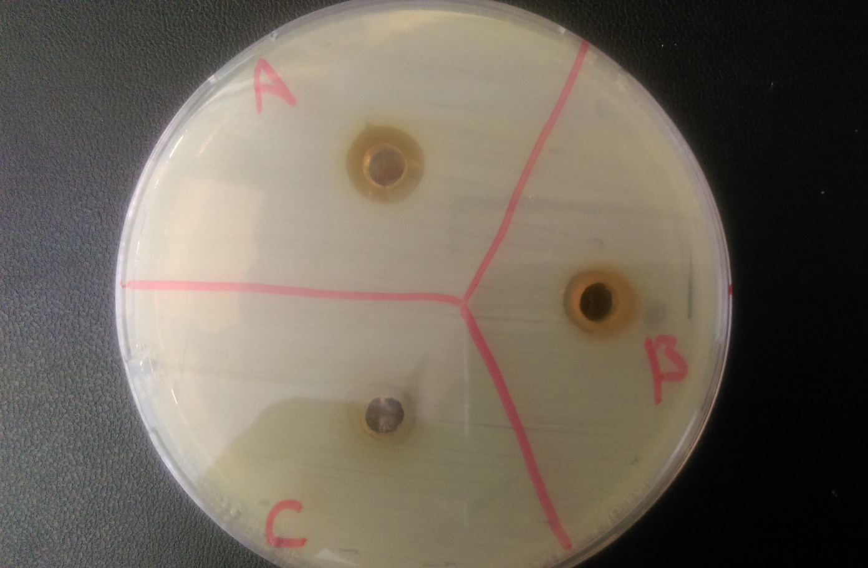
Figure 4: (A) and (B) AgNPs-OLE effect on Staphylcoccus aureus. (C) is a control of only the OLE.
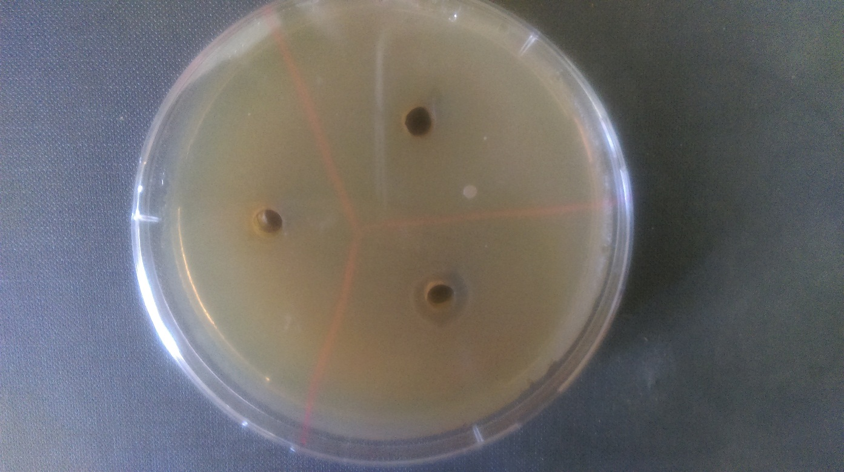
Figure 5: AgNPs-RLE effect on E-Coli, the well with the circle surrounding it. The others are controls of RLE only.
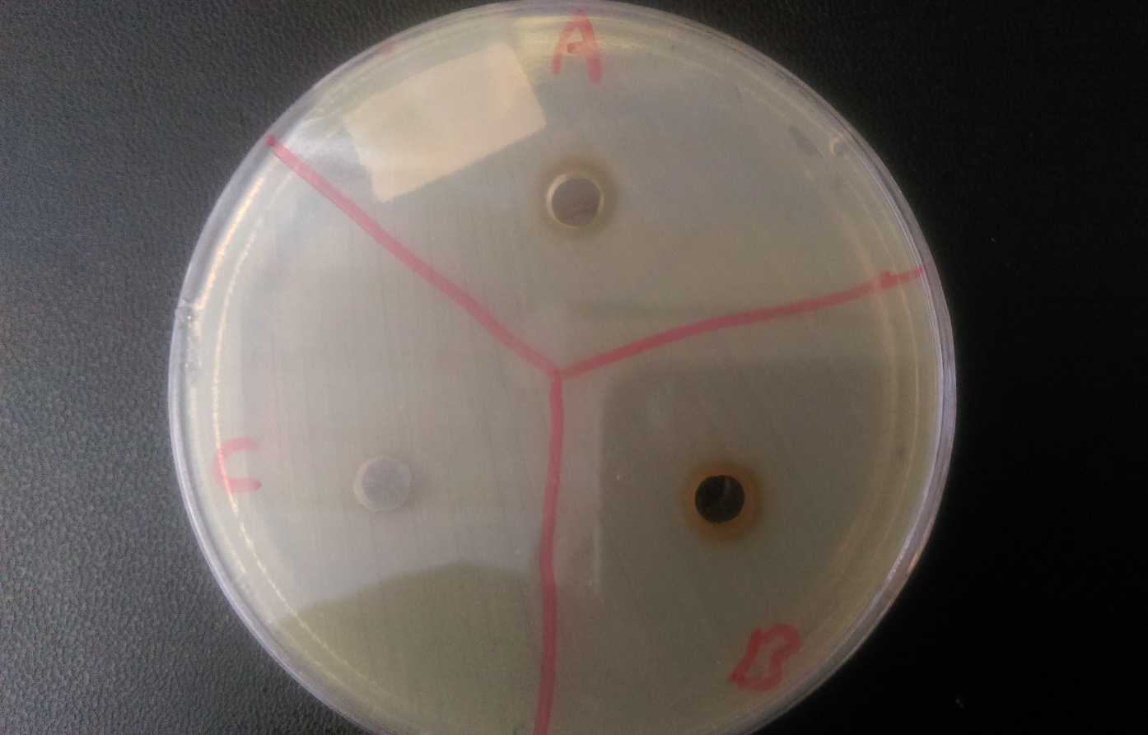
Figure 6: (A) and (B) AgNPs-RLE effect on Salmonella. (C) is a control of only the RLE.
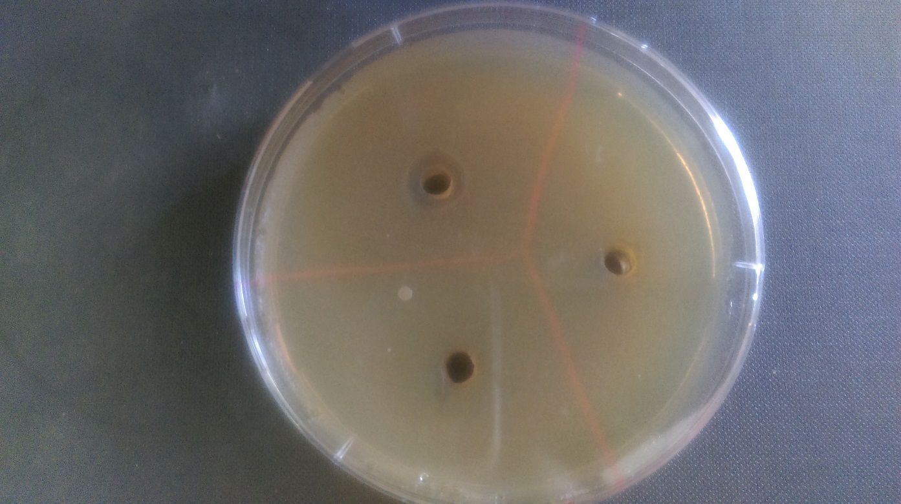
Figure 7: (A) and (B) AgNPs-OLE effect on Staphylcoccus aureus, the well with the circle surrounding it. The others are controls of OLE only.

