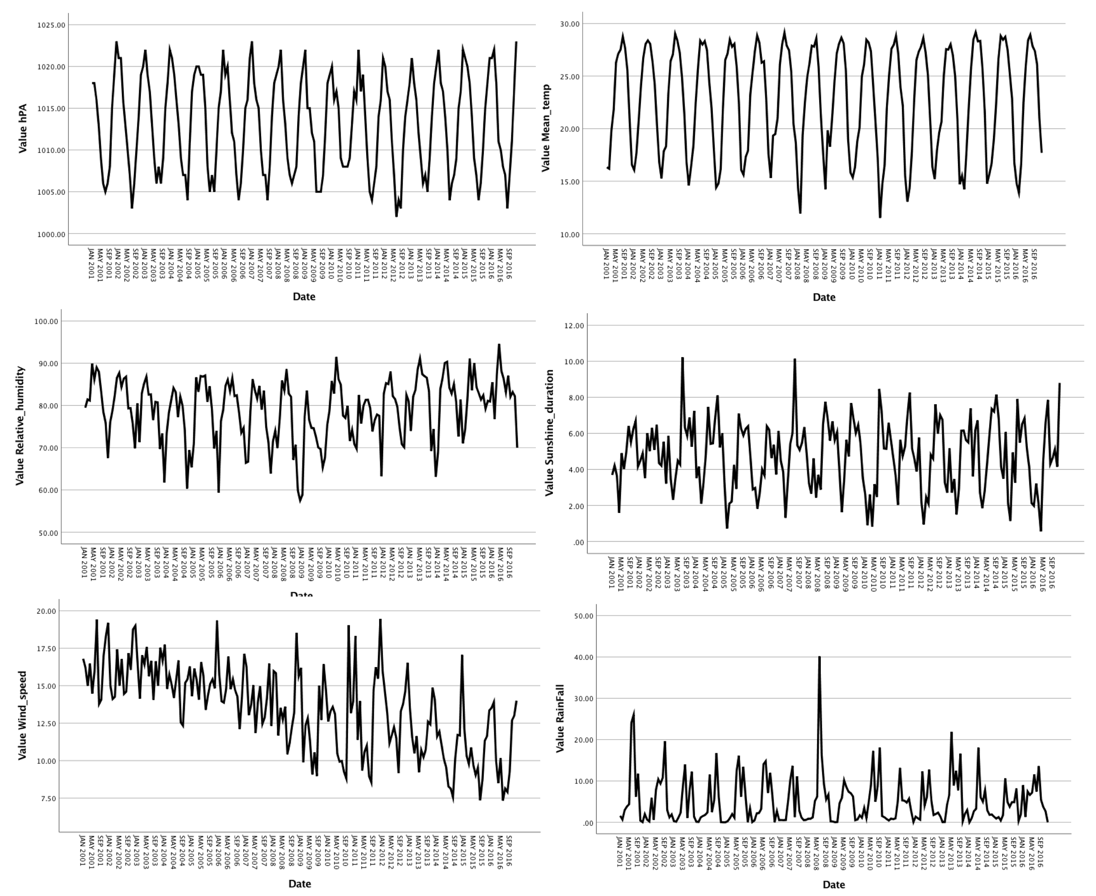
Table S1. The pattern of meteorological factors during the calibrating period.
All the parameters seem stable and periodic over calibration period except the variation of wind speed becomes greater in recent years.

