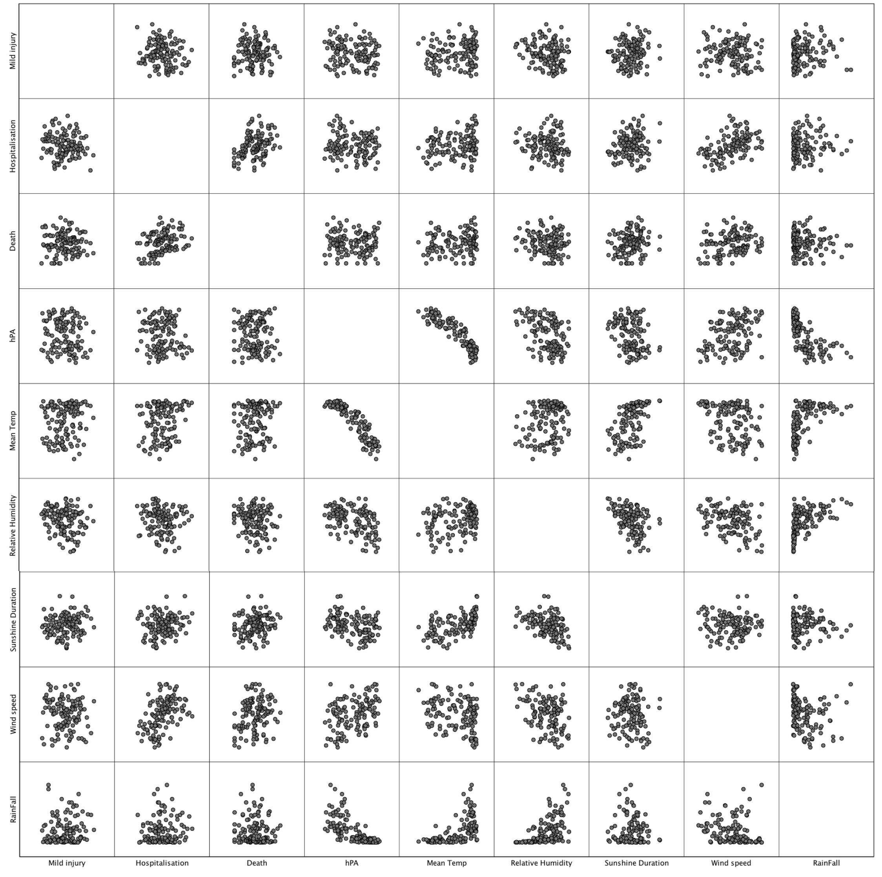
Table S2. Comprehensive scatter plots to show all the correlation between predictors

