Figure S1. Microscopic and macroscopic photographs of mucilage and mat present in Biobío river. A) Mucilage tubes generated by Cymbella spp. B) Mucilage stalk generated by D. geminata. C) Mucilage stalk produced by Gomphoneis spp. This genus did not have a relationship with mat thickness (unpublished data) (D) Mat in boulders. Scales of 10 μm.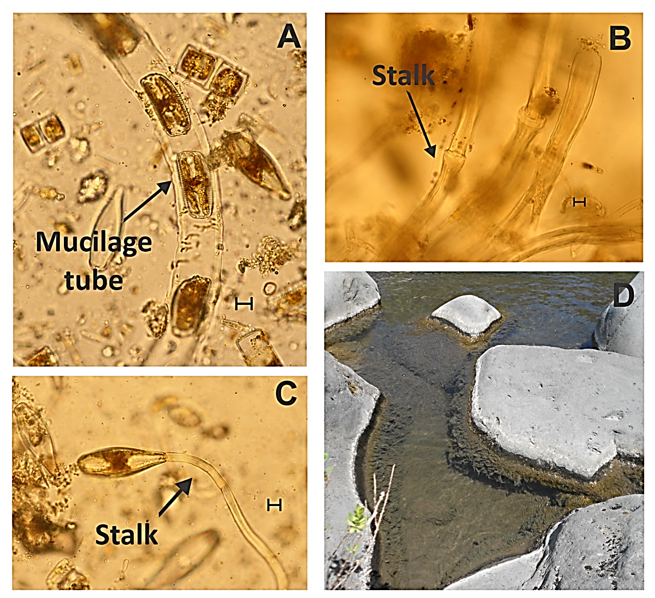

Table S1. Tables of ANOVAS and MANOVAS with permutations.
Permutation ANOVA 1 way
Resp. Var.: Mat thickness | Df | Sum Sq | Mean Sq | F value | P param | P perm
Categories D. geminata/Cymbella spp. Presence (A/A – C/A – A/D – C/D) | 3 | 2.73 | 0.91 | 3.39 | 0.02 | 0.02
Residuals | 119 | 31.93 | 0.27
Permutation MANOVA 1 way
Resp. Var.: Physico-chamical matrix | Df | Sum Sq | Mean Sq | F value | P perm
Sampling season (Spring - Autumn) | 0.25098 | 0.25 | 1 | 16.66 | 0.001
Residuals | 1.59654 | 0.02 | 106
Permutation MANOVA 1 way
Resp. Var.: Physico-chamical matrix | Df | Sum Sq | Mean Sq | F value | P perm
Categories D. geminata/Cymbella spp. Presence (A/A – C/A – A/D – C/D) | 0.13671 | 0.05 | 3 | 2.80 | 0.001
Residuals | 1.69444 | 0.02 | 104
Permutation ANOVA 1 way
Resp. Var.: SiO2 | Df | Sum Sq | Mean Sq | F value | P param | P perm
Categories D. geminata/Cymbella spp. Presence (A/A – C/A – A/D – C/D) | 3 | 22.08 | 7.36 | 9.01 | 0.00 | 0.001
Residuals | 104 | 84.92 | 0.82
Permutation ANOVA 1 way
Resp. Var.: Temp. Water | Df | Sum Sq | Mean Sq | F value | P param | P perm
Categories D. geminata/Cymbella spp. Presence (A/A – C/A – A/D – C/D) | 3 | 17.10 | 5.70 | 6.59 | 0.00 | 0.001
Residuals | 104 | 89.90 | 0.86
Permutation ANOVA 1 way
Resp. Var.: P | Df | Sum Sq | Mean Sq | F value | P param | P perm
Categories D. geminata/Cymbella spp. Presence (A/A – C/A – A/D – C/D) | 3 | 16.50 | 5.50 | 6.32 | 0.00 | 0.002
Residuals | 104 | 90.50 | 0.87
Permutation ANOVA 1 way
Resp. Var.: EC | Df | Sum Sq | Mean Sq | F value | P param | P perm
Categories D. geminata/Cymbella spp. Presence (A/A – C/A – A/D – C/D) | 3 | 15.13 | 5.04 | 5.71 | 0.00 | 0.002
Residuals | 104 | 91.87 | 0.88
Permutation ANOVA 1 way
Resp. Var.: DO | Df | Sum Sq | Mean Sq | F value | P param | P perm
Categories D. geminata/Cymbella spp. Presence (A/A – C/A – A/D – C/D) | 3 | 5.48 | 1.83 | 1.87 | 0.14 | 0.123
Residuals | 104 | 101.52 | 0.98
Permutation ANOVA 1 way
Resp. Var.: Fe | Df | Sum Sq | Mean Sq | F value | P param | P perm
Categories D. geminata/Cymbella spp. Presence (A/A – C/A – A/D – C/D) | 3 | 3.65 | 1.22 | 1.22 | 0.30 | 0.336
Residuals | 104 | 103.35 | 0.99
Permutation ANOVA 1 way
Resp. Var.: pH | Df | Sum Sq | Mean Sq | F value | P param | P perm
Categories D. geminata/Cymbella spp. Presence (A/A – C/A – A/D – C/D) | 3 | 1.59 | 0.53 | 0.52 | 0.67 | 0.684
Residuals | 104 | 105.41 | 1.01
Permutation ANOVA 1 way
Resp. Var.: Depth flow vel. | Df | Sum Sq | Mean Sq | F value | P param | P perm
Categories D. geminata/Cymbella spp. Presence (A/A – C/A – A/D – C/D) | 3 | 0.26 | 0.09 | 0.08 | 0.97 | 0.971
Residuals | 104 | 106.74 | 1.03
Permutation ANOVA 1 way
Resp. Var.: Ca | Df | Sum Sq | Mean Sq | F value | P param | P perm
Categories D. geminata/Cymbella spp. Presence (A/A – C/A – A/D – C/D) | 3 | 3.96 | 1.32 | 1.33 | 0.27 | 0.273
Residuals | 104 | 103.04 | 0.99
Permutation ANOVA 1 way
Resp. Var.: Water column depth | Df | Sum Sq | Mean Sq | F value | P param | P perm
Categories D. geminata/Cymbella spp. Presence (A/A – C/A – A/D – C/D) | 3 | 3.44 | 1.15 | 1.15 | 0.33 | 0.329
Residuals | 104 | 103.56 | 1.00

